Homework 4 Solution
Problem 1
a) 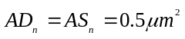, 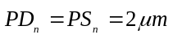,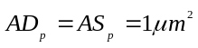, 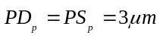, 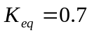
We refer to the NMOS and PMOS in the basic inverter as transistors 1, 2 respectively. Also 3, 4 refer to NMOS and PMOS in the load inverter.
Capacitor | Expression | Value(fF)
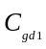 | 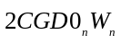 | 0.62
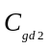 | 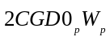 | 1.08
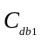 | 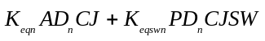 | 1.09
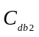 | 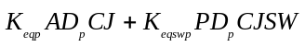 | 1.79
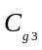 | 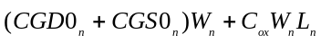 | 4.24
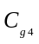 | 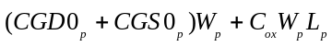 | 8.16
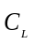 | 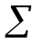 | 16.98
b) Effective output loading capacitances =
c) 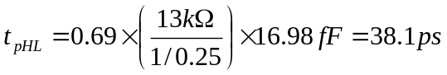
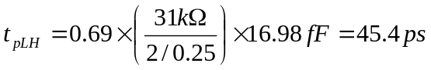
d) For the Basic Inverter: 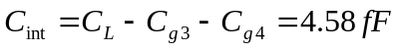 and therefore,
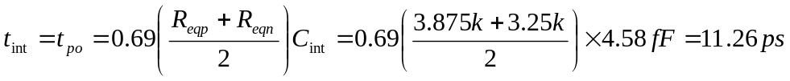
For basic inverter, 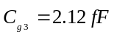, 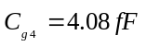 and hence 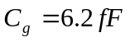
Now we have: 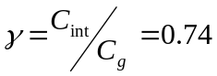
Finally with 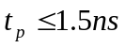 and 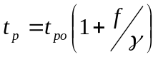 we have 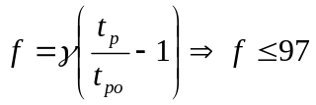
e) SPICE
Homework 4
.include 0.25um_PSPICE_BSIM3.txt
vdd vdd 0 dc 2.5
vin vin 0 pulse(0 2.5 0.2n 1p 1p 0.5n 1n)
M1 vout vin 0 0 NMOS L=0.25u W=1u AD=0.5p AS=0.5p PD=2u PS=2u
M2 vout vin vdd vdd PMOS L=0.25u W=2u AD=1p AS=1p PD=3u PS=3u
M3 1 vout 0 0 NMOS L=0.25u W=2u AD=1p AS=1p PD=3u PS=3u
M4 1 vout vdd vdd PMOS L=0.25u W=4u AD=2p AS=2p PD=5u PS=5u
.tran 1p 1.3n
.end
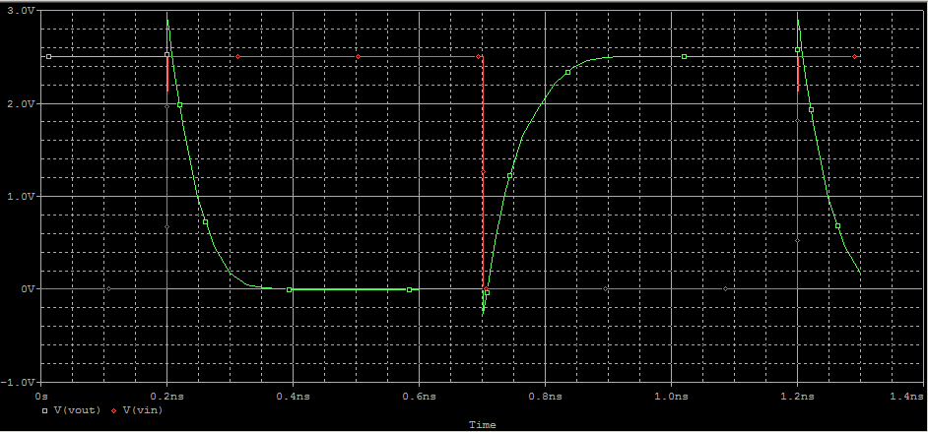

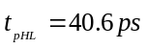, 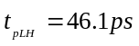 : slightly larger than hand-calculation mainly due to gate-drain coupling (inaccuracy of our Miller effect modeling) and RC approximation.
Problem 2
We know 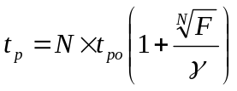 where 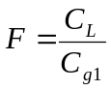 and 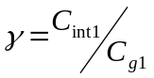.
Now we calculate 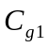, 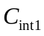, 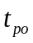 using the same method as in the first problem. The index 1 refers to the very first inverter whose size is given.
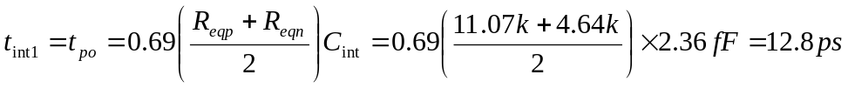
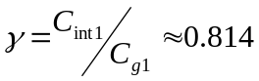 and 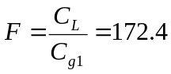
Hence,
For 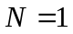; 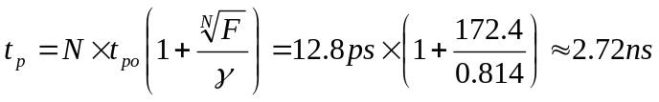
For 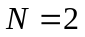; 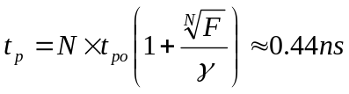
For 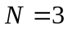; 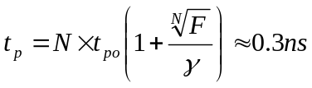
For 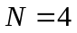; 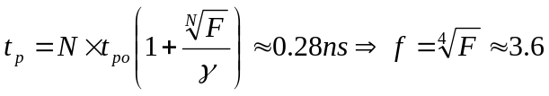
We need stages to meet requirement and the size of second stage is 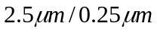.
Problem 3
a) The supply voltage Vdd consumes 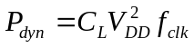 power to charge the load capacitor CL from 0 to Vdd because,
Half of this power 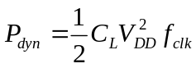 represents the energy that is stored on the capacitor as soon as it is charged to Vdd, because:
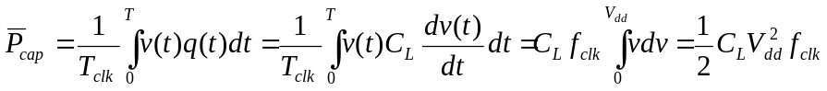
And the rest half is dissipated (Heat) through the PMOS (equivalent resistance) during the Pull-up (Charging the Cap). During the Pull-down process the whole stored energy on capacitor is also dissipated through the NMOS as the capacitor is discharged from Vdd to 0. Hence in this problem a total of 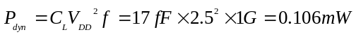 power is dynamically consumed by the first inverter. Note that CL is obtained in Problem 1.

b)
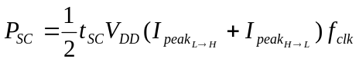
In this problem we can assume 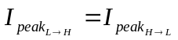 to simplify the matter and therefore 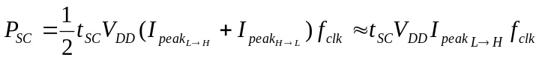

Where 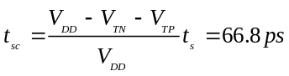
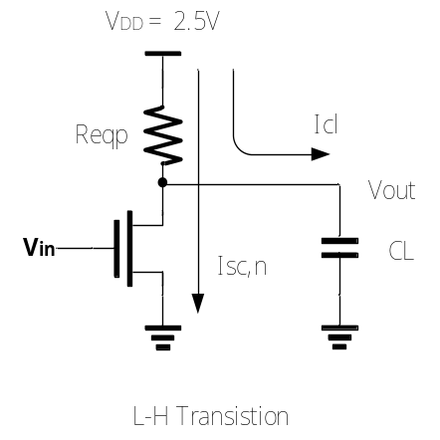
For L → H transition, 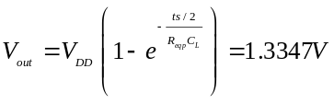
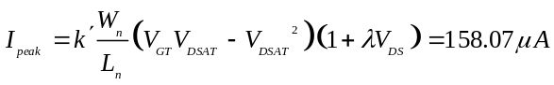, 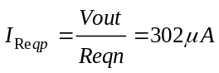
As mentioned, here in this problem we assume .
But FYI, here is how you can also calculate the 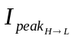. (useful whenever that assumption can’t be made)
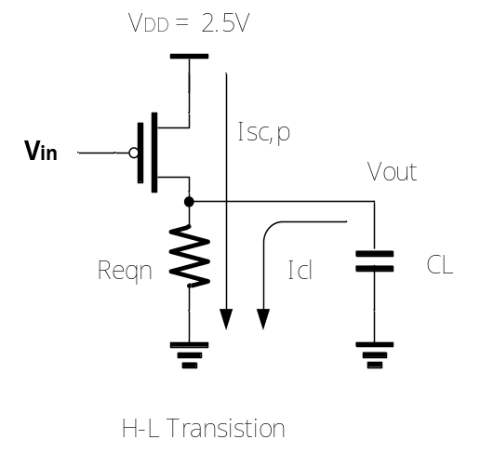
For H → L transition, 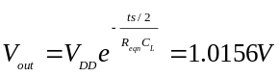
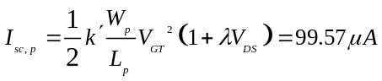, 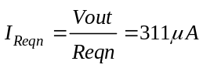

Now having the peak values for the short-circuit current, we can calculate the short-circuit power consumption:
Precisely (not using the assumption of ):
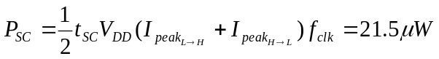

Or approximately based on the assumption of :
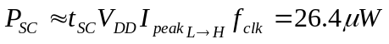

c) SPICE For Dynamic Power
Homework 4
.include 0.25um_PSPICE_BSIM3.txt
vdd vdd 0 dc 2.5
vdd1 vdd1 0 dc 2.5
vin vin 0 pulse(0 2.5 0.1n 1p 1p 0.5n 1n)
M1 vout vin 0 0 NMOS L=0.25u W=1u AD=0.5p AS=0.5p PD=2u PS=2u
M2 vout vin vdd vdd PMOS L=0.25u W=2u AD=1p AS=1p PD=3u PS=3u
M3 1 vout 0 0 NMOS L=0.25u W=2u AD=1p AS=1p PD=3u PS=3u
M4 1 vout vdd1 vdd1 PMOS L=0.25u W=4u AD=2p AS=2p PD=5u PS=5u
.tran 1p 100n
.probe
.end
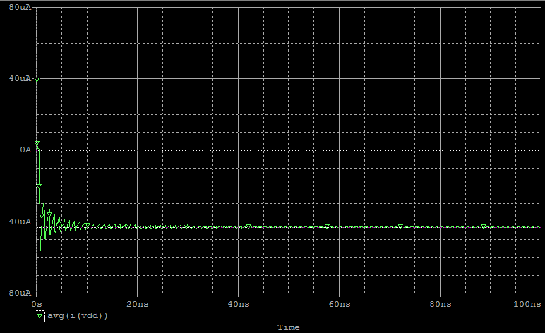
Average current of Vdd when ts=0 ; 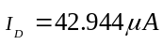
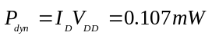
Hand Calculation for dynamic power is relatively accurate.
SPICE For Short Circuit Power
Homework 4
.include 0.25um_PSPICE_BSIM3.txt
vdd vdd 0 dc 2.5
vdd1 vdd1 0 dc 2.5
vin vin 0 pulse(0 2.5 0.1n 0.1n 0.1n 0.1n 1n) *For H-L Transition
*vin vin 0 pulse(2.5 0 0.1n 0.1n 0.1n 0.1n 1n) *For L-H transition
M1 vout vin 0 0 NMOS L=0.25u W=1u AD=0.5p AS=0.5p PD=2u PS=2u
M2 vout vin vdd vdd PMOS L=0.25u W=2u AD=1p AS=1p PD=3u PS=3u
M3 1 vout 0 0 NMOS L=0.25u W=2u AD=1p AS=1p PD=3u PS=3u
M4 1 vout vdd1 vdd1 PMOS L=0.25u W=4u AD=2p AS=2p PD=5u PS=5u
.tran 1p 1n
.probe
.end
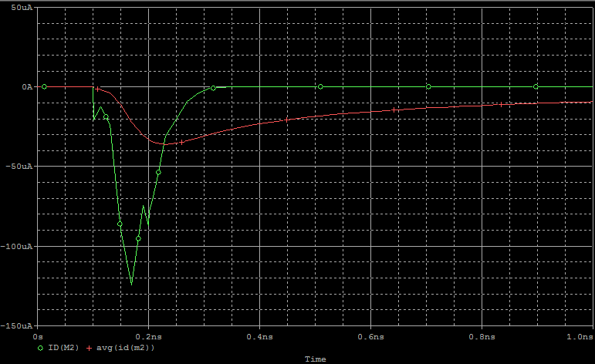
Average Short Current of PMOS(M2) when ts=0.1ns; 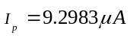, 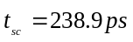
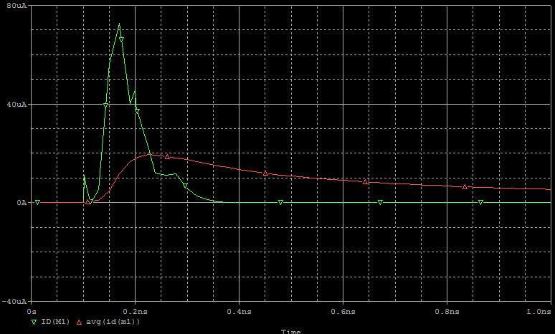
Average Short Current of NMOS(M1) when ts=0.1ns; 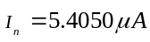,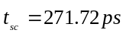
Short Circuit Power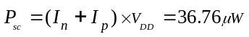
Simulated short circuit power is a little bit larger than hand-calculated because the actual tsc is longer than expected by hand-calculation.

