Homework 5
Solution
Prob 3.
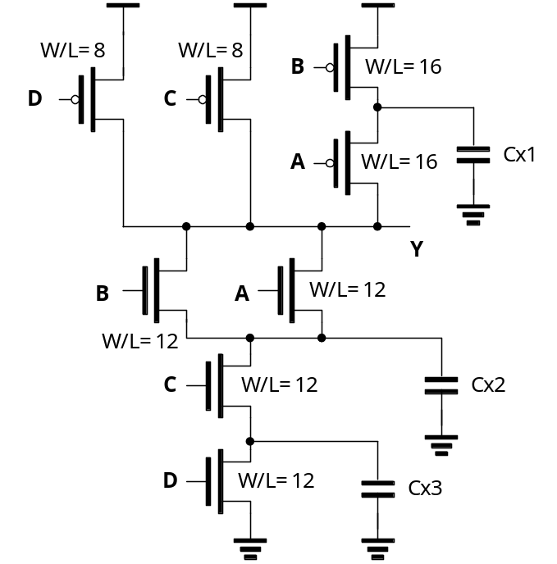
a. The logic function is : 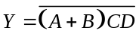. The transistor sizes are in the figure above.
b. The worst case 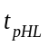 happens when the internal node capacitances (Cx2 and Cx3) are charged before the high to low transition. The initial state that can cause this are: ABCD = [1010, 1110, 0110]. The final state is one of : ABCD = [1011, 0111].
The worst case 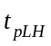 happens when Cx1 is discharged before the low to high transition. The input pattern that can cause this is: ABCD = [0111] => [0011].
c. The two cases are shown below.
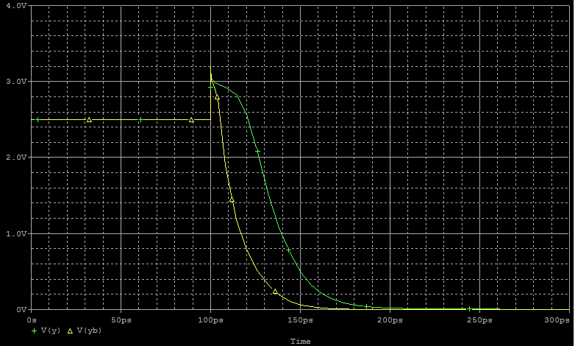
_{Best and worst t}pHL

_{Homework 5}
.include 0.25um_PSPICE_BSIM3.txt
_{vdd vdd 0 dc 2.5}
_{*For worst case}
_{va a 0 0}
_{vb b 0 2.5}
_{vc c 0 2.5}
vd d 0 0 pulse(0 2.5 0.1n 0.1p 0.1p 1n 1n)
MNA y a 1 1 NMOS L=0.25u W=0.25u
MNB y b 1 1 NMOS L=0.25u W=0.25u
MNC 1 c 2 2 NMOS L=0.25u W=0.25u
MND 2 d 0 0 NMOS L=0.25u W=0.25u
MPA y a 3 3 PMOS L=0.25u W=0.25u
MPB 3 b vdd vdd PMOS L=0.25u W=0.25u
MPC y c vdd vdd PMOS L=0.25u W=0.25u
MPD y d vdd vdd PMOS L=0.25u W=0.25u
_{*For best case}
vab ab 0 0 pulse(0 2.5 0.1n 0.1p 0.1p 1n 1n)
vbb bb 0 0 pulse(0 2.5 0.1n 0.1p 0.1p 1n 1n)
_{vcb cb 0 2.5}
_{vdb db 0 2.5}
MNAb yb ab 1b 1b NMOS L=0.25u W=0.25u
MNBb yb bb 1b 1b NMOS L=0.25u W=0.25u
MNCb 1b cb 2b 2b NMOS L=0.25u W=0.25u
MNDb 2b db 0 0 NMOS L=0.25u W=0.25u
MPAb yb ab 3b 3b PMOS L=0.25u W=0.25u
MPBb 3b bb vdd vdd PMOS L=0.25u W=0.25u
MPCb yb cb vdd vdd PMOS L=0.25u W=0.25u
MPDb yb db vdd vdd PMOS L=0.25u W=0.25u
_{.tran 1p 0.3n}
_{.probe}
_{.end}

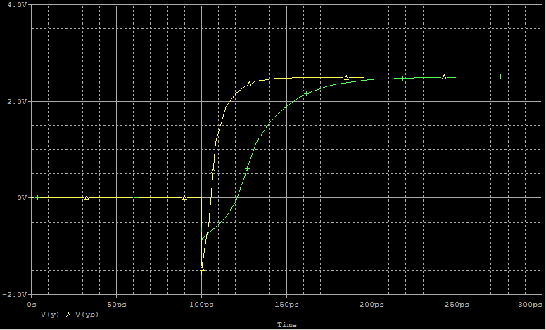
_{Best and worst t}pLH

_{Homework 5}
.include 0.25um_PSPICE_BSIM3.txt
_{vdd vdd 0 dc 2.5}
_{*For worst case}
_{va a 0 0}
vb b 0 2.5 pulse(2.5 0 0.1n 0.1p 0.1p 1n 1n)
_{vc c 0 2.5}
_{vd d 0 2.5}
MNA y a 1 1 NMOS L=0.25u W=0.25u
MNB y b 1 1 NMOS L=0.25u W=0.25u
MNC 1 c 2 2 NMOS L=0.25u W=0.25u
MND 2 d 0 0 NMOS L=0.25u W=0.25u
MPA y a 3 3 PMOS L=0.25u W=0.25u
MPB 3 b vdd vdd PMOS L=0.25u W=0.25u
MPC y c vdd vdd PMOS L=0.25u W=0.25u
MPD y d vdd vdd PMOS L=0.25u W=0.25u
_{*For best case}
vab ab 0 2.5 pulse(2.5 0 0.1n 0.1p 0.1p 1n 1n)
_{vbb bb 0 0}
vcb cb 0 2.5 pulse(2.5 0 0.1n 0.1p 0.1p 1n 1n)
vdb db 0 2.5 pulse(2.5 0 0.1n 0.1p 0.1p 1n 1n)
MNAb yb ab 1b 1b NMOS L=0.25u W=0.25u
MNBb yb bb 1b 1b NMOS L=0.25u W=0.25u
MNCb 1b cb 2b 2b NMOS L=0.25u W=0.25u
MNDb 2b db 0 0 NMOS L=0.25u W=0.25u
MPAb yb ab 3b 3b PMOS L=0.25u W=0.25u
MPBb 3b bb vdd vdd PMOS L=0.25u W=0.25u
MPCb yb cb vdd vdd PMOS L=0.25u W=0.25u
MPDb yb db vdd vdd PMOS L=0.25u W=0.25u
_{.tran 1p 0.3n}
_{.probe}
_{.end}

d. Since D is always 1, the circuit implements the following function: 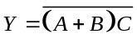.
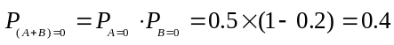, 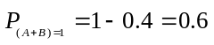
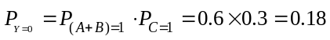, 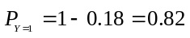
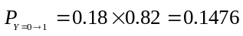,
Therefore,
Prob 5.
a. The lowest output resistance is obtained when all inputs (A, B, C, D and E) are equal to 1. In this case the output resistance is the parallel of the resistance of a NMOS of width 1, with a series of four equal NMOS of width 4. Both combinations have the same resistance, equal to the worst-case input resistance, 13kΩ. Then the output resistance, in this case is half this value, 6.5kΩ.
b. The lowest output resistance is obtained when all inputs are equal to 0. Each of the PMOS has the same width, so all of them have the same resistance. The worst case resistance happens when only one of the inputs (A, B, C or D) is equal to 0 while all the rest are equal to 1. The output resistance in that case is the series of the resistance of two of the PMOS and it is equal to 13kΩ. Then, each of the PMOS has an output resistance equal to 6.5kΩ. The output resistance is equal to the series of one of these resistance with the parallel of four of the same resistances. Then, the minimum output resistance is 6.5kΩ + 6.5 kΩ/4 = 8.125 kΩ.
Prob 8.
a. 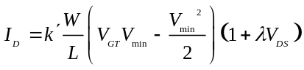
Consider a case when one input is high: A=V_{DD} and B=C=D=0V. Assume that V_{out} is small enough that V_{min}=V_{DSAT} for the PMOS device, and V_{min}=V_{DS}=V_{out} for the NMOS devices. Solve for V_{out} by setting the drain current in the PMOS and NMOS equal to each other, 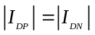, where the drain currents are functions of V_{out}, V_{DD}, and the device parameters. V_{out}=102mV, and I_{D}=35.7μA.
Now, verify that the assumptions for V_{min} are correct. For the PMOS: V_{DS}=-2.34V, V_{DSAT}=-1V, V_{GT}=-2.1V, therefore V_{min}=V_{DSAT}. For the NMOS: V_{DS}=102mA, V_{DSAT}=630mV, V_{GT}=2.07V, therefore V_{min}=V_{DS}.
Consider the case when all inputs are high: A=B=C=D=V_{DD}. For these hand calculation, this is numerically equivalent to a circuit with a single NMOS device with W/L=4*1.5 and its gate tied to V_{DD}. Now, the analysis used above for the case when one device is on can be reused, replacing W/L of the NMOS with 6, and using the same assumptions for V_{min}, V_{out}=25mV, and I_{D}=35.9 μA. The assumptions for V_{min} are correct.
b. Notice in part a. that the drain current in the PMOS is 35.7 μA with one NMOS on and 35.9 μA with four NMOS devices on. The current in the PMOS can be approximated as 35.8 μA when any number of NMOS devices on and 0 μA when all four are off. The probability that all for NMOS devices are off is (1-ρ)⁴ where ρ is the probability an input is high. Therefore,
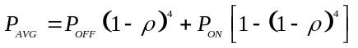
where P_{OFF}=0W, and P_{ON}=89.5μW. P_{AVG}=83.9 μW when ρ=0.5 and P_{AVG}=30.7 μW when ρ=0.1
Prob 15.
a. The truth table is shown below.
AB | Out
00 | 1
01 | 0
10 | 0
11 | 1
The circuit implements XNOR.
b. The PMOS device will be velocity saturated and the NMOS passgate will be in the linear region. I_{DN}+I_{DP}=0, therefore,
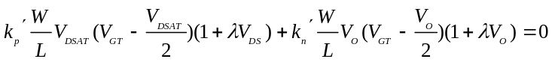
We know that V_{O}=0.3V, so we can plug in numbers and solve for W/L for the PMOS is 7. Let the PMOS be 1.75/0.25
c. No. If the PMOS were removed, the output node could remain low when AB=00 because it would be floating. The PMOS device pulls the output node high when it would otherwise be in a high impedence state.

