Homework 6

Hand out on: Lecture 16 (Nov. 20, 2003)
Due: Thu. Lecture 18 (Dec. 2, 2003)

Text Rabaey 2nd Edition, | read Sections 11.3, 11.4, 12.1, 12.2 of Text
Text Rabaey 2nd Edition, | Problems: Handout

- The indicated waveforms are applied to the JK master-slave flip-flop shown below. Assume that the gate delays are short compared to the input signal time scale.

- Sketch the waveforms that appear at the Q_{M} and Q_{S} outputs of the master and slave latches. Assume that the flip-flop is initially in the reset state.
- Do the waveforms exhibit any 1’s catching behavior? (1’s catching refers to the case where an unwanted transition on the input will force the output to an undesired state).

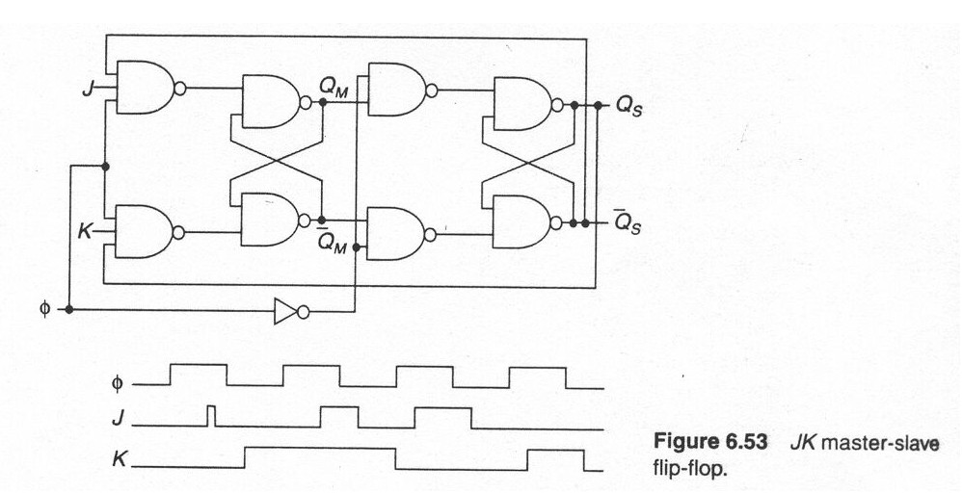

- A dynamic master-slave D flip-flop is shown in the figure below. Assume that there is no charge leakage and that a nonoverlapping clock pair φ₁−φ₂ with 50% duty cycle is available. The sizes of all NMOS and PMOS transistors are 0.5 μm/0.25 μm and 1.0/0.25 μm, respectively. Assume V_{dd}= 2.5 V and C_{L} = 8 fF at the D output
- Provide a first order estimate of the parasitic capacitances at the inverter inputs
- Determine the set-up time and propagation delay of the register, and compare with SPICE.
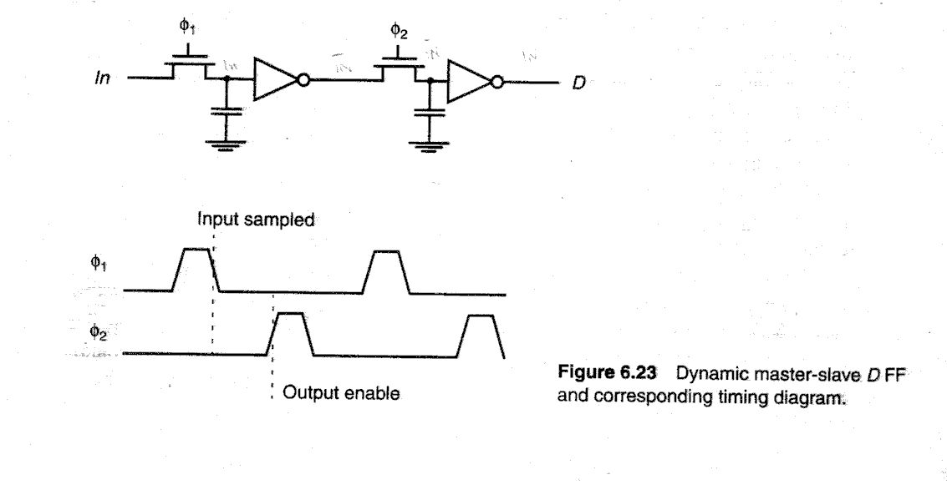

- Pipeline the function 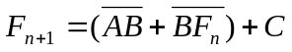with as many stages as possible. Include the input and output registers.
a) Design it at the gate level. Estimate the minimum clock period in terms of gate delays. Under what conditions can a race occur, assuming fast clock rise and fall times.

