EE115C Winter 2004

Design Project

4-bit Ripple Carry Adder
Due Friday March 19, 2004.

Topic:
You are to design a 4-bit Ripple Carry Adder. You are given three different implementations to optimize for a given power-delay product.

Background:
The block diagram of a Full Adder cell (FA) is shown in Figure 1. This is the basic building block for multi-bit adders. It takes three inputs, A, B and Carry In (C_{in}), and produces two outputs, S and C_{out}. This can be represented by the expressions:

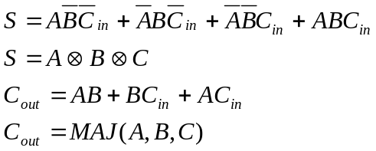

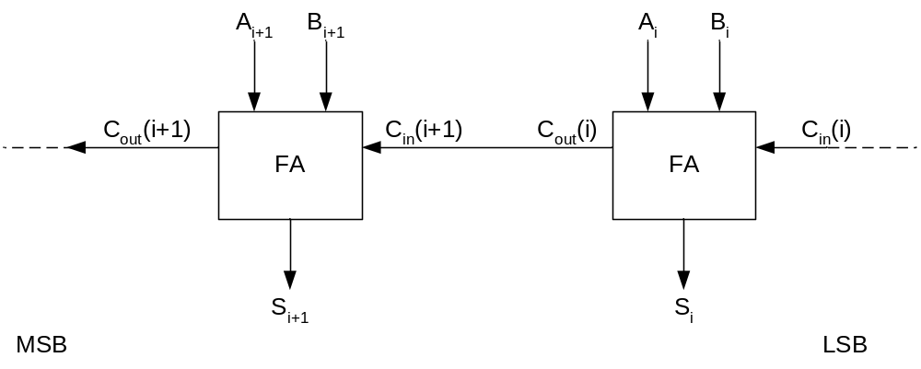
Figure 1. Full Adder Cells
Static CMOS logic gates could be used to directly implement the FA from the equations above. However speed and area savings can be achieved using compound gates. Examples are shown in Figure 2 and Figure 3.
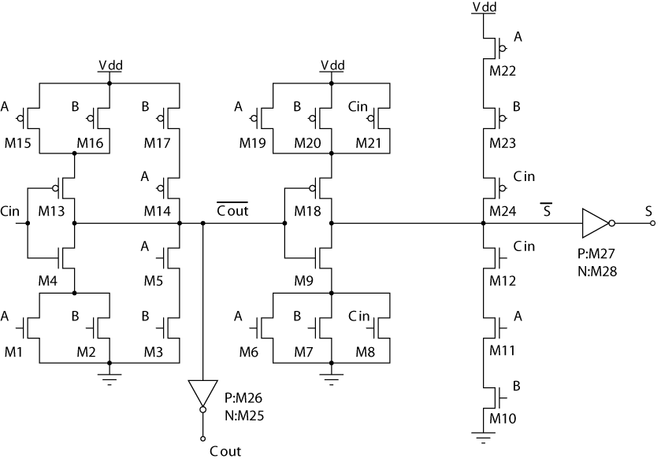
Figure 2. Mirror Full Adder Cell

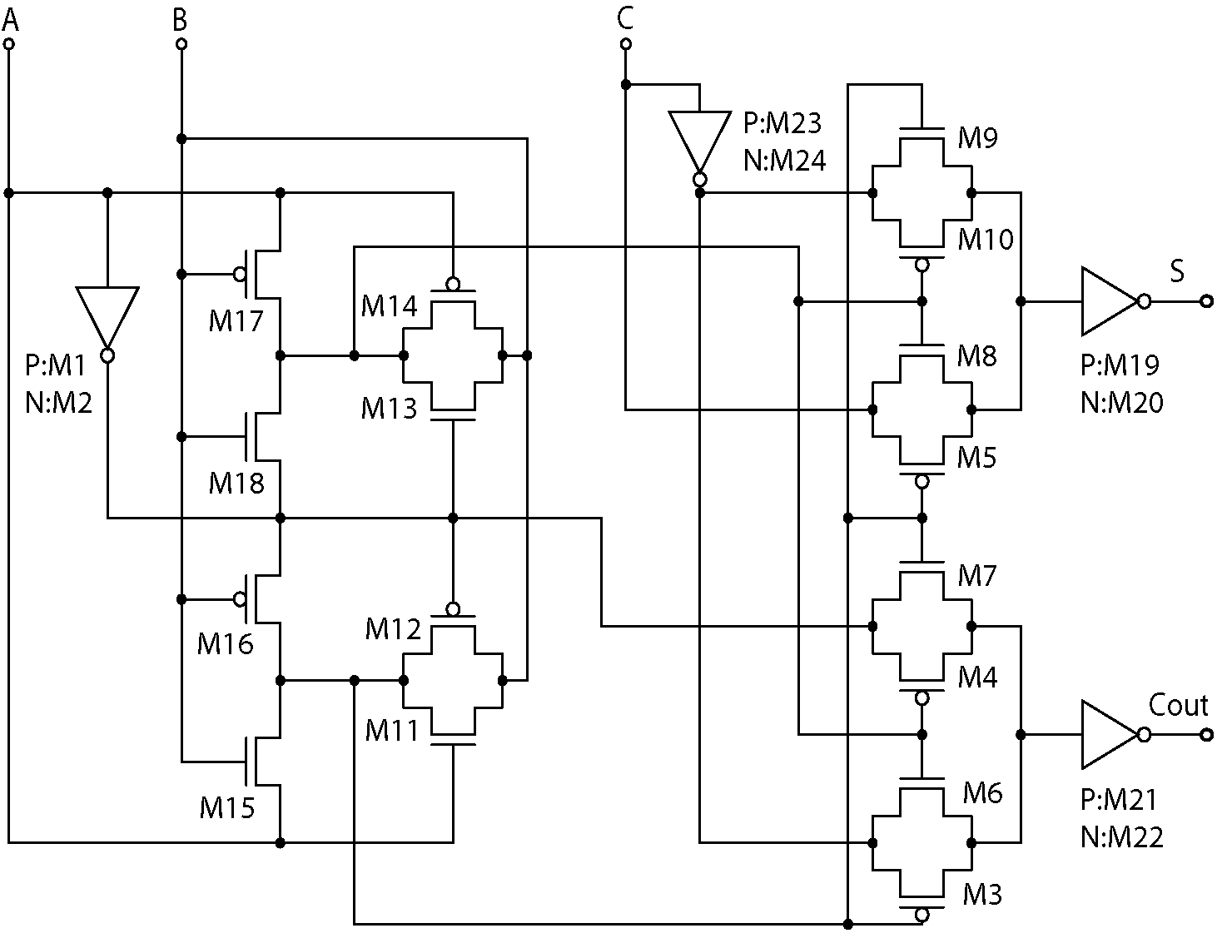
Figure 3. Transmission Gate Full Adder Cell

A 4-bit ripple carry adder is shown in Figure 4. It should be noted that the slowest path in the adder is the generation of S₃. It cannot be determined until the carry has “rippled” through the previous stages. Figure 4 b) shows that a modified adder cell that uses inverted inputs to generate the non-inverted outputs. The FA’ cell is the same as the FA cell in Figure 2, except the inverters at the outputs are not required; the outputs are 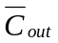 and . It does require however, that the inputs to the odd stages (A and B), and the S output of the even stages, are inverted to obtain the correct result.

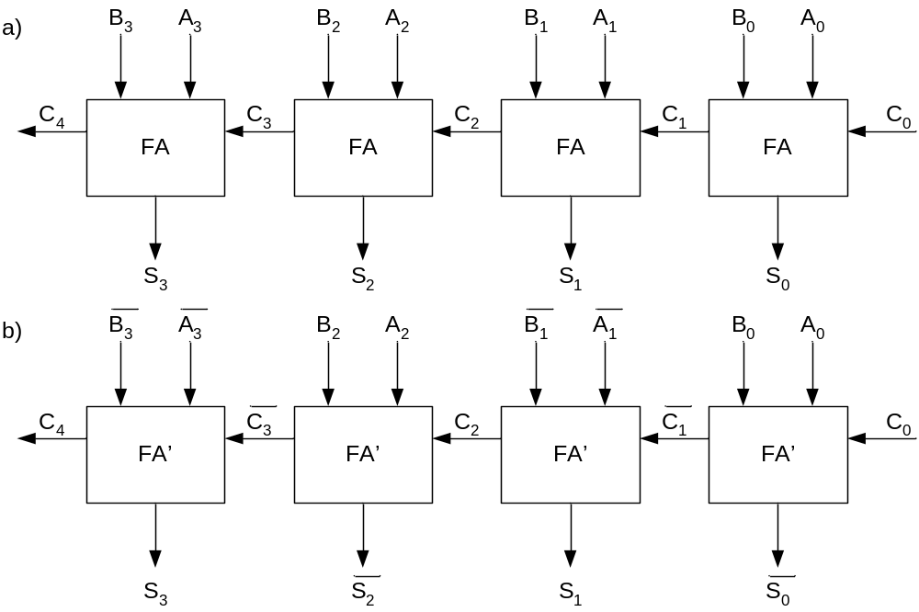
Figure 4. Ripple Carry Adders

Specification:
You are to design three different implementations of a 4-bit ripple carry adder, and try to meet the power-delay product specification. The power delay product (PDP) is defined as the average power, P_{av}, multiplied by the propagation delay, t_{p}. It is in indication of the average energy dissipated.
PDP = P_{av,} t_{p}
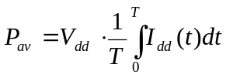
t_{p}=½(t_{pHL}+t_{pLH})
where T is the measurement time.

The three implementations are:
- Use the Mirror FA cell, with the inverters (Figure 2). Build the 4-bit adder by cascading four of these cells (Figure 4a).
- Use the Mirror FA cell, without the inverters. You will need to add inverters at the appropriate inputs and outputs however (Figure 4b).
- Use the Transmission Gate FA cell. Build the 4-bit adder by cascading four of these cells (Figure 4a).
- Using the implementations above, size the transistors to optimize each design.
- The inputs are driven from small inverters. A testbench with the input signals will be provided as a starting point. If you need the inverse of the inputs (A, B, C_{in}), you will need to generate them locally.
- The power supply is 2.5V, and the technology is 0.25μm CMOS. Use the models provided for the class.
- Size the transistors. Specify W, L, AD, AS. Assume AD/AS is 10⁻⁶W. Ignore PD and PS. You may use the m parameter, which is equivalent to m devices in parallel. A PMOS device with a W/L=0.5μm/0.25μm, would be instantiated as:
M1 Vdd Cin net1 Vdd PMOS w=0.5u l=0.25u ad=0.5p as=0.5p
- Each of the sum outputs (S₃-S₀) drives a 100fF load. C₄ also drives a 100fF load. Add buffering as required.
- Measure the propagation delay, using the cursors in the waveform viewer. Indicate in your report which outputs were the best and worst cases, and how you determined these. Can you identify the critical path? If the testbench does not test the worst path, add it to the input waveforms. What was the delay per full-adder cell?
- Measure the average power consumption. Use the functional test vectors given in the testbench to measure the average power dissipation. Do not use the same vectors as for testing the worst case delay. Power can be measured in PSPICE with avg(W(vdd)), and taking the value at the end of the simulation time.
- Your design target is PDP<50fJ. This is a specification, and there is no benefit in decreasing the PDP beyond this specification. Use the worst case propagation delay for t_{p}. As a guide, you should aim for P_{av}<100μW, and t_{d}<0.7ns.
- Discuss how you think the PDP would change if the designs were extended to 8-bits. What would be the maximum frequency of operation with this resolution, and the power consumption at this frequency?

Report:
Your report should concisely describe how you optimized your design, and what the main trade-offs were. Comment on the overall performance of the three different implementations. Include schematics or netlists, as well as a careful selection of PSPICE plots. Use the cover sheet to provide a summary of your design. You will be graded on how you identified the main issues and your sizing strategy, and the overall performance of the adders. Use hand calculations to compare the simulated and measured delay. The main report should be a maximum of 5 pages, with plots and schematics and/or netlists in an appendix. Be sure to include a plot of the carry propagation through the four stages, and annotate figures accordingly. Circuits should use the same transistor designations as Figures 2 and 3.

