Brief Discussion on Propagtion Delay :

This section briefly describes what effects of the inputs will have on our 4-bit adder. It describes the best case/worst case inputs (transitions).

The inputs that result in a best-case delay are those that do not create any generate signals in any of the fulladders. For example, the inputs can be: 0101 + 1010, or 1001 + 0110. In short, between any two pairs of inputs, if one is a 0, then the other has to be a 1. Graphically, this can be represented as:
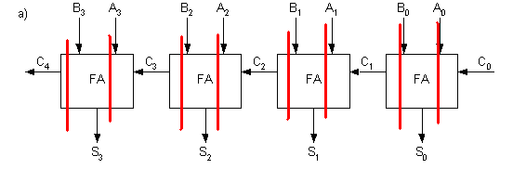
In the best case, the delay in the mirror adder, for instance, will simply be the time it takes to calculate the sum of the inputs of one full-adder. Since there is no ripple carry in any of the immediate stages, all the calculations will be done in parallel.

The inputs that result in a worst-case delay are those that does require a ripple carry to propagate through the immediate stages (C1 = C2 = C3 =1). The inputs that can generate this are 1111 + 1111 , or 1010 + 0101 with C0 =1. Graphically, this can be represented as:
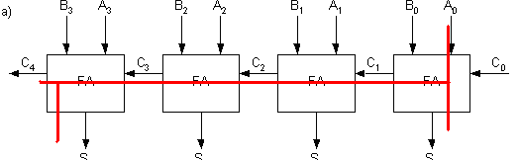

To calculate the delay in such a situation, we can reduce the full-adder to its component parts: namely, ripple-propagation, ripple-propagation, and sum-generation. The worst delay can be described as the time for a ripple-generate in the first stage, then ripple propagation in second, third stage, then sum generation in fourth and final stage. This gives the equation: A0->Co + 2*Cin->Co + Ci->S. *Note: an alternative equation can be A0->Co + 2*Cin->Co + Ci->C4. C4 is the overflow bit (to indicate summation overflow). But in our case, the overflow bit is ignored, so we consider the sum output at the fourth stage instead.

The way we calculate the delay through the circuit is by determining the equivalent capacitance at the output nodes (first order estimate.) We perform analysis for the worst case on the mirror adder. Please see the following hand calculations.

