Mirror-Adder (a)

Plots:

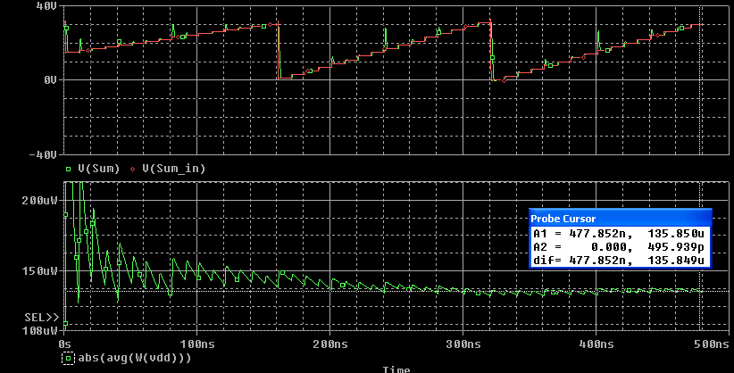

-Average Power Consumed: 135.8uW

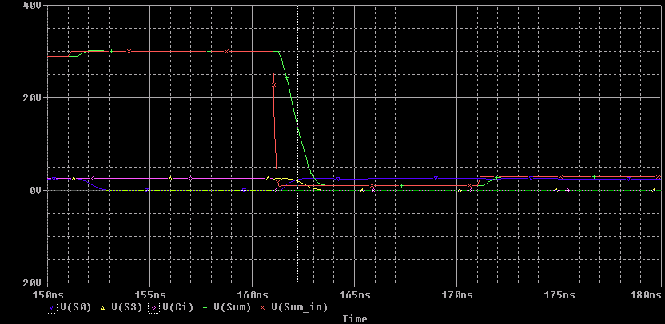

- Propagation Delay: 1.05 ns
- Propagation Delay per adder cell: .43 ns

Mirror-Adder (b)

Plots:

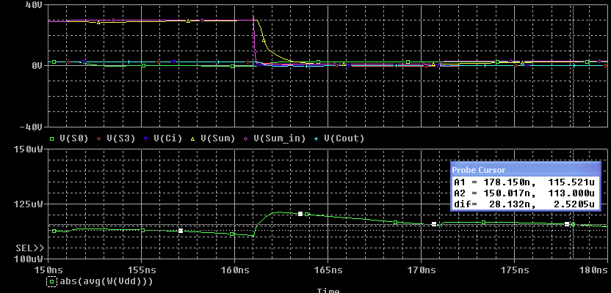

-Average Power Consumed: 141.0uW

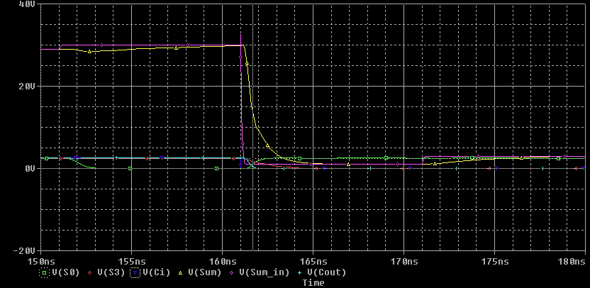

- Propagation Delay: .98 ns
- Propagation Delay per adder cell: .31 ns

TG-Adder

Plots:

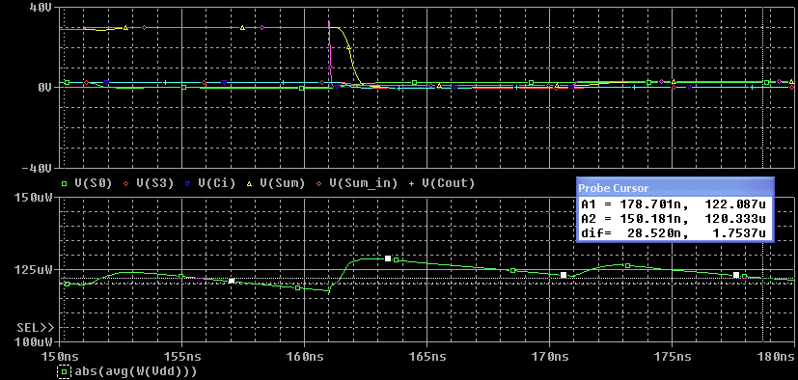

-Average Power Consumed: 147.33uW

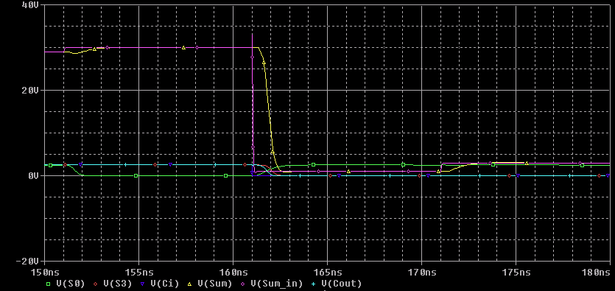

- Propagation Delay: .94 ns
- Propagation Delay per adder cell: .42 ns

