UNIVERSITY OF CALIFORNIA, LOS ANGELES
Department of Electrical Engineering
M 171L &CS 117 Laboratory

Pre-Laboratory Home Work #1;
With Solution

Signals in Time and Frequency Domains

1) Draw plots of amplitude versus time for the following rectangular signals with period T and amplitude A:
(a) Duty cycle d = 50% (also called a “square wave”)
(b) Duty cycle d = 25%

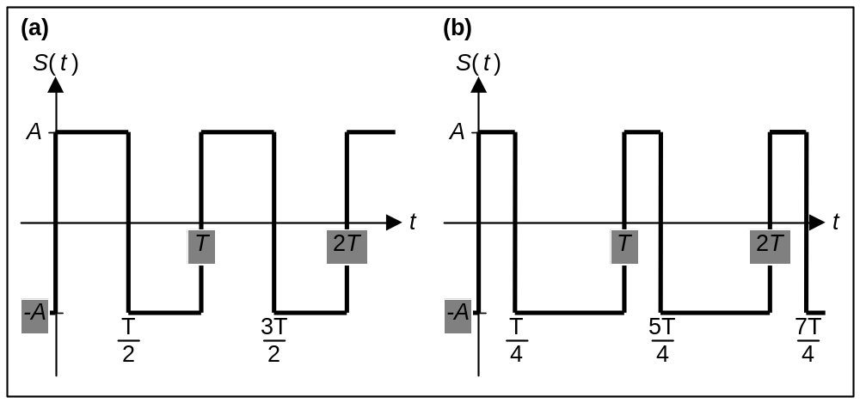

2) The Fourier series for the square wave signal in (a) is:
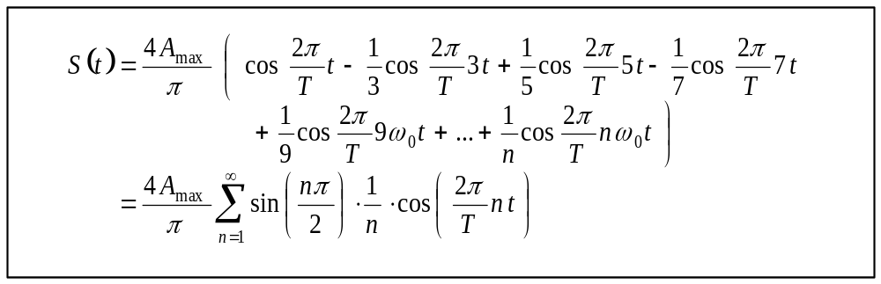

3) The Fourier series for the rectangular signal in (b) (duty cycle d = 25%) is:
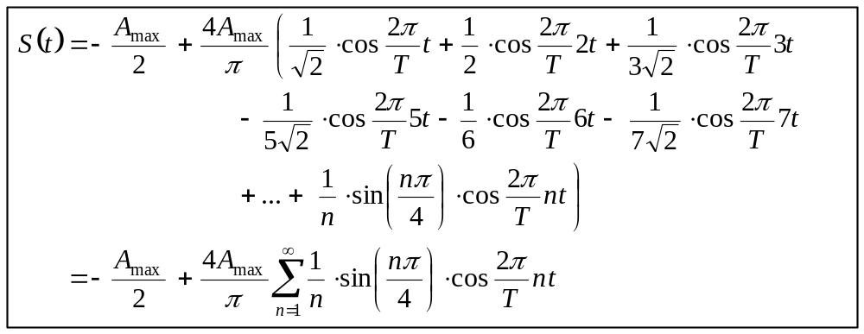

The effective amplitude spectrum of a signal is built from the RMS voltages of each frequency represented in the Fourier series for that signal.

4) If the amplitude of each signal is A_{max} = 2V, draw the effective amplitude spectra (through the 8th harmonic) for functions (a) and (b) above.
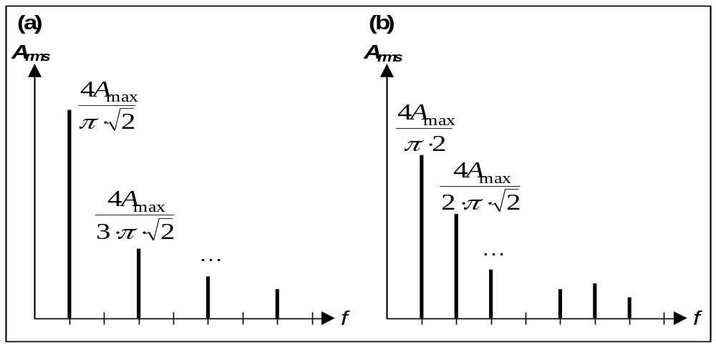

5) How does the effective amplitude spectrum of a signal change when we add a time shift or a phase shift to the signal?
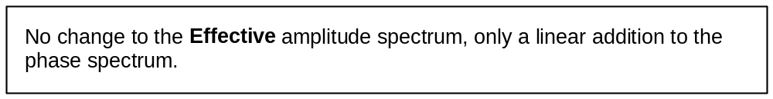

6) What are the differences between the amplitude spectrum and the effective amplitude spectrum?
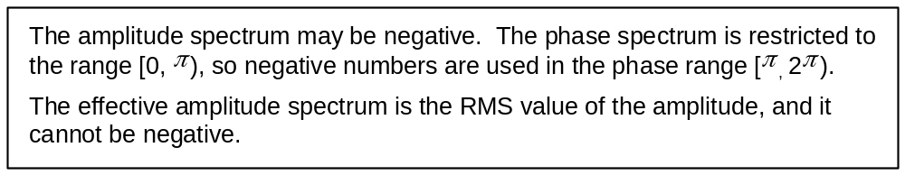

7) If the amplitude of the signals in (a) and (b) above is A = 2V, and each signal is sent to a 1 Ohm load, what is the spectral power of each signal? Calculate the spectral power by subtracting the DC offset power from the time-domain power.
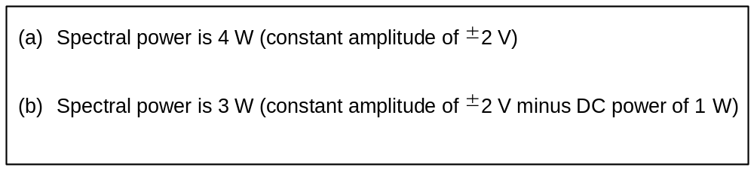

The spectral power of a periodic signal is defined as the sum of the power of the sinusoidal components of its Fourier series (the square of their RMS voltages divided by the impedance of the load). It is equal to the power of the signal in the time-domain minus the power of the signal’s DC offset.

8) How do we define the effective bandwidth of a periodic signal? 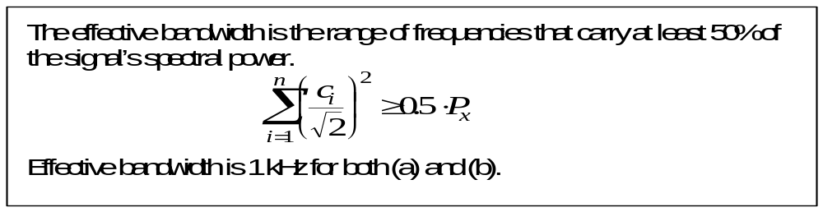

9) How do we define the absolute bandwidth of a periodic signal? What are the absolute bandwidths of the signals in (a) and (b) above? (Use the calculations in the lecture notes.)
