UNIVERSITY OF CALIFORNIA, LOS ANGELES
Department of Computer Science

CS M 171L &CS 117 Laboratory

INSTRUCTOR’S GUIDE, LABORATORY EXERCISE #2

Laboratory Exercise 2: Transmission Lines

In this lab you will investigate real-world transmission lines -- those that connect enormous numbers of computers and other devices. There is a limit to the range of signal frequencies which can be handled by a transmission line; this limit is called the transmission line bandwidth. Because higher frequency signal components will be attenuated greater than lower frequency components, the shape of the output signal may be different than the shape of the input signal. Proper line termination is necessary to eliminate reflections in the transmission line.

The first goal of this experiment is to experimentally determine the passband width and other properties of a coaxial cable and the dependence of these properties on the length of the cable. For this purpose, you will:

• Measure the time constant and capacitance of the coaxial cable, and use them to estimate the characteristic impedance.
• Construct Bode Plots for two coaxial cables of different lengths.
• Record how baseband signals are distorted by transmission through a coaxial cable of a certain length.
• Verify the effect of transmission line termination on the output signal.

The second goal of this experiment is to verify similar properties in a Category 5 twisted-pair cable.

Transmission line theory models the transmission line as a distributed network of: resistance per unit length R, capacitance per unit length C, inductance per unit length L, and conductivity per unit length G (leakage). A whole transmission line can then be modeled as a number of lumped circuits connected serially. Review transmission line theory if you are not familiar with this material.

Pre-Lab Assignment: The theory section on the next several pages must be completed correctly before you will be allowed to start the laboratory exercise. You must have your answers written in this sections before coming to the lab. They will be checked by the TA before you begin the experiment. Be prepared to answer questions about the material.

Exercise #2: Theory (Include with report)

A transmission line can be characterized in terms of its inductance per unit length L, resistance per unit length R, capacitance per unit length C, and conductance per unit length G. Based on these characteristics, we can find the attenuation, delay, and characteristic impedance of the cable. We assume that we are using the cable within a frequency band that minimizes frequency distortion.

1) Write the formulas for α, τ and Z for the transmission line without frequency distortion, when:
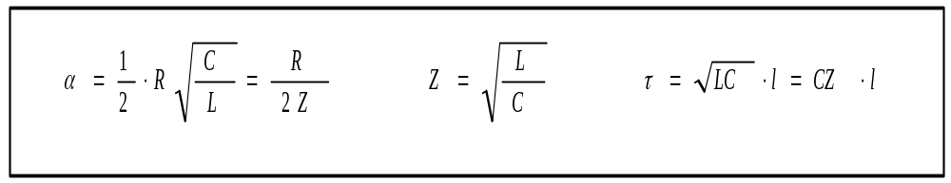

2) How does the length of a cable influence its characteristic impedance Z?
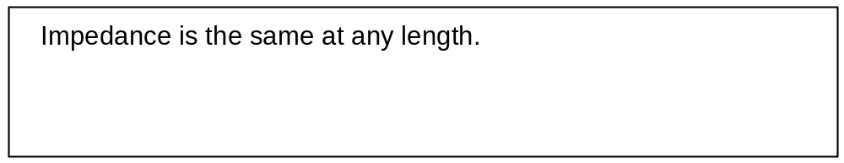

A cable will be properly terminated when it has a load impedance equal to the characteristic impedance of the cable.

3) For a signal transmitted on a perfectly terminated transmission line without frequency distortion, the formula for the attenuation of the signal is:
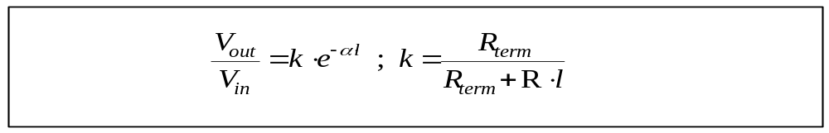

4) For this same signal, the formula for the phase characteristic φ is:
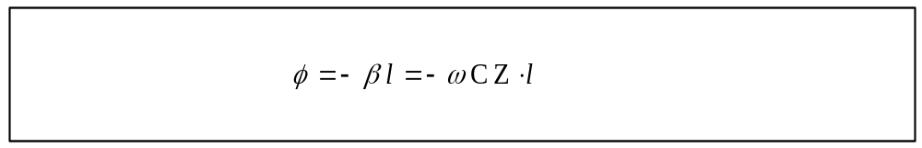

5) Calculate the attenuation introduced by transmission along a 1500 meter coaxial cable without frequencydistortion, if C is 100 pF/ meter, R is 5.00x10⁻³
Ω / meter, Z is 50Ω, and the conditions of question (1) are satisfied.
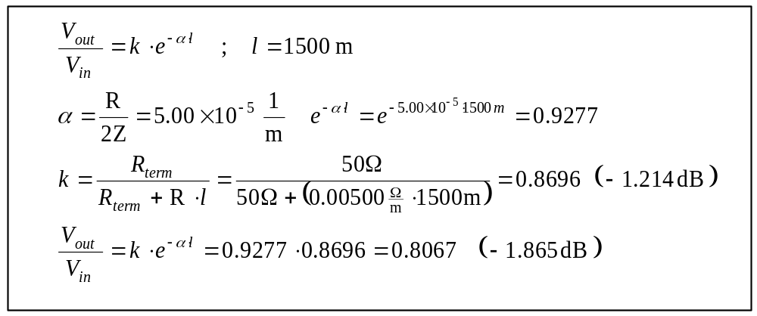

Exercise #2: Raw Data and Error Estimates (Include with report)

Student name: ________________________

Starting the laboratory exercise allowed by: ________________________

- - - - - - - - - - - - - - - - - - - - - - - - - - - - - - - - - - - - - - - - - - - - - - - - - - - - - - - - - - - - -

Part A:
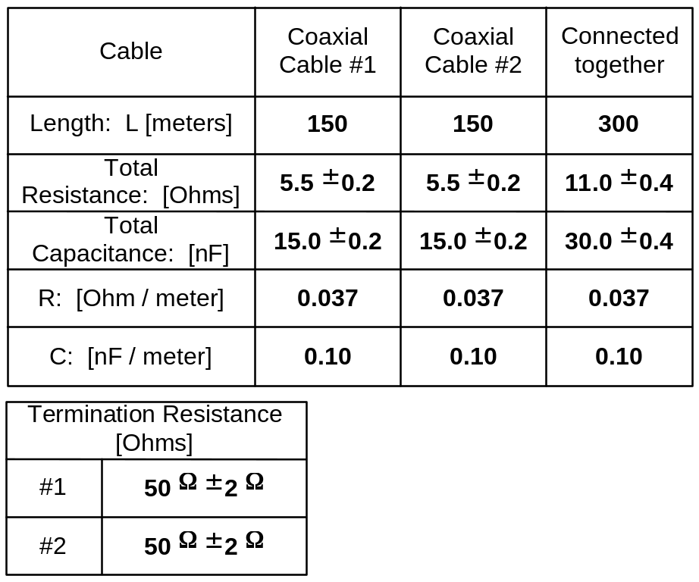

Results of this part checked by: ________________________

Exercise #2: Raw Data and Error Estimates (continued)

Part B:

Frequency Characteristics, Cable #_____ (length _______ m), 50Ω terminator

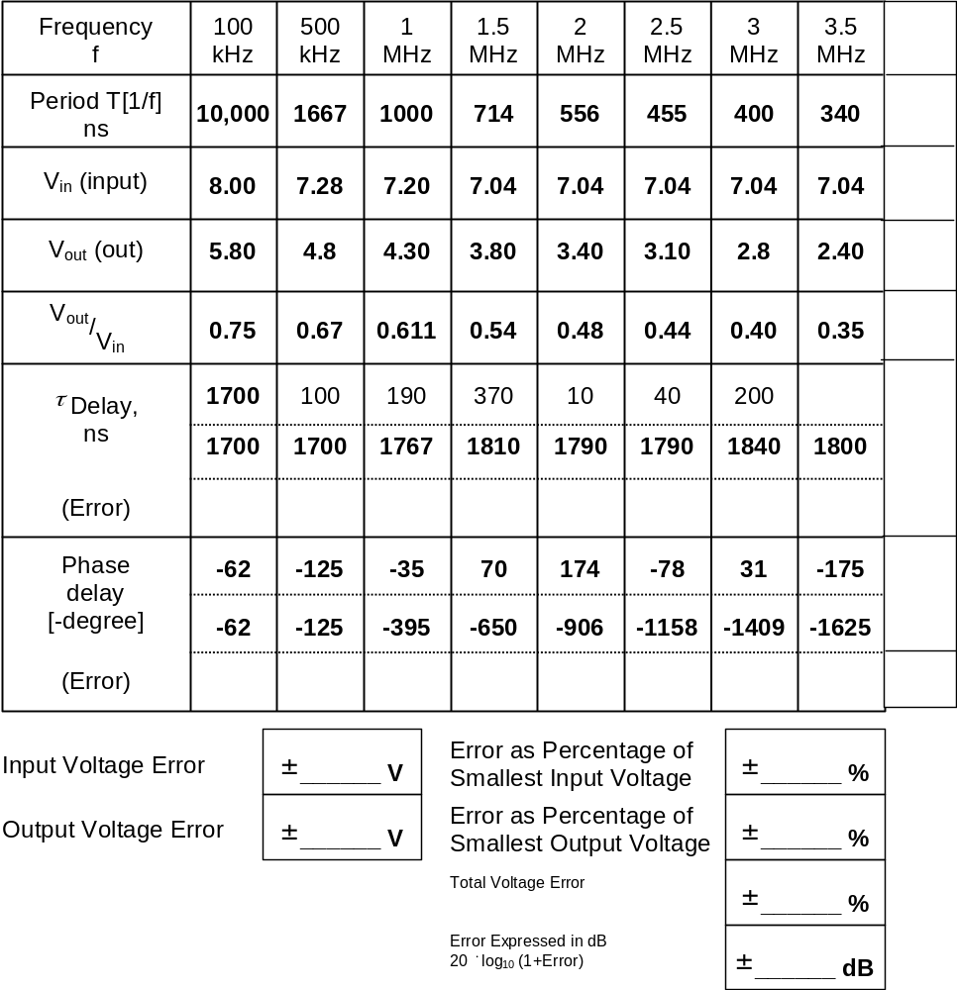

Results of this part checked by: ________________________

Exercise #2: Raw Data and Error Estimates (continued)

Part C:

Frequency Characteristics, Cables #_____ and #_____ (total length _______ m), 50Ω terminator

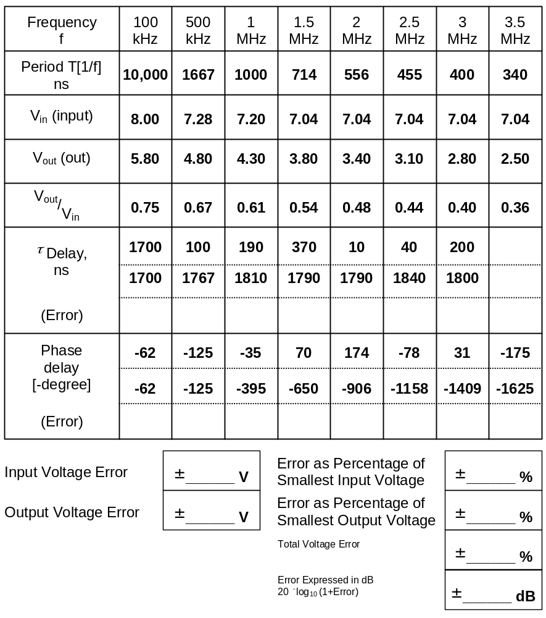

Results of this part checked by: ________________________
Exercise #2: Raw Data and Error Estimates (continued)

Part D:

Cable #_____ (length _______ m)

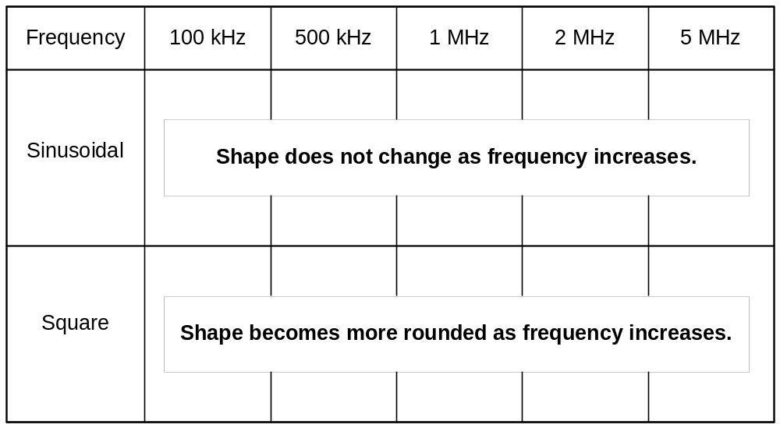

Results of this part checked by: ________________________

Part E:

Cable # 2 ( 150 m), signal frequency 300 kHz, signal amplitude 4V

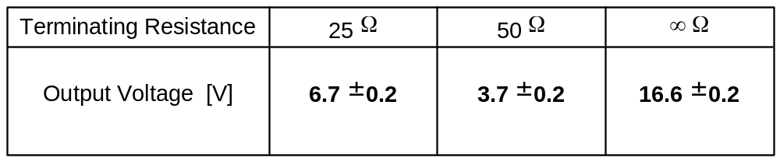

Results of this part checked by: ________________________

Exercise #2: Raw Data (continued)

Part F:
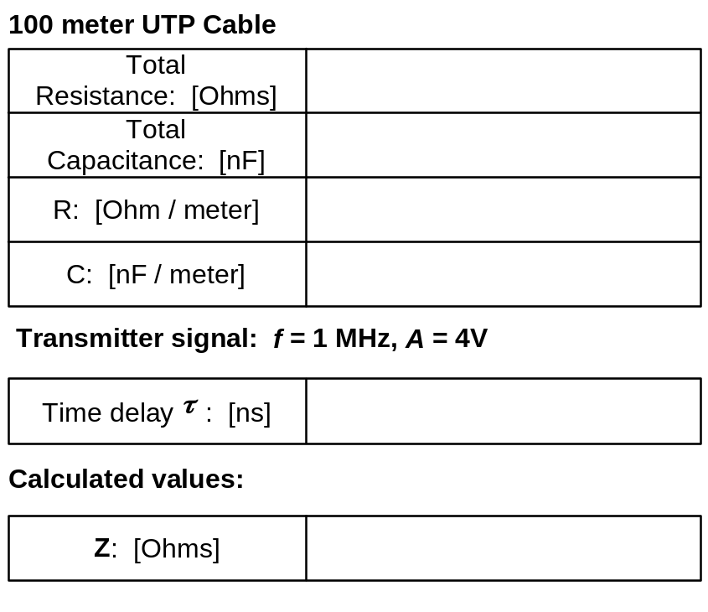

Attenuation at 20 MHz and 31.25 MHz for properly terminated 100 meter UTP cable:

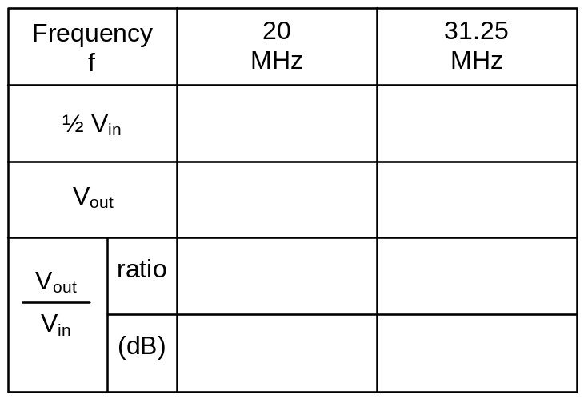

Results of this part checked by: ________________________
Exercise #2: PRE-LAB DISCUSSION

1) Explain the resistance and capacitance meters. Be sure to turn the ON/OFF switch all the way to “ON”, instead of just “Battery Check”. There are different scales for the SILVER range options than the RED range options, controlled by the RED/SILVER switch. The switch should be set to RED, and the range to 30 Ω for most measurements. On the capacitance meter, the switch setting is a maximum value, not a multiplier. The decimal place in the display will be in the correct position to measure nanofarads.

2) In parts B and C, do not change the voltage on each measurement to keep V_{in} constant. Allow V_{in} to decrease, and use the decreased value in establishing the ratio of V_{out} to V_{in} . You can record V_{in} and V_{out} as peak-to-peak measurements rather than amplitude, since you are simply using them to obtain the ratio. Since these are sine waves, use the Amplitude measurement, and adjust the high and low thresholds to 98% and 2% respectively.

3) In parts B and C, the time delay measurement on the digital oscilloscope should be CH1 → CH2. This yields a positive value for time delay. The phase delay measurement should be CH2 → CH1. This yields a negative value for phase delay.

There are two lines each for time delay and phase delay. On the first line, write the value displayed by the oscilloscope. This value may not be the correct value due to the next source peak being recorded before the original peak reaches the destination. The time delay measurement may even be negative if this next peak closely follows the original peak at the destination (the corresponding phase delay may be positive).

Therefore, for some measurements of time delay, you will have to add an integer multiple of the waveform period T. For some measurements of phase delay, you will have to subtract an integer multiple of 360°.

4) Review how to draw the error bars on the amplitude Bode plot. Errors on the frequency axis will be very small, so we don’t need to consider the frequency error (assuming frequencies were set up to within ±1 on the final counter digit).

5) Part D is observations of the destination waveform. You don’t need to print out the waveforms, but you should record what’s happening to the shape with a simple sketch of one signal period. You may also want to write down a description of how the waveform shape changes.

6) To make a 25 Ω resistor, simply connect two terminators in series. This will place the resistances in parallel.

7) Explain briefly the difference between unbalanced (coaxial) and balanced (UTP) transmission, and the reasons that we need the appropriate “balun” transformer between the two types of cable.

