UNIVERSITY OF CALIFORNIA, LOS ANGELES
Department of Computer Science
CS M171L &CS117 Laboratory

INSTRUCTOR’S GUIDE, LABORATORY EXERCISE #3

Laboratory Exercise 3: Amplitude Modulation and Frequency Modulation

This lab investigates modulation of a carrier waveform by a baseband signal that changes either the amplitude, the phase, or the frequency of the carrier waveform.

- In DSBTC AM, the amplitude of a carrier waveform is modulated by the baseband signal at the input of a transmission line.
- In DSBSC AM, the phase of the carrier waveform is modulated by the baseband signal in 180º increments.
- In FM, the frequency of the carrier waveform is modulated by the baseband signal.
- In this lab, you will measure the power and bandwidth of the signals created by these three modulation techniques, and compare the advantages and disadvantages of each technique.

Pre-Lab Assignment: The theory section on the next several pages and the theoretical calculations for your results (the shaded boxes in the Results section) must be completed correctly before you will be allowed to start the laboratory exercise.
- You must have your answers written in these sections before coming to the lab. They will be checked by the TA before you begin the experiment. Be prepared to answer questions about the material.

Be familiar with the properties of the function generator used to modulate the signal.

- For amplitude modulation, make sure that you understand the AM constructional coefficient, and how it affects the amplitude and power of the output signal.
- For frequency modulation, be sure you understand the FM constructional coefficient, and how it affects the frequency modulation index k_{f} .

Exercise #3: Theory (Include with report)

Signal modulation is the process of encoding a baseband signal S_{m} (t) onto a carrier signal. It allows us to transmit the baseband signal over a range of frequencies near the carrier signal, then demodulate to recover the original baseband signal.

1) What would happen if you were to transmit many baseband signals through the same medium simultaneously? (Recall the principal of superposition.) How could we use modulation to successfully transmit all of these signals?
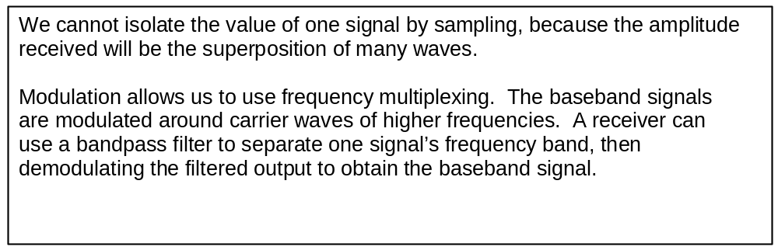

Amplitude modulation (AM) changes the amplitude of a sinusoidal carrier signal in direct proportion to the baseband signal.

If the baseband signal is periodic, the modulated signal can be represented by a Fourier series with terms symmetric around the original carrier frequency, which is present only if the baseband signal had a DC offset.

If the carrier frequency is included in the modulated signal, it is called Dual Sideband Transmitted Carrier (DSBTC) AM. If the carrier frequency is omitted in the modulated signal (DC offset of the baseband signal was zero), it is called Dual Sideband Suppressed Carrier (DSBSC) AM.

- The carrier signal S_{c} ( t ) = A_{c} cos( 2π f_{c} t ) is amplitude modulated by a baseband square wave signal S_{m} ( t ) with amplitude A_{m} = A_{c} (varies between +A_{c} and -A_{c} ) and frequency f_{m} . Write the Fourier series for the modulated signals S( t ), for DSBTC AM (where the baseband DC offset is equal to +A_{c} ) and DSBSC AM. Include the AM constructional coefficient K_{AM} .

Exercise #3 Theory (continued)

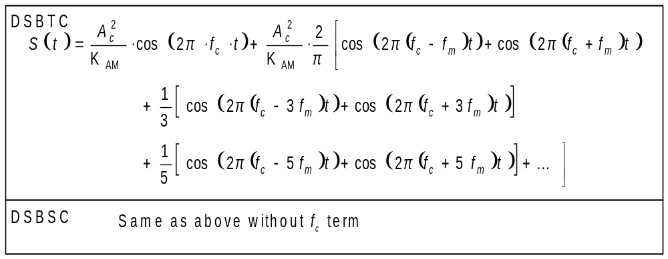

3) What is the power of each signal in question (2) above? Include the AM constructional coefficient K_{AM} .
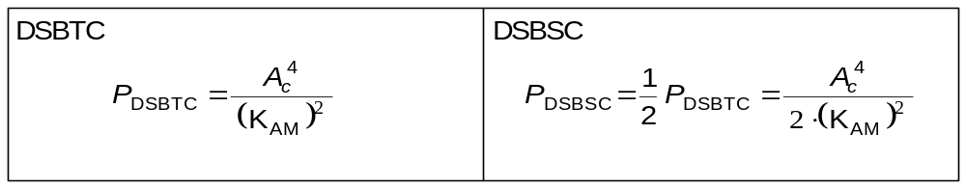

4) What is the absolute bandwidth of an AM signal in terms of the absolute bandwidth of the baseband signal?
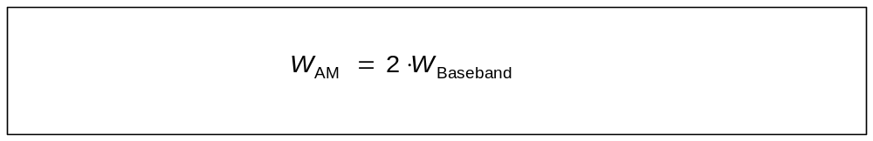

5) What is the absolute bandwidth of each signal in question (2) above?
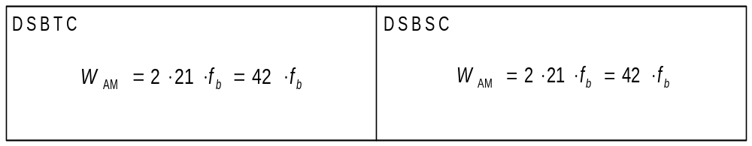
Frequency modulation (FM) changes the phase of a sinusoidal carrier signal in direct proportion to the integral of the baseband signal over time. The effect of

Exercise #3 Theory (continued)

this integration is to change the frequency of the carrier in direct proportion to the amplitude of the baseband signal.

If the FM baseband signal is sinusoidal, the modulated signal can be represented by a Fourier series with terms symmetric around the original carrier frequency. We can use Bessel's trigonometric identities to calculate the amplitudes of each term of the Fourier series.

6) Write the formula (using Bessel functions) for the frequency modulated signal when the baseband signal is S_{m} ( t ) = A_{m} cos( 2π f_{m} t ) and the carrier modulated signal is:

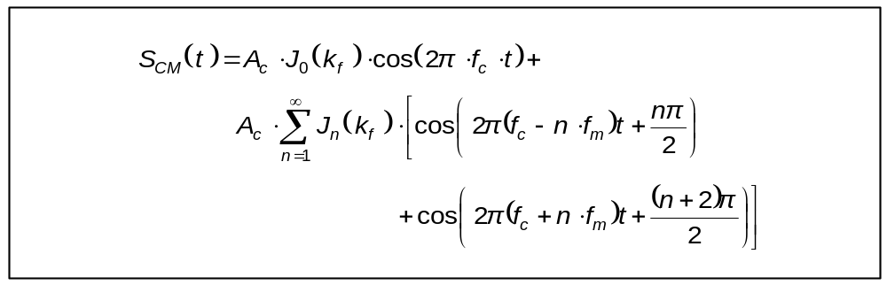

7) Write the formula for the frequency modulation index k_{f} with baseband signal S_{m} ( t ) = A_{m} cos( 2π f_{m} t ), and calculate k_{f} when A_{m} = 4V, f_{m} = 1000 Hz and K_{FM} = 2π x 340.

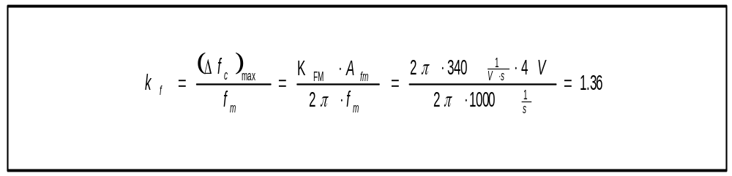

- Using the formula obtained in question (6) above and the Bessel function table given in the course reader, calculate and plot the power spectrum for the frequency modulated signal with a sinusoidal carrier signal (A_{c} = 4V and f_{c} = 25 kHz) and a sinusoidal baseband signal (A_{m} = 3V and f_{m} = 1000 Hz). Assume the generator has FM constructional coefficient K_{FM} = 2π x 340. Use these figures as the theoretical prediction in Part D of the experiment.
Exercise #3 Theory (continued)

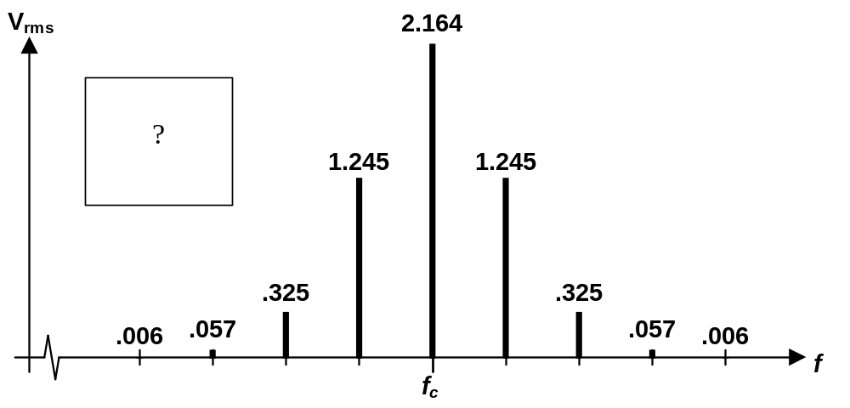

9) What is a useful approximation for the bandwidth of an FM signal in terms of k_{f} and the absolute bandwidth of the baseband signal?
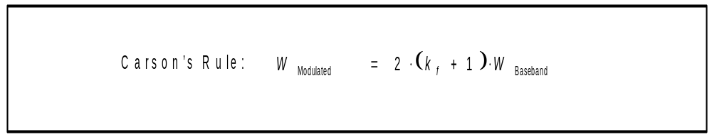

10) Calculate the amplitudes and frequencies in the theoretical AM and FM signal spectrum for the signals mentioned in parts A, B, C and D of the experiment. In part C, calculate the spectrum assuming that A_{m} and A_{c} are already adjusted for K_{AM} . Put these calculations into the shaded boxes of the Raw Data sheets ( ).

Exercise #3: Raw Data (Include with report)

Student name: ________________________

Starting the laboratory exercise allowed by: ________________________
- - - - - - - - - - - - - - - - - - - - - - - - - - - - - - - - - - - - - - - - - - - - - - - - - - - - - - - - - - - -

Print out the spectrum analyzer screen for every waveform in parts A through D and attach these sheets to your report.

Part A: Transmitted Carrier AM Signal with Square Wave Baseband

f_{c} = 25 kHz; A_{c} = 4V
f_{m} = 1.000 kHz A_{m} = 4V (i = 100%)
( DC shift ) _{resulting} = +4V
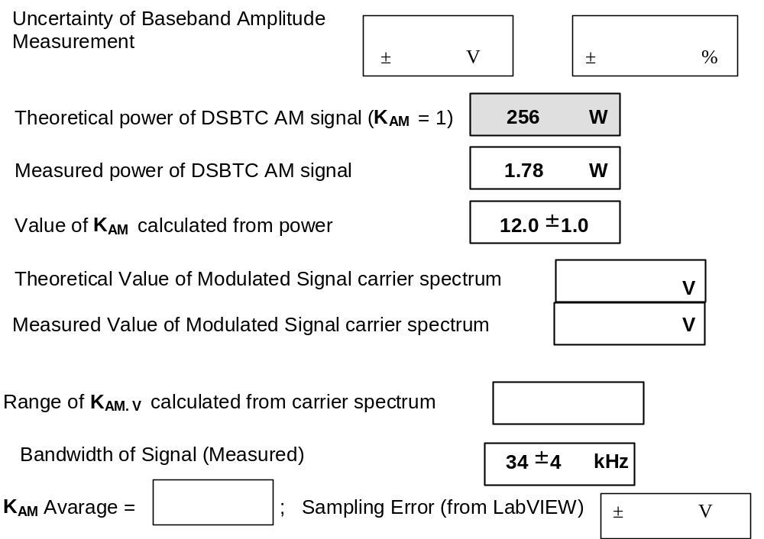
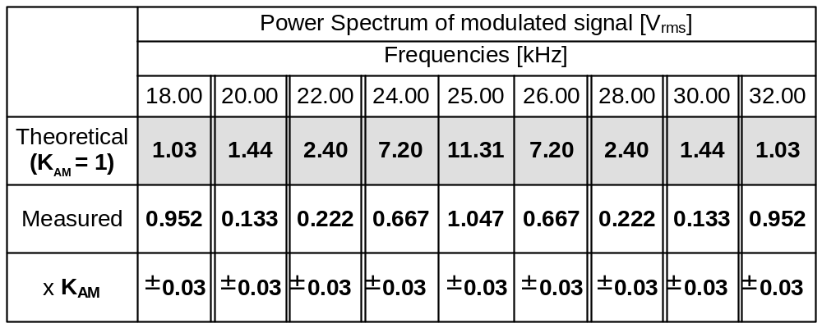

Results of this part checked by: ________________________

Part B: Suppressed Carrier AM Signal With Square Wave Baseband

f_{c} = 25 kHz A_{m} = A_{c} =4 V
f_{m} = 1.000 kHz
( DC shift ) _{resulting} = 0 V
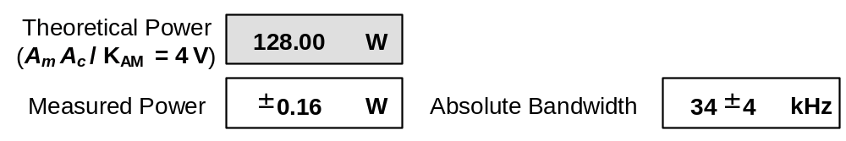
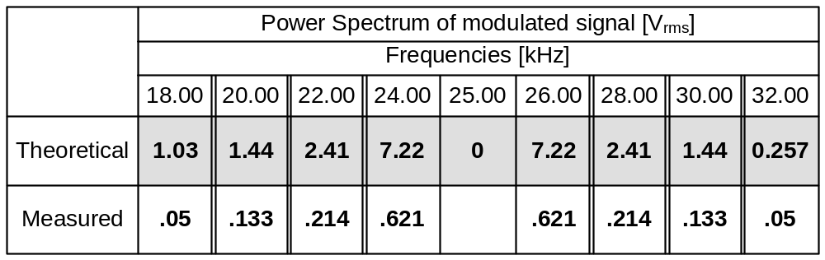

Results of this part checked by: ________________________

Part C: FM Signal With Sinusoidal Baseband

f_{c} = 25 kHz; A_{c} = 4 V; f_{m} = 1.000 kHz; A_{m} = 4 V
W
Measured Power =
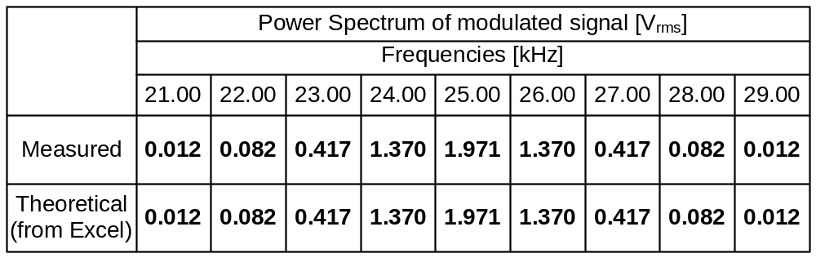
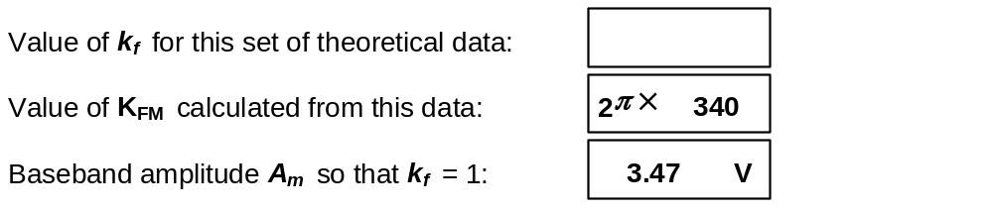

f_{c} = 25 kHz; A_{c} = 4V
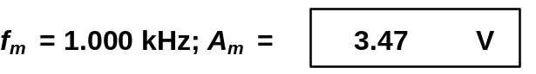

SO,
V
f_{c} = 25 kHz; A_{c} = 4 V; f_{m} = 1.000 kHz; A_{m} =

Exercise #3: Raw Data (continued)

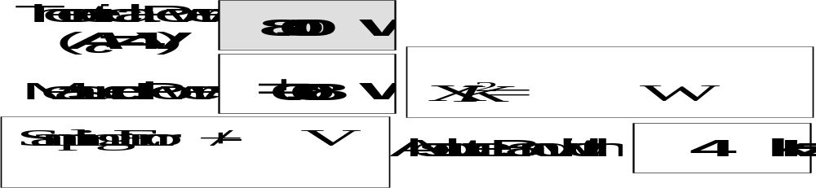
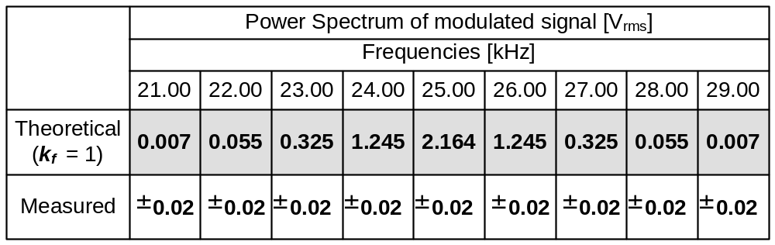

Part D: FM Signal With Square Wave Baseband

f_{c} = 25 kHz; A_{c} = 4V
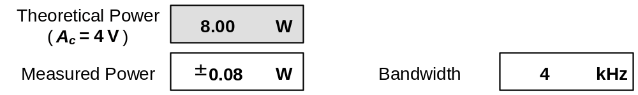
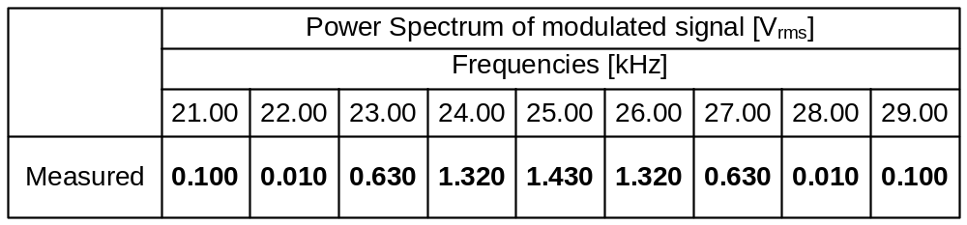

Results of this part checked by: ________________________
Exercise #3: PRE-LAB DISCUSSION

1) Review the frequency-domain representation of DSBTC AM and DSBSC AM signals. Demonstrate how to find K_{AM} (the AM constructional coefficient) from the signal power (review power of AM signals) and from the time-domain representation. The students should multiply their results by K_{AM} , then compare these numbers to the theoretical prediction in parts A and B.

2) Discuss the “Modulated” wave setting on the Spectrum Analyzer in LabView. Make sure they have the correct carrier frequency entered. Also make sure they use “AM” to measure bandwidth for AM signals, and “FM” to measure bandwidth for FM signals. The FM setting will include the carrier frequency when calculating the bandwidth of the signal, while the AM setting will not.

3) For a DSBTC AM signal with square wave baseband, the amplitude should be zero on a space. To determine if the waveform is correct, look for a very nearly flat line on the space.

4) To help in determining the amplitude of the sinusoidal waveforms, use reference levels of HIGH = 98% and LOW = 2% with the “Amplitude” measurement. It is very important to set the correct amplitudes and frequencies in this experiment.

5) For the 150% DSBTC AM signal with sinusoidal baseband, observe the spectrum and print it. You do not have to measure it, but you should be able to see the outline of the time-domain waveform. You will need to discuss this waveform in the lab report.

6) For a DSBSC AM signal with square wave baseband, the amplitude change between marks and spaces should be minimized (this will not be possible, due to the modulator passing some part of the baseband waveform). The students should minimize the amplitude of the carrier signal; it may be necessary to repeatedly adjust the baseband DC offset and run the spectrum analyzer.

7) Review the frequency-domain representation of FM signals; the calculations are very simple once the value of k_{f} is established. Review the use of K_{FM} (the FM constructional coefficient) to find k_{f} . Remind the students that the power of an FM signal is simply the power of the unmodulated carrier signal.

8) The link to the Bessel Function spreadsheet link should be on the desktop; the file is “Lab_3_Bessel_Function.xls.” It simply calculates the first 4 sidebands (and the carrier frequency) for a baseband amplitude of 4 V, baseband frequency of 1000 Hz, and the K_{FM} entered at the top of the spreadsheet. It’s based on minimizing the “sum of squares” for these measurements.

Exercise #3: PRE-LAB DISCUSSION (continued)

9) FSK is Frequency Shift Keying; it allows phase jumps in the time-domain representation. A binary FSK signal can be represented as the superposition of two AM signals. In the lecture notes, there is an example for a binary FSK signal.

MSK is Minimum Shift Keying, and it is simply FSK without phase jumps at signal transitions. A binary MSK signal (such as we construct in this experiment) will look very similar to a binary FSK signal, but not exactly. Observe which harmonics are missing from a binary FSK signal, and compare it to the missing harmonics that you observe in the binary MSK signal.

10) The bandwidth of the DSBTC AM and DSBSC AM signals with square wave baseband will be smaller than 2W (42 kHz). The AM modulator filters the input slightly. The students should still see many lines on the spectrum analyzer output well past the absolute bandwidth (all the way down to 0 Hz, and up to about 100 kHz).

11) The bandwidth of the FM signal with square wave baseband will be MUCH smaller than anticipated with Carson’s rule. This is because the FM modulator acts as a low pass filter; it is unable to change frequencies at a rate much higher than 1 kHz. According to Carson’s rule, the bandwidth for the FM signal with square wave baseband should be 88 kHz. If we approximate the signal as an FSK signal composed of two DSBTC AM waves, the absolute bandwidth would still be 44 kHz.

