UNIVERSITY OF CALIFORNIA, LOS ANGELES
Department of Computer Science
CS M & CS 117171L Computer Communication Systems Laboratory

INSTRUCTOR’S GUIDE, LABORATORY EXERCISE #4

Laboratory Exercise 4: Fiber-Optic Communication Lines

In this lab you will investigate the transmission of a rectangular form signal through a fiber-optic point-to-point communication system.

The goal of this experiment is to use the system's power budget to determine the maximum length and bandwidth of a single-channel fiber optic communication system.

You must determine the capacity of the fiber optic link and compare your results to the coaxial cable link from Laboratory Exercise 2.

Pre-Lab Assignment: The theory section on the next several pages and the theoretical calculations for your results (the shaded boxes in the Results section) must be completed correctly before you will be allowed to start the laboratory exercise. You must have your answers written in these sections before coming to the lab. They will be checked by the TA before you begin the experiment. Be prepared to answer questions about the material.

Exercise #4: Theory (Include with report)

An optical fiber is a thin strand of glass or plastic that serves as a transmission line for an optical signal. Unlike a copper wire, which transmits electrical signals in the form of electrons, an optical fiber carries light signals in the form of photons.

1) List the advantages of fiber optic signal transmission over electrical signal transmission.
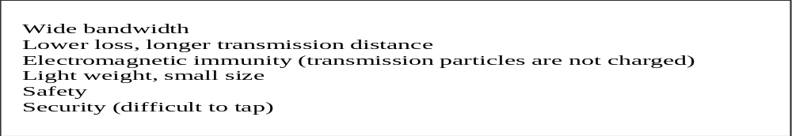TThe transmission properties of the optical fiber are dependent on the optical properties of the fiber’s core and cladding.

2) (a) What is the formula for the numerical aperture of an optical fiber?
(b) What is the formula for the fiber core refraction index given the numerical aperture and the clad refraction index?

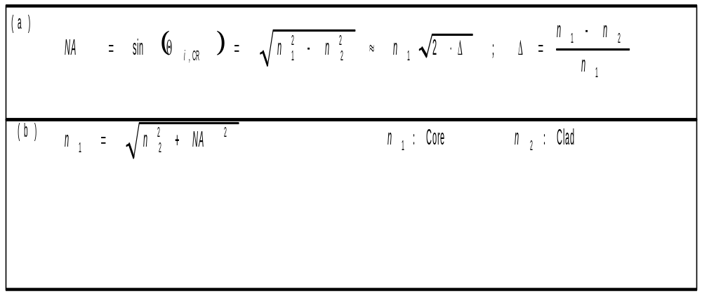

In a multimode step index fiber, the optical properties of core and cladding determine the modal dispersion of the fiber. This modal dispersion limits the bandwidth of the fiber.
Exercise #4: Theory (continued) (Include with report)

3) (a) What is the formula for the bandwidth of an optical fiber?
(b) What is the formula to calculate rise time from bandwidth?
(c) Calculate the rise time and bandwidth of a 25 meter optical fiber with the properties of the fiber in this experiment.
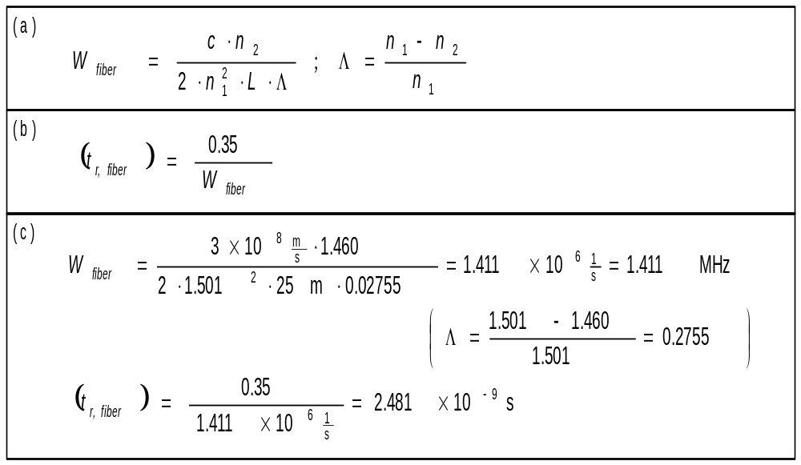

An optical fiber communication system consists of several components, all of which contribute to the overall rise time of the system.

4) What is the formula to calculate the rise time of a communication system from the rise times of each component?
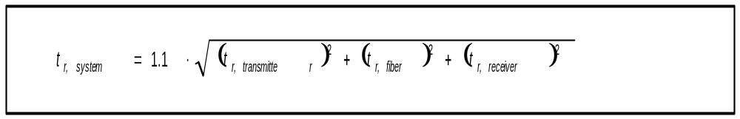

5) What is the formula to calculate a system’s channel capacity in bits per second from its analog bandwidth W and the signal to noise ratio?
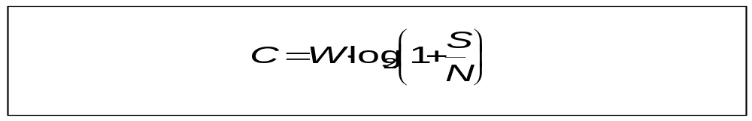
Exercise #4: Theory (continued) (Include with report)

6) What qualities are used to classify optical fibers? What are some types of fibers in commercial use?
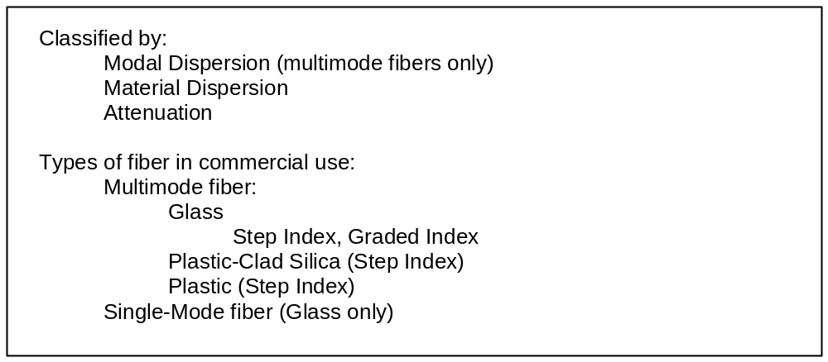

7) List the components of a point-to-point optical communication system, and briefly explain the function of each component.
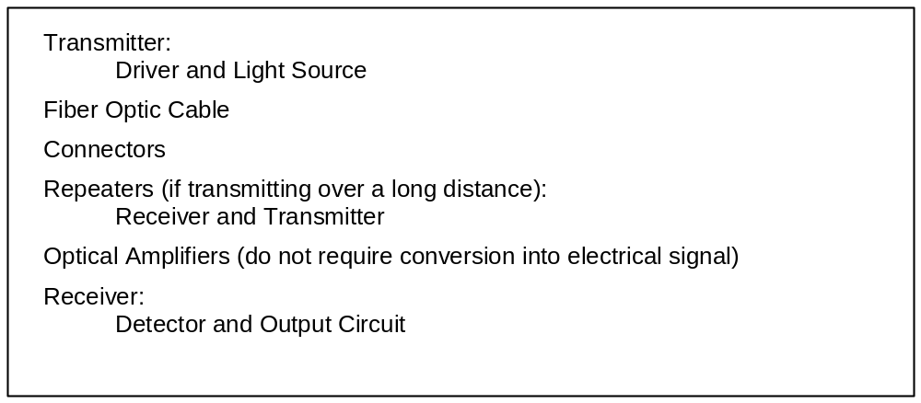
Exercise #4: Raw Data (Include with report)

Student name: ________________________

Starting the laboratory exercise allowed by: ________________________
- - - - - - - - - - - - - - - - - - - - - - - - - - - - - - - - - - - - - - - - - - - - - - - - - - - - - - - - - - -

Part A: Link Characteristics

Input square wave amplitude: A = 1.4V (pk-pk)

Link characteristics

Cable Frequency 1) 2) 3) 4) 5)
Rise time Time delay out. power Time delay Bandwidth
MHz ns ns dBm ns / m MHz

A 1

2
1
B
2
1
C
2

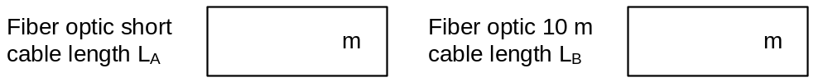

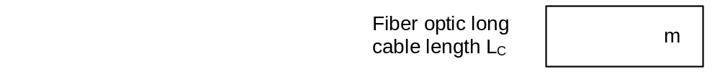
Results of this part checked by: ________________________
Exercise #4 : Raw Data and Error Estimates (continued)

Part B: Whole System Characteristics (Calculations)

Use the Table A data and the values calculated above to compile the following tables.

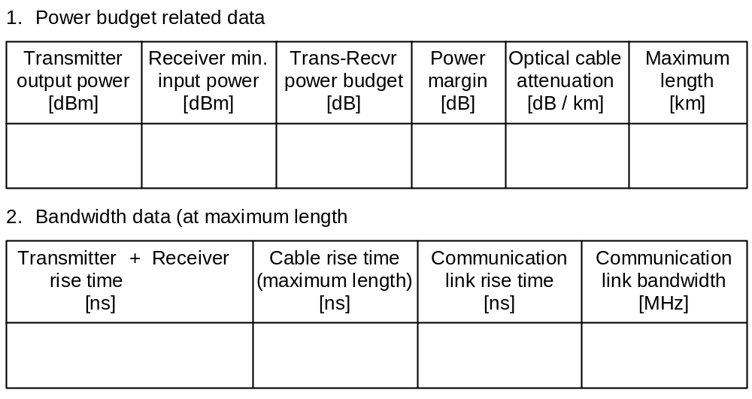

Power
Power Budget
dB
Link Maximum Distance
Km

Channel Capacity
For the Link
Mb/s

Results of this part checked by: ________________________

Exercise #4 : Raw Data (continued)

Part C: Fiber Optic Bandwidth experimental Determination

Rise Time
ns
a. Link with single mode fiber
b. Link with fiber cable C
c. Cable
C
Bandwidth of Cable C
MHz
From
Part A. 5
Based on rise time

Results of this part checked by: ________________________

Exercise #4: PRE-LAB DISCUSSION

1) Optical power meter: Note the plug on the power meter. Two of the power meters use ST connectors, while the third has an SMA connector. Because the transmitter, receiver, and fibers in this lab use SMA connectors, an adapter is necessary for the power meters with ST connectors. The adapter losses will decrease the power measured, but since the power loss is equal for all parts of the experiment, the results will be unaffected.

To operate the optical power meters, you must first select the correct wavelength using the λ button. Next, when the fiber is attached, press and hold the “dB / dBm” button until an “r” flashes on the LCD display. Release the button to calibrate the power meter at the current power value. The LCD will show a measurement in dB, which is the power relative to this calibration point. To find the power in dBm, press the “dB / dBm” button once. This will add the current calibration point (in dBm) to the relative power measured (in dB) to obtain a measurement in dBm.

2) Use the short 2 meter cable to make all power measurements. We can ignore the losses in this short length of cable. Because all measurements will pass through two nearly identical connectors, the connector losses can be ignored as well (since they are the same for all measurements and for the communication link once in place).

3) Remind the students to be careful with the optical cables. Disconnect them by holding only the metal collar. Do not pull on the cables or bend them excessively (beyond a 3-inch radius arc).

4) During the entire lab, the receiver must be set to “Receiver Test.” For most of the lab, the transmitter will be set to “Regular.” In Part C, you will measure the receiver sensitivity, and for this measurement only, you will set the transmitter to “Test.” Make only one measurement of the minimum sensitivity.

5) Briefly go over the relationship between rise time and bandwidth, as explained in Lecture 4. We are modeling all of these devices as low pass filters. Because they are not perfect low pass filters, and because we are not sure how successive devices will affect the cumulative rise time, we add the correction factor of 1.1 to the system rise time, to allow for non-ideal effects.

