UNIVERSITY OF CALIFORNIA, LOS ANGELES
Department of Computer Science
CS M171L & CS 117 Computer Communication Systems Laboratory

INSTRUCTOR’S GUIDE, LABORATORY EXERCISE #5

Laboratory Exercise 5: Demodulation of AM and FM Signals

This lab investigates demodulation of amplitude-modulated and frequency-modulated signals to regenerate the original signal.

In this lab, the original signal is reconstructed at the other end of the transmission line. A modulated signal may also be transmitted using radio waves. You will compare the output signal of the link to the original signal and assess the quality of the signal transmission.

Pre-Lab Assignment: The theory section on the next several pages must be completed correctly before you will be allowed to start the laboratory exercise.

You must have your answers written in these sections before coming to the lab. They will be checked by the TA before you begin the experiment. Be prepared to answer questions about the material.

Review the theory of amplitude modulation and frequency modulation. You should understand the reasons to transmit a modulated signal as opposed to transmitting the baseband signal directly.

Be familiar with the properties of the function generator used to modulate the signal. For frequency modulation, you should know the value of the FM constructional coefficient measured in last week’s lab. You should also understand how to calculate the maximum possible frequency deviation ( Δf_{c} )_{max} for a binary frequency shift keyed signal (2-FSK, an FM signal with two-valued digital baseband signal).

One reason to use signal modulation is to allow multiplexing of several signals over the same medium. Another reason is to allow transmission of the signal with electromagnetic waves, or radio waves. To receive an electromagnetic signal using an antenna, the dimensions of the antenna must be of the same order of magnitude as the wavelength of the signal being transmitted.
Exercise #4: Theory (Include with report)

1) What are the most important distinctions between envelope detection and synchronous detection of an amplitude modulated signal?
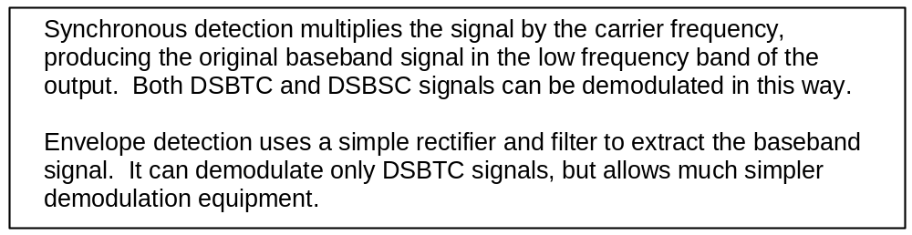

2) What is the two main components of a circuit which performs envelope detection?

3) Draw the block diagram of the Phase-Locked Loop frequency demodulator, and explain the assignment of each block.
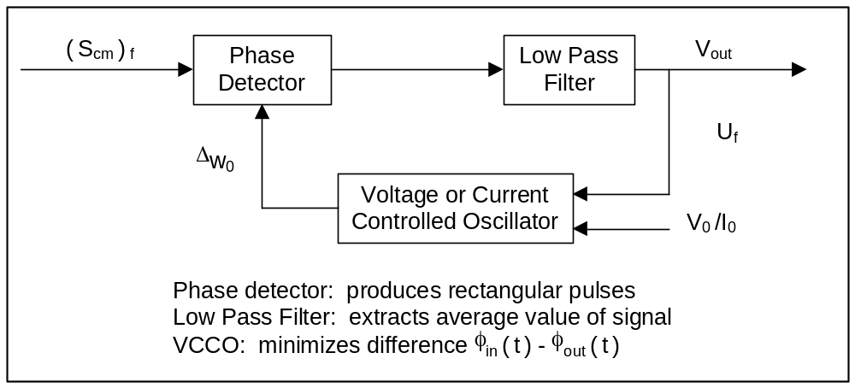

4) If bias distortion is +0.020, what is the duty cycle of the rectangular wave at the regenerator output when the baseband signal is a 1 kHz square wave (pulse width of 500 microsecond)?


5) Using the value of K_{FM} = 2 x340 calculate the value of ( Δf_{c} )_{max} for the signal in part E of this lab.


6) What is the formula to calculate the analog bandwidth BW of a system from its rise time?


7) What is the formula to calculate a system’s channel capacity in bits per second from its analog bandwidth W and the signal to noise ratio?

8) What is the bandwidth required to transmit a 2 kbps digital signal with a signal-to-noise ratio of 1?

Exercise #4: Raw Data (Include with report)

Student name: ________________________

Starting the laboratory exercise allowed by: ________________________
- - - - - - - - - - - - - - - - - - - - - - - - - - - - - - - - - - - - - - - - - - - - - - - - - - - - - - - - - - - - -

Part A:
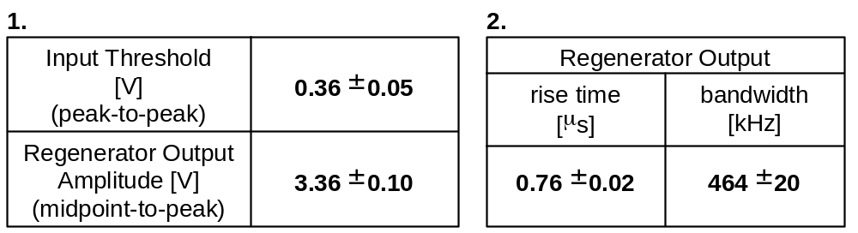

Results of this part checked by: ________________________

Part B:

Sinusoidal carrier signal: A_{c} = 5 V; f_{c} = 100 kHz.

Square wave baseband signal: A_{m} = 5 V; f_{m} = 1 kHz; (DC offset)_{resulting} = +5 V

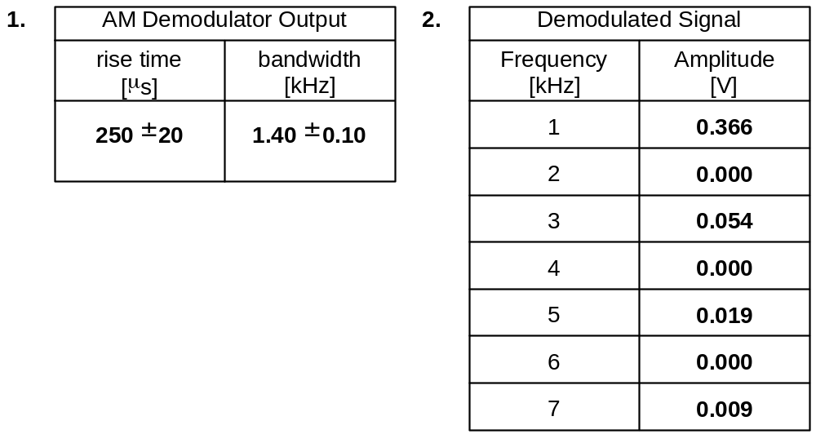
Results of this part checked by: ________________________
Exercise #4: Raw Data (continued)

Part C:
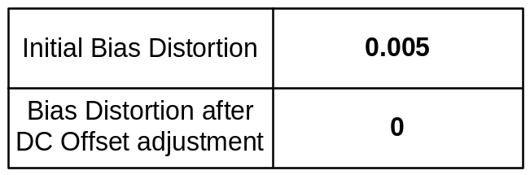
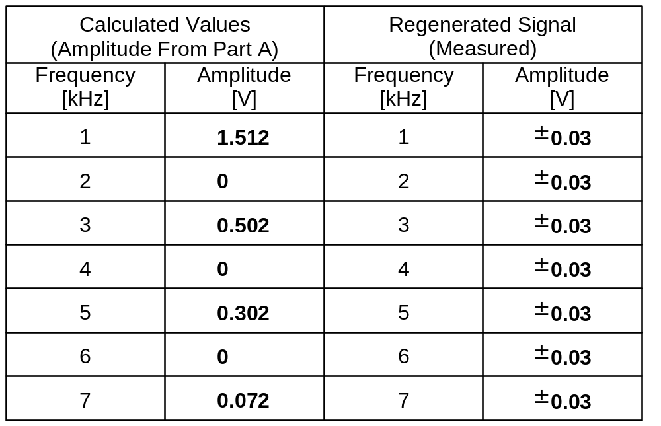
Results of this part checked by: ________________________

Part D:
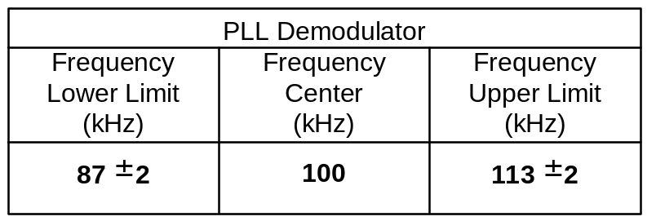

Results of this part checked by: ________________________
Exercise #4: Raw Data (continued)

Part E:

Sinusoidal carrier signal: A_{c} = 1 V; f_{c} = 100 kHz.
Square wave baseband signal: A_{m} = 4 V; f_{m} = 1 kHz.
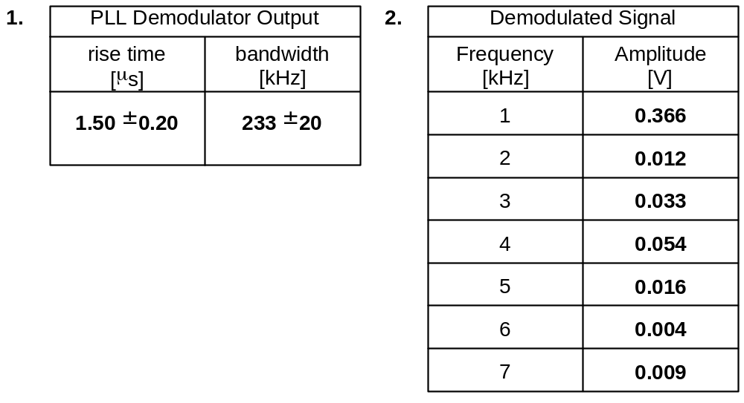
Results of this part checked by: ________________________

Part F:
Results of this part checked by: ________________________
Exercise #5: Raw Data and Error Estimates (Include with protocol)

Student name: ________________________

Starting the laboratory exercise allowed by: ________________________
- - - - - - - - - - - - - - - - - - - - - - - - - - - - - - - - - - - - - - - - - - - - - - - - - - - - - - -
Part A:
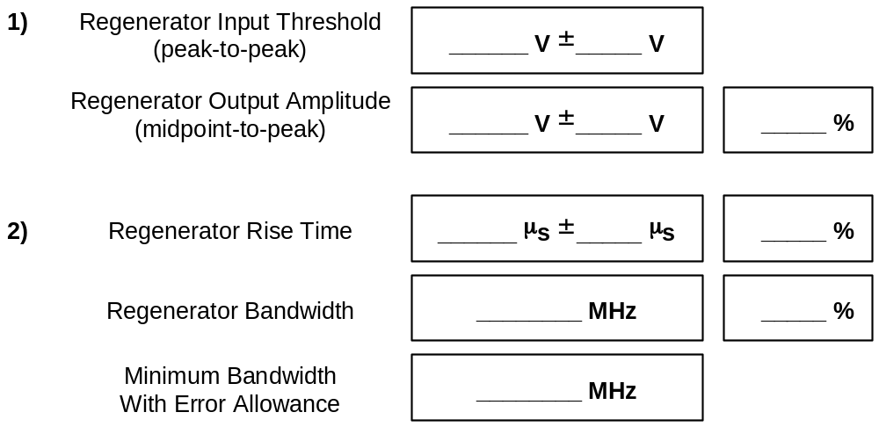
Results of this part checked by: ________________________

Part B:

Square wave baseband signal: A_{m} = 5 V; f_{m} = 1 kHz; (DC offset)_{resulting} = +5 V

Sinusoidal carrier signal: A_{c} = 5 V; f_{c} = 100 kHz.

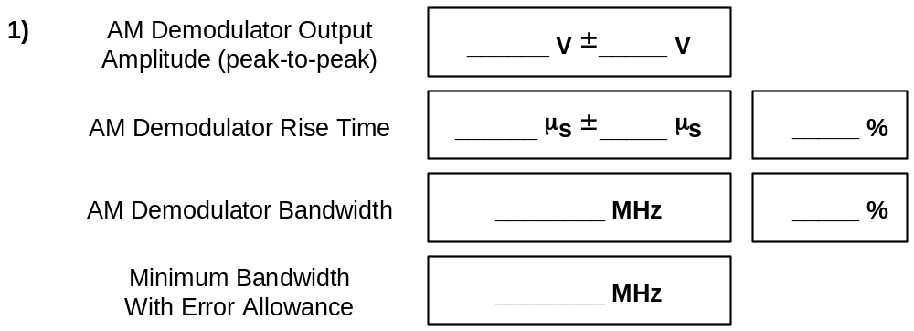

Part B, continued:

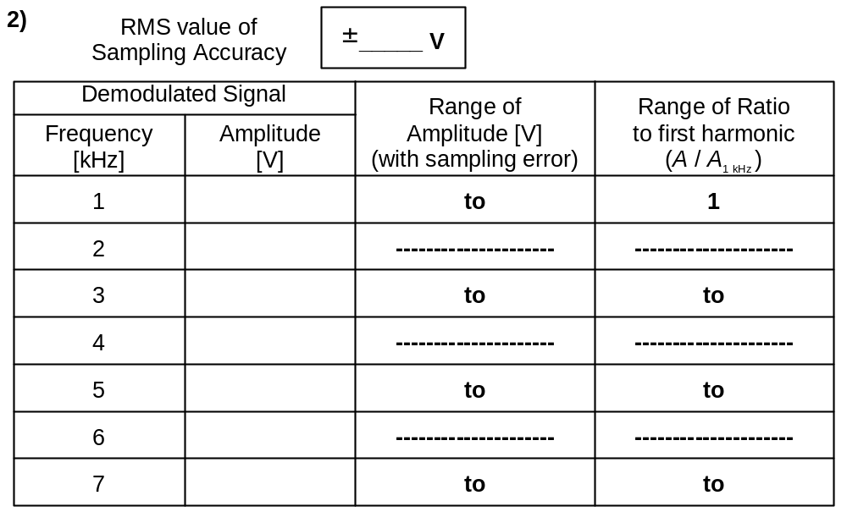
Results of this part checked by: ________________________

Part C:
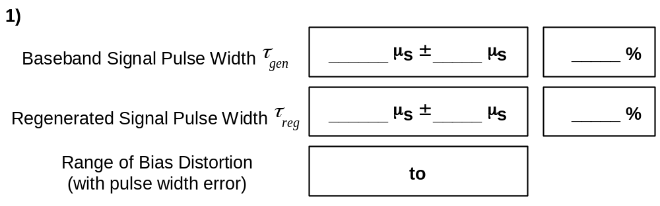
Exercise #5: Raw Data and Error Estimates (continued)

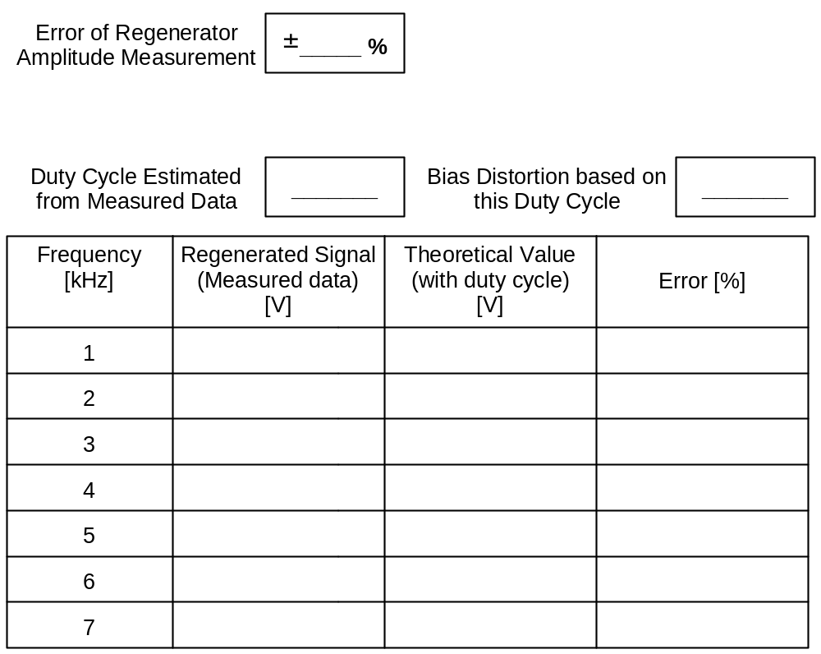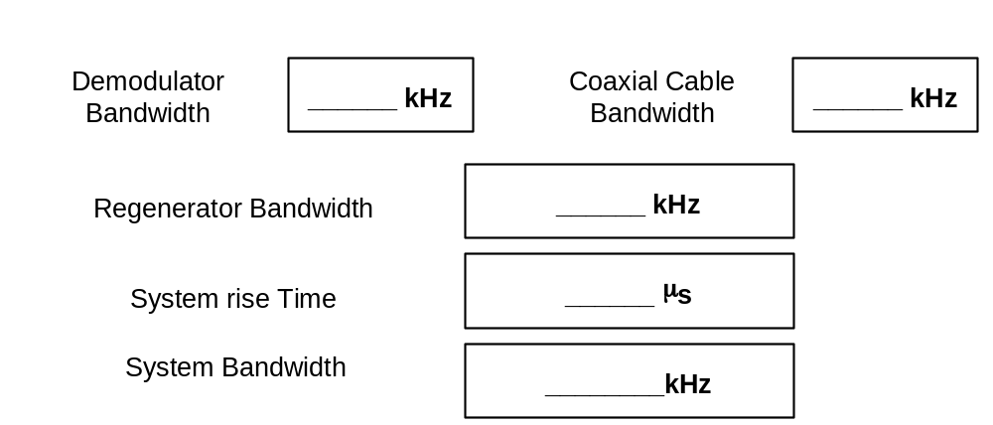

Results of this part checked by: ________________________
Exercise #5: Raw Data and Error Estimates (continued)

Part D:

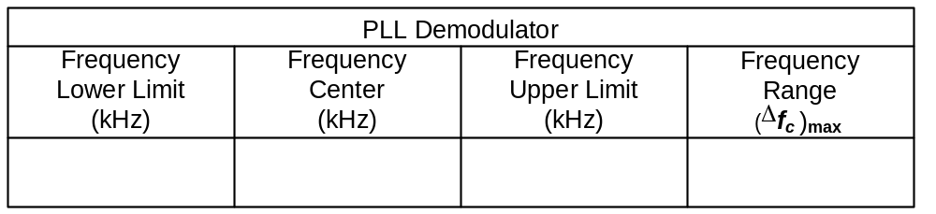

Results of this part checked by: ________________________

Part E:

Sinusoidal carrier signal: A_{c} = 1 V; f_{c} = 100 kHz.

Square wave baseband signal: A_{m} = 4 V; f_{m} = 4 kHz.

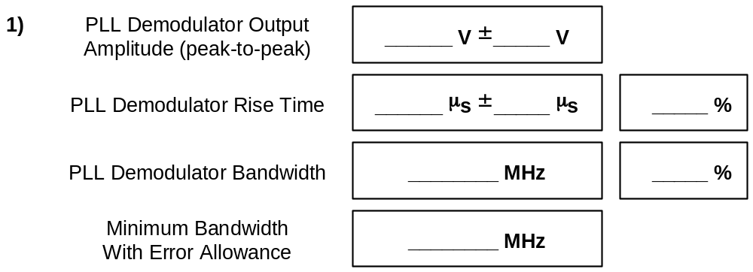

Exercise #5: Raw Data and Error Estimates (continued)

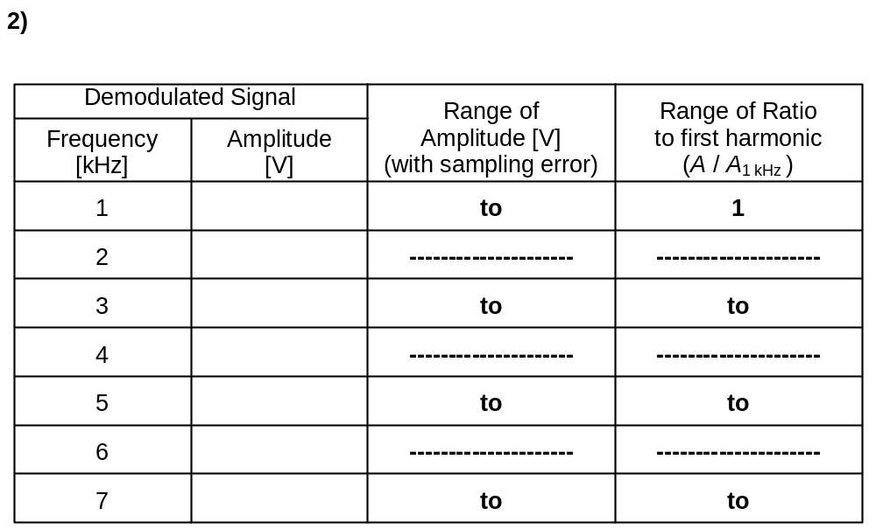
Results of this part checked by: ________________________

Part F:

Exercise #5: Raw Data and Error Estimates (continued)

Part F (continued):

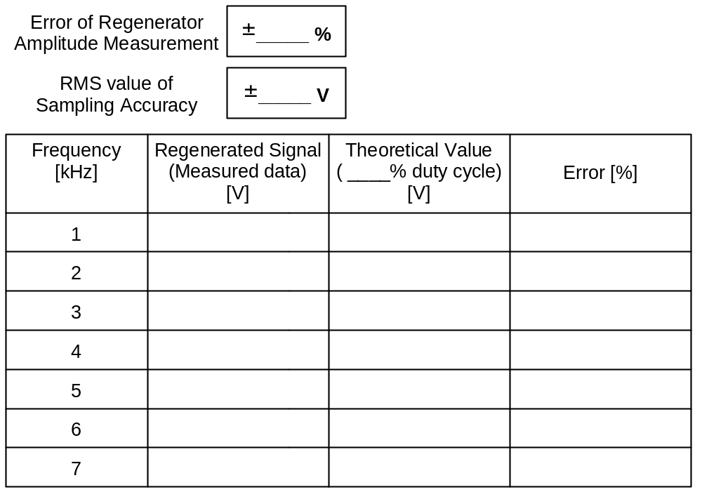

Results of this part checked by: ________________________

Exercise #5: PRE-LAB DISCUSSION

1) Signal regeneration is a crucial part of digital transmission. A regenerator can use a complex algorithm for making a 0/1 decision on a signal. Most regenerators simply read an input voltage and activate when it increases past a certain point.

In Part A, we measure the threshold voltage of the regenerator; this is the minimum demodulator output voltage needed to activate the regenerator. We also measure the output amplitude of the regenerator. The ideal output of the demodulator will duplicate the pattern of 1’s and 0’s of the original signal, but the amplitude will be different. For a square wave input, we expect a square wave output whose amplitude equals the regenerator output amplitude. Divide the peak-to-peak regenerator output voltage by 2 to get the midpoint-to-peak amplitude (used in calculating spectrum of regenerator output). We will use this amplitude in parts C and F of this lab.

2) The rise time of each component determines the potential bandwidth of the system. We want to examine each component to see if it has sufficient bandwidth to transmit our signal. Visually measure the rise time on the oscilloscope screen so you can verify that the oscilloscope measurement is accurate. Remember to check that the reference levels of the oscilloscope are set to 90% high, 10% low.

3) For the AM demodulation parts of the exercise, be sure to include the 50Ω terminator at the demodulator output. Otherwise, the circuit will not work properly. Also, remember to terminate the transmission line properly.

4) The rise time of the demodulator will be measured using the square wave input signal. Because the demodulator bandwidth is much less than the carrier frequency, the rise time will not change if we change the carrier frequency.

5) While the demodulator may have sufficient bandwidth to transmit the information carried by a digital signal, it may not have sufficient bandwidth to transmit all the harmonics of the digital signal. Examine the demodulator output and determine whether this signal accurately reproduces the input (look at both the time domain and the frequency domain).

6) Bias distortion is an important concept in digital communications. It is a quick way to categorize how well your digital output signal reconstructs the input signal. For simple communication links, it will determine the jitter (time variation) allowed when sampling the signal. If the reconstructed signal has high bias distortion, an early sample or a late sample will be more likely to cause an error.

To eliminate bias distortion, measure the positive duty width of the regenerated signal. Adjust the voltage output of the modulator slightly to minimize the bias distortion (the positive duty width should be close to 500 μs).

Exercise #4: PRE-LAB DISCUSSION (continued)

7) The eye chart is another tool used to evaluate a digital output signal. It superimposes all 8 possible transitions of a 0/1 digital signal. The box at the center of the eye chart displays both the jitter tolerance and the decision range available to the receiving device. It allows us to build the simplest, lowest cost receiver which still minimizes the error rate.

8) After you have taken the regenerated spectrum, disconnect the signal from the AM demodulator and attach it to the oscilloscope. This is to ensure that you still have a DSBTC AM signal.

9) In Part D, we determine the range of frequencies that can be detected by our PLL demodulator. The FM demodulator must produce frequencies in this range. We can calculate the maximum possible frequency deviation from the formula in Lecture 4.

10) The rise time of the PLL demodulator will be measured using the square wave input signal. The demodulator rise time will limits the transmission bandwidth of the system.

11) To eliminate any bias distortion in the regenerated signal, adjust the voltage level of the modulator output slightly until you the positive duty width is very nearly 500 μs.

