UNIVERSITY OF CALIFORNIA, LOS ANGELES
Department of Computer Science
CS M 171L & CS 117 Computer Communication Systems Laboratory

INSTRUCTOR’S GUIDE, LABORATORY EXERCISE #6

Laboratory Exercise 6 –Dense Wavelength Division Multiplexing (WDM)

In this lab you will investigate the simultaneous transmission of four signals through a single multimode optical fiber. You will determine the characteristics of the various components of a wavelength division multiplexing system, and use the system's power budget to determine the system's maximum length and information carrying capacity. For this purpose, you will measure the emitted light power of the transmitters, determine the power distribution in the system's splitters and wavelength dependent couplers when used for multiplexing or demultiplexing, and measure reflected power and crosstalk in the system.

Pre-Lab Assignment: The theory section on the next several pages must be completed correctly before you will be allowed to start the laboratory exercise. You must have your answers written in this section before coming to the lab. They will be checked by the TA before you begin the experiment. Be prepared to answer questions about the material.

Exercise #6: Theory (Include with report)

In fiber optic communications, the two techniques available for multiplexing are Time Division Multiplexing (TDM) and Wavelength Division Multiplexing (WDM). TDM TDM divides a high-bandwidth transmitted signal into time slots, where each time slot carries a different low-bandwidth signal.

1) How does WDM work and what are its advantages over TDM?
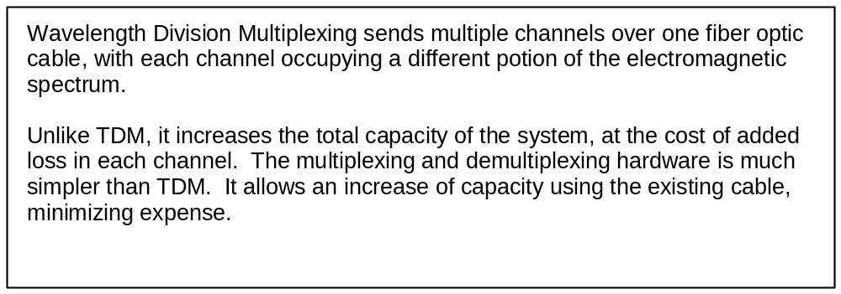

2) What are the components of a WDM network? Briefly, what are their functions?
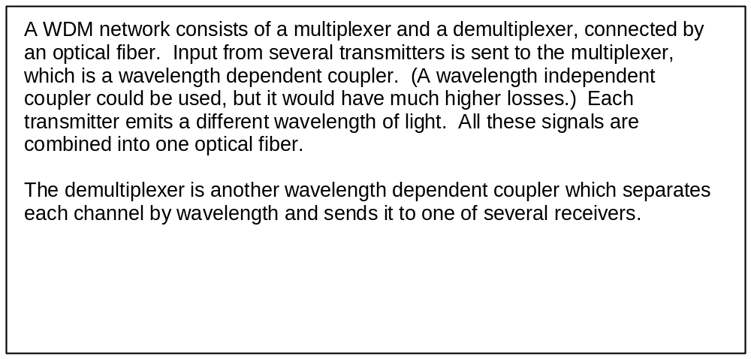

Exercise #6: Theory (continued) (Include with report)

A wavelength dependent coupler can be used as a multiplexer to combine light of different wavelength onto a single fiber, or as a demultiplexer to split combined light back into the component signals.

3) For a wavelength dependent coupler, how do you calculate:
a) channel separation (“cost of channel separation”)
b) crosstalk
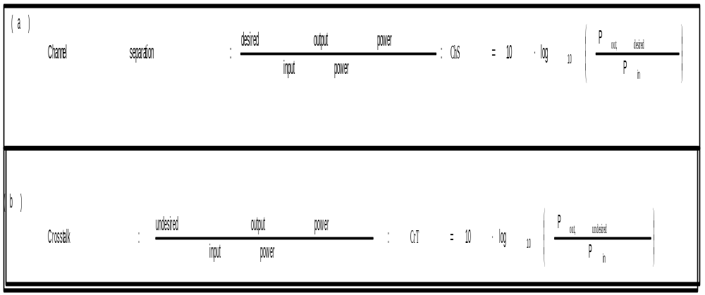

4) What is the formula to calculate the power budget of a DWDM communication link? Include all component losses assuming two wavelength dependent couplers are used for multiplexing and demultiplexing.
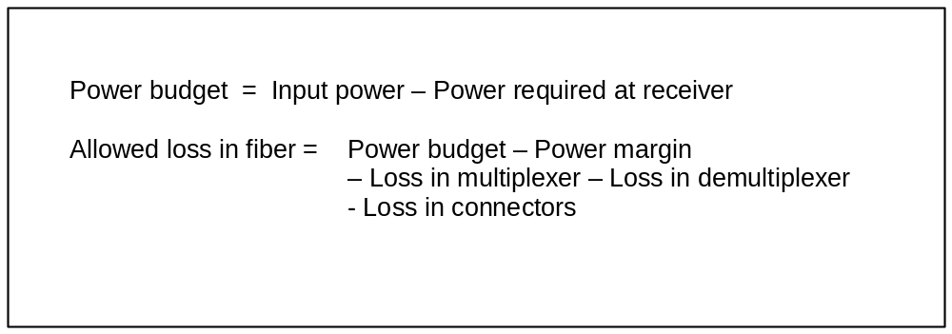

Exercise #6: Theory (continued) (Include with report)

The capacity of each channel of the DWDM system can be determined from Shannon’s formula

5) What are the formulae to calculate:
a) maximum channel capacity in bits per second?
b) bandwidth of the communication link if you know system rise time?
c) 4 channel DWDM system channel capacity in bits per second?
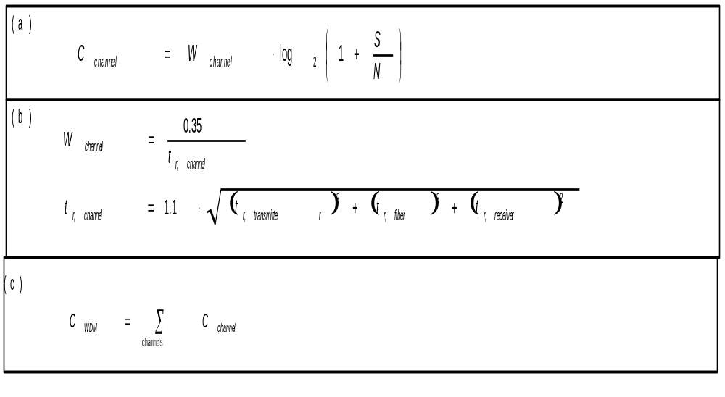

Exercise #6: Raw Data and Error Estimates (Include with report)

Student name: ________________________

Starting the laboratory exercise allowed by: ________________________
- - - - - - - - - - - - - - - - - - - - - - - - - - - - - - - - - - - - - - - - - - - - - - - - - - - - - - - - - - - - -

Part A Transmitter Test:

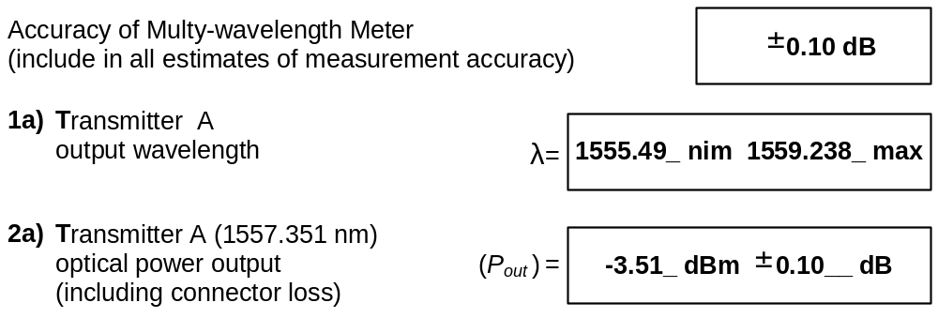
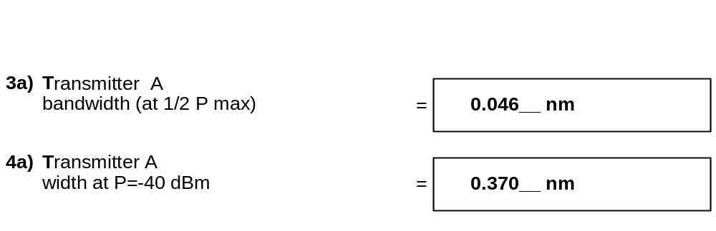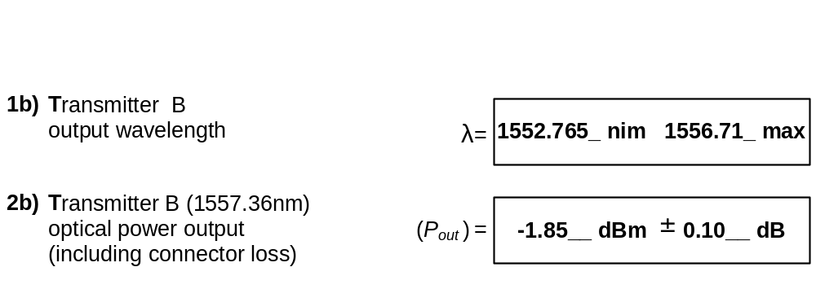

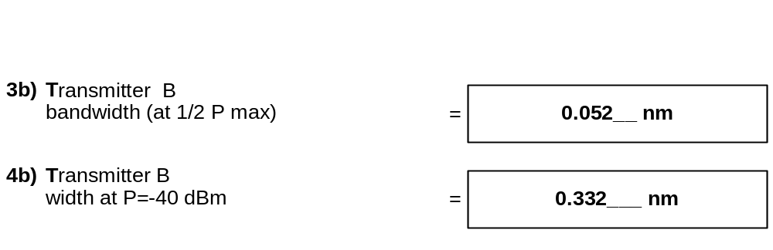6); 7) Printout observation. (Overlap+0, Crosstalk=0)

Results of this part checked by: ________________________

Part B: Wavelength Independent Coupler test

1), 2) and 3): Excess Loss, splitting ratio and directionality
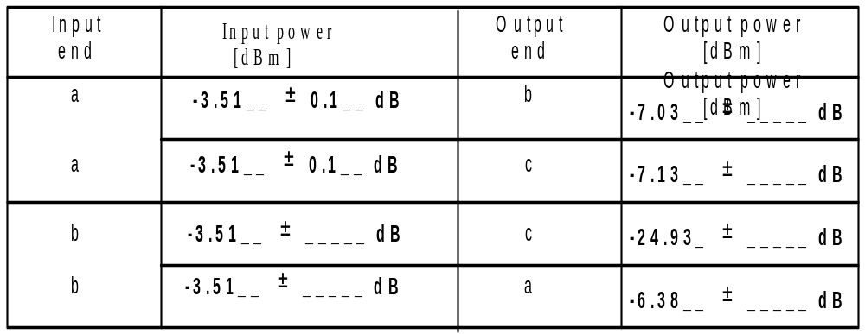

-3.51__ ± ____ dB
-24.7 ± _____dB
b
c

c
-3.51__ ± _____ dB
-6.89_ ± _____dB
a

4) Printout observation.

Results of this part checked by: ________________________
Exercise #6: Raw Data (continued)

Part C: Wavelength Dependent Coupler test

1) Multiplexing and Excess Loss
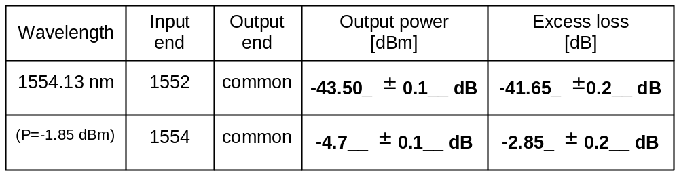
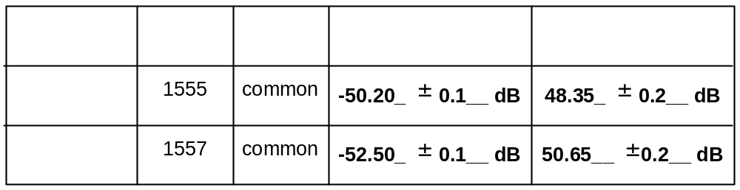

- Observation of Channel Separation (ChS) and Crosstalk (CrT)
- Observation of overlapped spectrum (nm)
- Observation of crosstalk power, that is maximum power value in overlapped spectrum (dB).

- Demultiplexing
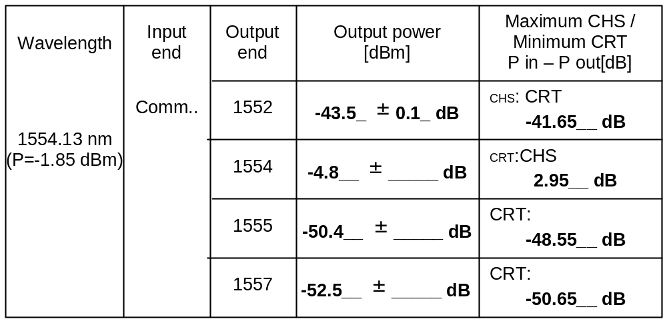
Results of this part checked by: ________________________
Exercise #6: Raw Data (continued)

Part D: DWDM system test

a), Transmitter A- center wavelength 1554.13 nm; B- 1557.36 nm.

b), c) Input rectangular waveform signal:
Frequency f = 25 MHz
Amplitude A = from 0.7 V to 1.5 V
(Voltage is in the range +0.7V < V_{in} < +1.5V)

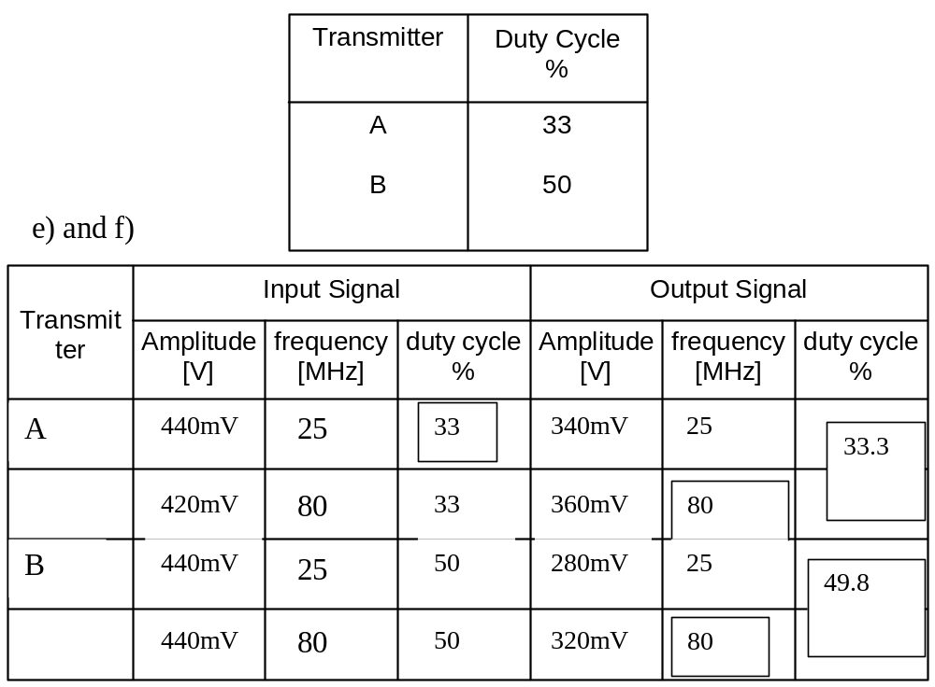
d) Printout observation.
g) Power Budget
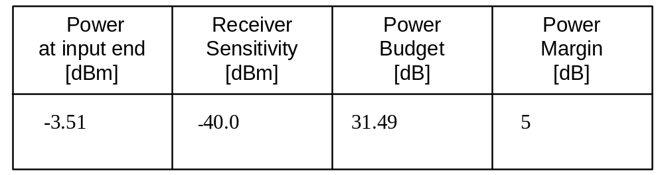
Exercise #6: Raw Data and Error Estimates (continued)

h) Maximum Length:
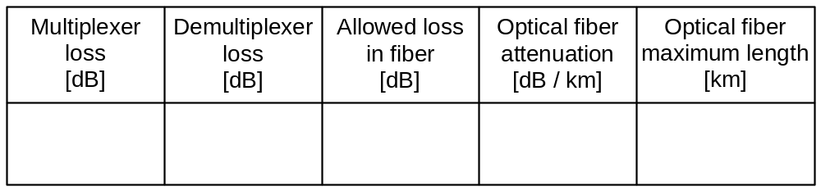
2.85
2.85
25.79
0.3
86

i) System characteristics at maximum length

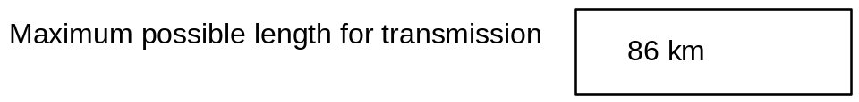
(You will need to calculate rise time for fiber cable with maximum possible length)

Maximum channel capacity for OC-3 carrier
Transmitter rise time ns

O.3

Receiver rise time ns
0.4

Single channel capacity
Mbps
1263

DWDM System capacity
Mbps
1263X2=2526

Results of this part checked by: ________________________

Exercise #6: PRE-LAB DISCUSSION

1) Explain the difference between the SMA connectors used in Lab 5 and the ST connectors used this week. The inside notch on the ST connector is only on one side; make sure you align this notch properly with the inside of the connector.

2) Review the differences between wavelength independent couplers and wavelength dependent couplers. A wavelength independent coupler is much less expensive than a wavelength dependent coupler. You are studying the properties of the wavelength independent couplers in order to determine what the impact of substituting a less expensive wavelength independent coupler would be in the experiment.

3) Wavelength independent couplers are most often used for two-way transmission down a fiber optic cable. The 10BASE-FL link in use at the back of the lab uses two wavelength independent couplers to divide the Transmit and Receive fibers. Therefore it is important to study reflection in a wavelength independent coupler; if the reflected power is sufficient, a “false collision” will result.

4) Explain the difference between crosstalk and channel separation (or “cost of channel separation”). How do these two concepts apply to systems where many channels share the same medium? If there are many other signals, then the crosstalk is the sum of power leaking from all other channels into the channel we are studying.

5) In the lab, the system should be set up so that two fibers are used. One will carry signals from nodes 1 and 3 to nodes 2 and 4. The other channel will carry signals from nodes 2 and 4 to nodes 1 and 3. Channels 1 and 2 of the oscilloscope will show the input and output of the 1300 nm channel (node 1 to node 3), and channels 3 and 4 of the oscilloscope will show the input and output of the 850 nm channel (node 2 to node 4).

6) In Part D, we want to verify that the two channels are transmitting independently. Measure the input duty cycle and the output duty cycle for each of the four channels. You will probably need to turn off the two oscilloscope channels that you are not using, so that you can get a better measurement of the duty cycle of the signals you are interested in.

7) For the calculations in part E, we want to find out which channel is limiting our system length, then calculate the system bandwidth for both channels at this maximum length. In your report, you should address the impact of using a wavelength independent coupler on the maximum possible length of the system.

