UNIVERSITY OF CALIFORNIA, LOS ANGELES
Department of Computer Science
CS 117 Laboratory

Laptop password < lab >

Laboratory Exercise 7: Data Transmission over 802.11b Wireless LAN

In this lab you will investigate data transmission over 802.11b Wireless LAN using different transport protocols and in presence of noise sources.

The main goals for experiments are:

- To give students the basic knowledge of various factors affecting data throughput in a wireless channel.
- To expose students to the effect of sporadic losses on TCP throughput.
- To familiarize students with basic performance measurement tools in computer networks.

For this purpose:

- Measure UDP and TCP data throughput using Iperf measurement tool at different locations in Boelter Hall.
- Measure UDP and TCP data throughput in Lab with and without microwave turned on.

Exercise #5: Theory (Include with Report)

1) (a) List the three different modes of signal propagation (besides direct signal) and the cause for each of these modes.
(b) What kind of signal reception problems these different modes cause?
a)
Reflection-propagation wave reflected by objects larger than wavelength results.
Diffraction-wave obstructed by surface with sharp irregular edges.
Scattering-wave hits loose objects smaller than wavelength, signal scattered in bunch of outgoing weaker signals are result

b)
Reflection causes large scale fading
Scattering causes small scale fading

2) (a) How do multipath signals effect signal reception? This effect limits
the transmission rate of wireless channel.
(b) Give relation between transmission rate and this “effect“ in part (a).
a)
Time delayed multipath signal causes inter-symbol interference of different waves. Inter-symbol interference also has an impact on the burst error rate of the channel. In some cases, the second multipath signal is delayed so much that is it received during the next symbol interval.

b)
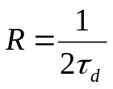. From this it can be seen that as more multipath transmission occur, the transmission rate will decrease due to late data

Exercise #5: Theory (continued) (Include with Report)

3) (a) How much power you expect to receive if your receiver is at distance
d away from the transmitter and the transmitter transmits at frequency
f_{c}. Assume isotropic receiver/transmitter antennas and isotropic free
space loss. Give path loss in dB.
(b) Assume your WLAN system has transmission power of 15 dBm and the received power must be at least –72 dBm. WLAN radio frequency is 2.4 GHz. Assuming isotropic antennas and no obstructions (i.e. isotropic free space loss), what is the maximum distance you can communicate over.
a)
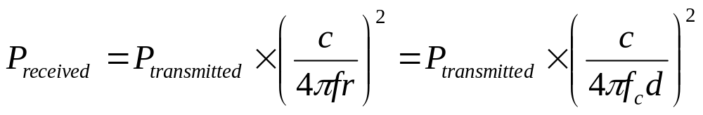

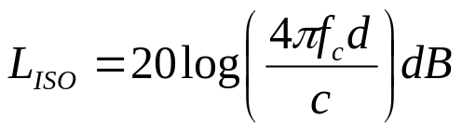

b)
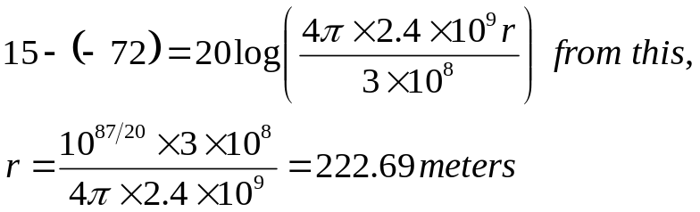

4) What is frequency range of 802.11b Wireless Channel?

2.4-2.4835 GHz

5) a) How do intermittent losses (say, on average one packet loss every 20
packets) affect TCP throughput?
b) If your application can tolerate 10% packets loss, will you use TCP or
UDP if your channel characteristics are as in part a) above.
a)
When a packet is lost, TCP reduces the number of packets being sent and thus will reduce throughput. This is due to the TCP slow start mechanism to prevent data loss.

b)
If the application can tolerate 10% packet loss and packet loss one packet every 20 packets (5%), then UDP offers faster transmission and should be used to improve performance. Since packet loss is below what the application can tolerate, UDP will work and have less overhead than a TCP connection which requires handshaking, so making it the protocol of choice.

Exercise #7: Raw Data

Starting the laboratory exercise allowed by: ________________________

Part A Table 1. TCP and UDP Throughput vs. Signal Strength
Location | Approx. Distance from Access Point (feet) | Signal  Strength  (dBm) | Noise  Strength  (dBm) | SNR  (dB) | UDP Data Rate  (Kbps) | TCP Data Rate (Kbps) | Observations  (record anything that seems interesting or peculiar e.g. datagram loss)
1.  Next to 3704 Entry | 25 |  |  | 29 | 448 | 903
2.  Next to 3732  Suite Main Entry | 80 |  |  |  | 201 | 0
3.  Next to 3750 Entry | 135 |  |  |  | 174 | 16
4.  Next to 3rd Floor Stairs | 150 |  |  |  | 0 | 0

Results checked by ____________
Exercise #7: Raw Data

Part B Table 2. Noise and Throughput in presence of Microwave Oven
Micro-wave Oven Level | Signal Strength  (dBm) | Noise  (dBm) | UDP Data Rate  (Kbps) | TCP Data Rate  (Kbps) | Spectrum Analyzer  Display Observation | Other Observation e.g. datagram loss
Off | -29 | -82 | 448 | 903 | Single peak; fluctuating signal power.  Freq: 2.46 GHz  Signal Power=  -68dBm | UDP loss=0%  TCP loss=0%
High | -45 | -86 | 300 | 663 | Many signal peaks in spectrum often higher than wireless channel | UDP loss=0%  TCP loss=0%
Medium High | -35 | -81 | 320 | 500 | Same | UDP loss=3%  TCP loss=0%
Medium | -26 | -82 | 300 | 681 | Same | UDP loss=.4%  TCP loss=0%
Defrost | -30 | -84 | 340 | 650 | Same | UDP loss=0%  TCP loss=0%
Warm | -33 | -86 | 320 | 555 | Same | UDP loss=.3%  TCP loss=0%

Approx. Distance from AP (feet) _______

Results checked by__________

