In partial fulfillment of the requirements for the

ITE121 – Intermediate Programming

**“Guess The Number Game”**

Presented to:

Dr. Unife O. Cagas

Professor

Prepared by:

Remark Medalla Jayme

BSCS – 1B2

May 2, 2024

**INTRODUCTION**

The Guess The Number game is a simple yet engaging game where the player attempts to guess a randomly generated number within a specified range. In this implementation, the player is prompted to guess a number between 1 and 10. They have three attempts to correctly guess the number. After each guess, the game provides feedback to the player, indicating whether their guess was too high, too low, or correct.

* 1. **OBJECTIVE**
* Guessing the Correct Number: The primary objective is for the player to guess the randomly generated number correctly within the specified range 1 to 10 in this implementation.
* Limited Attempts The player has a limited number of attempts (three in this implementation) to guess the correct number. The game encourages strategic thinking and decision-making within this constraint.
* Depending on the outcome of the game (whether the player guesses the number correctly within the attempts or not), appropriate messages are displayed to congratulate the player for a successful guess or inform them of the correct number if they exhaust their attempts.
  1. **SIGNIFICANCE**

As a classic game, "Guess The Number" provides entertainment and enjoyment for players of all ages. It's a simple yet engaging game that can be played casually to pass the time or as a competitive challenge among friends or family members.

* 1. **BENEFITS**
* Improves Problem-Solving Skills: Players must use logical deduction and reasoning to narrow down the possible range of numbers and make educated guesses. This enhances their problem-solving abilities, especially in scenarios where they have limited information.
* Promotes Numerical Literacy Guess The Number provides a fun way to basic numerical concepts such as number recognition, number comparison, and understanding number ranges. This can be particularly beneficial for children learning mathematics.
* Provides Entertainment and Relaxation As a leisure activity, the game offers entertainment and relaxation. It serves as a pleasurable diversion from daily routines and stresses, allowing players to unwind and enjoy a moment of lighthearted fun.
  1. **FEATURES**
* Random Number Generation: The game generates a random number within a specified range between 1 and 10 that the player needs to guess.
* Visual Interface The game typically includes a graphical user interface (GUI) with elements such as labels, entry fields, buttons, and possibly graphics or animations to enhance the user experience.
* Scoring or Timing Mechanism: In more advanced versions, the game may include scoring mechanisms based on factors such as the number of attempts taken or the time elapsed. This adds an additional layer of challenge and competitiveness.
* High Score Tracking: In some implementations, the game may keep track of the player's highest score or best performance, encouraging replayability and competition among players.
  1. **CODE**

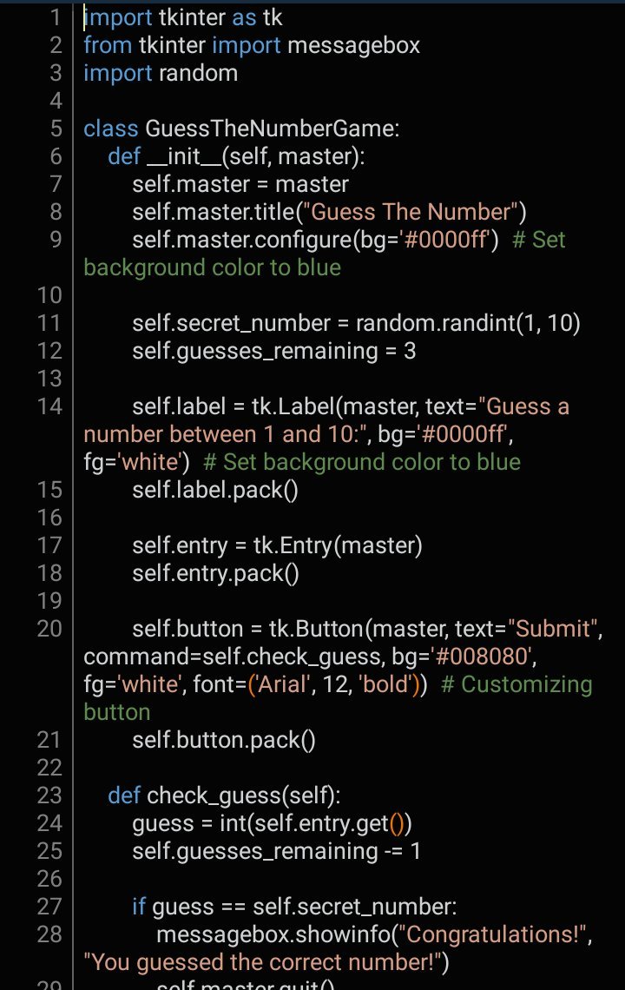

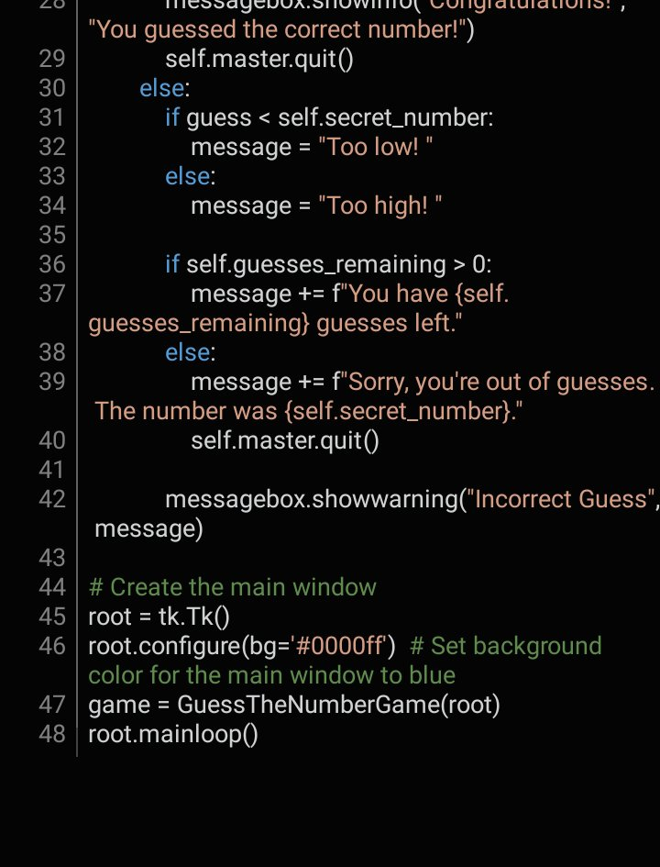

* 1. **OUTPUT**

