MQQT – Message Queuing Telemetry Transport

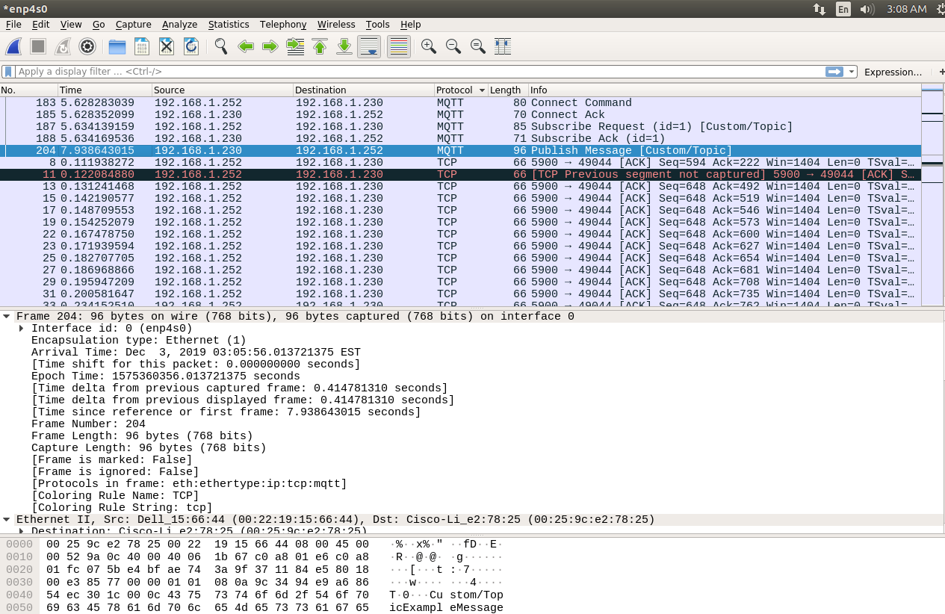

Let’s break it down.

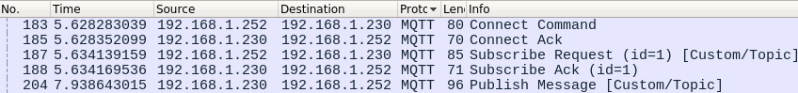

In this example, 192.168.1.230 is a Dell desktop running Ubuntu Linux, connected via Ethernet. It is running the Mosquitto broker server and also our publisher client.

192.168.1.252 is a Raspberry Pi running Raspbian Linux connected via wifi. It is running the subscriber client.

Since these packets are sorted by time, we can read the Info section and check it against the message types from slide 83:

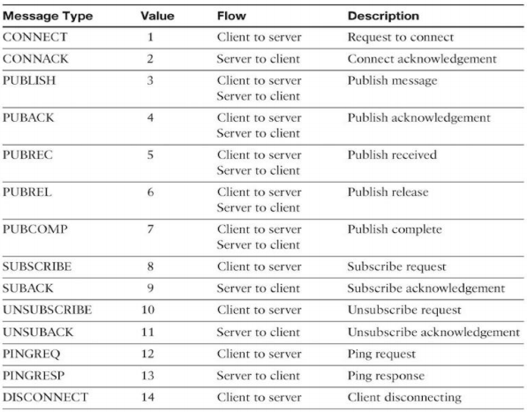

1. We start with the CONNECT command as the Raspberry Pi client connects to the desktop.
2. This is is acknowledged with a CONNACK/Connect Ack message back from the desktop.
3. The Raspberry Pi then tells the broker on the server the subscription topic it wants to hear about. In a SUBSCRIBE message In this case the topic is literally “Custom/Topic”.
4. The desktop again sends an acknowledgement back to the Pi as a SUBACK.  
     
   Note: there are likely many pings and ping responses going on under the hood, but a typical use case will be focusing on the sub/pub model and not simple pings.



The Source is





Expanding these we get:

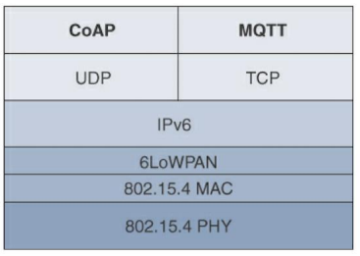

Source: Prof. Nof Abuzainab, ENPM 809F: Internet of Things Lecture 5: RPL Security + Application Protocols for IoT, slide 63.

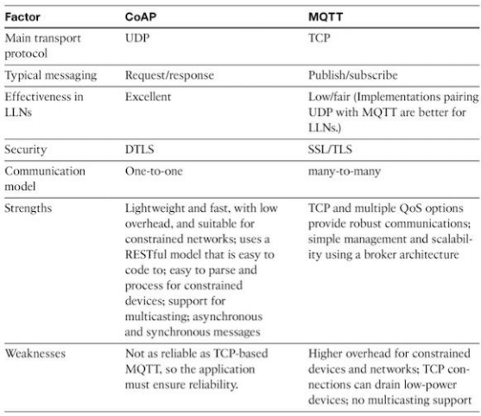

Source: Prof. Nof Abuzainab, ENPM 809F: Internet of Things Lecture 5: RPL Security + Application Protocols for IoT, slide 91.

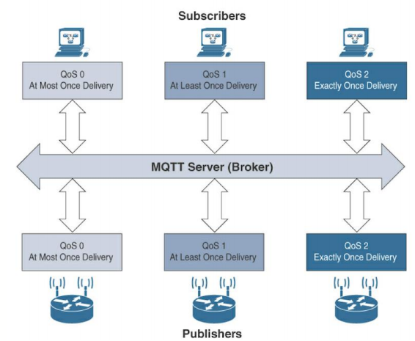

Source: Prof. Nof Abuzainab, ENPM 809F: Internet of Things Lecture 5: RPL Security + Application Protocols for IoT, slide 90.

Pub/sub is better for iot because lower overhead

Source: Prof. Nof Abuzainab, ENPM 809F: Internet of Things Lecture 5: RPL Security + Application Protocols for IoT, slide 92.

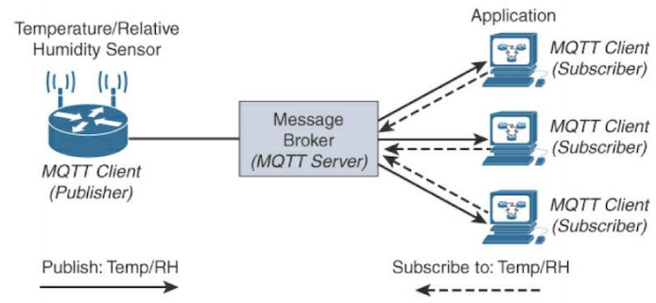

TODO: QoS

Show size difference with http

What was MQTT originally named for

Source: Prof. Nof Abuzainab, ENPM 809F: Internet of Things Lecture 5: RPL Security + Application Protocols for IoT, slide 80.

TODO:

QoS

Mention that payload is up to 256 megs 82

LEDs/Buttons

Disconnect command

Discuss size

github

Install wireshark, mosquitto on laptop

Make sure things auto connect to phone hotspot

virtual pub client

virtual sub client

selective sub

Does changing the QoS change the timing?