

**CAR RENTAL SYSTEM**

High Level Design & Low Level Design

**Document Control :**

|  |  |  |  |  |  |  |  |  |
| --- | --- | --- | --- | --- | --- | --- | --- | --- |
| **Project Revision History** | | | | | | | | |
|  |  |  | |  |  |  |  |  |
| **Date** | **Version** | **Author** | **Brief Description of Changes** | | | | **Approver Signature** | |
|  |  | GROUP 8 |  | | | |  | |
|  |  |  |  | | | |  | |
|  |  |  |  | | | |  | |

**1.Introduction**

Car Rental system is a novel business model which allows customers to borrow cars either for personal use or for any official/business purposes. Car Rental is a vital service in our country as not many people have cars and rely on public transport for any kind of travel. The use of public transportation is convenient as some may argue, but it’s not always feasible.

In that case, comes Car Rental service. Car Rental service tackles the problem of waiting in lines for public transport, avoids the long rushes of public transportation, allows the user to travel at their convenient times as they do not have to rely on the timings of public transport. Allows flexibility in travel plans as the user can practically go to their destination without any substantial detours.

This project aims to tackle these pain point by implementing a Car Rental service in order to create a sustainable application which alleviates the problems of the customers.

* 1. **Key Project Objectives**

To build a Car rental System which includes both Admin and Users.

**1.2 Project Purpose**

To create a system for a car rental, which helps users to book car easily and also helps the admin to manage the car rentals smoothly without much efforts and confusion. The most important part of this system is dynamic flow between user and admin interface and generating the invoices for users after each trip.

**1.3 Project Scope**

The scope of this project is as follows

* A system to keep track of the cars and the customers, provide them easy functionalities for both.
* The car rental system to keep detail records of both cars and the customers, and also the duration they rent car as well as the type of car they rent.
* The system will be mainly design for small a company that renders it car rental services to customers.
* This system will have the ability to generate and print invoice for each successful transaction.
* Hierarchy of Access
* The system will have two levels of access
  + The Administrator
  + Customer.

**1.4 In scope**

1. Renting the cars
2. Update and manage user and car details
3. Maintaining booking details
4. Generating invoice.

**1.5 Limitations**

The Limitations of our Project are:

* User is not verified while returning of the car
* Payment Process could be developed to the current system.

**1.6 Functional Overview**

**User**

These users are general customers of this Car Rental System. Anyone can create their accounts through registration by adding their personal information in it. After successful registration user log in with valid email and password. If the person is an existing user, then they can directly go for login and can access the services.

***Display car:*** This function enables users to see car details either for a particular type or all the types of cars.

***Car Reservation:*** After selecting the car user can reserve the car through this option by providing the travel information.

***Returning Car:*** By entering valid car id user can return the car and update the booking status.

**Admin**

Admin is the superuser of this Car Rental Service and can directly login to the system and he has the credentials to add or delete or update all information regarding cars and users.

***Adding Car Details:*** Admin has the credentials to add car details of new car.

***Modify Car Details:*** Admin can able to modify the existing car details. Admin will update all the information regarding the car bookings and according to that display the available cars list after each car reservation and returning.

***Deleting the Car Details:*** If any car goes out of service Admin will delete the car details from the records.

***Searching Car:*** By entering valid car id which exists in the records, admin can search the car details.

***Generating Invoice****:* A car rental invoice is a type of bill that's delivered either in-person or via email. It's usually sent to customers of a rental car service center that rented a motor vehicle for one or multiple days. The cost charged to clients will depend on the following factors: Type of vehicle chosen.

**2.BLOCK DIAGRAM:**

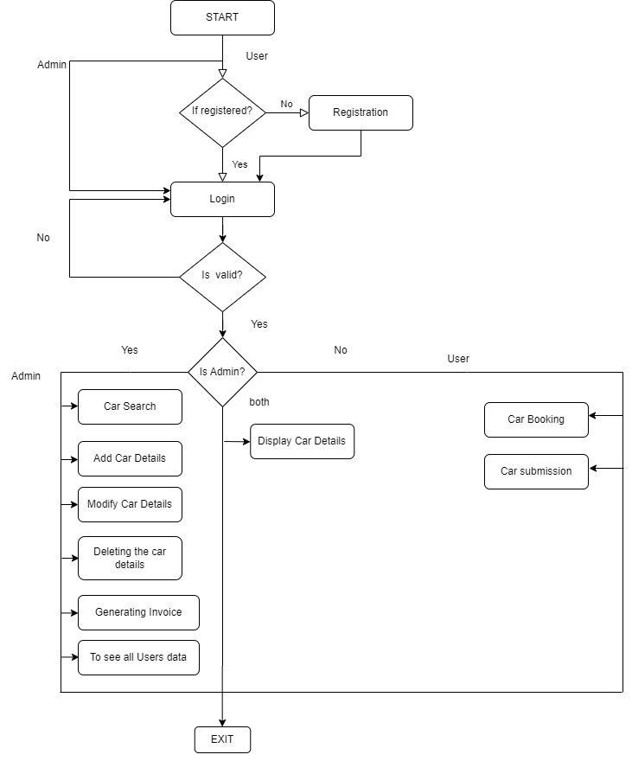

**3. FLOW CHART**

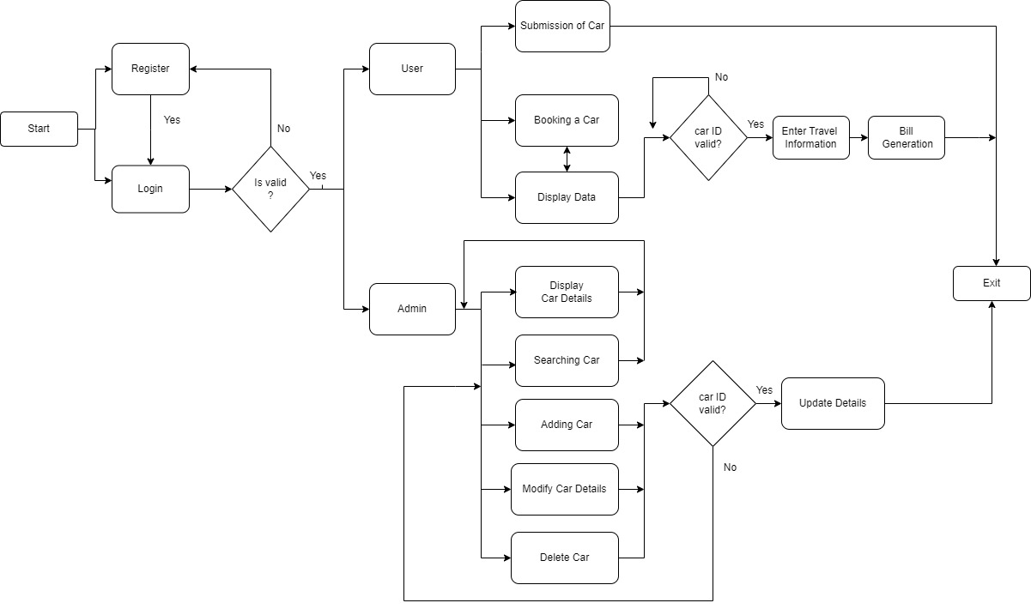

**4. DESIGN OBJECTIVES**

**Admin**

1. using login() ,Creating login of the system.

2. using getdata(), Gets data pertaining to the cars.

3. using putdata(), puts the data of the cars into respective domains.

4. using modify(), to modify the car information.

5. using login_admin(), to login the admin account

6. using read_userdata(), to read the data inputted by the user

7. using add_car(), to add a new car

8. using display_car(), to display car.

9. using search_car(), to search car.

10. using modify_car(), to modify car.

11. using delete_c(), to delete the contents of the file

12. using do_work(), to allow the admin to select the car choices

**User**

1. using check_user_existence(), to check whether the user is present

2. using Register(), to register a new user

3. using show(), to show the car.

4. using book(), to book the car.

5. using unbook(), to unbook the car.

6. using bill(), to generate the bill

7. using display(), to display booking status

8. using do_user_work(), to allow user to select their choice

**5.Environment Description:**

**UBUNTU**: Ubuntu is an open-source operating system (OS) based on the Debian GNU/Linux distribution. Ubuntu incorporates all the features of a Unix OS with an added customizable GUI, which makes it popular in universities and research organizations. Ubuntu is primarily designed to be used on personal computers, although a server edition does also exist.

**CPP language**: C**++** (pronounced "C plus plus") is a [high-level](https://en.wikipedia.org/wiki/High-level_programming_language) [general-purpose programming language](https://en.wikipedia.org/wiki/General-purpose_programming_language) created by Danish computer scientist [Bjarne Stroustrup](https://en.wikipedia.org/wiki/Bjarne_Stroustrup) as an extension of the [C programming language](https://en.wikipedia.org/wiki/C_(programming_language)), or "C with [Classes](https://en.wikipedia.org/wiki/Class_(programming))". The language has expanded significantly over time, and modern C++ now has [object-oriented](https://en.wikipedia.org/wiki/Object-oriented_programming), [generic](https://en.wikipedia.org/wiki/Generic_programming), and [functional](https://en.wikipedia.org/wiki/Functional_programming) features in addition to facilities for [low-level](https://en.wikipedia.org/wiki/Low-level_programming_language) [memory](https://en.wikipedia.org/wiki/Memory_(computing)) manipulation.  
**gdb**: **gdb** is the acronym for GNU Debugger. This tool helps to debug the programs written in C, C++, Ada, Fortran, etc. The console can be opened using the **gdb** command on terminal.