myStatus

Jake Bailey

rjacob@cs.washington.edu
Emily Chien
University of Washington
Seattle, WA 98195
eechien@cs.washington.edu
Chuong Dao

chuongd@cs.washington.edu

ABSTRACT
We present myStatus, a mobile health app allowing clinicians to collect self-reported health data from patients without compromising patient privacy. While some solutions exist for collecting longitudinal health data from patients, they are cumbersome and require significant patient involvement. In patients dealing with clinical depression, severe problems can develop in the 2-8 weeks that pass between appointments. If clinicians could detect these problems as they happen instead of at the appointment (when they have already become a severe issue), recovery times may improve. The application presented in this paper provides a much easier to use and less intrusive interface for patients, while also protecting private information. myStatus is an Android application for taking surveys provided by physicians to self-evaluate their condition such as depression. Users get reminders about when to take the surveys so they don’t have to remember themselves. The long-term vision of the project is a general mobile health solution useful for more than just depression, which allows for a stronger line of communication between patient and clinician.

Categories and Subject Descriptors
General Terms
Keywords

INTRODUCTION
Our application started out as a method for depression care. Among patients who have sought depression care, only 50% of those referred to a mental health professional follow through with that referral³. Many do not have more than one visit and 50-70% of patients do not have a full response to the first treatment plan. A significant part of treatment is that the patient has to be willing to be engaged but part of the reason for unwillingness is that the effort is too great when patients aren’t motivated. Our application seeks to enforce patient self-monitoring in a way that’s not intrusive to everyday activities and does not take an undue degree of effort.
The Patient Health Questionnaire⁷ (PHQ-9) is a nine question survey used by clinicians to monitor the severity of depression. To help clinicians be effective in their treatment, they request their patients to fill these out at regular intervals. Instead of filling them out only when a patient comes in for an appointment, clinicians can have patients fill it out through our application. This then allows immediate help for managing symptoms or finding support.
Another issue clinicians are seeing is that patients with prescriptions either always take them, refuse to take them, or want to but sometimes forget. Also, if a patient has multiple prescriptions it can be hard to remember what they look like. Users also do not want unwanted eyes seeing what prescriptions they are taking or even that they’re using an application to treat depression or some other condition. So our application has to keep their data secure.

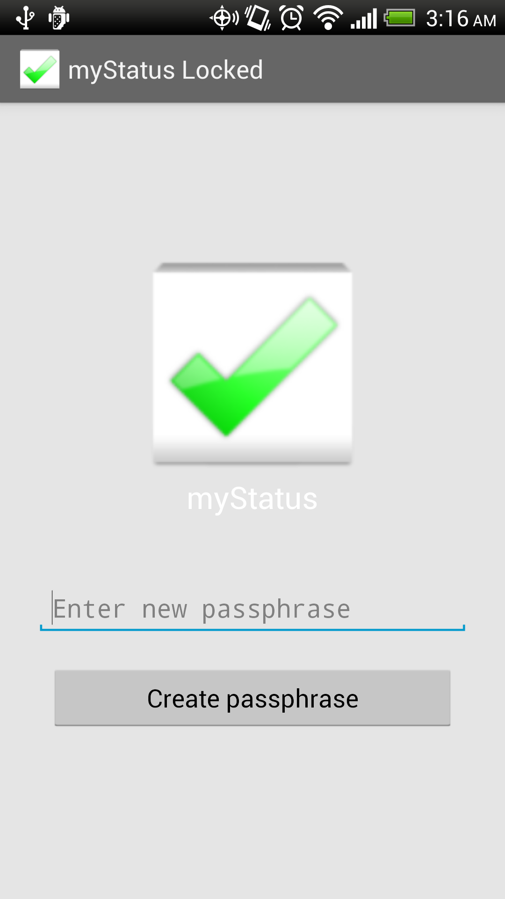
Figure 1: myStatus lock screen and start screen

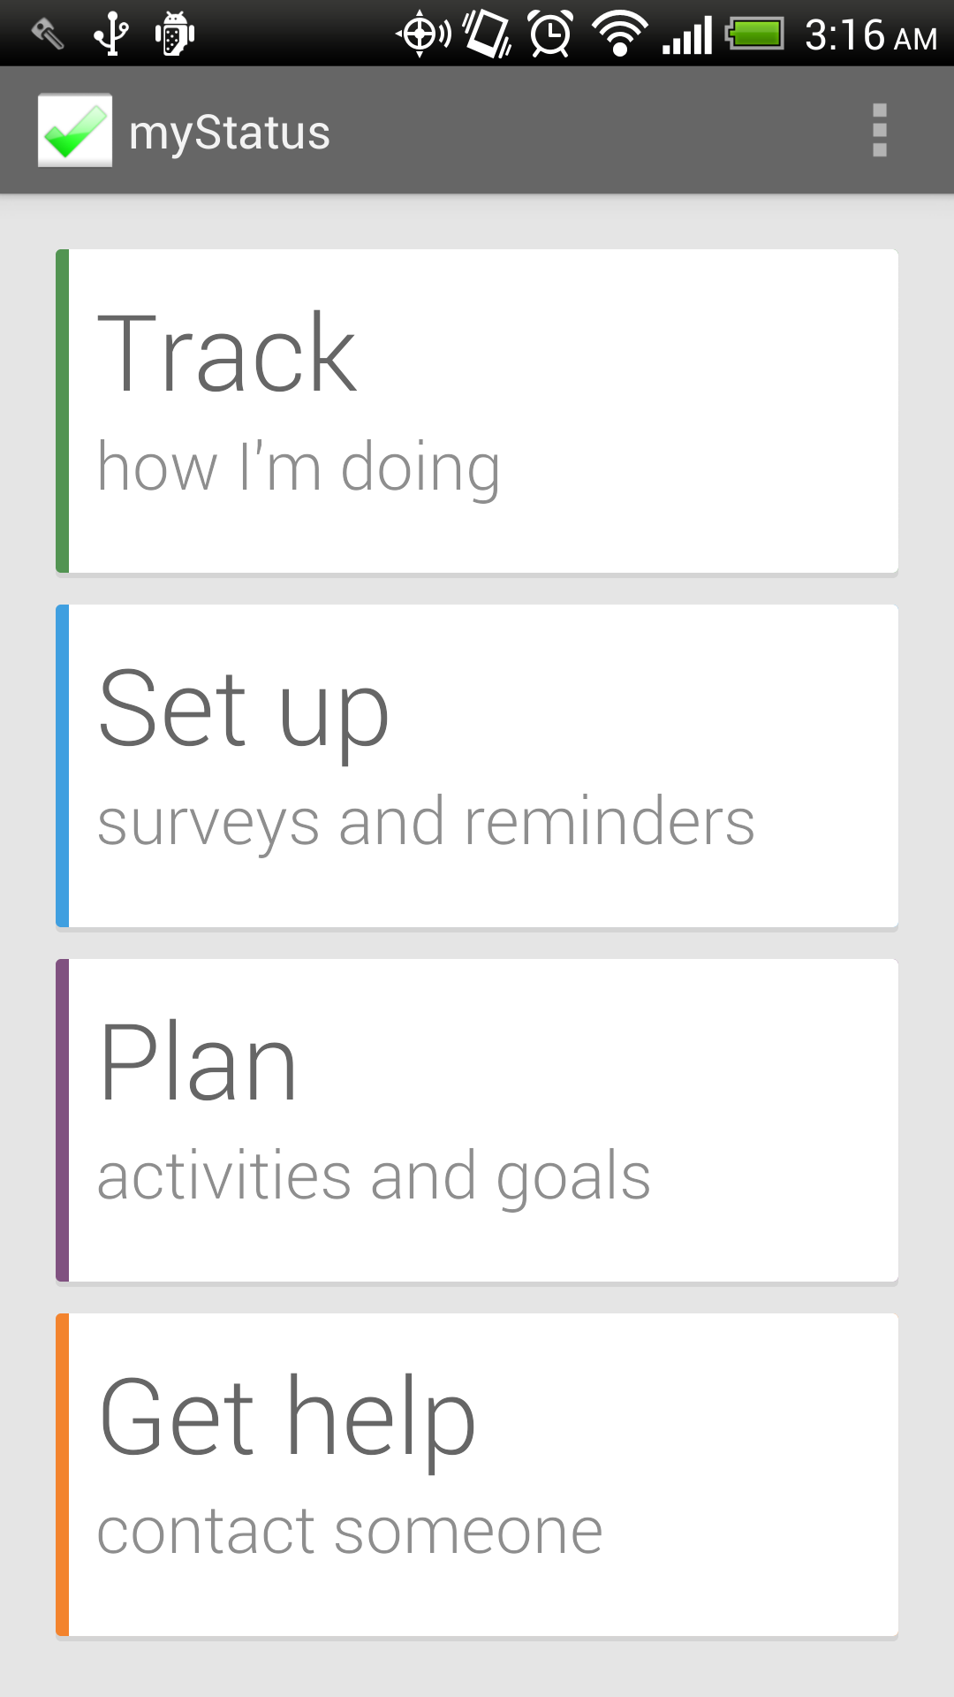
Figure 2: myStatus main menu

The basic idea for our application is that users download surveys their doctors advise them to. By setting up reminders, users will be notified when there are surveys to take; some of which need to be taken once a day, once a week, etc. Our application keeps track of when surveys were last taken and determines which ones need to be filled out at the time of notification. Addressing the issue of prescription tracking, users can add their prescriptions and set up reminders. To keep the data secure and users safe from prying eyes, myStatus has a one-time password creation to discourage unwanted users from access. When there has been five minutes of inactivity, or the user navigates away from the application, it will lock. Notifications that can be seen without logging into myStatus, do not reveal anything about what the application is being used to treat.

RELATED WORK
Patient self-management tools can be categorized as one of the following: subordinate, structured, collaborative, or autonomous⁵. Subordinate tools include home surveillance monitoring. Structured tools refer to notifications through other devices. Collaborative tools include online interventions and patient education materials. Autonomous tools do not require regular participation or physician input. Clinicians have mostly focused on collaborative tools thus far. Our current version of myStatus belongs more to the structured category based on taking surveys when prompted by notifications but because the survey data is sent to Aggregate it is also collaborative.
“PTSD Coach”⁶ is a mobile application, which allows users to assess their state through a single seventeen-question survey. By taking that survey over a period time, a history is developed that the user can track. The user can manage symptoms, but this includes only a set of eight, all of which direct the user to the same sort of exercises in self-management such as deep breathing. Another feature it includes is finding support, either from crisis resources, personal contacts or professional care. They can also learn more about PTSD. One major drawback is that anybody looking through a user’s applications can see that the user is monitoring her depression, which could possibly lead to the user being harmed. Our application removes that risk not only with its name “myStatus” which could be for anything, but also by not revealing anything in the notifications either. By having a login requirement, we also reduce the risk of exposure.

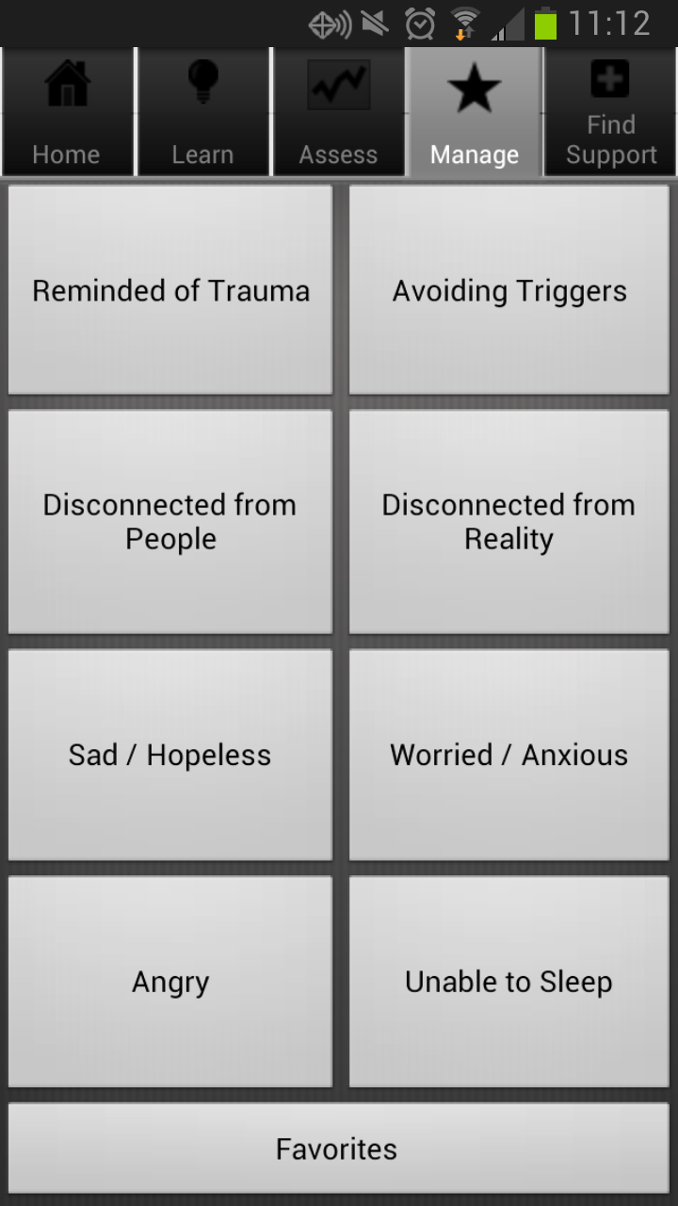
Figure 3: PTSD Coach symptom management
“eCBT Calm”⁴ is an application that evaluates a user’s stress level through a series of questions and teaches them relaxation skills. While this is great for self-management, it provides no collaboration between a patient and physician. By sending survey data collected in myStatus to a server, physicians can track a patient’s progress along with them. This way if a patient does not follow through with appointments, physicians are, in a way, still in contact with their patient.

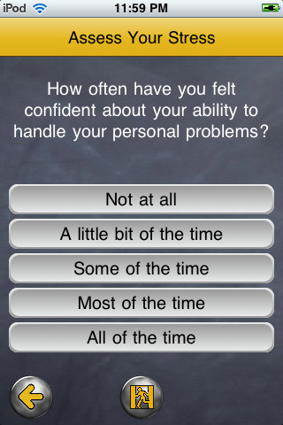
Fig. 4: eCBT Calm question sample
A different form of mental health monitoring applications includes headbands that monitor a user’s EEG connected to his mobile device¹. While this would provide constant data from a patient it can be cumbersome. We want to give the user the least amount of reasons not to use our application. We want it to be subtle and quick but also provide aid when needed.

APPROACH

Existing Technologies Used
We designed our system with the goal of collecting information, storing it securely, and submitting it automatically to a dedicated server. For our solution, we chose several existing technologies appropriate for this design and integrated them with new components we developed. The myStatus components we engineered are described in the following section. The existing technologies we used, XForms, Open Data Kit, SQLCipher, CacheWord, and SpongyCastle, are described below.

XForms
XForms is a standardized XML format for specifying form data and appearance. XForms provide a relatively simple data processing model that makes it easy to describe common data manipulation tasks, including constraints on inputs, calculation based on inputted data, and branching logic. The XForms format is also the one used by Open Data Kit, which also provides an easy-to-use, Excel-based XForms specification tool called XLSForm.

Open Data Kit
Open Data Kit is a free and open source set of tools designed as solutions for mobile data collection. Our application is based on ODK Collect, an Android application used for rendering surveys, collecting data, and submitting collected data to a server. Using an existing data collection tool allows us to support rich and complex forms that we would otherwise not have been able to support. Embedded media, branching logic, and a variety of data entry widgets can give clinicians a great deal of freedom in creating surveys for their patients. Since Collect is designed as a tool for researchers, it provides a lot of options and settings not necessary for our use case, and our system attempts to streamline the application for use by patients.
We also make use of ODK Aggregate, a server and data repository in the ODK tool set. Using ODK Collect's components, our application can download surveys from and upload survey responses to the Aggregate server. Aggregate also provides a web interface with data visualization and export tools. For our solution, Aggregate serves as the clinician interface, allowing clinicians to make surveys available to patients and review submitted patient data.

Security Libraries
Due to the fact that myStatus contains health-related patient information, security is a major concern. myStatus stores data in two formats: SQLite databases (for form and submission metadata) and files in the /sdcard directory of the Android device (for forms and form media). Since this directory is unprotected, anyone with a micro USB cable and ADB (Android Debugging Bridge) installed on their computer can view all myStatus data with a few Linux and sqlite3 commands. In addition to protecting the raw data, our solution needed to involve a method of ensuring that only the patient could access their data through the application front-end.

SQLCipher is an open-source library for database encryption, which provides transparent 256-bit AES (Advanced Encryption Standard) in CBC (Cipher Block Chaining) mode. Our application makes use of this library to encrypt all SQLite databases. With this feature, anyone who has access to the device through ADB can no longer retrieve information from myStatus databases without the user's key.

In order to access these databases, our application needed to store a key derived from a user login password. We decided to use the CacheWord library provided by the Guardian project for maintaining and providing this key. The primary features of this library are strong key derivation using PKDF2 (Password-Based Key Derivation Function 2) and highly secured storage using AES-256. In addition, this library also provides a configurable timeout, which is used by myStatus to lock the app after a certain amount of idle time, at which point the user is prompted to type in their password again.

Lastly, myStatus uses the SpongyCastle library for encrypting media files as well as form XML files. The SpongyCastle library can make use of the derived secret keys provided to it by the CacheWord service to encrypt and decrypt files. Even if a curious user has access to the Android devices and uses ADB pull to get the media and xml files, they cannot see, watch, or listen to them at all since the files are encrypted.
The time for encryption and decryption can be lengthy for large files and each file must be decrypted before being used, so we create a folder for storing temporary decrypted files, which can be reused for a certain amount of time. When the timeout is signaled from the CacheWord service, all the data in the temporary folder is removed before the application locks. In general, all files stored by myStatus are encrypted, and a correct password is required to get the derived key for decryption.

Architecture
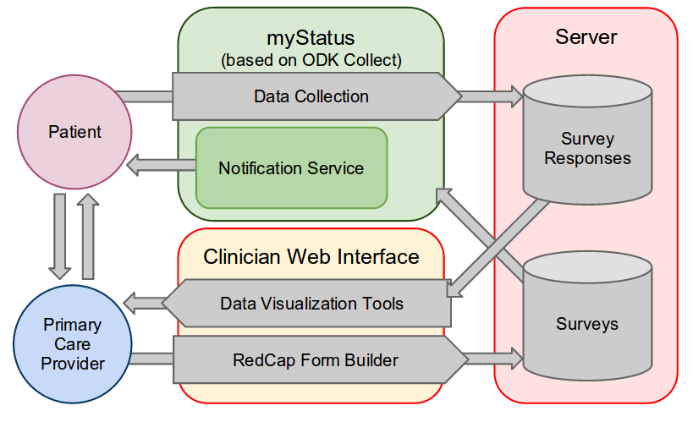
Figure 5: myStatus downloads surveys from a server such as ODK Aggregate, notifies the user to fill out surveys, and submits survey responses to the server, where they can be viewed by clinicians
Our application, being based on ODK Collect, uses the same model for data collection and aggregation as Collect and Aggregate. Namely, the mobile application downloads surveys from Aggregate and submits survey responses automatically, while the Aggregate web interface allows clinicians to view and visualize submitted data. What differentiates our application from Collect is its simplified interface, its ability to generate notifications when relevant, and its additional tools for patients with chronic medical conditions.

Data Collection
The primary feature of the application is the ability to collect status information from patients. Our solution for collecting data from patients was to use ODK Collect's form entry components, but since Collect is not designed for longitudinal data collection, it provides no mechanisms for managing what surveys need to be responded to and when. Since some forms are only relevant after a given period (the PHQ-9, for example, is intended to be given no more frequently than every two weeks), we provide notifications that alert the user when surveys are due, and a method of specifying when a survey needs to be responded to.
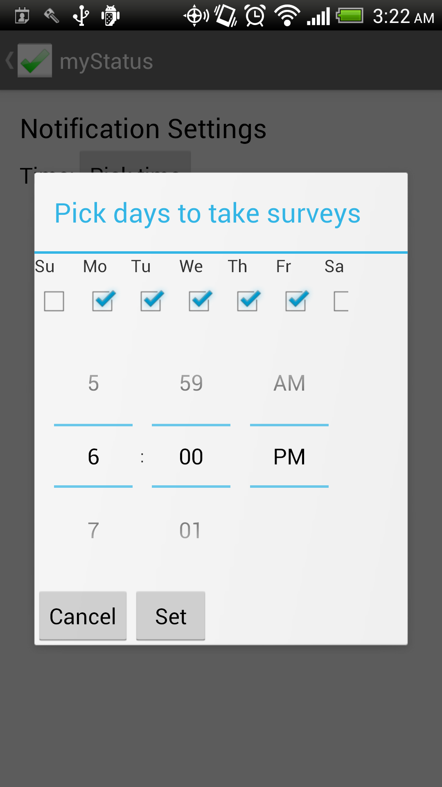
Figure 6: Users can specify what time of day and what days they would like to receive a notification about due surveys.
Since our application needs to be as unobtrusive as possible, we give the user control over when they would like to receive notifications. myStatus allows users to set which days of the week they would like to receive a notification, and what time of the day would be convenient (Figure 6). At these times, the application determines whether any surveys are due, and if so, generates a notification. The notification includes a snooze option, so if the user is busy at the time they set, they can temporarily dismiss the notification and be reminded again shortly after.

The notion of when a survey is due is determined by a survey's predicate, a non-standard attribute we add to the data model of myStatus XForms. The predicate is one of a few simple expressions indicating when the survey needs to be responded to. For example, the predicate for the PHQ-9, which is relevant at most every two weeks, is "daysSinceLastResponse:14". Also supported are predicates for once-only surveys (for unchanging information like medical history) or delayed surveys (for information that will only be available in the future, like future parts of a longitudinal survey).

Clinician Interface
Our system has made no improvements on the interface already provided by ODK Aggregate and other ODK tools. In its current state, the system requires clinicians to develop forms using ODK Build or XLSForm, upload them to Aggregate, and view survey responses using Aggregate's data visualization tools. Clinicians can also use Aggregate's export features to download all collected data as a CSV file.

Prescription Reminders
Patients who take a large number of prescriptions or have trouble remembering to take medications could make use of a pill reminder application. While such applications exist, they don't provide the privacy or security that myStatus provides. Integrating these reminders into our application prevents exposure of potentially sensitive data regarding a patient's pill regimen.
For each medication, a patient can record the medication type, take a photo, and set reminders. Each reminder (after the user has bypassed the lock screen) displays the recorded information about the medication and the quantity to be taken.

IMPLEMENTATION

At first, we tried to use to implement myStatus using ODK as a foundation library. However, we had faced some difficulties in utilizing ODK without modifying it. For instances, it’s quite a challenge for encrypting all the forms and media files of the surveys obtained through the ODK apps without knowing when it is get downloaded to the mobile device. Also, in order to make our apps generate notification based on the last completion time, we need to be able to access and adding extra information to the database of the survey XForms. It is also quite difficult to add support for longitudinal studies in the future as well as using ODK Collect as library will cause some unexpected interference with the original ODK Collect application, which can be downloaded from the Google Play Store. Therefore, we decided to modify ODK collect source code and integrate with myStatus source code. While modifying the open-source ODK project, we tried to make minimal changes as well as modularize our changes so that it can be easy to contribute back to the original project. Furthermore, we also documented our additional functionalities informatively to avoid confusion for future use.

One of the major functionalities of myStatus is the ability to generate notifications based on user configuration and survey types (daily survey or one-shot survey) and to generate reminder in helping user manage their prescriptions. We also noticed that the way notification get generating should be friendly to the user as they do not want to be bothered too many times in a day. We looked into different applications in the market for different time of notification models such as allowing user to set notification times as calendar events which will show up in Google Calendar application of the Android device. Another model we had considered is allowing user to set multiple notification times per day of the week either before or after work. However, after having a discussion with Dr. Bauer about these ideas, we decided to simplify our notification model, which permits users to set what time of days and which days of week they would like to receive the notification. This has the disadvantage of requiring that notifications always arrive at the same time, but we decided that having a "Snooze" button on notifications was a sufficient compromise. Also, the “Dismiss” button appears with the generated notification also allow user to keep myStatus from re-generated notification. In order to make the notification generating at the appropriate time, we implemented our own model which allowed user to specify some conditions: days between responses to a periodic form (e.g. PHQ-9 should be responded to every 14 days, one-off forms (first time setup, feedback surveys) and forms with a time delay. The two figures below illustrated how the notification looks like and by clicking on the notification the user would get prompt to the list of surveys needs to be completed.

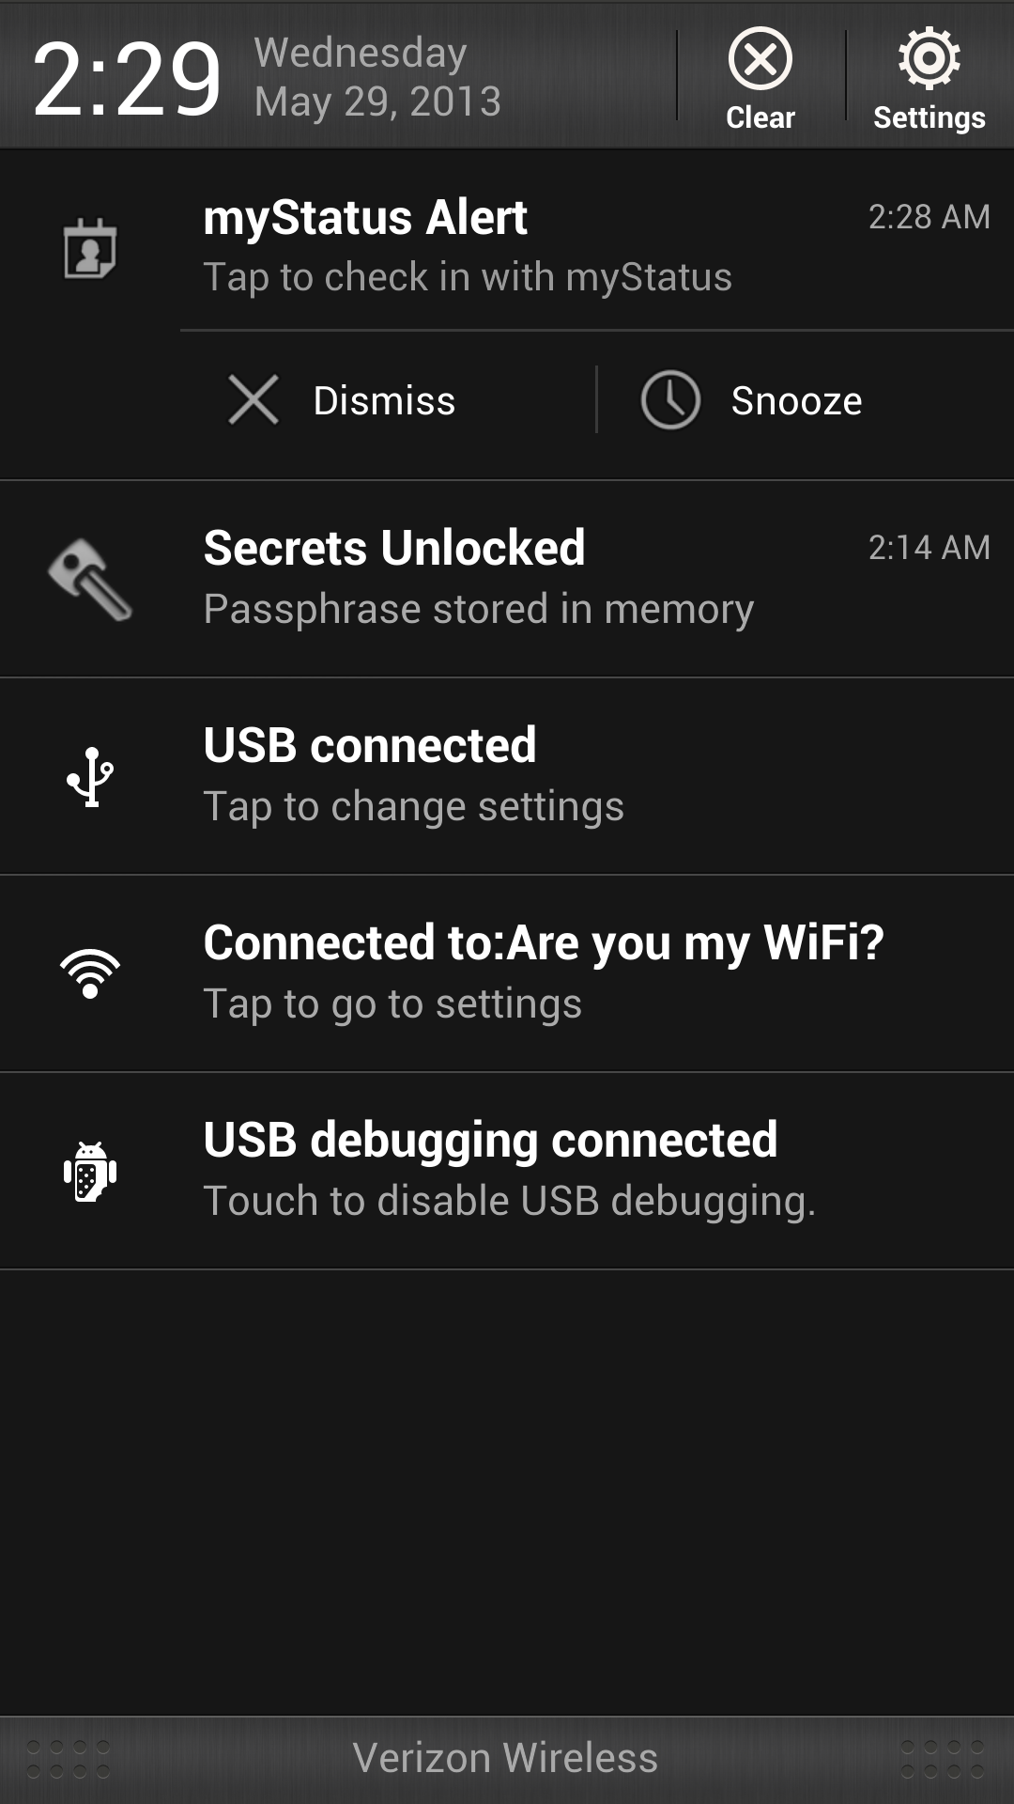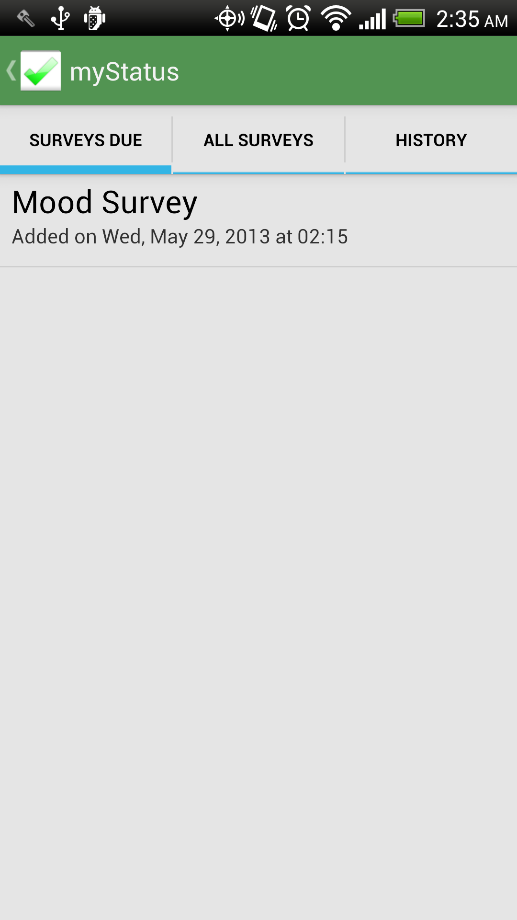
Figure 7: Generated Notification prompted to Due Surveys List
Clicking on one of the due survey on the list will prompt the user through the process of answering all the questions in the surveys as in figures below. Also, the completed forms will automatically send it to the Aggregate server specify in the URL setting page of ODK collect.

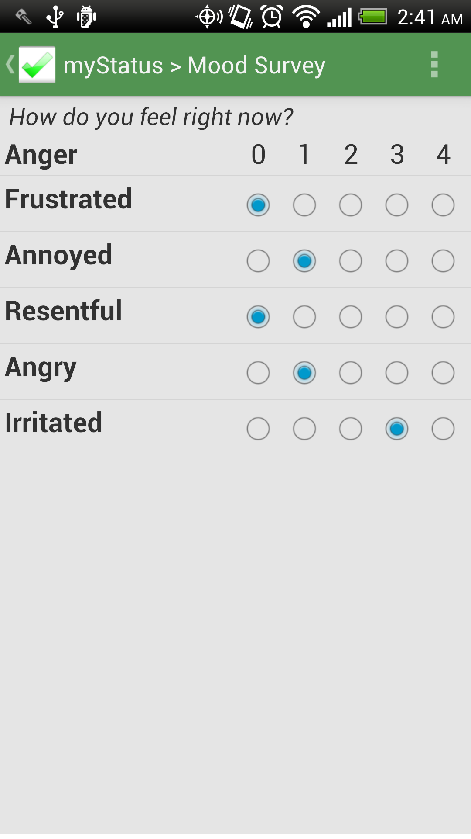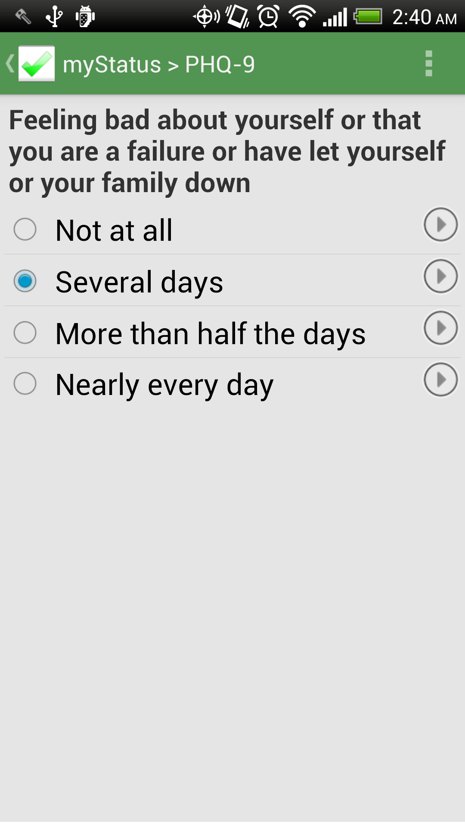
Figure 8: Sample survey questions
Furthermore, we also added a history feature, which allows user to view all of the surveys they have been completed as well as the status of them such as incompletion, submitted. Also, the information in the surveys could be summarized in tabular format, which helps user keeping track of their records. Figure 9 shows the example of how the table information looks like as well as how all the forms with different status marked with different notations.

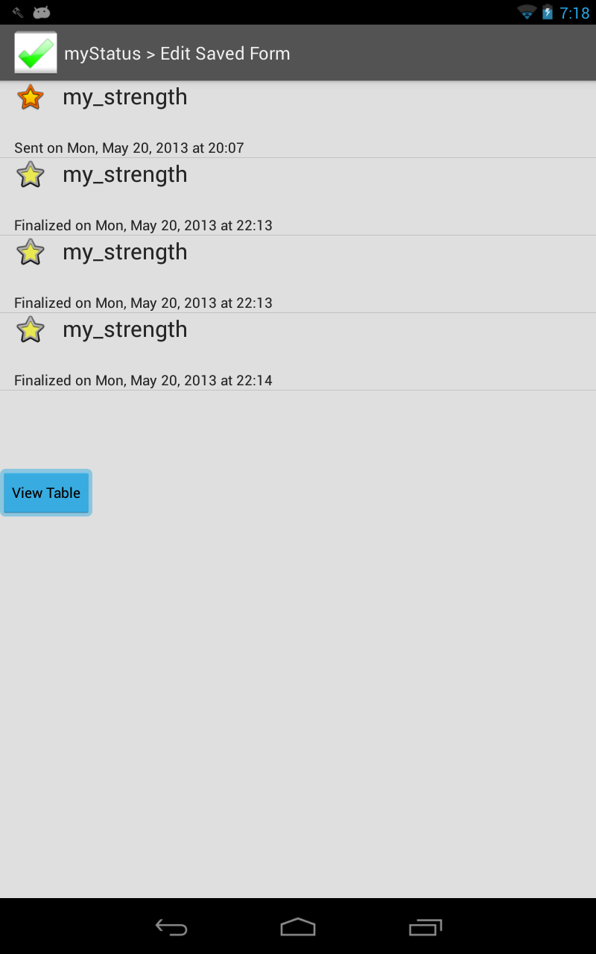

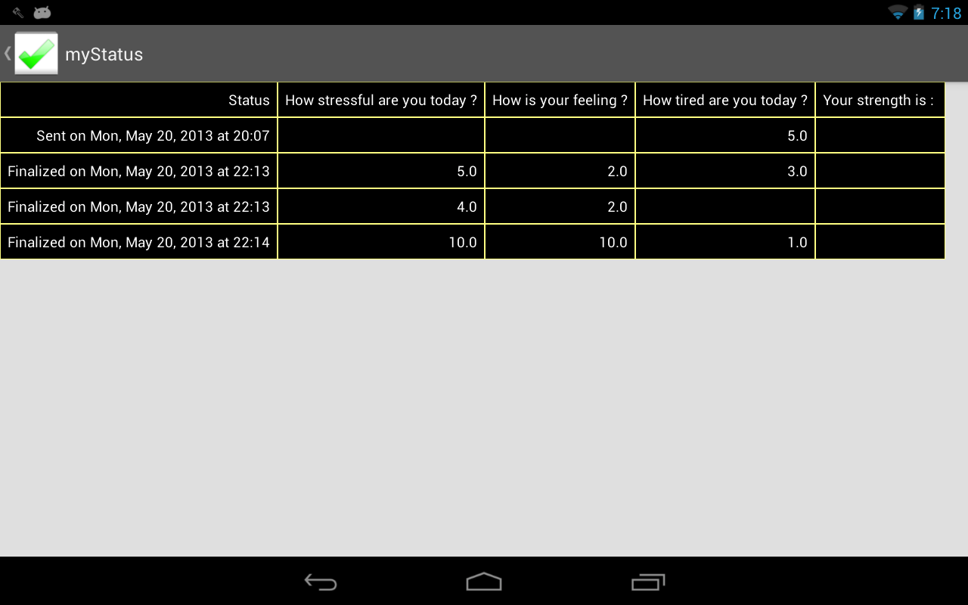
Figure 9: History view

Besides these basic features, we also added the extra features, which help user to manage their own prescriptions. This feature allows user to take the picture of their meditation, set time reminder for taking it.

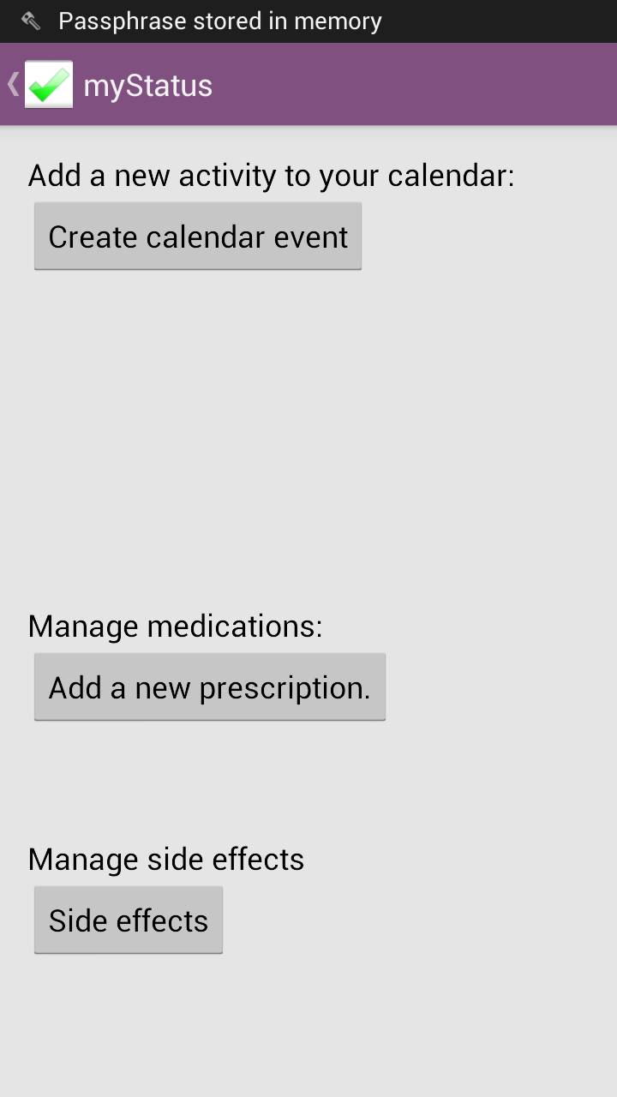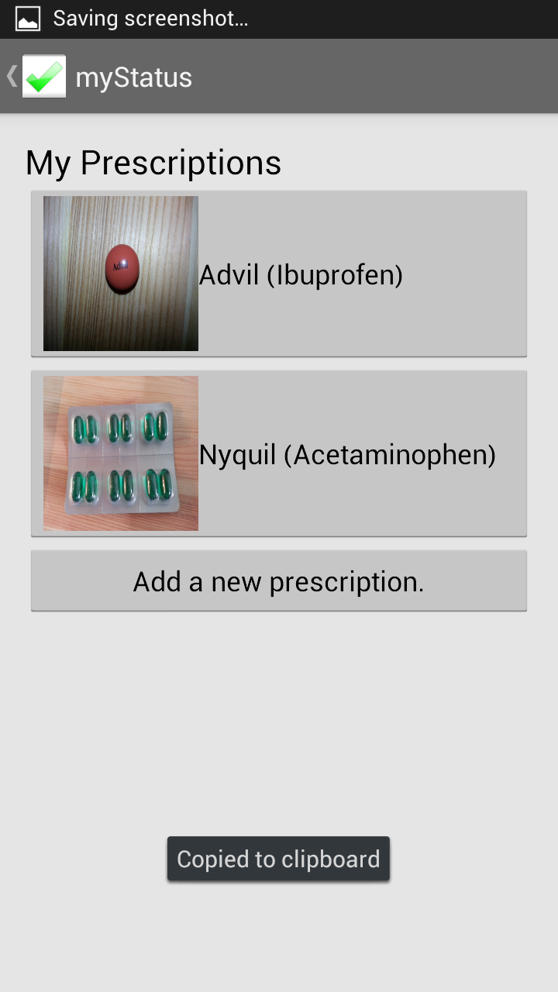
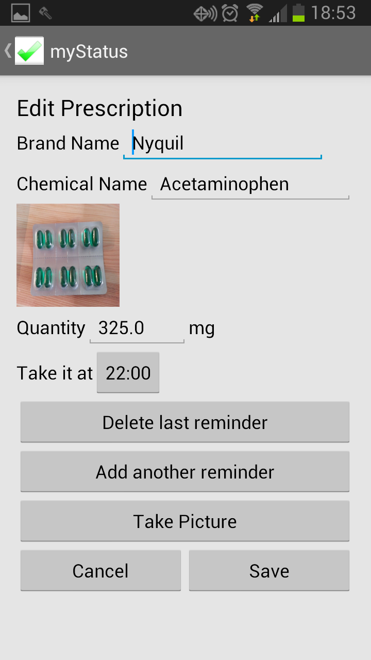
Figure 10: Manage prescriptions view

Lastly, we also added a help page to myStatus, which allows user to call their clinician and friends in order to ask for quick advice or for sharing some uneasy feeling.

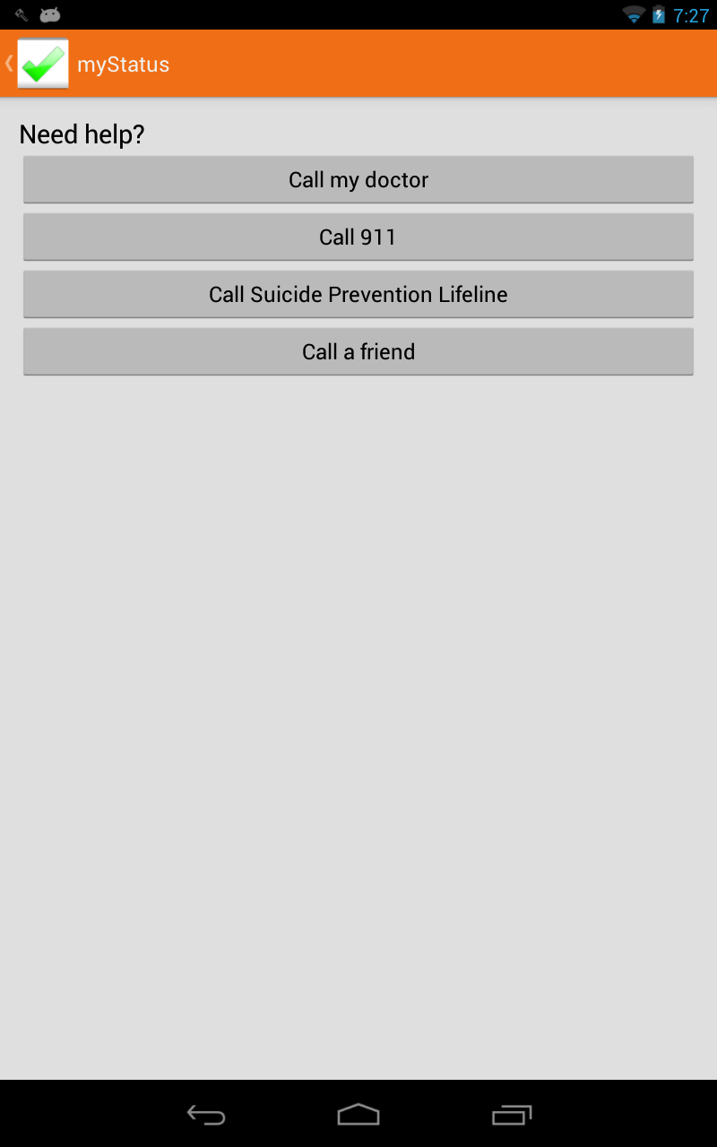
Figure 11: Get Help page

As mention earlier in the approach sections, we used SQLite Cipher library to encrypt our database using the derived key from the user password. The figure below shows how encryption database would prevent other curious people from viewing user data through SQLite commands in a terminal.

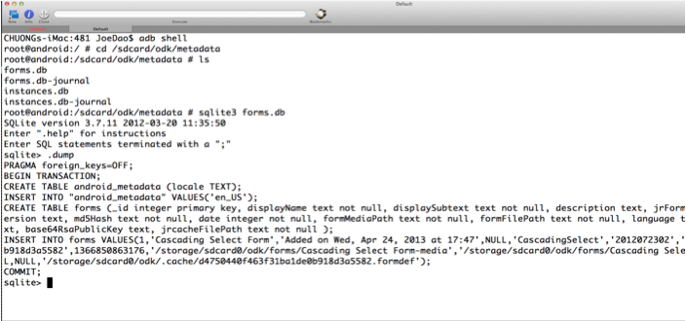
Figure 12: Without SQLite Cipher encryption for database – data is exposed
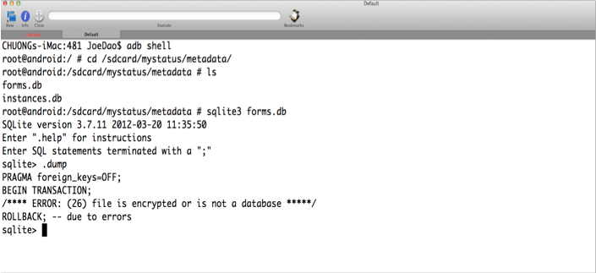
Figure 13: With SQLite Cipher encryption for database – data is not exposed

In the similar way, the Spongy Castle library provided a mechanism for encrypting the XForms and media files. Figures 14-17 illustrate how XForms and media files get protected through encryption. We had been trying to also change the name of the XForms in order to avoid other people to have any ideas about the content of the surveys. However, we still cannot change the media files name to prevent exposing the content. We think that it would be easier for the clinician or people who make the surveys to name the media files in some manner that would keep the information more secretive.

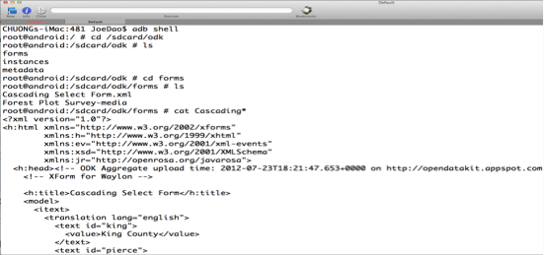
Figure 14: XForms without encryption

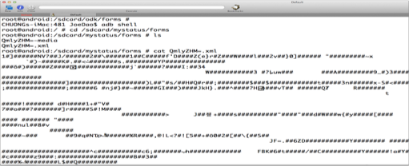
Figure 15: Adding encryption to XForms

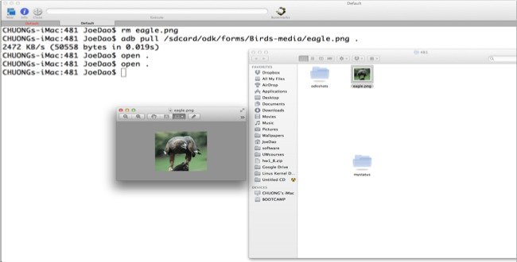
Figure 16: Pulling encrypted image data

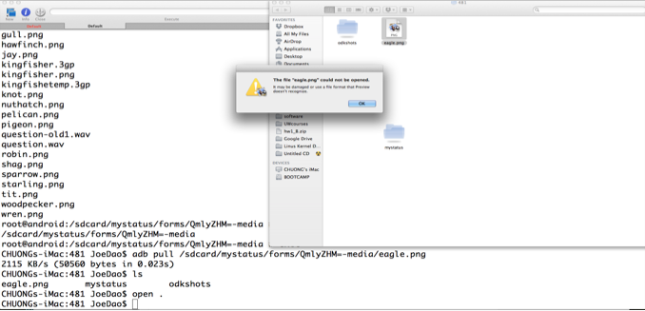
Figure 17: Pulling encrypted image data – cannot be viewed

EVALUATION
We did not have time for user testing during this quarter but we were able to get feedback while working with Dr. Bauer. Her main goal was to have the needed features she saw in other applications like the “PTSD Coach” and make sure they were exposed to the user in reasonable ways.

In terms of quantitative feedback, were we to go on with user testing, we would have to use surrogate users such as students and not real patients because of the lack of HIPAA Compliance. We would ask users whether they found the log in and encryption intrusive to their experience. We would also like to know if there was more information they’d like to get in their notifications.

In terms of qualitative data, we want to know if encryption is efficient and if access to the databases is efficient as well.

CONCLUSION AND FUTURE WORK
Continuing with this project we’d hope to add features for collaboration between patients and physicians. Physicians should be able to directly add which surveys to take to the app so that patients who may forget what they’re provider suggested do not need to find them. We would also like to see direct communication between the physicians and patients through the application.

Added features for self-management would include activity planning and goal setting. By encouraging the user to make plans to go out or get exercise, our application would promote symptom treatment. If the information was submitted to Aggregate so that the providers could see what activities were planned and accomplished the provider could track patients’ progress that way too.

For our history page we would like to see a graph of progress over time instead of the table. This way, users could see only the information needed to check their status. With surveys like the PHQ-9 only the final result is necessary to track improvement because the score is based on the total from the questions asked.

Currently there are a lot of setup details that aren’t obvious to users. A first time use walk through would help the user see these features. For example, they need to let the application know when a good time to be notified about surveys are and they should be notified about the length of time of inactivity the app allows before it is locked. The walk through could also guide them through the prescription management.

Were we to do this over, we would have cut out the security aspect of myStatus. This way we could focus on the collaborative side to deal with patient-physician communication. Security took up a good deal more time than anticipated and that time could have been used for giving the app more features that contribute to self-management. Securing patient data is always important but for the time frame we had it should not have been a priority.

At the beginning of the project when we tried to use ODK Collect as a library, we learned that with the way we were using it, making changes in it because we needed the data encrypted, this was not possible. Instead we had to make the least amount of changes possible to keep it reusable in case the writers of ODK Collect wanted to use our material.
myStatus is meant to be a mobile app encouraging collaboration between patient and provider while also allowing the patient to self-manage their condition. While our app lacks much of the collaboration we anticipated having, future work would prove it to be useful for these measures.

ACKNOWLEDGMENTS
We would like to thank Amy Bauer for her help with the design of our application. We would also like to thank Gaetano Borriello, Ruth Anderson, and Rohit Chaudhri for their instructional aid and input.

REFERENCES
- Bong, Kyeongryeol, Hyunwoo Cho, Sunjoo Hong, Taehwan Roh, and Hoi-Jun Yoo. "Wearable Mental-health Monitoring Platform with Independent Component Analysis and Nonlinear Chaotic Analysis." IEEE Xplore. Korean Adv. Inst. of Sci. & Technol. (KAIST), Daejeon, South Korea, 28 Aug. 2012. Web. 03 June 2013. <http://ieeexplore.ieee.org/xpl/articleDetails.jsp?tp=&arnumber=6346977&url=http%3A%2F%2Fieeexplore.ieee.org%2Fxpls%2Fabs_all.jsp%3Farnumber%3D6346977.>
- "Block Cipher Mode of Operation." Wikipedia. Wikimedia Foundation, 06 Jan. 2013. Web. 03 June 2013. <http://en.wikipedia.org/wiki/Block_cipher_mode_of_operation#Cipher-block_chaining_.28CBC.29.>
- Dr. Bauer, Amy. Personal interview. May 2013.
- ECBT Calm. Computer software. Mind Apps Llc, 20 Jan. 2011. Web. 03 June 2013. <https://itunes.apple.com/us/app/ecbt-calm/id356997070?mt=8>.
- Michael, Barrett J. "Patient Self-Management Tools: An Overview." Critical Mass Consulting, June 2005. Web. May 2013. <http://www.chcf.org/~/media/MEDIA%20LIBRARY%20Files/PDF/P/PDF%20PatientSelfManagementToolsOverview.pdf>.
- Mobile App: PTSD Coach. National Center for PTSD. United States Department of Veteran Affairs, Mar. 2011. Web. 03 June 2013. <http://www.ptsd.va.gov/public/pages/ptsdcoach.asp>.
United States. Agency Medical Directors' Group. The Patient Health Questionnaire. Pfizer, 1999. Web. <http://www.agencymeddirectors.wa.gov/Files/depressoverview.pdf>

APPENDIX

