**Ryan Britt**

* **Abstract:** 
  + This app is an advanced task manager that helps a user keep track of how long a task should take and how long it actually took them to finish. It does this while also providing them with aggregation of naturally occurring data such as the percentage of on-time completion, average time it takes per difficulty, etc. It provides the user with a list interface where they can determine what order to complete the task. Using a set of difficulty levels, the app will determine how long the task should take and then compare that to how long it takes the user to complete the task (set when the user marks the task as completed). The app will take data created by the user (start/end time and other data) and allow reports to be created which will tell the user how long, on average, certain difficulties of tasks are taking them and will suggest re-allocating time based on whether or not the user is exceeding the estimated time needed for a task.
* **Modules:**
  + Movable list of tasks
    - Status indicator as to whether started or not.
  + Reports
    - Overview
      * Percentage of tasks completed on time
      * Percentage of tasks late
      * How many tasks have been completed
      * How many tasks are in progress
    - Recommendations
      * Time taken per difficulty
        + Recommendations for different time appropriation
  + Settings
    - Change difficulty time allocations
* **Database:**
  + External
    - There will be no need for an external database
  + Internal
    - 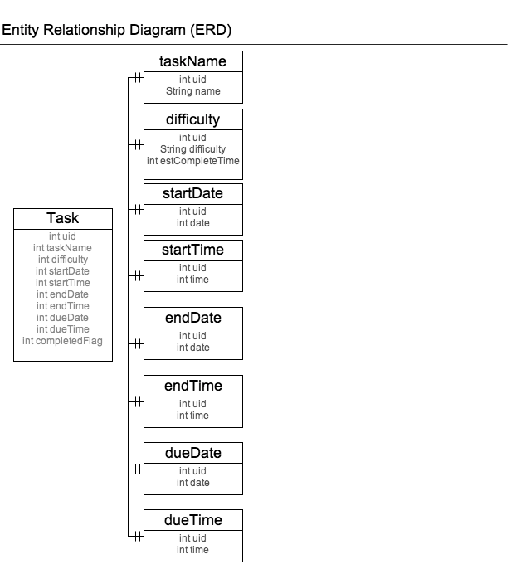
* **Mobile Features:**
  + None other than touch and ease of use of mobile devices.
* **Schedule of Implementation**
  + Database design: **Detailed** list of contents of external database and local database
    - Draft - 14 March
    - Final - 29 March (include *.jpg images of schemas)
  + Software design: **Detailed** list of functions (modules) of your app and (for team projects) who is primarily responsible. Include description of authoring tool, if any.
    - Draft - 5 March
    - Final - 14 March
  + What will be accomplished on
    - 2 April: Movable List of tasks
    - 9 April: Internal Database
    - 16 April: Settings
    - 23 April: Reports
    - 29 April: Complete First Draft of Software and Documentation
    - 3 May: Final Presentation?
    - 3 May: Final Submission