Ryan Collins

A11739931

Lab 2 Report - Using Eagle

**Introduction**

This lab introduces different aspects of Eagle for PCB design. It includes the configuration, addition of libraries, addition of Design Rule Checks, addition of CAM jobs, schematic design, device design, board design, and adding graphics.

**Analysis**

Schematic Design

In order to create the schematic, a few steps had to be taken first. First of all, the correct parts needed to be uploaded to the eagle library so that they could be placed in the schematic. To do that, I navigated to “directory” in the control panel and browsed to the folder with the lab2.lbr, then added that folder. Then it had to be enabled in the control panel (the green circle lights up next to the library). The design rule checks and CAM jobs were added similarly.

A schematic was designed by navigating to the library within the “add part” menu and selecting the individual parts. They were then added to the schematic as seen below:

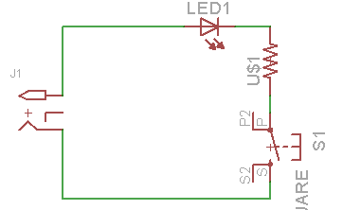

Board Creation

The board was auto generated using the tool on the taskbar. The parts were dragged into the board area, and the board perimeter thickened to 0.01 inch in order to create a “cut line” with non zero thickness. The wires were then routed on the bottom layer (which is the copper layer) and the board was checked with the design rule check (DRU) provided. No errors were present. The board was laid out as below:

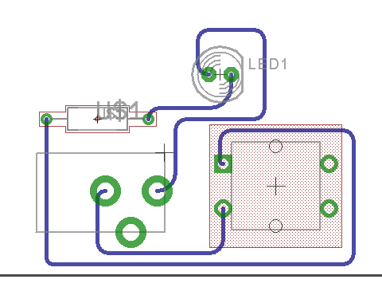

Preparing the Board for Manufacturing

The CAM files were generated using the provided CAM rules. Viewplot was downloaded and the files were checked on viewplot. Then the design files generated were placed in a zip folder and uploaded to a free PCB Design For Manufacturability (DFM) website: ( <https://www.my4pcb.com/net35/FreeDFMNet/FreeDFMHome.aspx> ).

The options were selected, and a few errors were present. The errors included: no silkscreen selected for the bottom, and ITAR not selected. These were corrected, and the board submitted.

Creating a New Package

Sometimes the device you are using comes in various packages. If you cannot find the Eagle package for the part that you purchased, you have to create your own. Since packages are physical representations of the device being used, the datasheet had to be consulted in order to recreate accurate dimensions.

The new package was created, linked to the existing device, and then the old package was replaced with the new. Finally, the CAM job was generated.

Adding Graphics

Difficulties were encountered when adding the logo. When trying to run the script after selecting the bitmap image, an error stating that I do not have permission to write to the files. It turns out that while the main Eagle folder is within Programfilesx86, adding graphics won’t work on some computers. It was fixed by moving the eagle folder to my documents folder. However moving it disassociated the startbar thumbnail for Eagle, which I don’t know how to get back. The final graphic was added as shown below.

