*Introduction to Machine Learning (BRI-507)*

**Assignment #1**

Submission type: individual

Deadline: April 11th, 2021 (end-of-the-day)

**Write a code to compare and analyze features by diagnostic group using a** **univariate/bivariate Gaussian estimation.**

**Read All Instructions Carefully**

1. 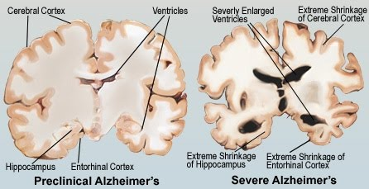Use every feature in alzheimers_disease_dataset.csv
   1. Colum A: Subject ID
   2. Colum B: Diagnosis group of subject  
      0: Cognitive normal

1: Mild cognitive impairment   
2: Alzheimer’s disease

* 1. Colum C - Feature1: morphological volume of hippocampus
  2. Colum D - Feature2: morphological volume of entorhinal cortex

1. Maximum Likelihood Estimation (MLE) is a method that determines values for the parameters of the model. The probability density of observing a single data point, that is generated from a Gaussian distribution is given by:

Univariate MLE

|  |  |
| --- | --- |
|  | (1) |

Multivariate MLE

|  |  |
| --- | --- |
|  | (2) |

, where is the number of subjects.

1. ***Task Description:*** Compute and plot the univariate and bivariate MLE for each diagnosis group.
   1. In other words, compute and plot MLEs:
      1. Feature 1 (Hippocampus) univariate MLE for each diagnosis group
      2. Feature 2 (Entorhinal cortex) univariate MLE for each diagnosis group
      3. Hippocampus / Entorhinal cortex bivariate MLE for each diagnosis group
   2. Example with Scipy:  
      <http://web.vu.lt/mif/a.buteikis/wp-content/uploads/PE_Book/3-4-UnivarMLE.html>
2. Implementation instructions
   1. Use the Google Colab (https://colab.research.google.com/)
   2. **Only allowed libraries are pandas, numpy, matplotlib (or any other visualization libraries such as Pillow).**

[Submission: “BRI507_**yourID_name**.ipynb” file (in Colab menu: File-.ipynb Download)

1. For a segment of codes, you should describe their function by using “markdown” scripts.
2. It is also required to write your analysis in regard to the resulting figures.

TA’s note: Beware of plagiarism (we use proprietary plagiarism checkers in addition to BlackBoard plagiarism checker). Ask the TAs if you have any questions.