COLT
QLD Basketball Pilot Blueprint
The curated-expert hybrid model · June 2026
This blueprint sets out how COLT tests its operating model in a single, deliberately narrow market — Queensland basketball — by pairing a club’s squad-wide distribution with one vetted expert coach, and by splitting paid value into two tiers. It is a pilot design and a decision framework, not a commitment of final pricing. Figures marked illustrative are hypotheses to calibrate in the pilot.

1. Strategic thesis
The hard problem in youth athlete development is not building a coach tool — that layer is mature and crowded (TrainHeroic, CoachNow, Playbook). The real constraints are demand and supply. Clubs are the cheapest source of demand: a single club delivers a whole squad of engaged families at once, plus the trust to recommend the product. Expert coaches are the scarce source of supply: real development expertise that volunteer-run clubs generally lack.
So COLT does not become a two-sided marketplace (ruled out for cold-start, youth-safeguarding and channel-conflict reasons). Instead it keeps clubs as the demand and distribution engine, brings in one vetted expert as the supply, and owns the engagement loop, the billing and the data in the middle. Demand is built first — for free — and only then monetised.
Why Queensland basketball: basketball is Australia’s fastest-growing team sport and second most-played, with roughly 1.3 million participants nationally and 350,000+ regular juniors; Queensland alone has 210,000+ participants and a documented court shortfall in the south-east — demand outstripping supply, which is exactly the condition in which parents pay for an edge. It is also local, hot, and big enough to clone from.

2. The operating model
The journey runs from a free, club-driven day-one sign-up, through a gamified habit loop that doubles as the data-capture engine, across a conversion gate into two paid tiers, and out to a verified development profile that feeds elite pathways — which in turn drives the next wave of sign-ups (the flywheel).
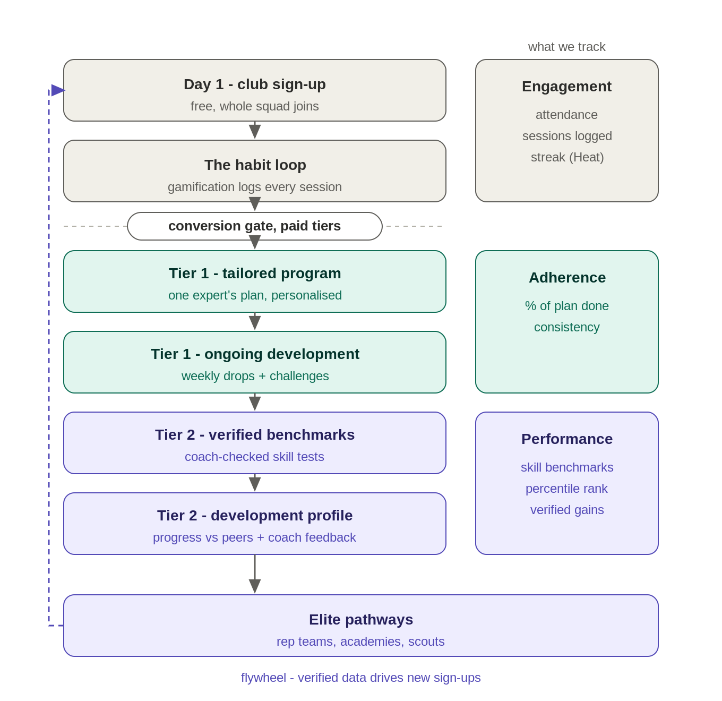
Key point: gamification is the data-capture engine, not the product. XP, streaks (Heat) and squad leaderboards exist to get athletes logging attendance, sessions and drills consistently. That behavioural record is the raw material everything paid is built on.

3. The tiers
Free is the collective layer that builds the moat and is never paywalled. Tier 1 is the individual training edge. Tier 2 adds verification and human feedback — the “close to a personal coach” layer where willingness-to-pay is highest and where the operationally heavy verification work is deliberately placed behind the higher price.
 | Free (collective) | Tier 1 — ~$9.99/mo | Tier 2 — ~$19.99/mo
Who it's for | Whole squad + parents | Parent wants the edge | Parent wants a personal-coach experience
Squad, comms, schedule | Yes | Yes | Yes
Core library + social gamification | Yes | Yes | Yes
Tailored expert program | — | Yes | Yes
Ongoing development (weekly drops, challenges) | — | Yes | Yes
Parent progress view | Basic | Full | Full
Verified benchmark testing | — | — | Yes
Coach feedback / video review | — | — | Yes
Development profile (player card, percentiles) | — | — | Yes
Pathway-shareable report | — | — | Yes
Pricing shown is a proposed starting point (~$9.99 Tier 1, ~$19.99 Tier 2); both tiers carry the 70/30 COLT/club split. Validate price points in the pilot.

4. The verification engine
Data is only attractive to rep teams, academies and scouts if it is verified and longitudinal — not self-reported XP. The model runs a standardised, basketball-specific benchmark battery on a cycle (e.g. every six weeks), captured by the athlete on video so it scales, with automated counting/timing plus coach sampling for integrity. Scores are reported as percentiles against age and position peers, producing a development curve rather than a single number.
Test | Metric | Method | Verification
Spot shooting | Makes / 50 (5 spots) | Self-film, fixed setup | Auto-count + coach sample
Free throws | Makes / 25 | Self-film | Auto-count + coach sample
Dribble course | Time (s) | Self-film, cone layout | Timed clip review
3/4 court sprint | Time (s) | Self-film / timer | Timed clip review
Lane agility | Time (s) | Self-film, cone layout | Timed clip review
Standing vertical | Max touch (cm) | Self-film vs wall marker | Marker calibration
Target passing | Makes / 20 | Self-film | Auto-count + coach sample
Technique grades | Coach 1–5 scale | Coach reviews submitted clips | Coach attestation (T2)
Output: a verified development profile (player card) showing trend lines, peer percentiles and coach attestation — the durable asset and the reason the next squad of parents signs up. The wedge worth prototyping is video-based capture so verification scales without a coach grading every rep.

5. Unit economics (illustrative)
A single pilot club, sized at 200 engaged athletes, with conservative conversion assumptions. These percentages are the hypotheses the pilot exists to test.
Item (illustrative, per 200 engaged athletes) | Value
Free users (full squad base) | 200
Tier 1 conversion @ 15% → $9.99/mo | 30 × $9.99 = $299.70/mo
Tier 2 conversion @ 5% → $19.99/mo | 10 × $19.99 = $199.90/mo
Gross MRR | $499.60
Gross annual revenue | ≈ $5,995
COLT share (70%) | ≈ $4,197 / yr
Club share (30%) | ≈ $1,799 / yr
Sensitivity: the model is most sensitive to Tier 1 conversion and to the Tier 1→Tier 2 upgrade rate. Doubling T2 uptake roughly doubles per-club revenue, which is why the personal-coach tier matters disproportionately.

6. The pilot setup

Target club profile
- One QLD basketball club/association with an engaged junior base (target ~150–250 athletes).
- A committee willing to actively promote the app to families (the 30% share is the incentive).
- A mix of ages/levels so benchmark percentiles have a meaningful peer set.

The expert coach
- One credible development coach (ex-NBL, state program, or a known junior-development specialist) — ideally bringing some of their own audience.
- Working With Children Check, child-safe training, and clear safeguarding boundaries (no private 1:1 video or DMs; all contact club-mediated).
- Deal terms: exclusivity for the pilot window, a rev-share on Tier 1/2 attributable to their content, and a clear position as supplier, not competitor — COLT owns the parent relationship and the data.

7. The 90-day plan
Weeks | Focus | Key activities
0–2 | Set up | Sign 1 club; onboard whole squad on free tier; recruit + vet one expert coach (WWCC, child-safe); run baseline benchmark testing.
3–6 | Build the loop | Drive habit loop (logging, streaks); measure weekly-active %; launch Tier 1 tailored program.
7–10 | Monetise | Open Tier 1 + Tier 2; measure free→paid conversion and T1→T2 upgrade; mid-cycle benchmark retest + first coach feedback.
11–13 | Validate | End-cycle retest; generate development profiles; measure paid retention; gather pathway interest; go/no-go review.

8. Metrics & decision gates
One headline number decides the model: of the free squad, what share of parents convert to paid — and of those, how many take Tier 2. Everything else is supporting evidence.
Metric | Target (illustrative — to calibrate in pilot)
Free→Tier 1 conversion (north star) | ≥ 12–15% of engaged athletes
Tier 1→Tier 2 upgrade | ≥ 25–30% of Tier 1
Weekly-active squad members | ≥ 60% during pilot
Tier 1 program adherence | ≥ 50% of plan completed
Tier 2 benchmark-cycle completion | ≥ 70% of T2 athletes
Month-3 paid retention | ≥ 70%
CAC test (club vs standalone) | Club CAC materially below standalone
Go/no-go: if conversion and retention clear the illustrative thresholds with safeguarding and verification proven operable, the unit (club + expert program) is repeatable and COLT clones it sport-by-sport. If not, the failure is cheap and instructive — far cheaper than building a marketplace that must be fed forever.

9. Risks & mitigations
Risk | Mitigation
Child safeguarding (adult–minor, video) | One vetted coach with WWCC + child-safe training; club-mediated; no 1:1 DMs or private video; parental consent; mandatory-reporting compliance.
Verification doesn't scale | Video-based self-capture + automated counting/timing, with coach sampling rather than coach grading every rep.
Low conversion | Keep free genuinely useful but make T1/T2 clearly worth it; parent visibility is the willingness-to-pay lever.
Coach dependency / channel conflict | Coach is a supplier, not a competitor: exclusivity + rev-share; COLT owns the parent relationship and the data.
Churn after one program cycle | Recurring cadence — weekly drops, fresh challenges, and benchmark re-tests that show progress.
Single sport / region concentration | Pilot is deliberately narrow; clone the unit (club + program) sport-by-sport only after proof.

10. Sources
Basketball — Australia’s fastest-growing team sport (Basketball Australia)
1.3M players and junior participation (Basketball.com.au)
QLD growth, 210k+ participants and court shortfall (Basketball Queensland)
AusPlay youth participation (Australian Sports Commission)
Volunteer / community-coach training gaps (Annals of Leisure Research)
Safeguarding for coaches (Sport Integrity Australia)
TrainHeroic marketplace economics · CoachNow PRO · Playbook

