Practical 1

Aim: Practical of Data collection, Data curation and management for Unstructured data(NoSQL)
Steps:
Step-1: Install CouchDB. After installation go to your browser and type below url: http://localhost:5984/_utils/ and login with username and password.
Step-2: After login go to Databases and click on “Create Database” and give name to your database(name should be in lowercase) and click on create.
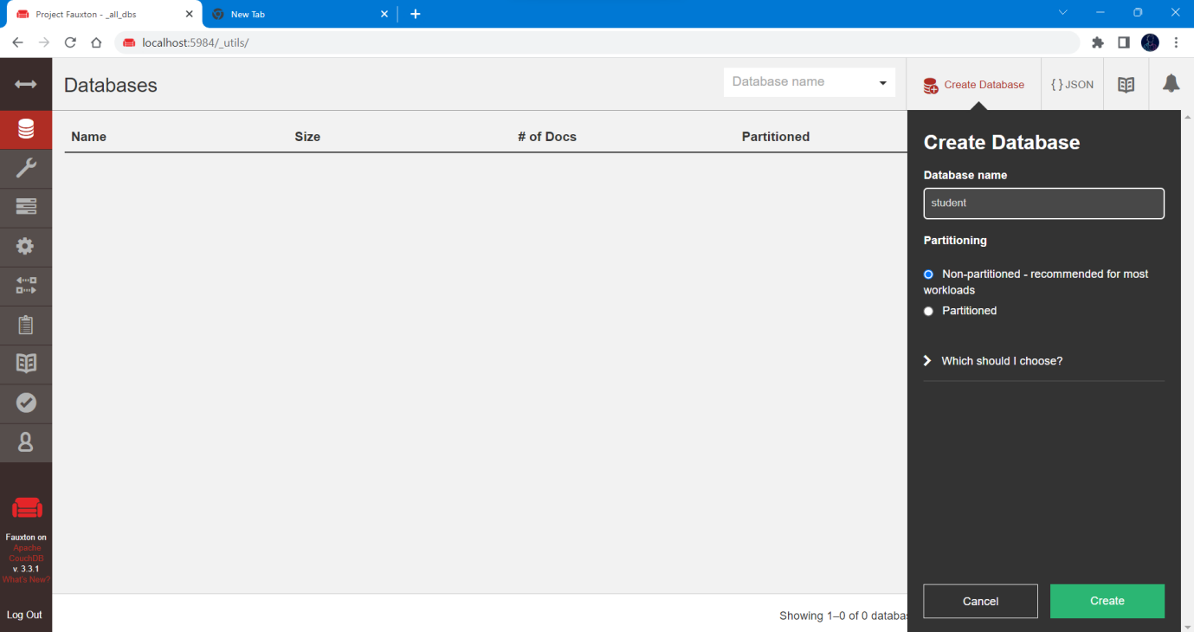
Step-3: Now in your created database go into the Design Documents and click on Create Document. Now add columns into your database accordingly as shown in image:
You can add multiple columns.
You can also create new document for new data with additional columns.
For saving document click on create document.
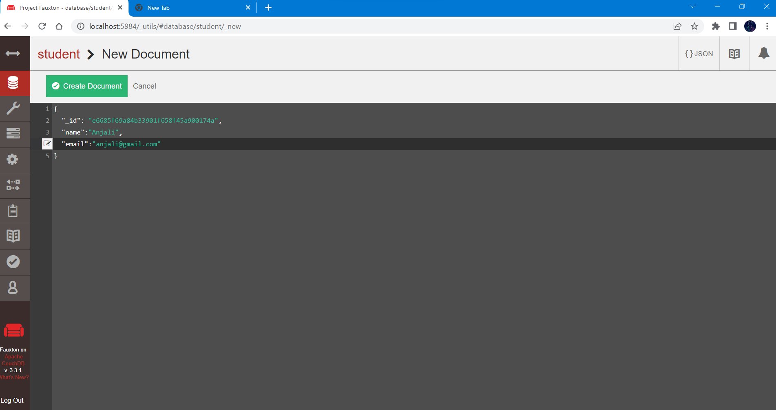

Step-4: Now to view data in json format click on JSON. For table format click on TABLE.

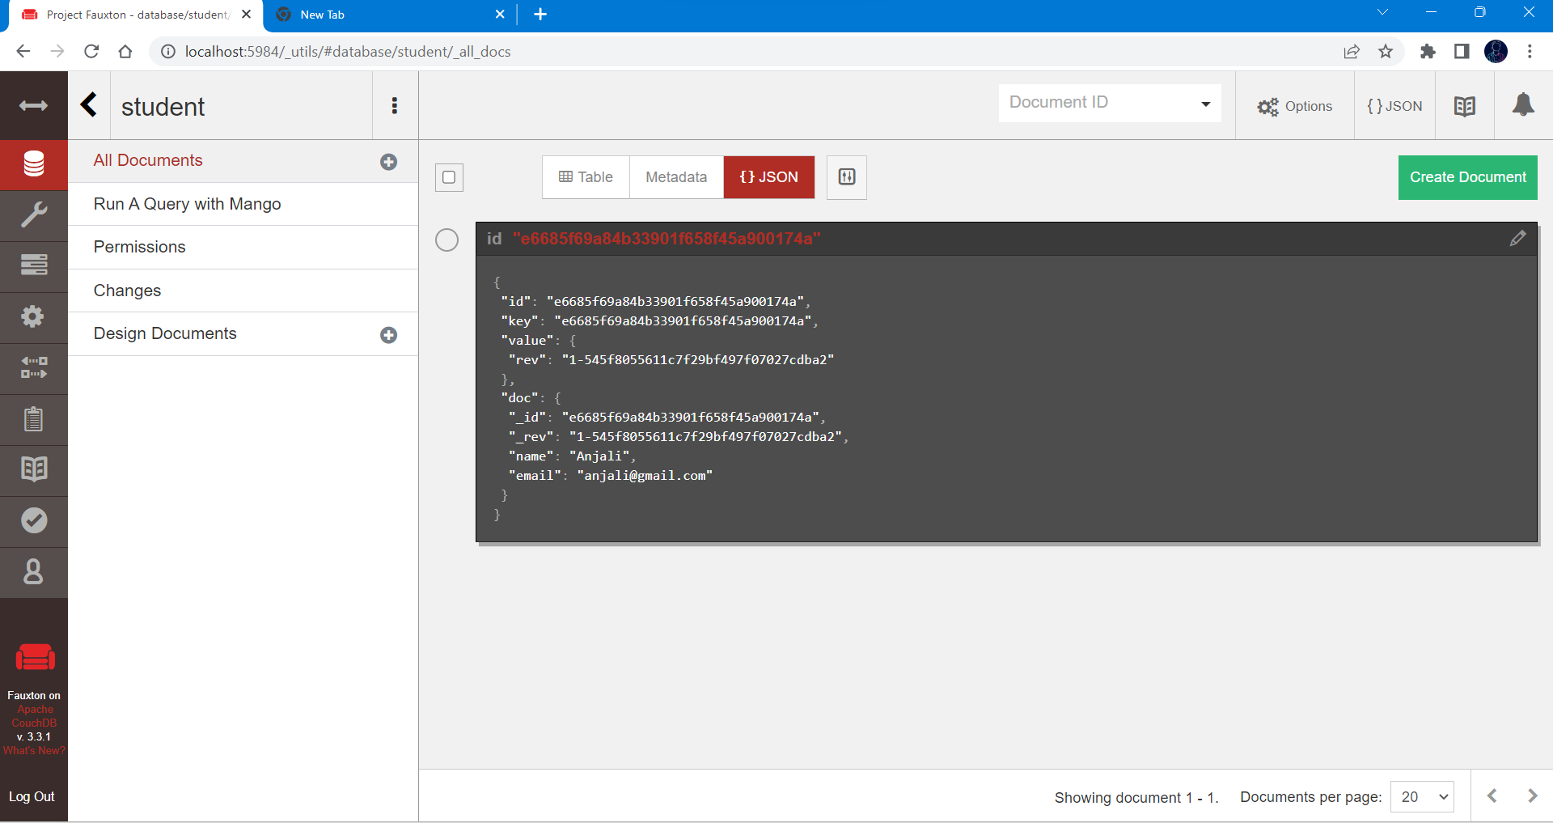

Step-5: To edit data click on id number in red and it will redirect your to window where you can make changes. To save data click on save changes.
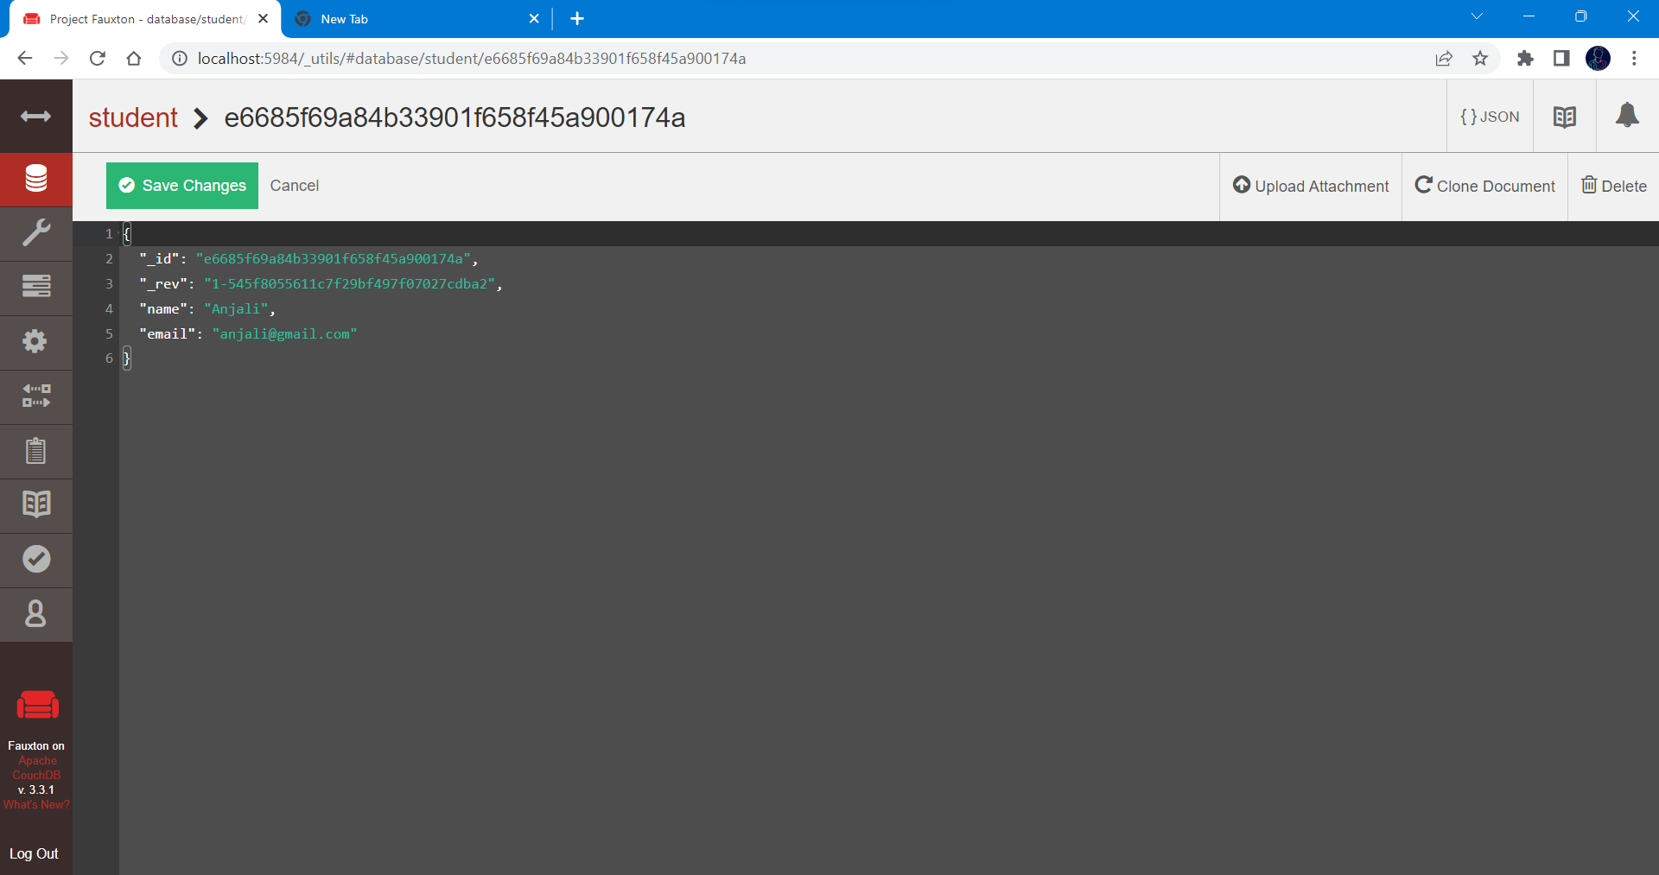
Step-6: To delete column click on check button and click delete button.
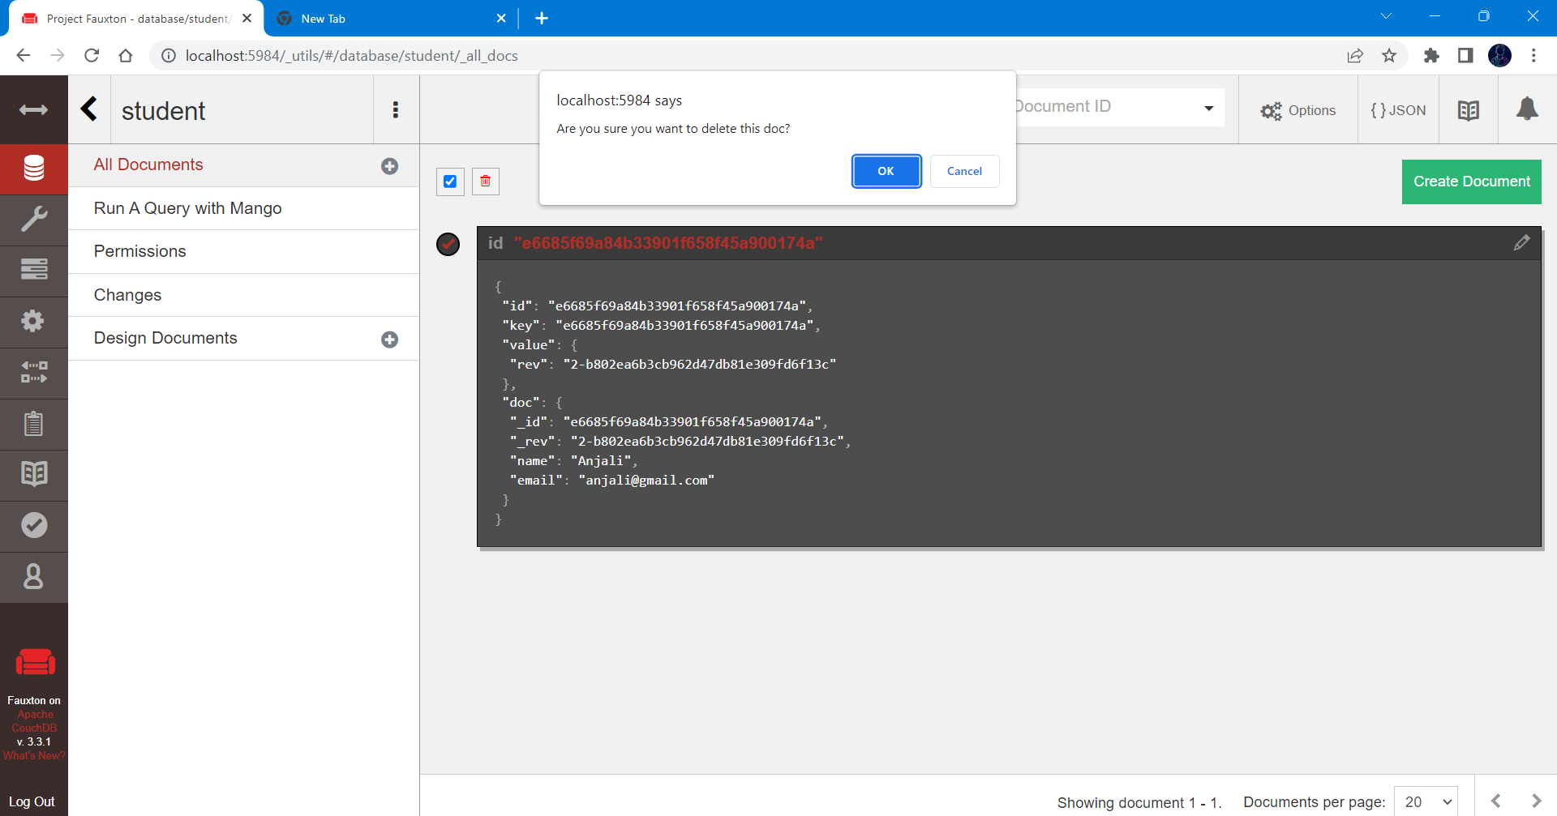

Practical 2
Practical of Data collection, Data curation and management for Unstructured data
(NoSQL)
• Search on Chrome: nosql client for mongodb > Windows 64 bit > Download > Open
• Click on Connect > New Collection > Ok > Save & connect
• Right click on Localhost > Create Database > Name: Employee >Ok
• Right click on Employee > Create Collection > Name: Emp > Ok

Create Database
• Right click on Emp > Create Document > Insert documents > enter values > click on ‘Run’
• Right click on Emp and Choose View.

Update Database
• To update: right click on Emp > Update documents… > make following changes > click on ‘Run’
• Right click on Emp and Choose View.
Delete Database
• To delete: right click on Emp > Delete documents…

Practical 3
Write a program in R to implement simple linear regression
Simple/multiple linear regression
height <- c(102, 117, 105, 141,135,115, 138, 144, 157, 100, 131,119, 115,121, 113)
weight <- c(61, 46, 62, 54, 60, 69, 51, 50, 46, 64, 48, 56, 64, 48,59)
student <- lm(weight~height)
student
predict(student, data, frame(height=199), interval="confidence")
plot(student)

Practical 4

Time-series forecasting
data('AirPassengers')
class(AirPassengers)
start(AirPassengers)
end(AirPassengers)
frequency(AirPassengers)
summary(AirPassengers)
plot(AirPassengers)
abline(reg=lm(AirPassengers~time(AirPassengers)))
cycle(AirPassengers)
plot(aggregate(AirPassengers, FUN=mean))
boxplot(AirPassengers ~ cycle(AirPassengers))

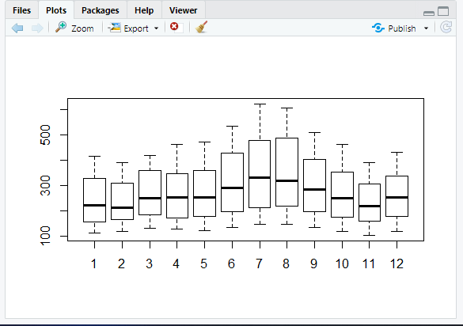

Practical 5
Time series analysis
rainfall <- c(799, 1174, 865.1, 1334.6, 635.4, 918.5, 685.5, 998.6, 985, 882.8, 1071)
rainfall.timeseries <- ts(rainfall, start = c(2012, 1), frequency = 12)
print(rainfall.timeseries)
png(file="rainfall.png")
plot(rainfall.timeseries)
dev.off()

Output:
Files-> rainfall.png
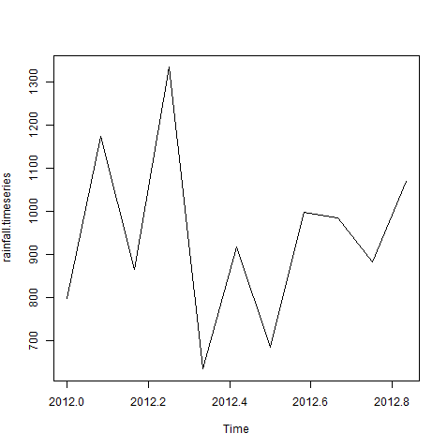

Practical -6
K-means clustering
data(iris)
names(iris)
new_data<-subset(iris,select=c(-Species))
new_data
c1<-kmeans(new_data,3)
c1
data<-new_data
wss<-sapply(1:15,function(k){kmeans(data,k)$tot.withinss})
wss
plot(1:15,wss,type="b",pch=19,frame=FALSE,xlab="Number of clusters K",ylab="Total within-clusters sums of squares")
library(cluster)
clusplot(new_data,c1$cluster,color=TRUE,shade=TRUE,labels=2,lines=0)
c1$cluster
c1$centers
"agglomarative clustring"
clusters<-hclust(dist(iris[,3:4]))
plot(clusters)
clusterCut<-cutree(cluster,3)
table(clusterCut,iris$Species)

Ouput:-
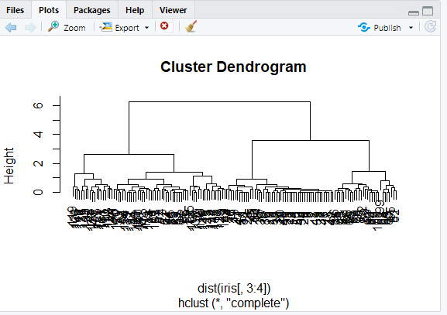

Practical 7
Decision tree
insatll.packages("party")
library(party)

input.dat<-readingSkills[c(1:15),]

png(file="decision_tree.png")

output.tree<-ctree(nativeSpeaker~age+shoeSize+score,data=input.dat)

plot(output.tree)

dev.off()
OUTPUT:
Go to the location where you put it and there will be a doc name as Decision_tree.png.Open it and you will have your output.

Practical 8
Hypothesis testing
dataf<-seq(1,20,by=1)
dataf
mean(dataf)
sd(dataf)
a<-t.test(dataf,alternate="two.sided",mu=10,conf.int=0.95)
a
a$p.value
a$statistic
(10.5-10)/(sd(dataf)/sqrt(length(dataf)))
length(dataf)=1
length(dataf)
dataf
dataf<-seq(1,20,by=1)
length(dataf)-1

Practical -9

Analysis of variance
data("warpbreaks")
head(warpbreaks)
summary(warpbreaks)
Model_1<-aov(breaks~wool+tension,data=warpbreaks)
summary(Model_1)
plot(Model_1)
Model_2<-aov(breaks~wool+tension+wool:tension,data=warpbreaks)
summary(Model_2)
plot(Model_2)

