**5.1) Use WireShark sniffer to capture network traffic and analyze.**

Step 1: Install and open WireShark .

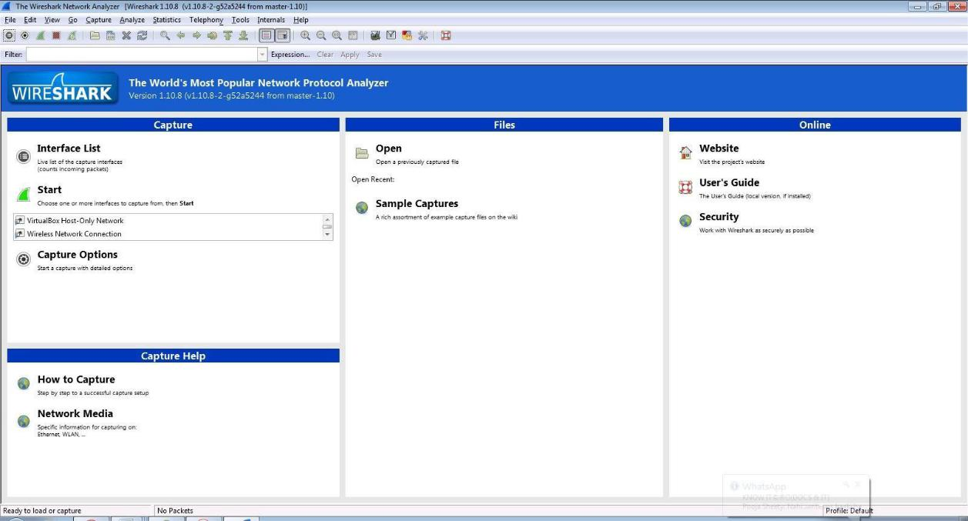

Step 2: Go to Capture tab and select Interface option.

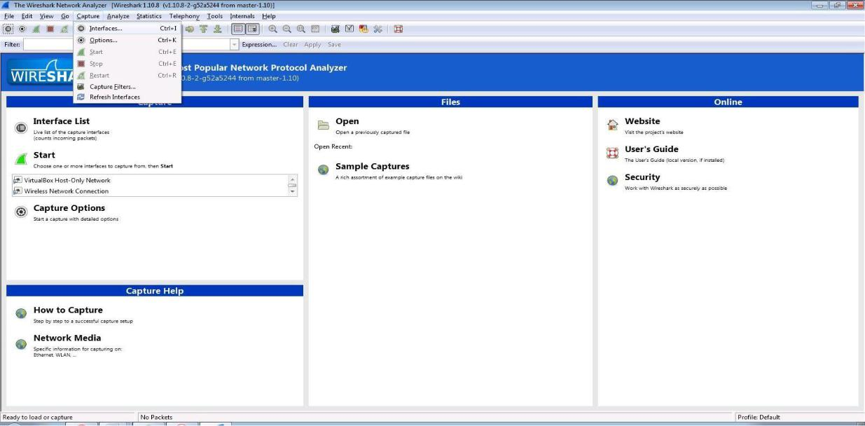

Step 3: In Capture interface, Select Local Area Connection and click on start.

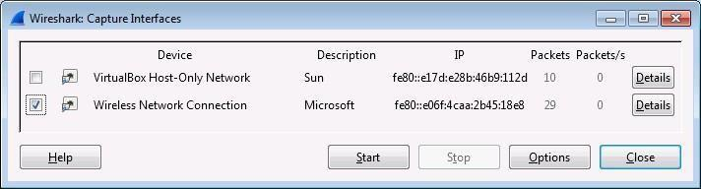

Step 4: The source, Destination and protocols of the packets in the LAN network are displayed.



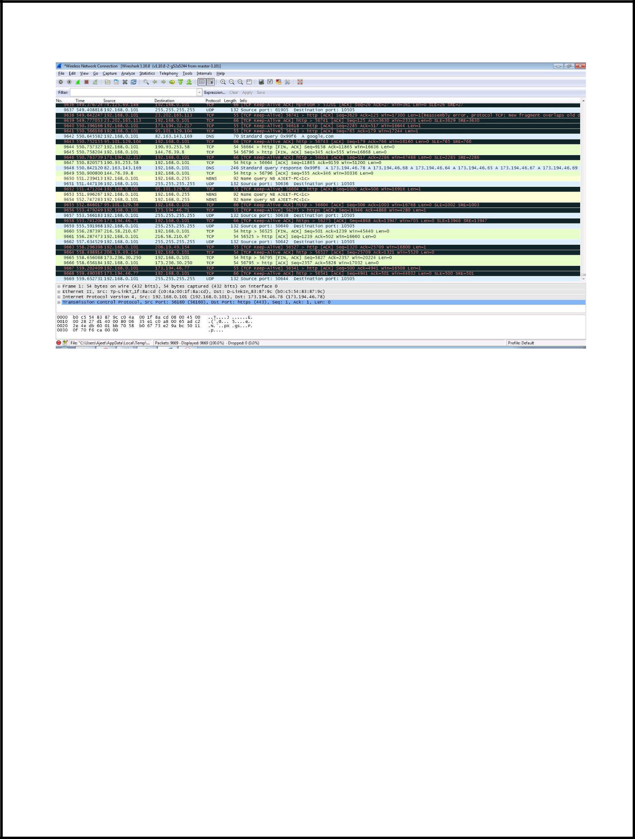

Step 5: Open a website in a new window and enter the user id and password. Register if needed.

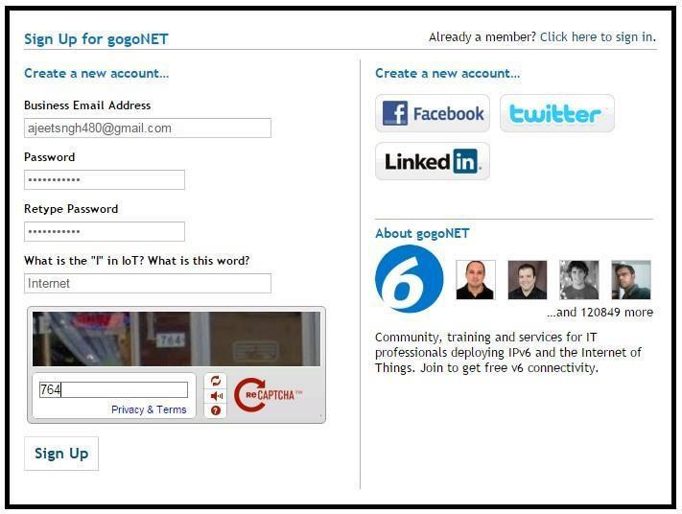

Step 6: Enter the credentials and then sign in.

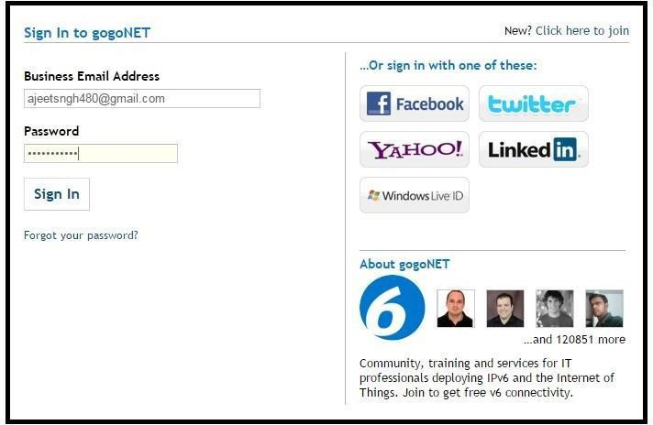

Step 7: The wireshark tool will keep recording the packets.

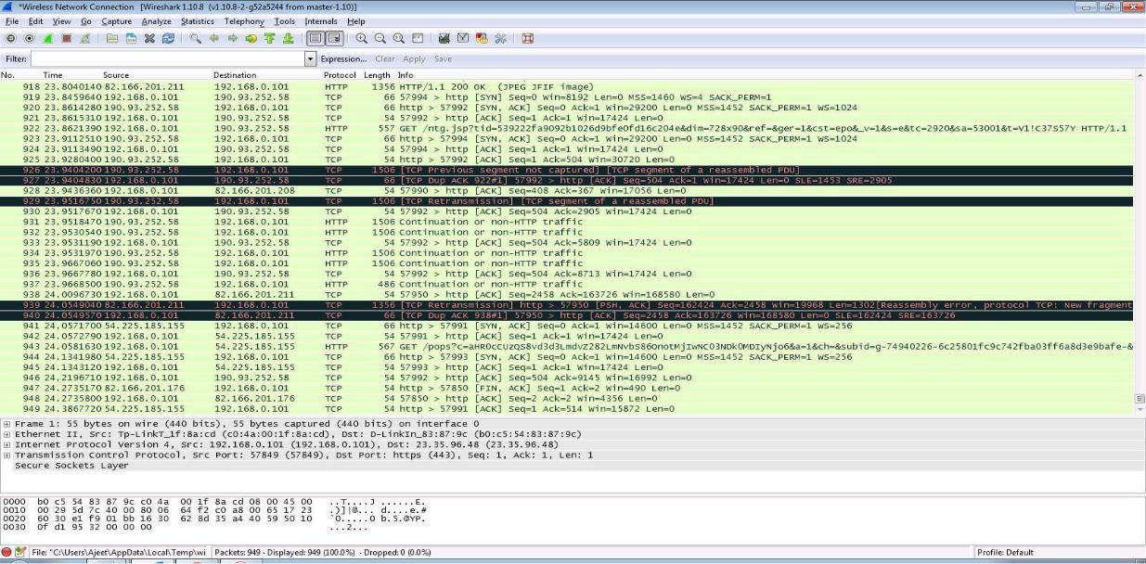

Step 8: Select filter as http to make the search easier and click on apply.

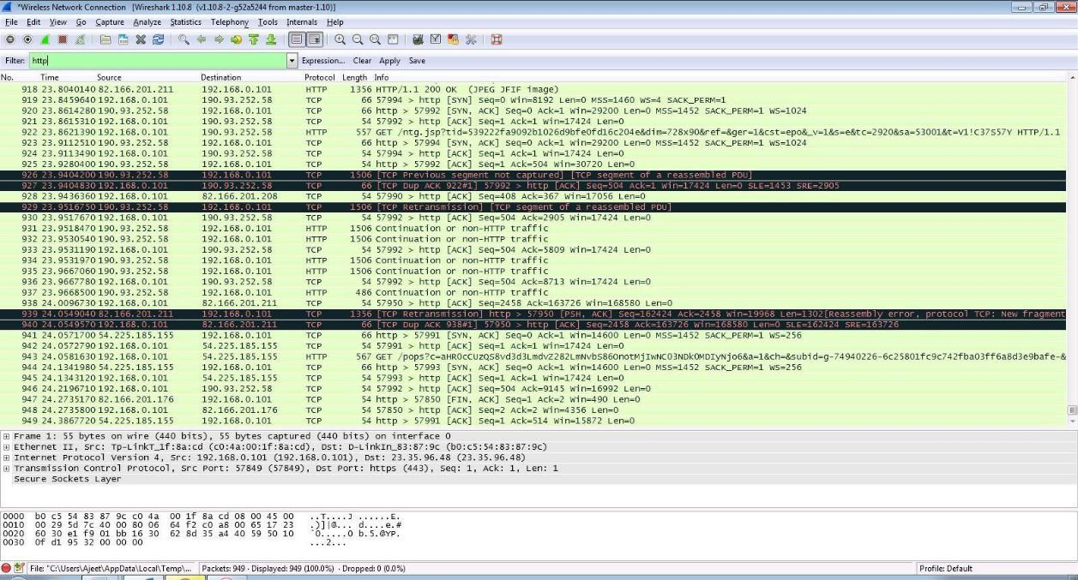

Step 9: Now stop the tool to stop recording.



Step 10: Find the post methods for username and passwords.

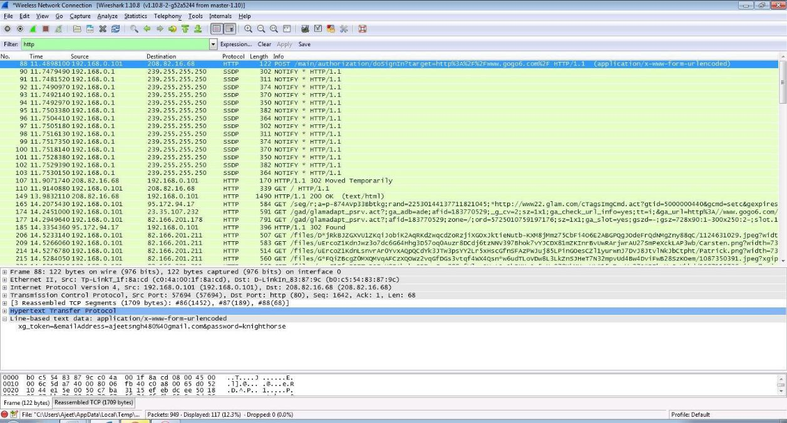

Step 11: U will see the email- id and password that you used to log in.

