# Practical-1

### **Aim:** To study cloud architecture and cloud computing model.

1. **Objectives:** From this experiment, the student will be able to
   * provide an overview of concepts of Cloud Computing.
   * To encourage students to indulge into research in Cloud Computing.
2. **Outcomes:** The learner will be able to
   * understand and appreciate cloud architecture.
   * analyze the local and global impact of computing on individuals, organizations, and society.
   * recognize the need for, and an ability to engage in life-long learning.
3. **Hardware / Software Required:** Ubuntu operating system, Internet
4. **Theory:**

Cloud computing enables companies to consume compute resources as a utility -- just like electricity -- rather than having to build and maintain computing infrastructures in-house. Cloud computing promises several attractive benefits for businesses and end users.

Three of the main benefits of cloud computing include:

* [Self-service provisioning](http://searchcloudprovider.techtarget.com/definition/User-self-provisioning): End users can spin up computing resources for almost any type of workload [on-demand.](http://searchdatacenter.techtarget.com/definition/on-demand-computing)
* [Elasticity](http://searchcio.techtarget.com/definition/IT-elasticity): Companies can scale up as computing needs increase and then scale down again as demands decreases.

[Pay per use](http://searchcio.techtarget.com/definition/metered-services): Computing resources are measured at a granular level, allowing users to pay only for the resources and workloads they use.

Cloud computing services can be [Private,](http://searchcloudcomputing.techtarget.com/definition/private-cloud) [Public](http://searchcloudcomputing.techtarget.com/definition/public-cloud) or [Hybrid.](http://searchcloudcomputing.techtarget.com/definition/hybrid-cloud)

Private cloud services are delivered from a business' data center to internal users. This model offers versatility and convenience, while preserving management, control and security. Internal customers may or may not be billed for services through [IT chargeback.](http://searchaws.techtarget.com/definition/IT-chargeback-showback)

In the Public cloud model, a third-party provider delivers the cloud service over the Internet. Public cloud services are sold on-demand, typically by the minute or the hour. Customers only pay for the [CPU](http://whatis.techtarget.com/definition/CPU-central-processing-unit) cycles, [storage](http://searchstorage.techtarget.com/definition/storage) or [bandwidth](http://searchenterprisewan.techtarget.com/definition/bandwidth) they consume. Leading

public cloud providers include Amazon Web Services ([AWS](http://whatis.techtarget.com/definition/Amazon-Web-Services-AWS)), Microsoft [Azure](http://searchwindowsserver.techtarget.com/definition/Microsoft-Azure-Windows-Azure), IBM/SoftLayer and [Google Compute Engine.](http://searchaws.techtarget.com/definition/Google-Compute-Engine)

Hybrid cloud is a combination of public cloud services and on-premises private cloud – with orchestration and automation between the two.

Companies can run mission-critical workloads or sensitive applications on the private cloud while using the public cloud for workloads that must scale on-demand. The goal of hybrid cloud is to create a unified, automated, scalable environment which takes advantage of all that a public cloud infrastructure can provide, while still maintaining control over mission-critical data.

Types of cloud computing:

IT people talk about three different kinds of cloud computing, where different services are being provided for you. Note that there's a certain amount of vagueness about how these things are defined and some overlap between them.

* + Infrastructure as a Service (IaaS) means you're buying access to raw computing hardware over the Net, such as servers or storage. Since you buy what you need and pay-as-you-go, this is often referred to as utility computing. Ordinary web hosting is a simple example of IaaS: you pay a monthly subscription or a per- megabyte/gigabyte fee to have a hosting company serve up files for your website from their servers.
  + Software as a Service (SaaS) means you use a complete application running on someone else's system. Web-based email and Google Documents are perhaps the best-known examples. Zoho is another well-known SaaS provider offering a variety of office applications online.
  + Platform as a Service (PaaS) means you develop applications using Web-based tools so they run on systems software and hardware provided by another company. So, for example, you might develop your own ecommerce website but have the whole thing, including the shopping cart, checkout, and payment mechanism running on a merchant's server. Force.com (from salesforce.com) and the Google App Engine are examples of PaaS.
  + Advantages and disadvantages of cloud computing

Advantages: The pros of cloud computing are obvious and compelling. If your business is selling books or repairing shoes, why get involved in the nitty gritty of buying and maintaining a complex computer system? If you run an insurance office, do you really want your sales agents wasting time running anti-virus software, upgrading word- processors, or worrying about hard-drive crashes? Do you really want them cluttering

your expensive computers with their personal emails, illegally shared [MP3](http://www.explainthatstuff.com/how-mp3players-work.html) files, and naughty YouTube videos—when you could leave that responsibility to someone else? Cloud computing allows you to buy in only the services you want, when you want them, cutting the upfront capital costs of computers and peripherals. You avoid equipment going out of date and other familiar IT problems like ensuring system security and reliability. You can add extra services (or take them away) at a moment's notice as your business needs change. It's really quick and easy to add new applications or services to your business without waiting weeks or months for the new computer (and its software) to arrive.

Disadvantages: Instant convenience comes at a price. Instead of purchasing computers and software, cloud computing means you buy services, so one-off, upfront capital costs become ongoing operating costs instead. That might work out much more expensive in the long-term.

If you're using software as a service (for example, writing a report using an online word processor or sending emails through webmail), you need a reliable, high- speed, [broadband](http://www.explainthatstuff.com/howbroadbandworks.html) Internet connection functioning the whole time you're working. That's something we take for granted in countries such as the United States, but it's much more of an issue in developing countries or rural areas where broadband is unavailable.

If you're buying in services, you can buy only what people are providing, so you may be restricted to off-the-peg solutions rather than ones that precisely meet your needs. Not only that, but you're completely at the mercy of your suppliers if they suddenly decide to stop supporting a product you've come to depend on. (Google, for example, upset many users when it [announced](http://www.zdnet.com/google-apps-axes-export-support-for-doc-and-other-old-microsoft-office-formats-7000004884/) in September 2012 that its cloud-based Google Docs would drop support for old but de facto standard Microsoft Office file formats such as .DOC, .XLS, and .PPT, giving a mere one week's notice of the change— although, after public pressure, it later extended the deadline by three months.) Critics charge that cloud-computing is a return to the bad-old days of mainframes and proprietary systems, where businesses are locked into unsuitable, long-term arrangements with big, inflexible companies. Instead of using "generative" systems (ones that can be added to and extended in exciting ways the developers never envisaged), you're effectively using "dumb terminals" whose uses are severely limited by the supplier. Good for convenience and security, perhaps, but what will you lose in flexibility? And is such a restrained approach good for the future of the Internet as a whole? (To see why it may not be, take a look at Jonathan Zittrain's eloquent book [The](http://futureoftheinternet.org/) [Future of the Internet—And How to Stop It](http://futureoftheinternet.org/).)

## Conclusion:

Cloud computing enables a convenient and on-demand network access to a wide range of resources. The different services and also the deployment models allow flexible service provider interaction with minimal human intervention. It saves costs but also can lead to risk issues and suspension of resources when in huge quantity.

# Practical-2

Ex 2. Installation and Configuration of virtualization using KVM

1. sudo grep -c "svm\|vmx" /proc/cpuinfo

2. sudo apt-get install qemu-kvm libvirt-bin bridge-utils virt-manager

3. sudo adduser rait

4. sudo adduser rait libvirtd

5. virsh -c qemu:///system list

(Run following command after logging back in as rait and you should see an empty list of virtual machines. This indicates that everything is working correctly.)

6. virt-manager

(Open Virtual Machine Manager application and Create Virtual Machine )

### Result:

SNAPSHOTS

Step 1 : #sudo grep -c "svm\|vmx" /proc/cpuinfo

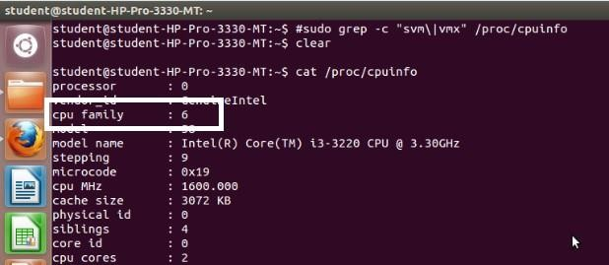

Step 2 : #sudo apt-get install qemu-kvm libvirt-bin bridge-utils virt-manager

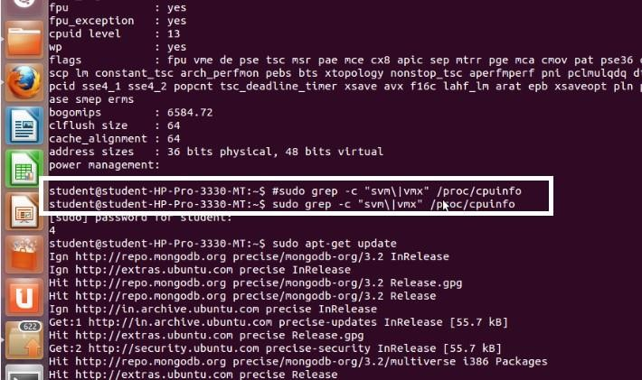

Step 3 : #sudo adduser rait

After running this command, log out and log back in as rait

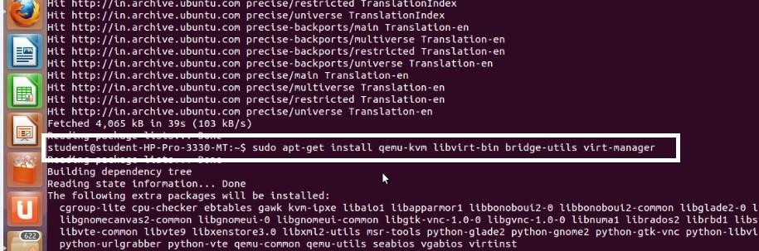

Step 4 : #sudo adduser rait libvirtd

After running this command, log out and log back in as rait

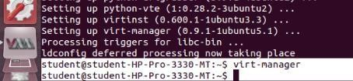

Step 5 : Open Virtual Machine Manager application and Create Virtual Machine #virt-manager as shown below

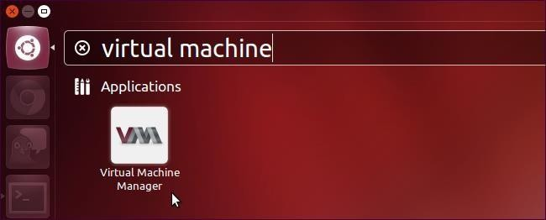

Step 6 : Create a new virtual machine as shown below

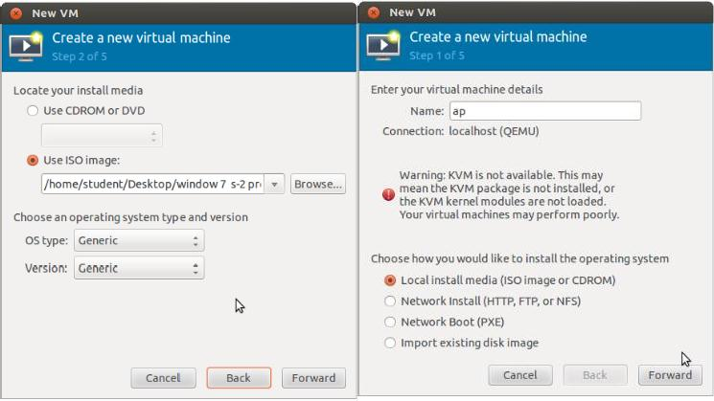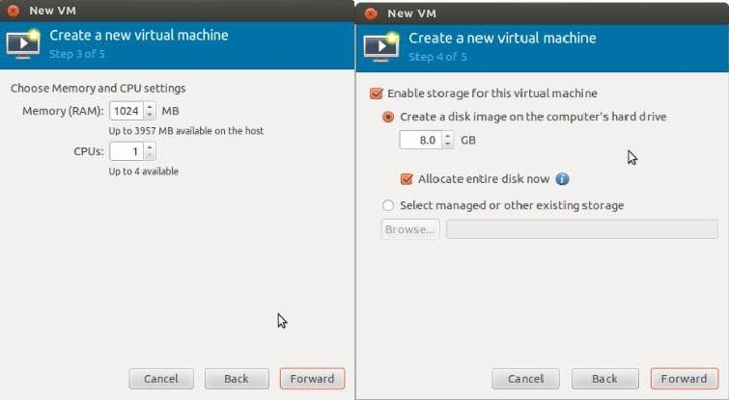

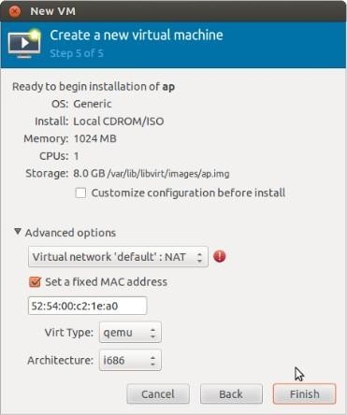

Step 7 : Install windows operating system on virtual machine

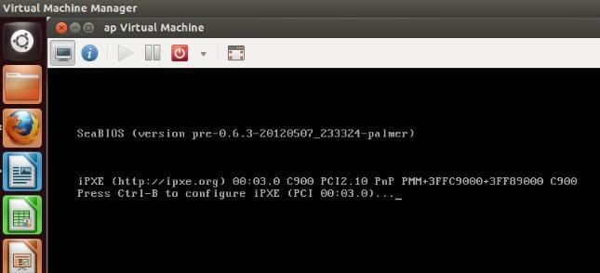

Step 8: Installation of windows on virtual machine

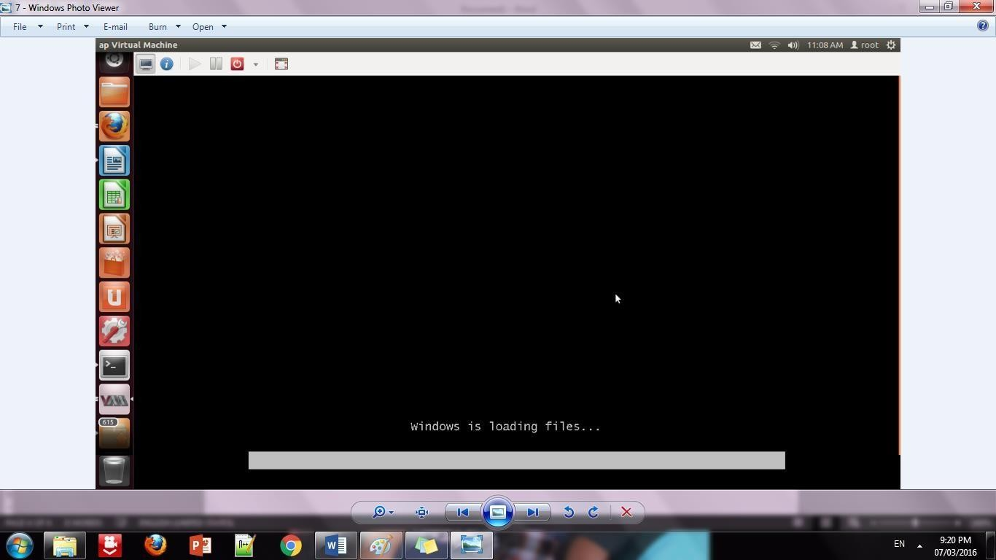

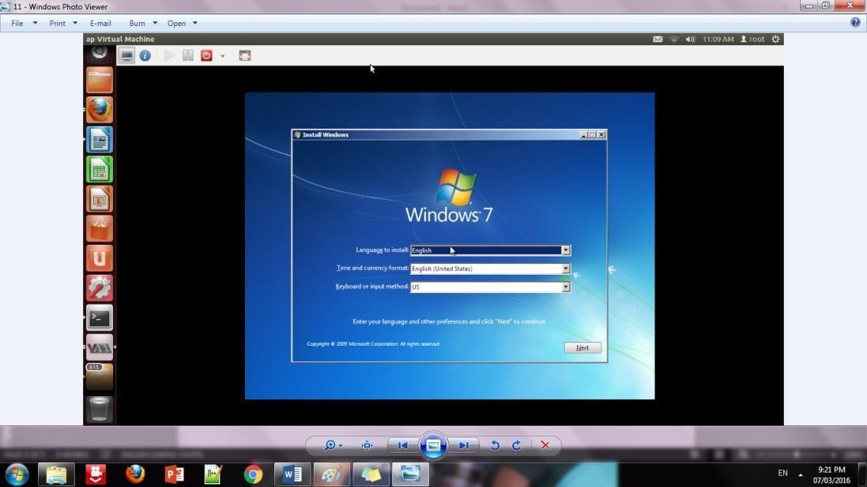Step 9: Installation of windows 7 on virtual machine

Step 10: Initialization of windows on virtual machine

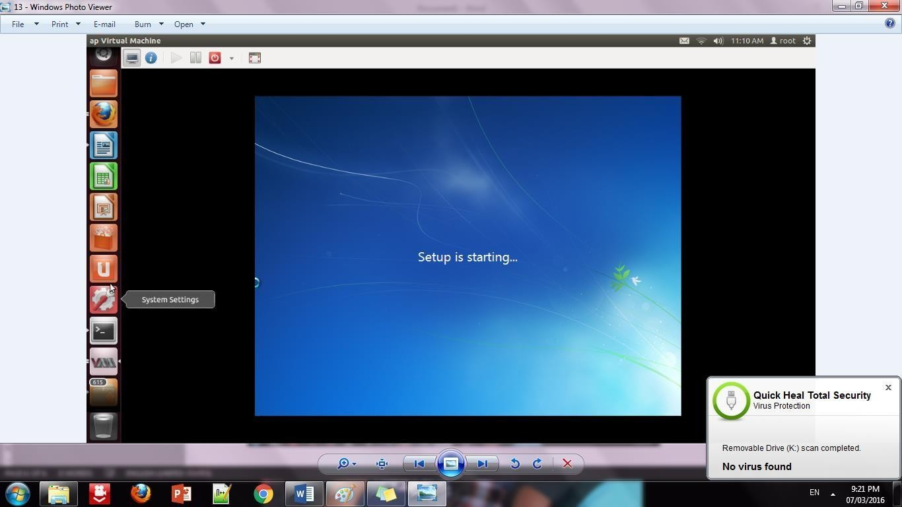

##### Conclusion:

Installation and configuration of KVM have been done successfully onto Ubuntu and users added. Like this we can create as many virtual machines as possible on OS and can install any windows onto it.

# Practical-4

### **Aim:** Study and implementation of Storage as a Service.

Drive on

# Practical-5

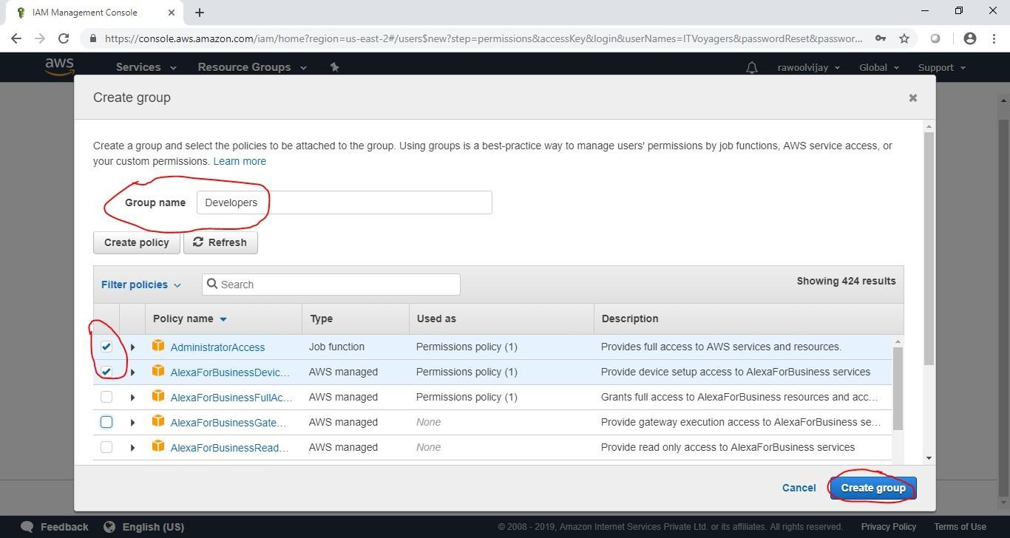

6

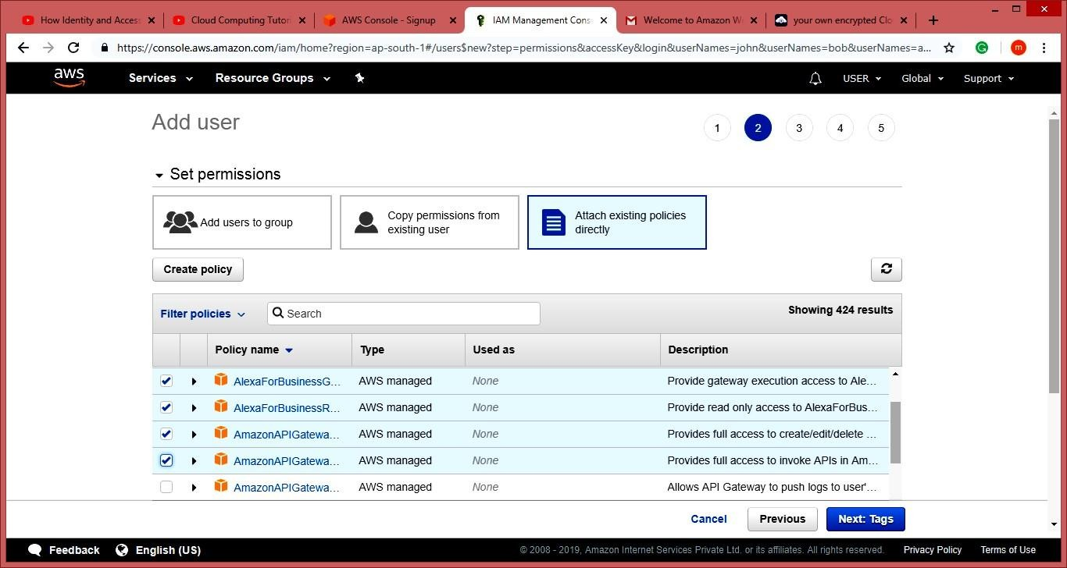

# Practical-7

Aim: Write a program for web feed.

<?xml version="1.0" encoding="UTF-8"?>

<rss version="2.0">

<channel>

<title>W3Schools Home Page</title>

<link>https:/[/www.w3schools.com](http://www.w3schools.com/)</link>

<description>Free web building tutorials</description>

<item>

<title>RSS Tutorial</title>

<link>https:/[/www.w3schools.com/xml/xml_rss.asp](http://www.w3schools.com/xml/xml_rss.asp)</link>

<description>New RSS tutorial on W3Schools</description>

</item>

<item>

<title>XML Tutorial</title>

<link>https:/[/www.w3schools.com/xml<](http://www.w3schools.com/xml)/link>

<description>New XML tutorial on W3Schools</description>

</item>

</channel>

</rss>

**Now copy that rss file which was saved with .xml extention inside your website folder.**

<p>here is ur <a href="rss.xml">feed</a>.</p>