**Windows Server**

9/19/2019 – Met with SECS IT to request VM/server... APPROVED!

9/24/2019 – VM activated

9/26/2019 – Had to reopen ticket to get proper permissions since vCenter was telling me I didn't have access to any VMs on the system

9/30/2019 – Finally got proper permissions and began setting up the server

9/30/2019 – Request to install vmware tools since I currently don't have mouse functionality and have to navigate the desktop with the keyboard. :'(

**Accessing the VM**

School provided VM info: <http://secs.oakland.edu/docs/pdf/vm.pdf>

vCenter link: <https://vcenter6.secs.oakland.edu/>

** You must be connected to the university network to access vCenter! Either on campus via WiFi or elsewhere, you must be connected to the VPN (instructions here: <http://secs.oakland.edu/docs/pdf/vpn.pdf>)

Login with SECS account. (I believe Mary and I are the only ones who currently have access so if anyone else would like access to it, we will have to ask)

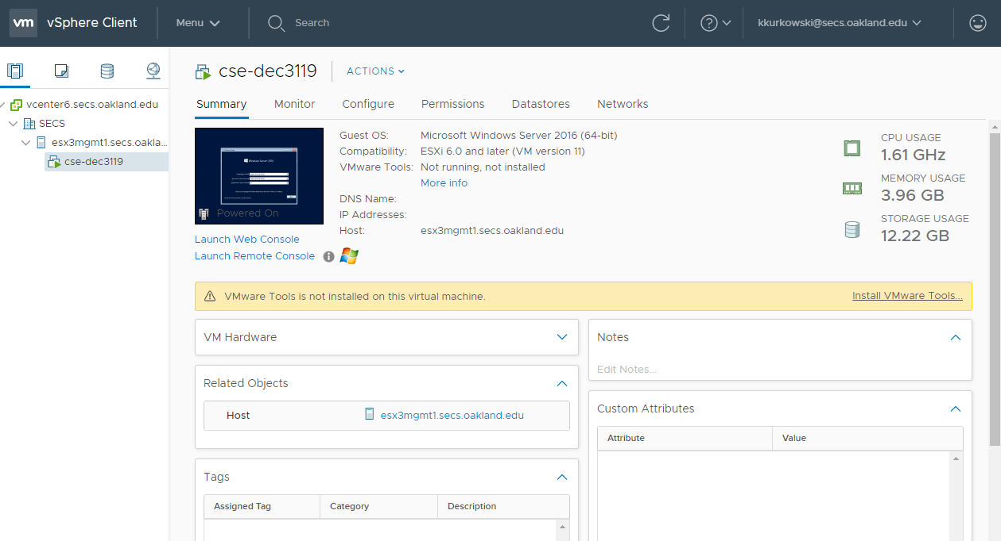  
(VM Dashboard)

To access 🡪 "Launch Web Console"

**OS Installation**

**Step 1**: Choose language and other preferences.

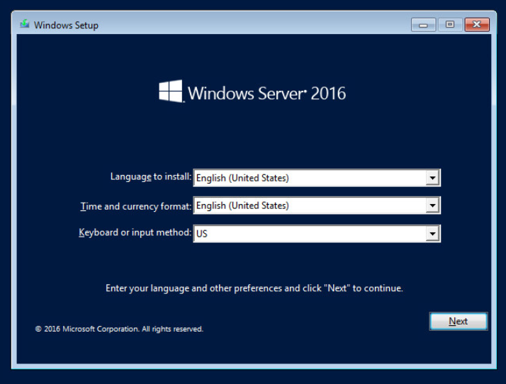

**Step 2**: We don't have a Windows key so select "I don't have a product key" and we'll be using the free trial. It should be good through the end of the semester.

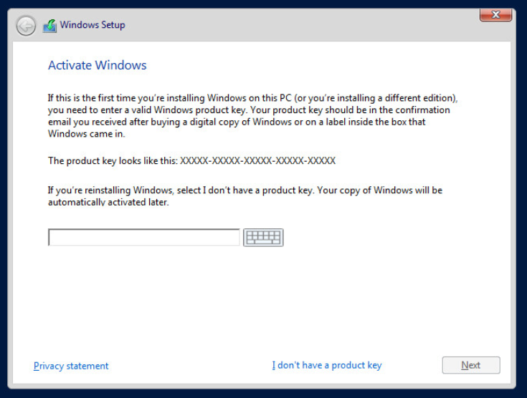

**Step 3**: Choose the operating system. We're going to use Windows Server 2016 Datacenter (Desktop Experience).

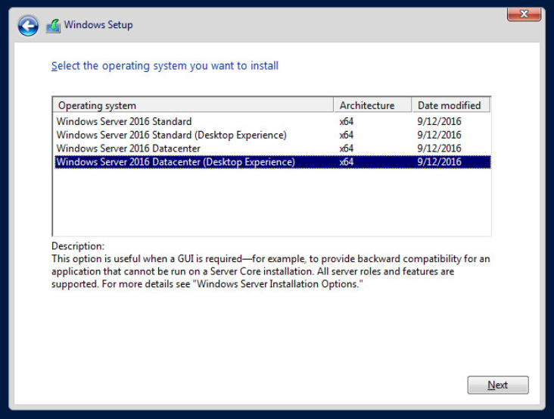

**Step 4**: Accept the license terms.

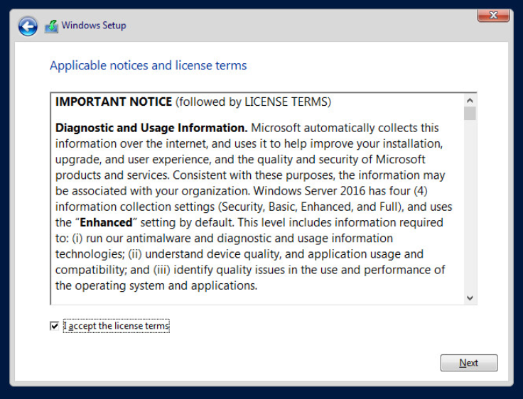

**Step 5**: Choose the custom install

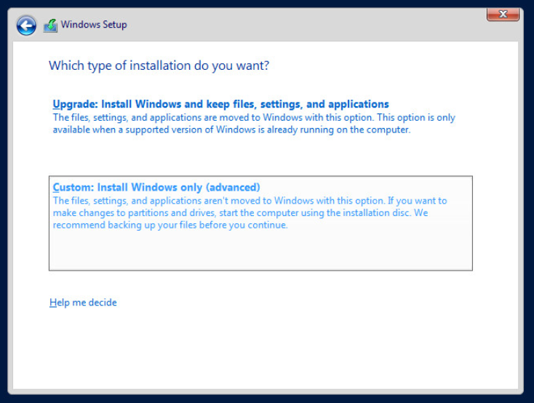

**Step 6**: Choose the partition which the OS will be installed on.

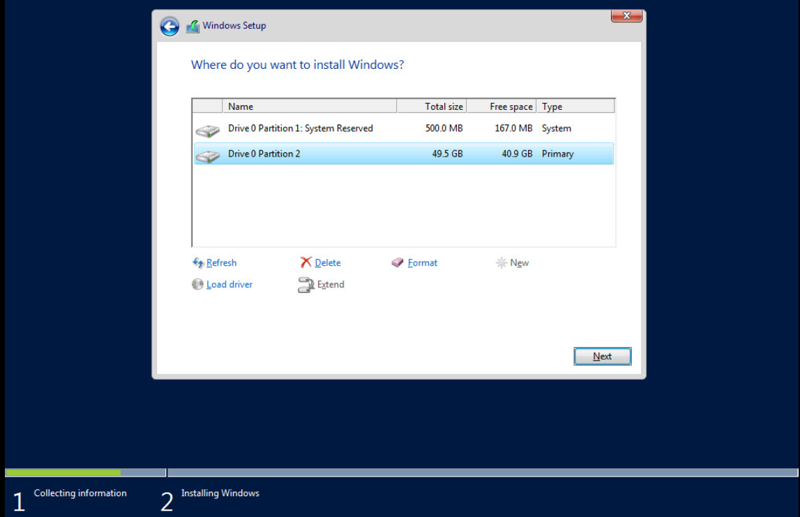

**Step 7**: Wait forever for it to install.

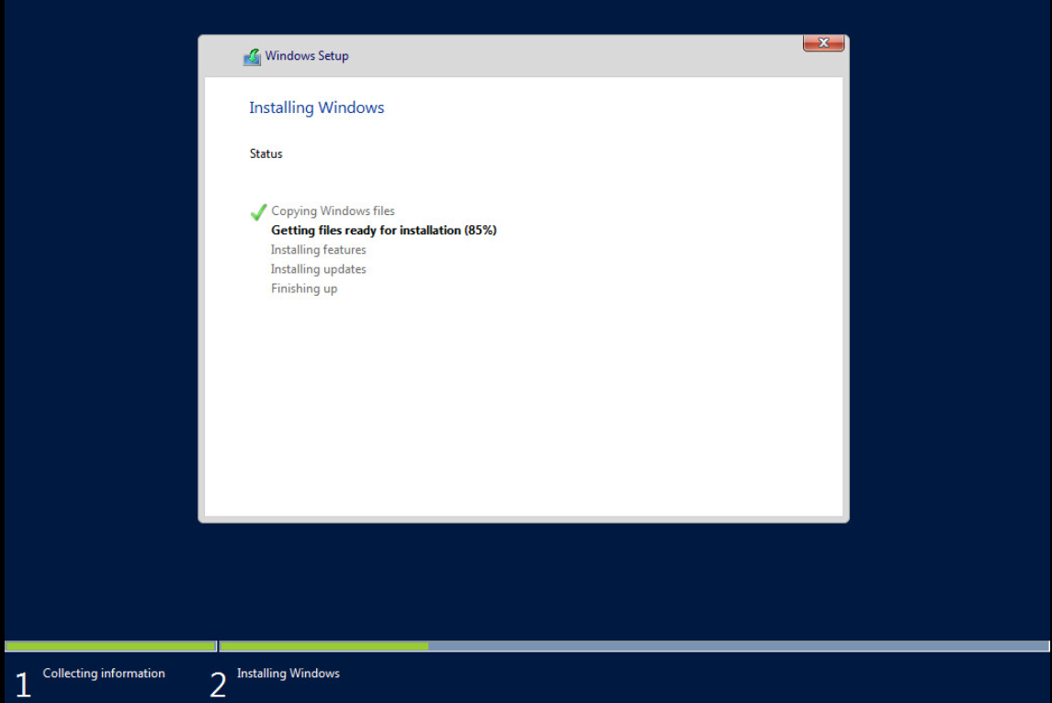

**Step 8**: Once it finishes, it will restart.

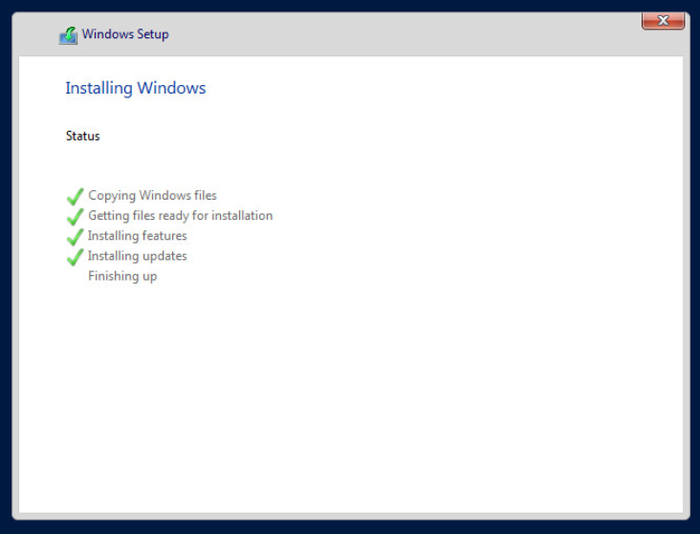

Once it restarts, it will ask to setup an administrator password. The administrative password is set as "ReServe2019"

**Step 9**: The server is ready!

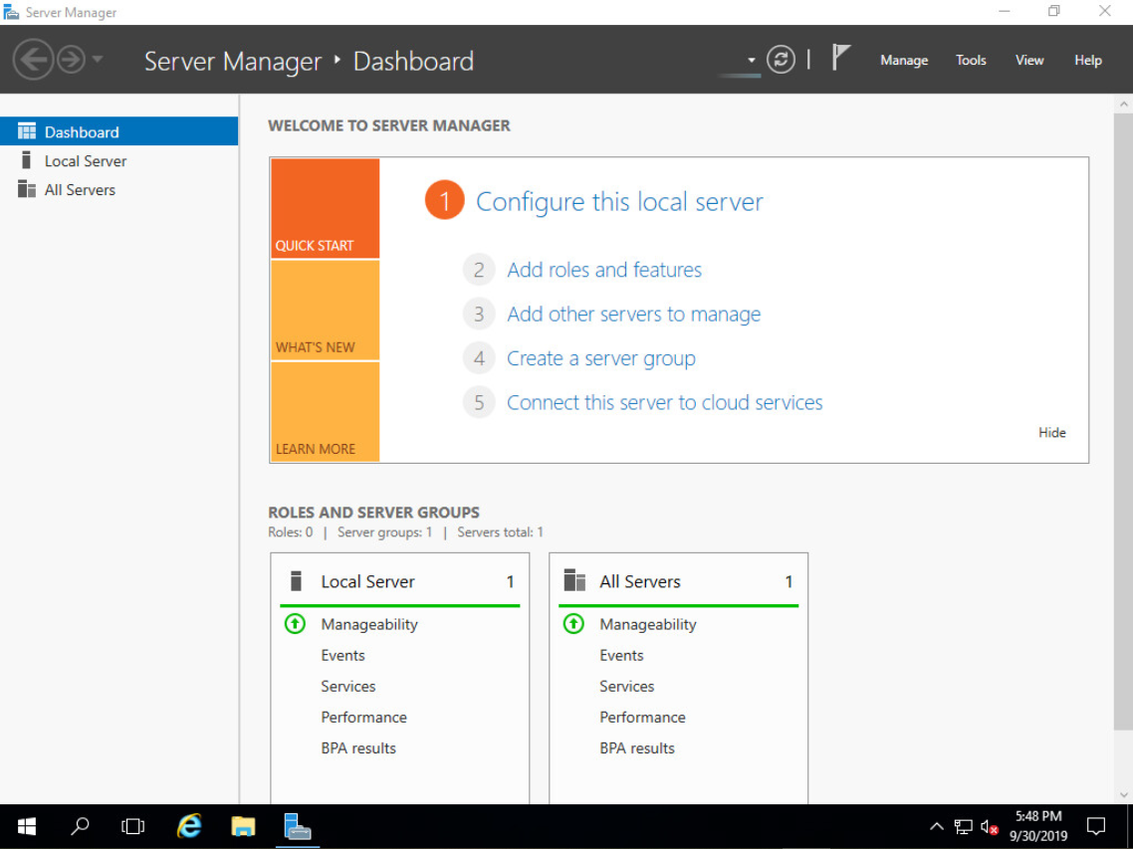

Once I get mouse access, I can begin installing features so we can get our project going on the server! I could probably struggle though with the keyboard, but I really don't want to ;)