Kevin Kaminski

10/14/19

Created TestProjectXamarin project inside visual studio.

Created the login page below.

This Xamarin project includes a username, passwords entry fields, and a button.

The button will check the username and password texts. The button will show the alerts.

I created 3 folders, some C# and xaml files as well.

Results shown below on the next pages:

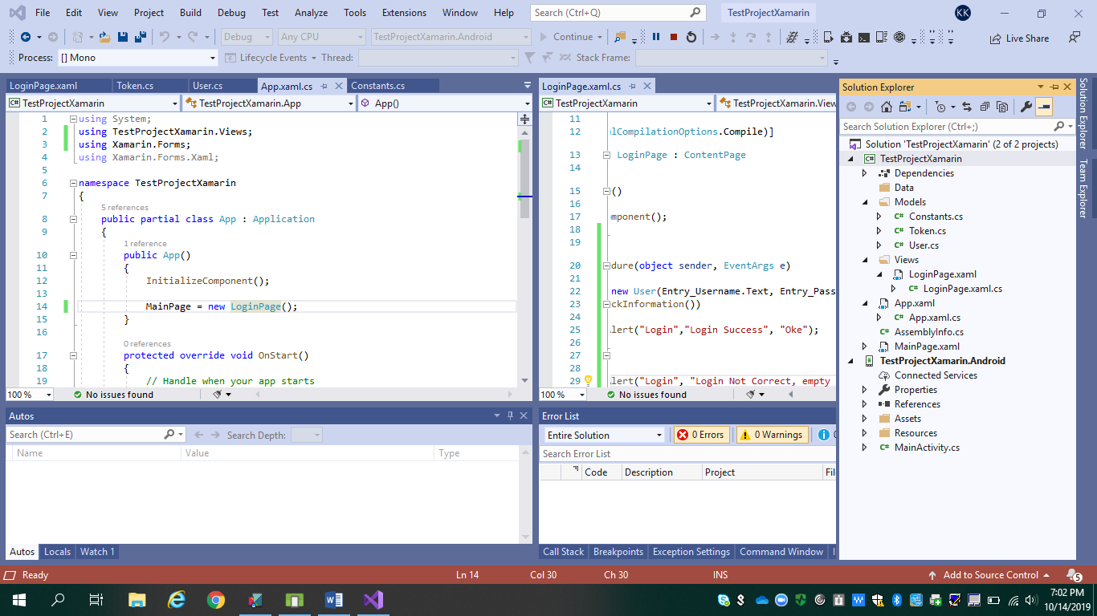

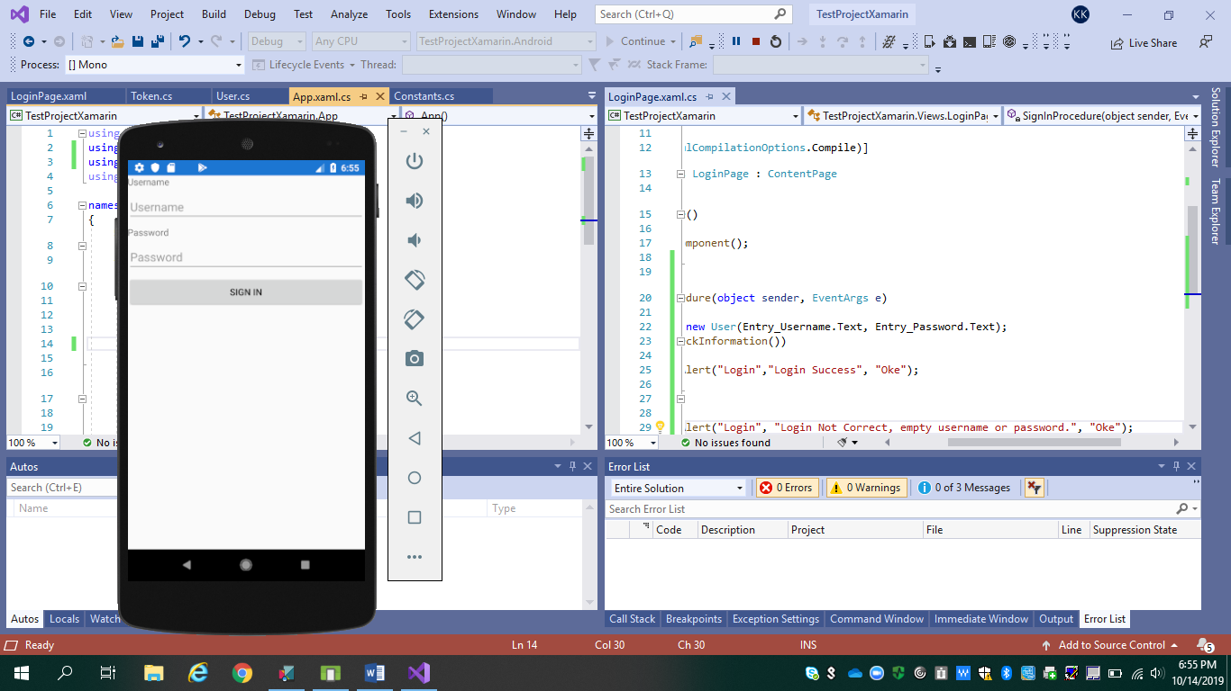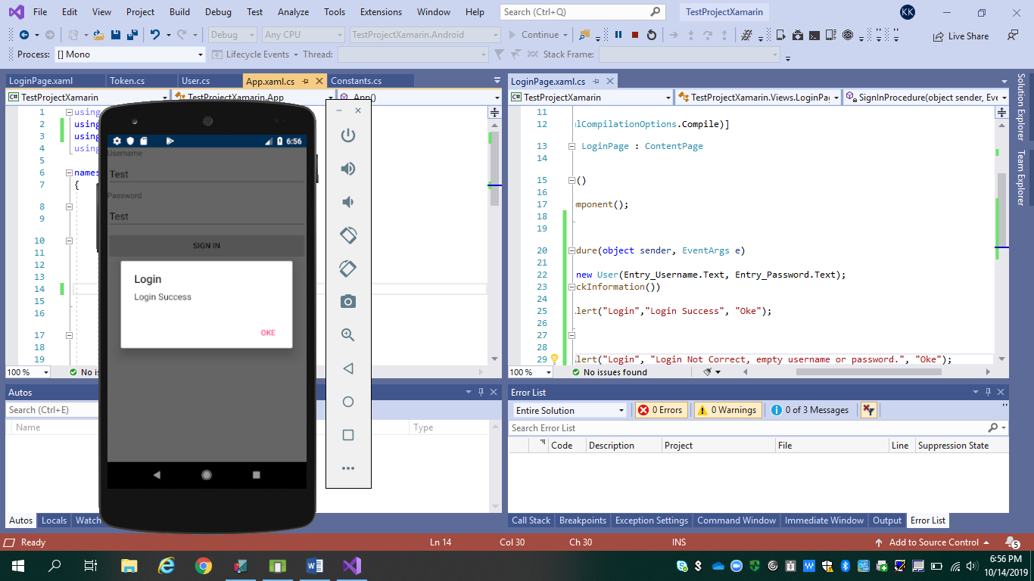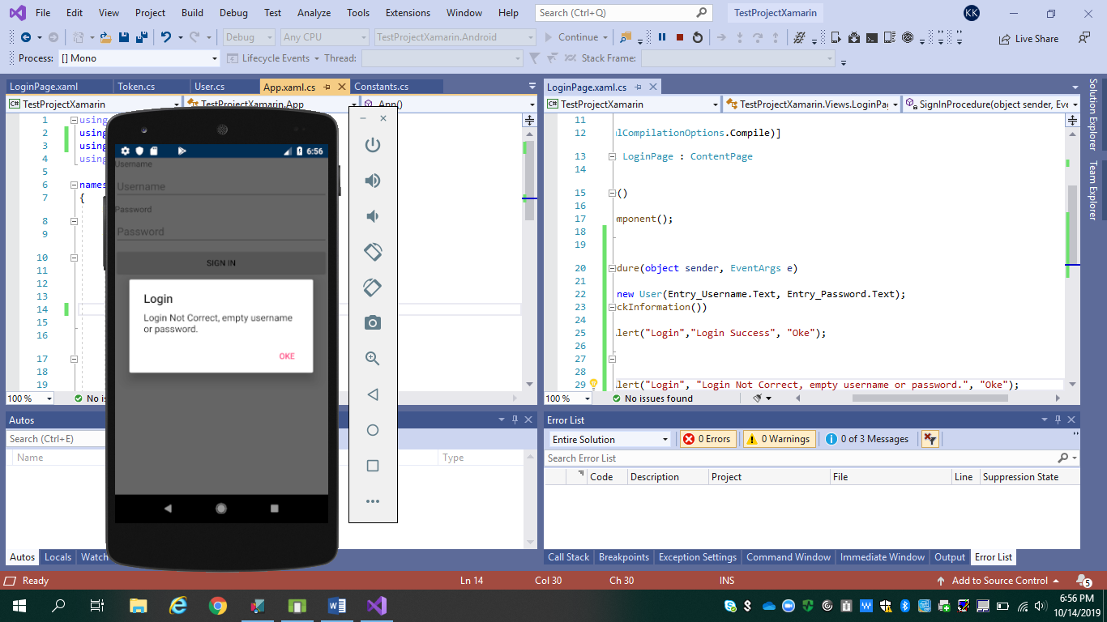

Now I am doing the Login Screen Design.

This will include background color, the padding, a logo, and a margin around all the elements.

Also, I want to show the user when the login is loading by using an activity spinner.

I am going to create a background color and in Android you can set this by using styles.

I got the new screen to show below with an icon. Everything is different, including the layout of the login page.

