Kevin Kaminski

10/13/19

Researching Applebee’s

1. Restaurant name is Applebee’s
2. Style is Family bar and grill oriented and takeout
3. Hours: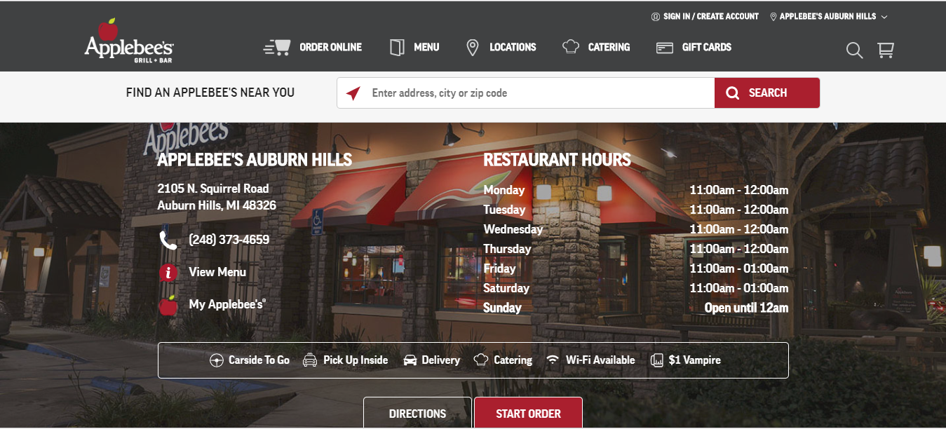
4. Every applebee’s is different. Will walk into the one in Auburn Hills to find out
5. Every applebee’s is different. Will walk into the one in Auburn Hills to find out
6. Booths and chairs
7. Yes
8. 2105 N. Squirrel Road, Auburn Hills, MI 48326
9. (248) 373-4659
10. Not far
11. Has 3 stars according to Yelp

<https://www.yelp.com/biz/applebees-grill-bar-auburn-hills-2>

1. Applebee's Neighborhood Grill & Bar offers a lively casual dining experience combining simple, craveable American fare, classic drinks and local drafts. Applebee's are known for their fun and family-friendly neighborhood atmosphere along with signature grill & bar menu items that guests can only get at Applebee's.
2. AppleBee’s has vegan options found here: <https://veganrestaurantguide.wordpress.com/tag/applebees/>  
   PPETIZERS. Chips & Salsa. TOPPERS. Grilled Onions. SIDES. Baked Potato (plain) French Fries. ...SALADS WITHOUT DRESSING. House Salad (no cheese, no dressing) Fiesta Chicken Chopped Salad (no chicken, no cheese, no dressing) ...SALAD DRESSINGS. Fat-Free Italian. Champagne Vinaigrette. SAUCES. Pico de Gallo. Southern Barbecue.  
   Allergy information is found here: <https://www.applebees.com/en/nutrition/allergen-info>  
   Their website reads the following relating to allergy information: “Because we have multiple sources of allergens in our shared cooking and prep areas, including common fryer oil, we are unable to guarantee that any menu item can be completely free of allergens. In addition, we use highly refined soybean oil in our fryers, which the FDA exempts from being labeled an allergen. Due to the complexity of our ingredients, other allergenic foods may be present in a menu item, but not declared on this section or menu.”
3. Catering options found here: <https://www.applebees.com/en/catering>  
   Catering menu found here: <https://www.applebees.com/en/catering/menu>  
   You can order food online and cater that way
4. Some Applebee’s have outdoor seating. The one in Auburn Hills does not.
5. The restaurant does have handicap parking spaces
6. Applebee’s does not allow you to make reservations. It’s a first come, first serve restaurant. However, you can call ahead to ask about combining empty tables for bigger parties and see what they say.

<https://www.yelp.com/biz/applebees-grill-bar-auburn-hills-2>