Kevin Kaminski

11/27/19

I was tasked with producing HTML Code for Restaurant Signup. Below is the code I came up with on November 16th:

HTML Code for Restaurant Signup

<%@ Page Language="C#" AutoEventWireup="true" CodeBehind="reServe-RestaurantSignUp.aspx.cs" Inherits="ReServeAPI_v2._0.reServe_RestaurantSignUp" %>

<!DOCTYPE html>

<html xmlns="http://www.w3.org/1999/xhtml">

<head runat="server">

    <title></title>

</head>

<body>

    <form id="form1" runat="server">

        <div>

            &nbsp;&nbsp;&nbsp;&nbsp;&nbsp;&nbsp;&nbsp;&nbsp;&nbsp;&nbsp;&nbsp;&nbsp;&nbsp;&nbsp;&nbsp;&nbsp;&nbsp;&nbsp;&nbsp;&nbsp;&nbsp;&nbsp;&nbsp;&nbsp;&nbsp;&nbsp;&nbsp;&nbsp;&nbsp;&nbsp;&nbsp;&nbsp;&nbsp;

            <asp:Label ID="RestaurantSignUp" runat="server" Text="Restaurant SignUp"></asp:Label>

        </div><br/>

        <div><asp:Label ID="AdminEmail" runat="server" Text="Admin Email"></asp:Label>

            <div><asp:TextBox ID="AdminEmailEntry" runat="server"></asp:TextBox></div>

            <br/>

        </div>

            <div><asp:Label ID="AdminPassword" runat="server" Text="Password"></asp:Label>

            <div><asp:TextBox ID="AdminPasswordEntry" runat="server"></asp:TextBox></div><br/>

                <div><asp:Label ID="RepeatPassword" runat="server" Text="Repeat Password"></asp:Label>

            <div><asp:TextBox ID="RepeatPasswordEntry" runat="server"></asp:TextBox></div><br/>

                    <div><asp:Label ID="RestaurantName" runat="server" Text="Restaurant Name"></asp:Label>

            &nbsp;&nbsp;&nbsp;&nbsp;&nbsp;&nbsp;&nbsp;<asp:TextBox ID="RestaurantNameEntry" runat="server"></asp:TextBox>

                        <div><asp:Label ID="RestaurantAddress" runat="server" Text="Address"></asp:Label>

            &nbsp;&nbsp;&nbsp;&nbsp;&nbsp;&nbsp;&nbsp;&nbsp;&nbsp;&nbsp;&nbsp;&nbsp;&nbsp;&nbsp;&nbsp;&nbsp;&nbsp;&nbsp;&nbsp;&nbsp;

            <asp:TextBox ID="RestaurantAddressEntry" runat="server"></asp:TextBox>

                            <div><asp:Label ID="RestaurantPhoneNumber" runat="server" Text="Phone Number"></asp:Label>

            &nbsp;&nbsp;&nbsp;&nbsp;&nbsp;&nbsp;&nbsp;&nbsp;&nbsp;&nbsp;

            <asp:TextBox ID="RestaurantPhoneNumberEntry" runat="server"></asp:TextBox>

                                        &nbsp;&nbsp;&nbsp;&nbsp;&nbsp;&nbsp;&nbsp;&nbsp;&nbsp;&nbsp;&nbsp;&nbsp;&nbsp;&nbsp;&nbsp;&nbsp;&nbsp;&nbsp;&nbsp;&nbsp;&nbsp;

                                        <asp:Label ID="Description" runat="server" Text="Description"></asp:Label>

                                <div><asp:Label ID="RestaurantHours" runat="server" Text="Hours"></asp:Label>

            &nbsp;&nbsp;&nbsp;&nbsp;&nbsp;&nbsp;&nbsp;&nbsp;&nbsp;&nbsp;&nbsp;&nbsp;&nbsp;&nbsp;&nbsp;&nbsp;&nbsp;&nbsp;&nbsp;&nbsp;&nbsp;&nbsp;&nbsp;&nbsp;

            <asp:TextBox ID="RestaurantHoursEntry" runat="server"></asp:TextBox>

                                    &nbsp;&nbsp;&nbsp;&nbsp;&nbsp;&nbsp;&nbsp;&nbsp;&nbsp;&nbsp;&nbsp;&nbsp;&nbsp;&nbsp;&nbsp;&nbsp;&nbsp;&nbsp;&nbsp;&nbsp;&nbsp;

                                <asp:TextBox ID="DescriptionEntry" runat="server" Height="41px" Width="159px"></asp:TextBox>

                                    <div><asp:Label ID="RestaurantTypeofFood" runat="server" Text="Type of Food"></asp:Label>

            &nbsp;&nbsp;&nbsp;&nbsp;&nbsp;&nbsp;&nbsp;&nbsp;&nbsp;&nbsp;&nbsp;&nbsp;

            <asp:TextBox ID="RestaurantTypeofFoodEntry" runat="server"></asp:TextBox>

                                        &nbsp;&nbsp;&nbsp;&nbsp;&nbsp;&nbsp;&nbsp;&nbsp;&nbsp;&nbsp;&nbsp;&nbsp;&nbsp;&nbsp;&nbsp;&nbsp;&nbsp;&nbsp;&nbsp;&nbsp;&nbsp;&nbsp;&nbsp;&nbsp;&nbsp;&nbsp;&nbsp;&nbsp;&nbsp;&nbsp;&nbsp;&nbsp;&nbsp;&nbsp;&nbsp;&nbsp;&nbsp;&nbsp;

                                        <asp:Button ID="NextBtn" runat="server" Text="Next" />

        </div>

    </form>

</body>

</html>

When running this code it shows the following screen in visual studio:

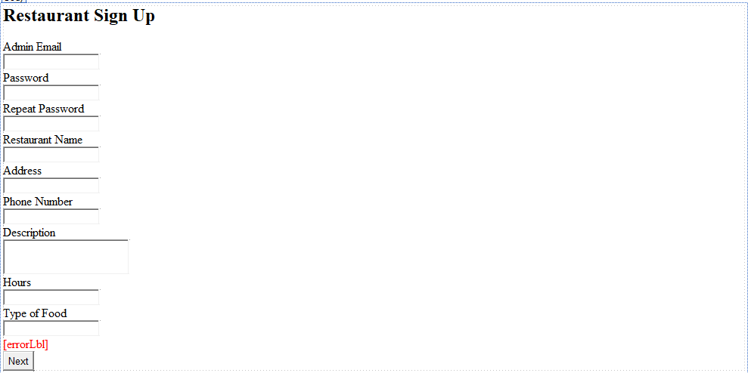

I have also created a C# app that can do calculations. These may be helpful for calculating wait time.

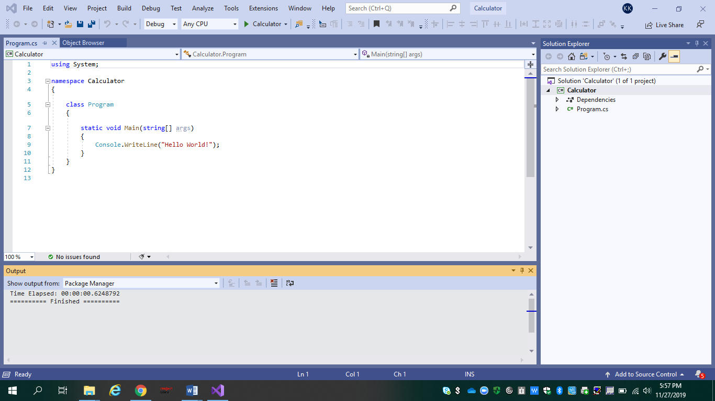

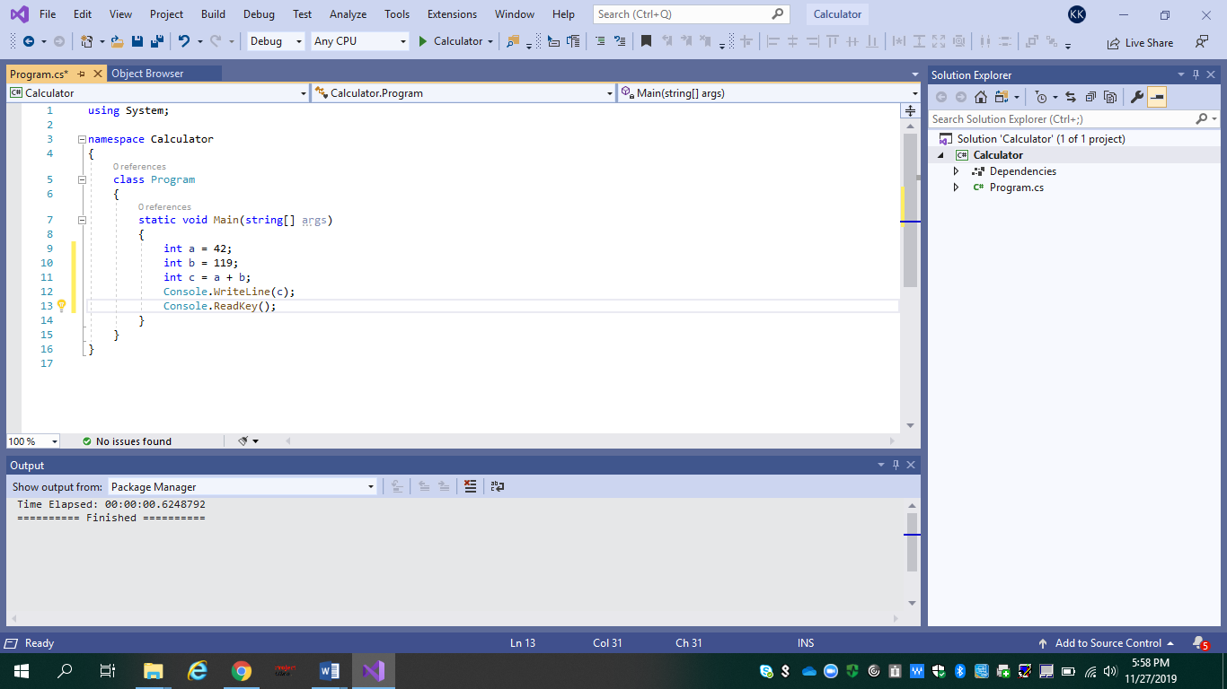

Pressed F5 below and produced this result:

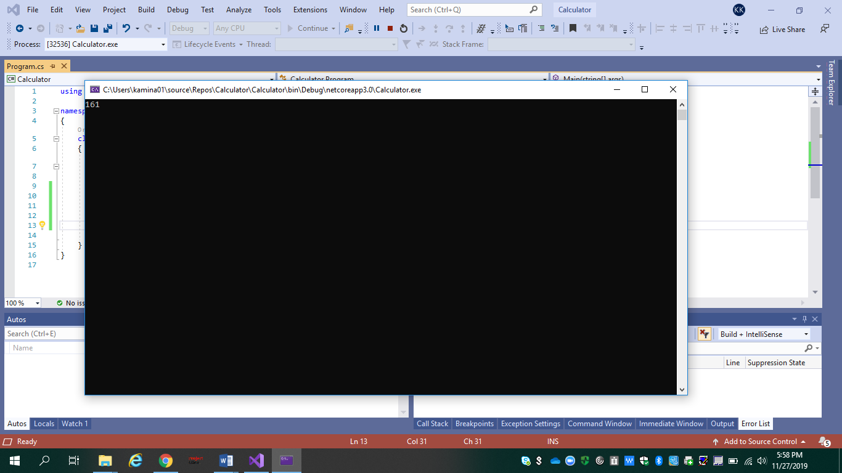

Now I will be adding code to create a calculator

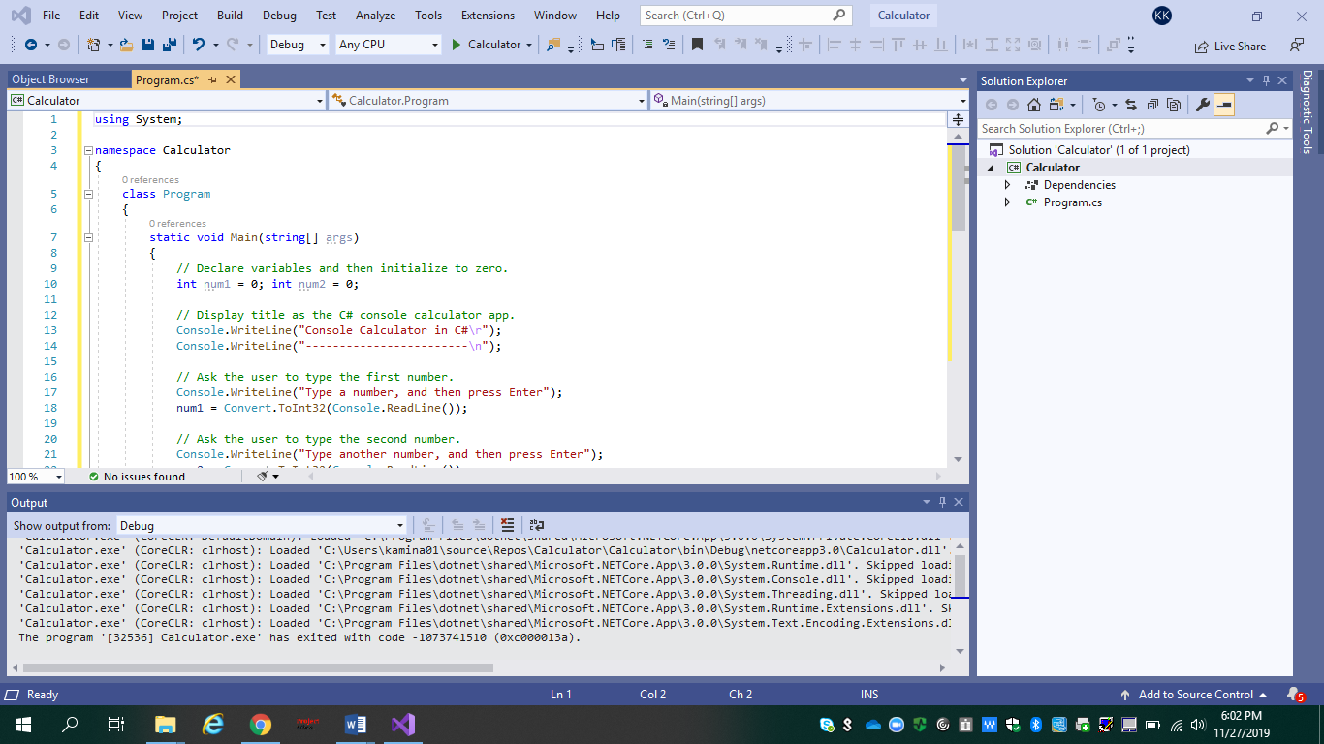

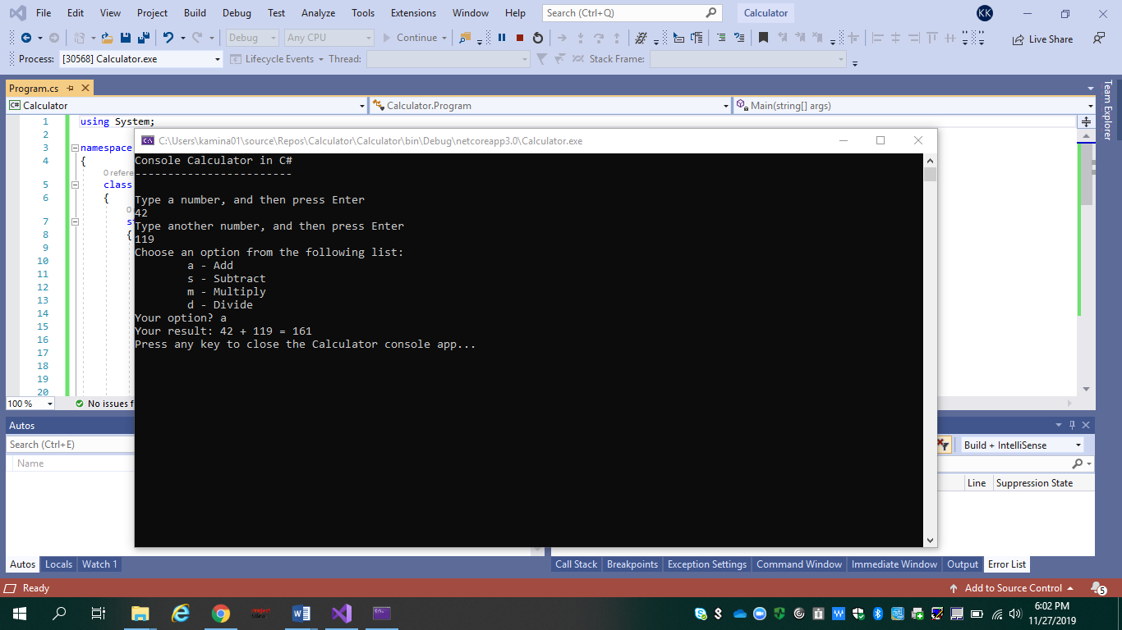

Now I will be adding functionality to the calculator:

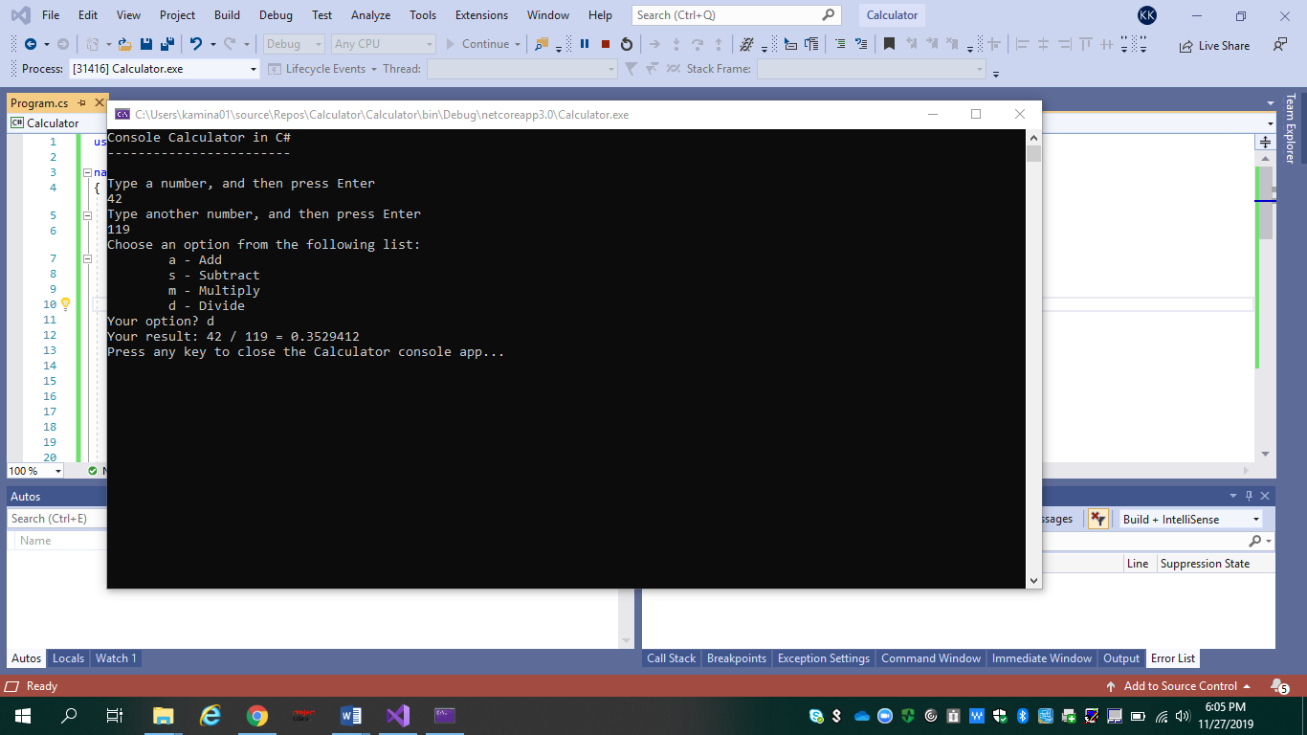

The above shows decimals by using a float variable instead of an int.

However, the app produces only a decimal result. I’ll make a few more tweaks to the code so that the app can calculate decimals too.

I will achieve this by changing each instance of the float variable to double, and to change each instance of the Convert.ToInt32 method to Convert.ToDouble.

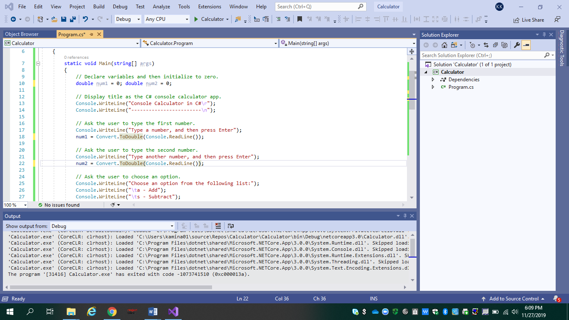

Notice that the app now accepts decimal values and returns a longer decimal numeral as its result below:

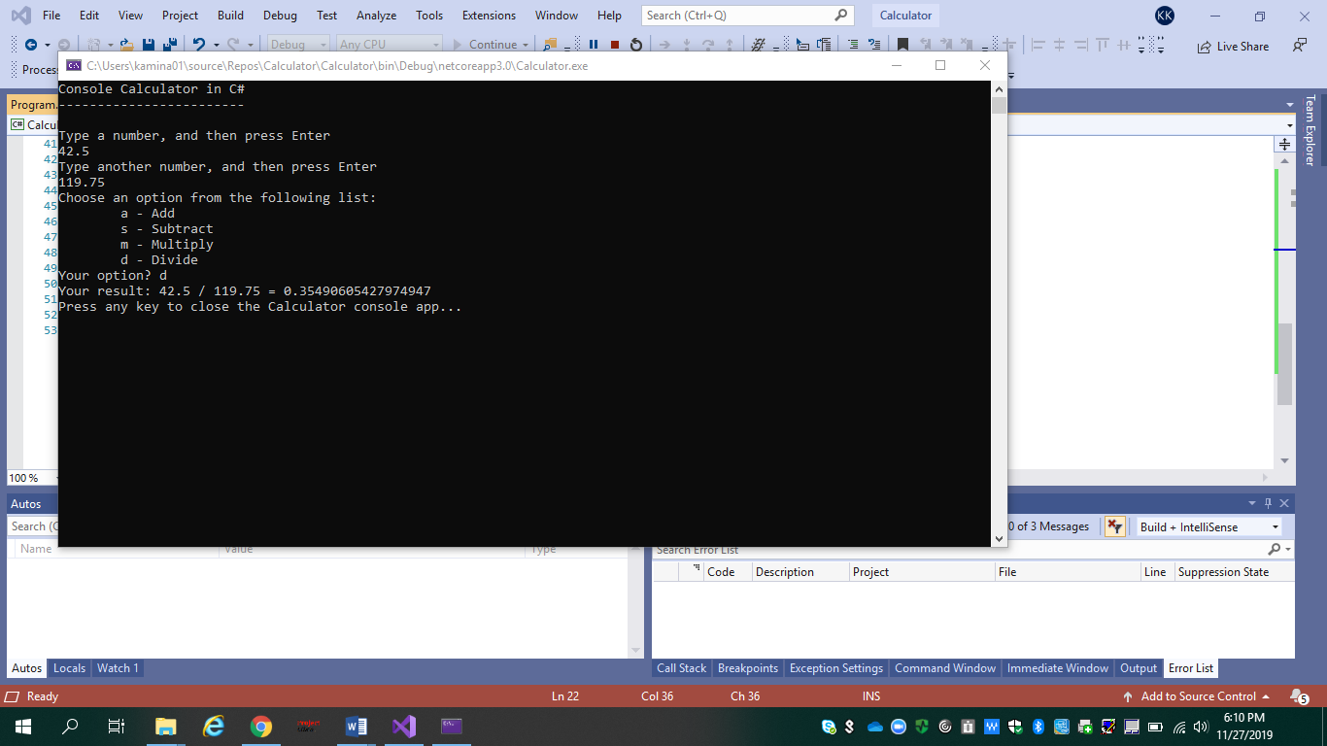

The final result is shown below of my work:

