Kevin Kaminski

09/30/19

Researched for our ReServe project on learning how to use Xamarin and being an expert.   
Created my first Android App with Xamarin below to show my progress of understanding the functionality of Xamarin and how to use it with our team project:

Step 1 is to create a new project and then look for the Project Type menu as mobile

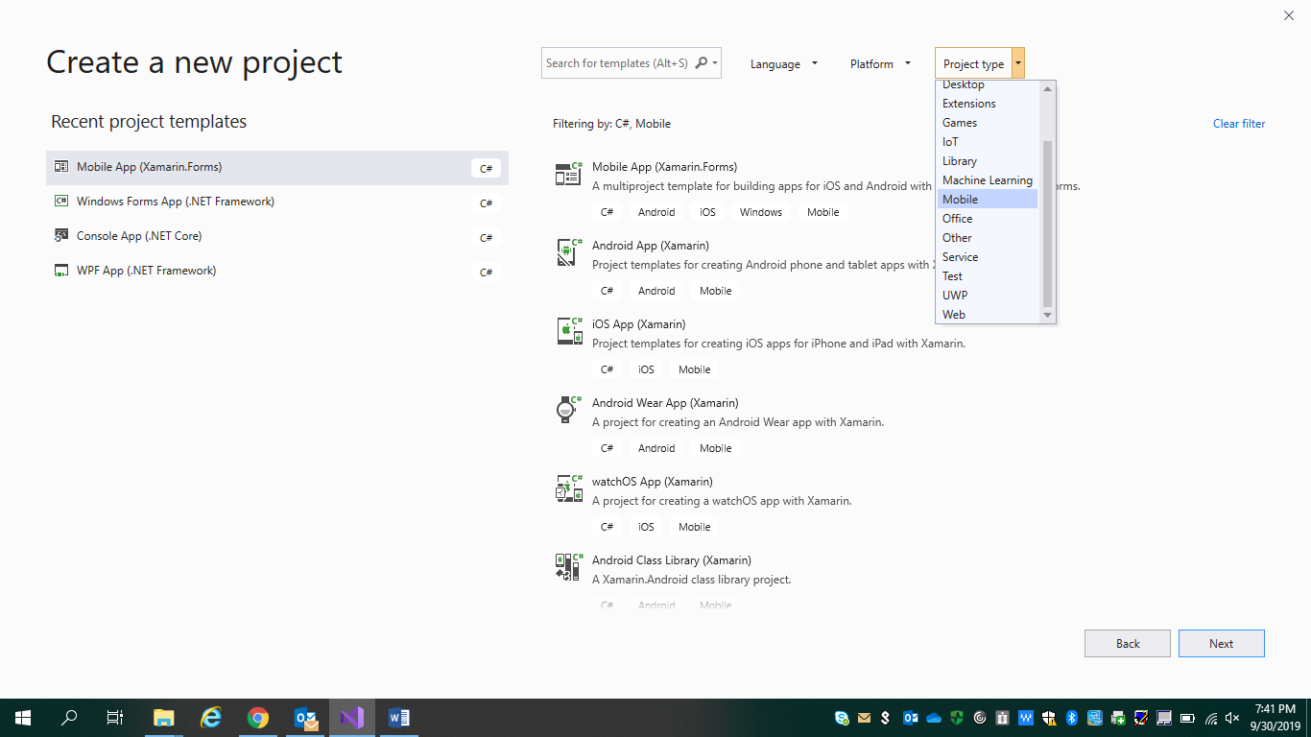

I built a cross platform Android mobile app using Xamarin.Forms as my user interface.

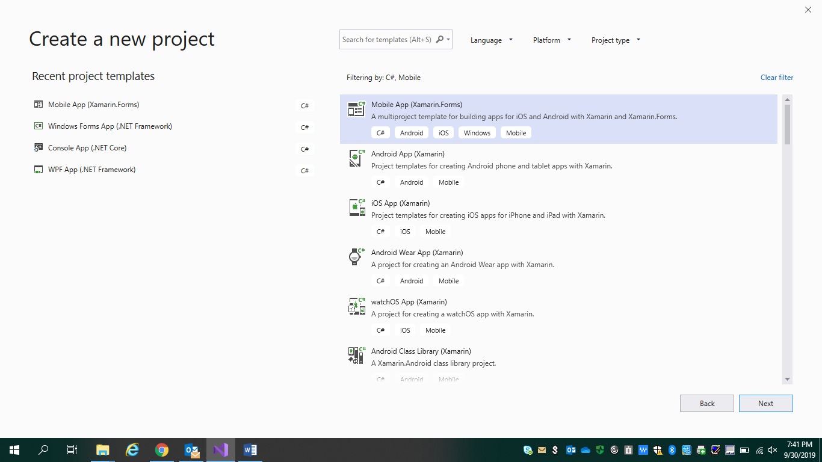

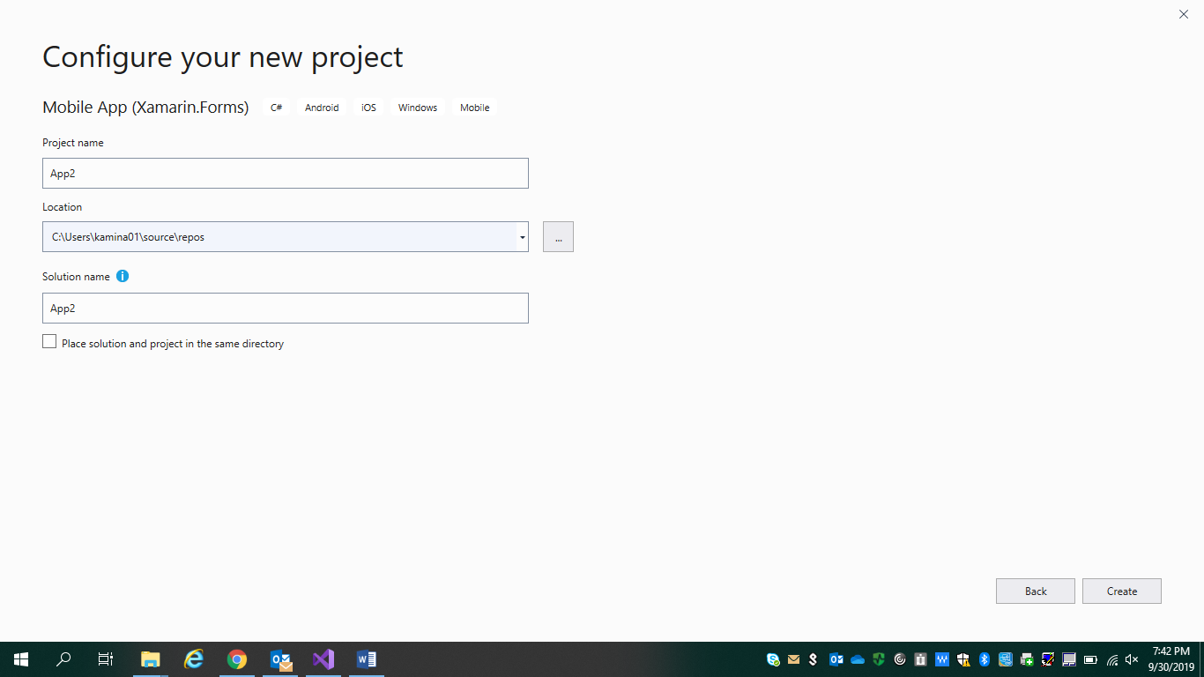

Kept the project default name and hit create.

Below I have options of creating a master application or a tabbed application

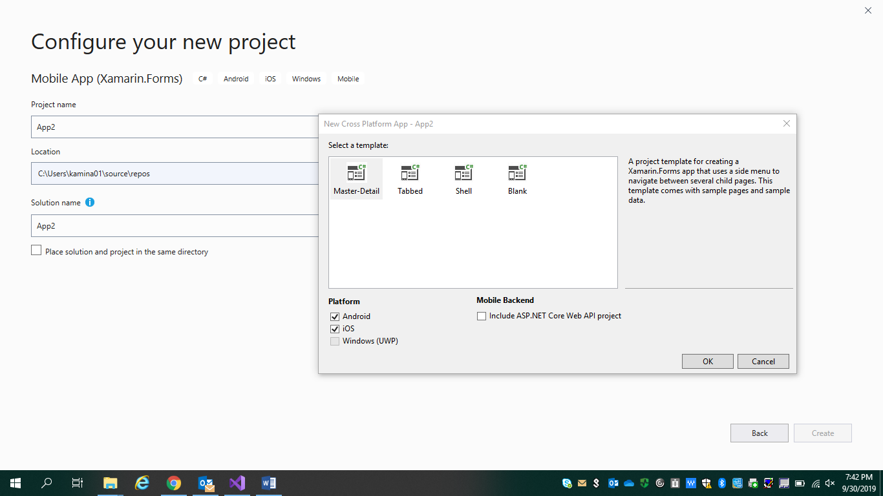

I can even add an ASP.NET Core Web API backend that I can easily debug locally or deploy into Azure or our team will deploy into Kelly’s Virtual Server from Oakland.

I choose to create a blank application and chose to add both Android and iOS.

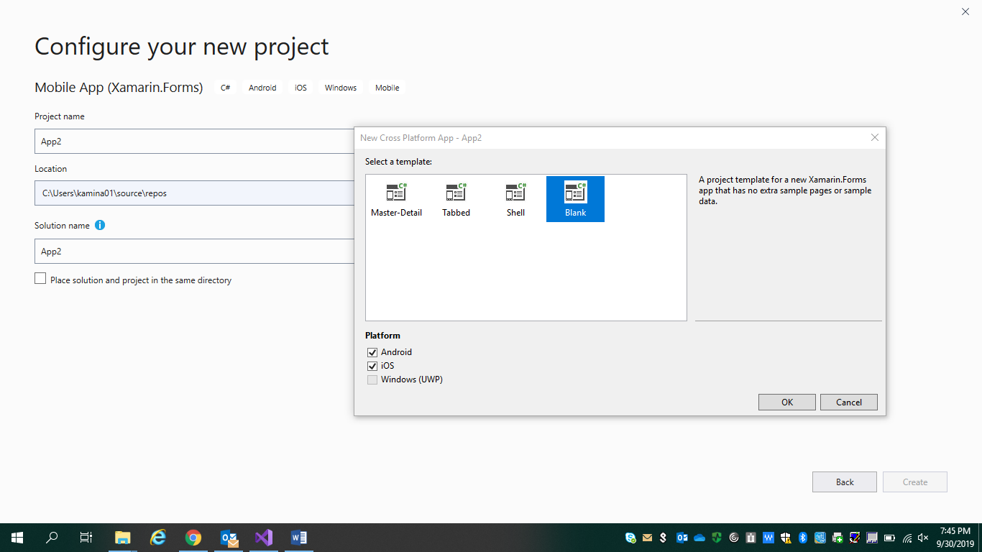

Below I have my project structure with my .NET standard Library with my shared backend business logic and user interface here with Xamarin forums.

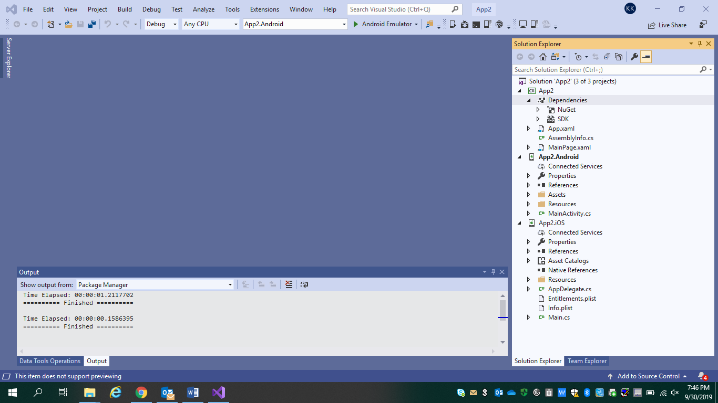

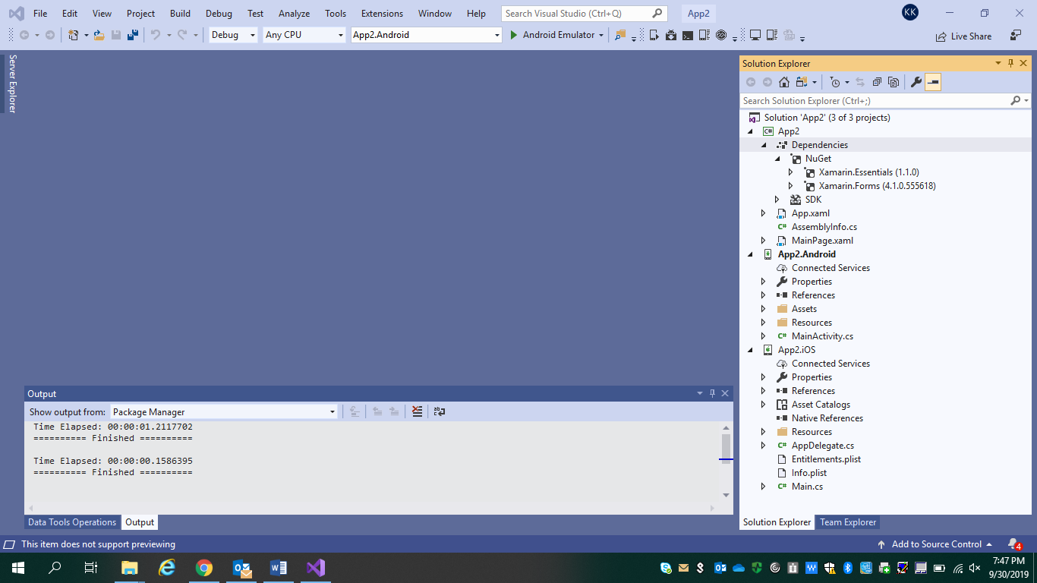

I have my Android and iOS project, so I have all my resources and all the libraries I need, and my MainActivity.cs file.

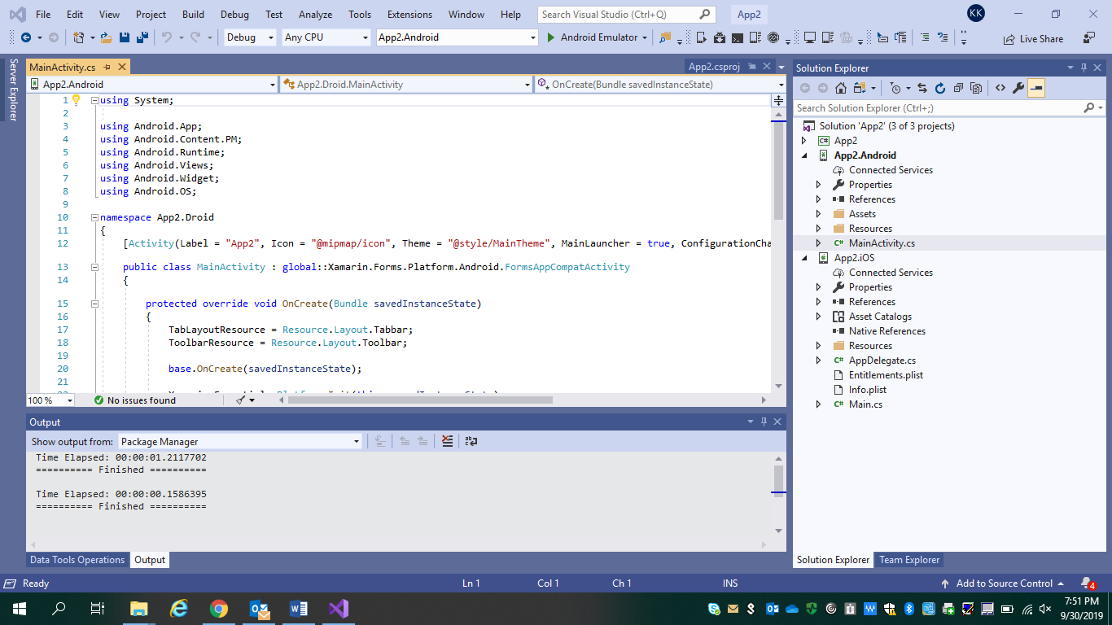

This is the launch point of my application, so I have a little bit of setup here. But the bulk of my setup is here below inside my MainPage.xaml

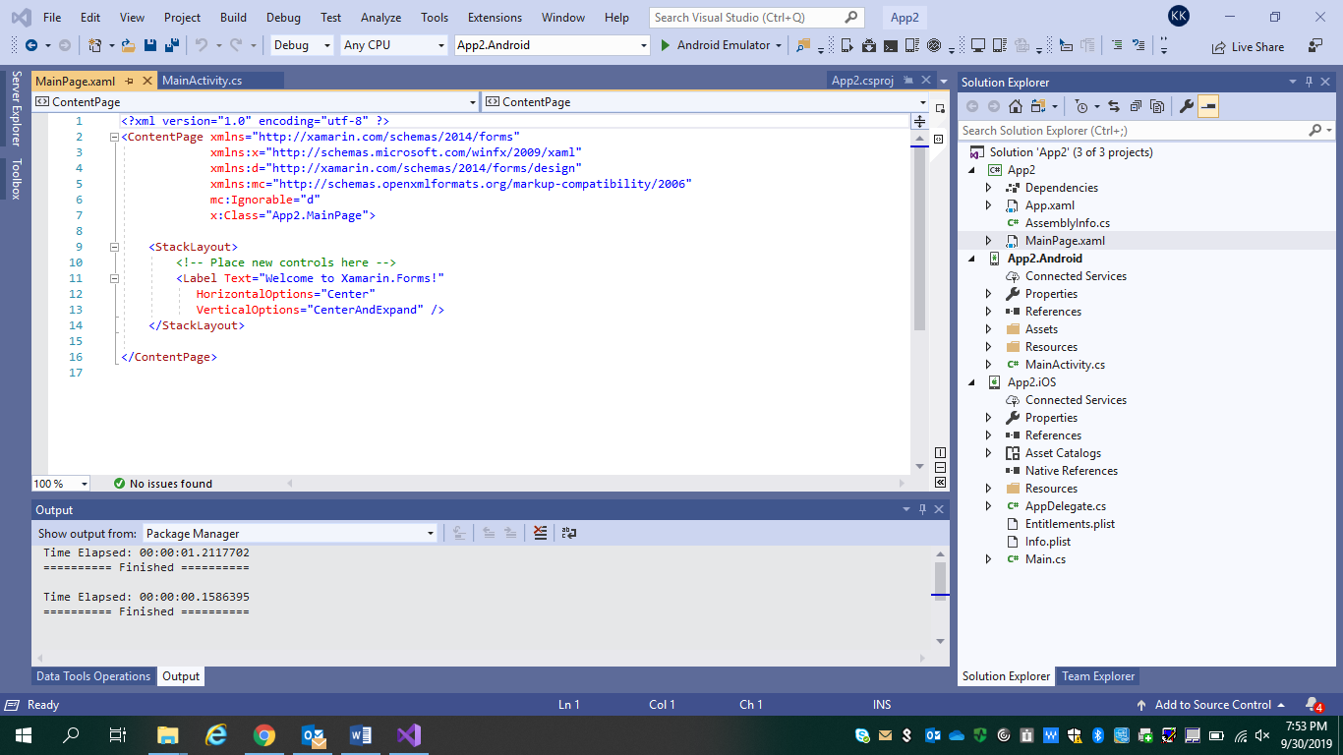

This is the entry point for our ReServe app.

So we have a stack layout that says “Welcome to Xamarin.Forms!” Now I need to compile up my application and deploy it to an emulator.

So inside the debug menu I can see that I have my Android project as the startup and I can launch to the Android emulator or create one.

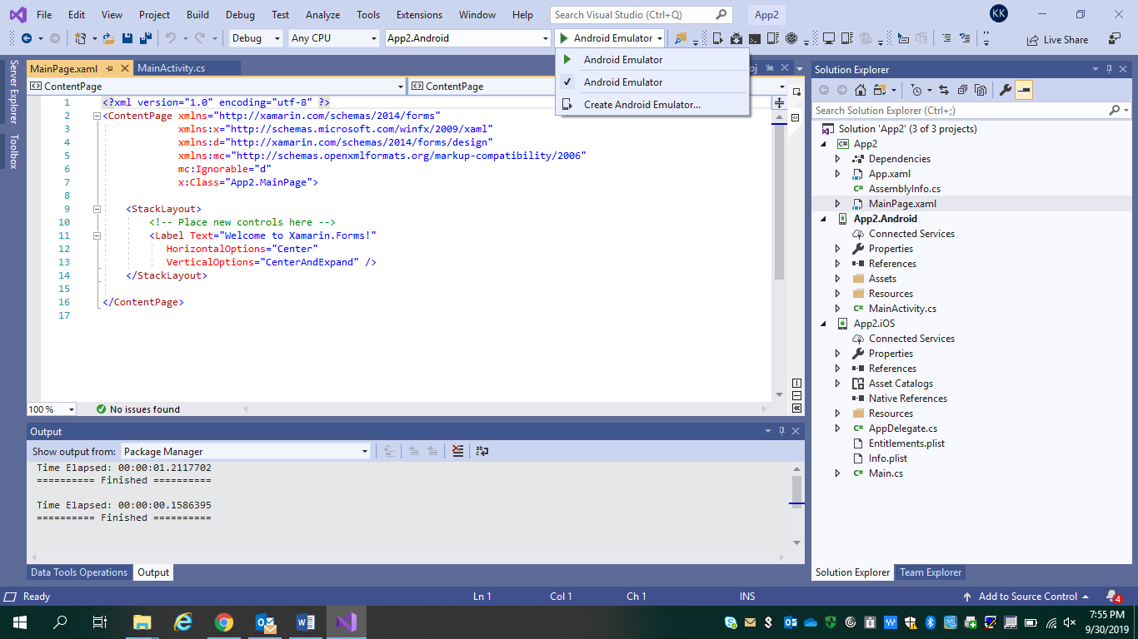

When I installed Visual studio for the first time, there’s no Android emulators. So when I hit debug it launched my android emulator manager below to allow to create my default device:

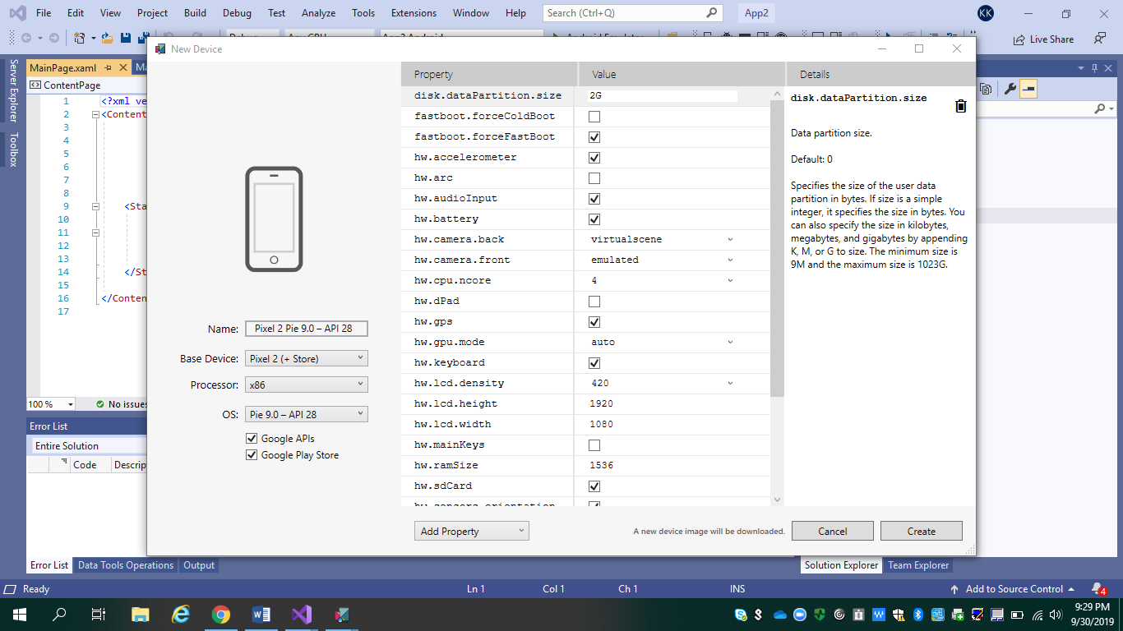

Here I can select different devices and different processor types:

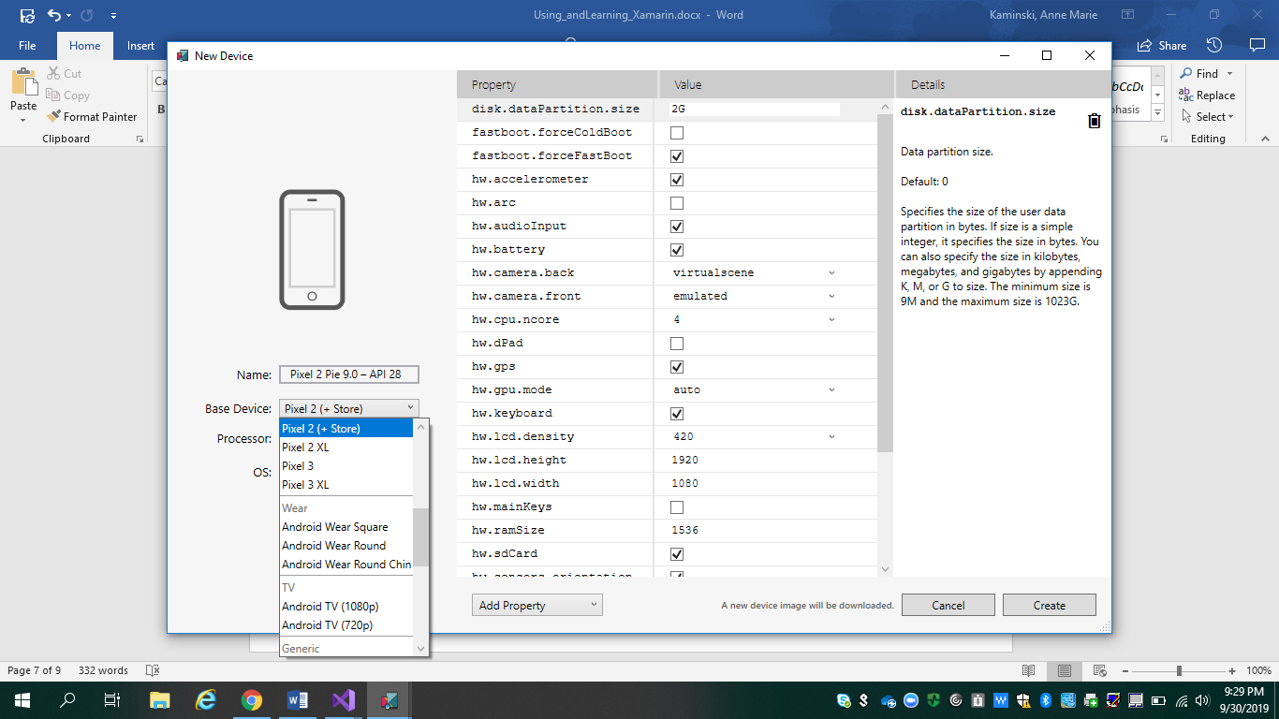

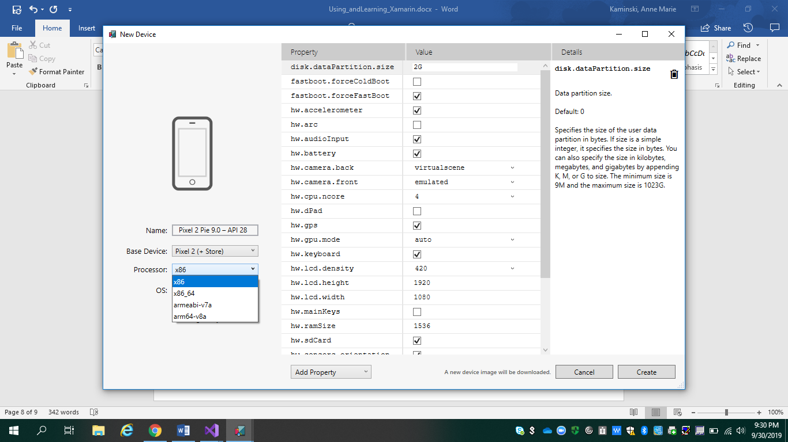

I went with the default for now and hit create which will download any necessary files that I need and create my android emulator. The only change was an X86_64 processor because that worked for me downloading the emulator phone:

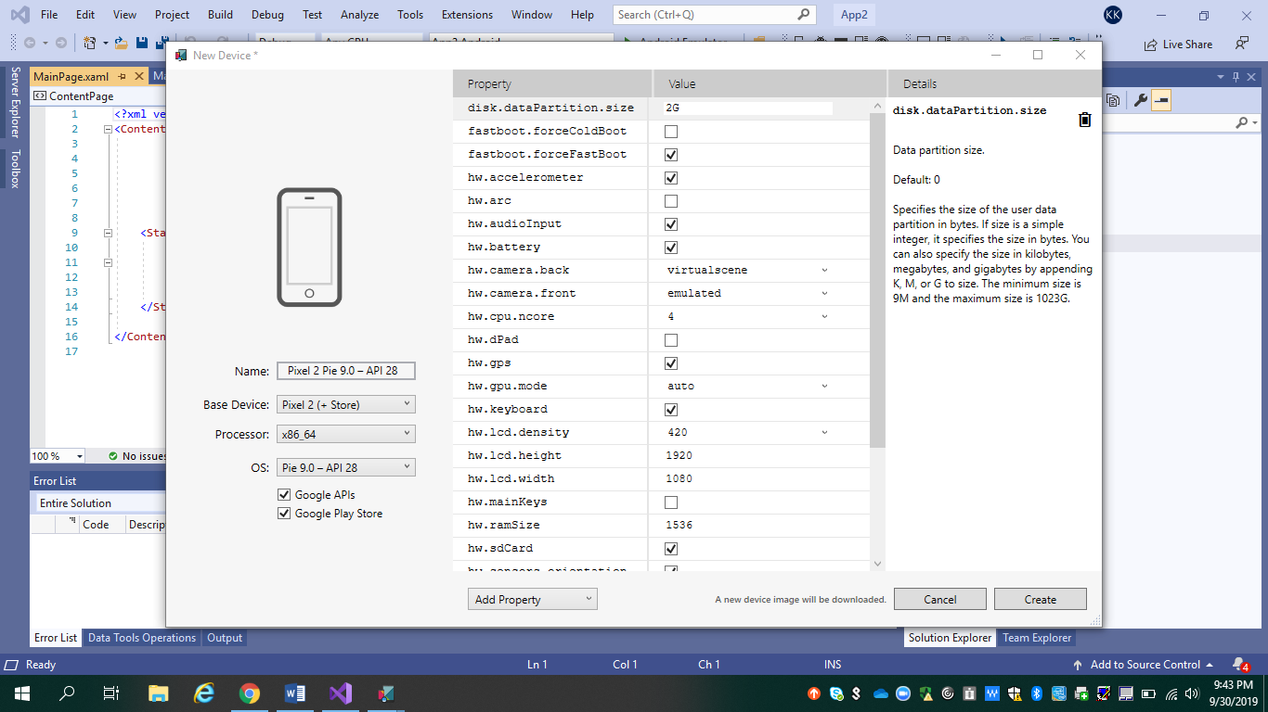

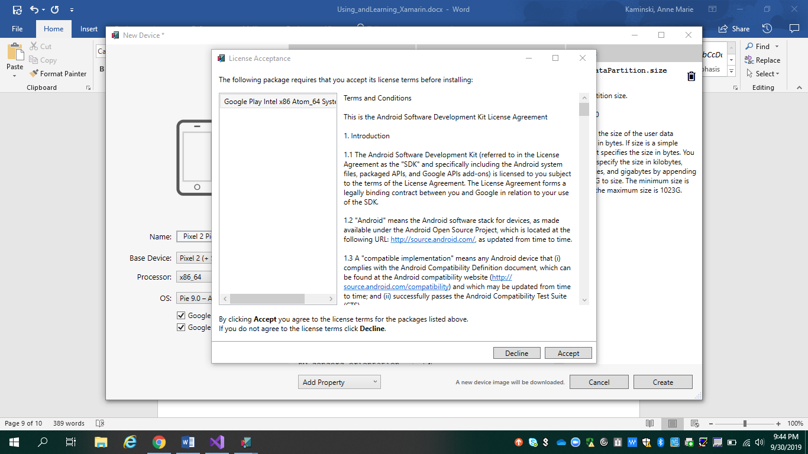

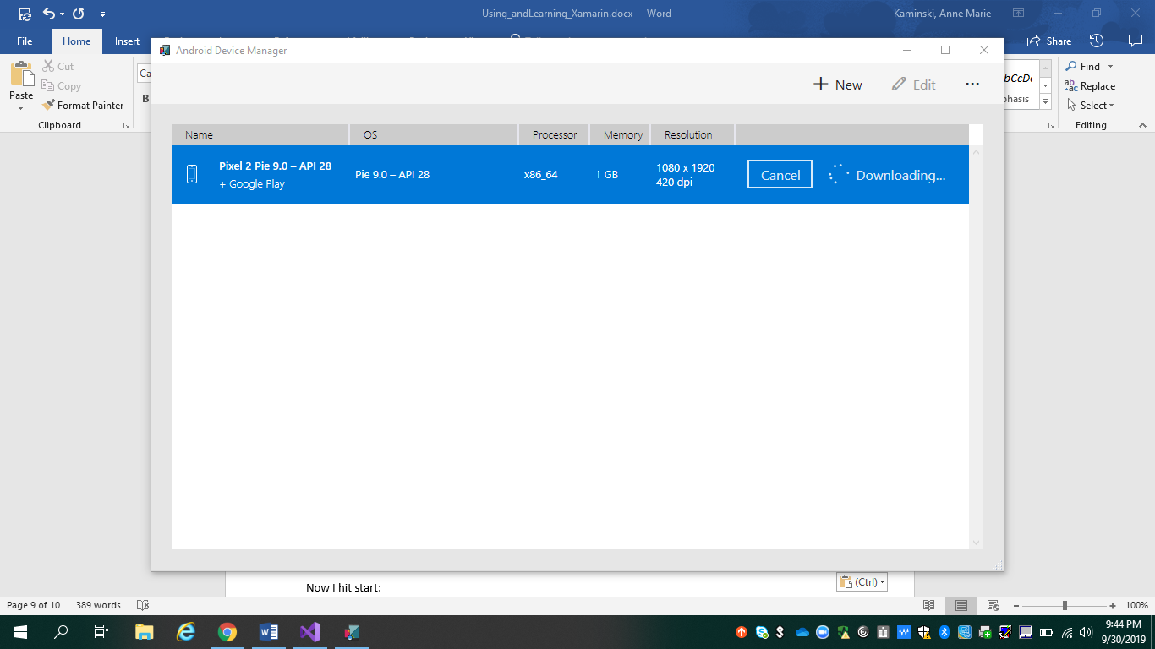

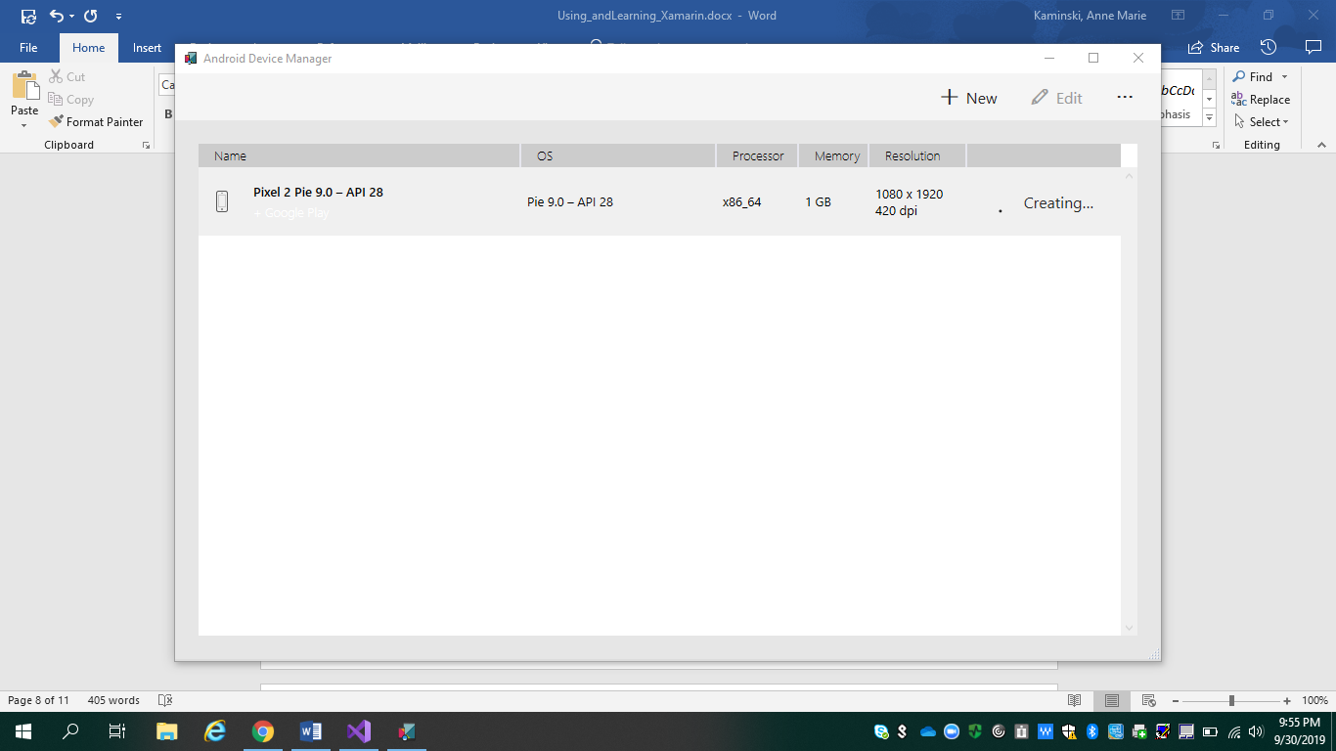

Now I hit start:

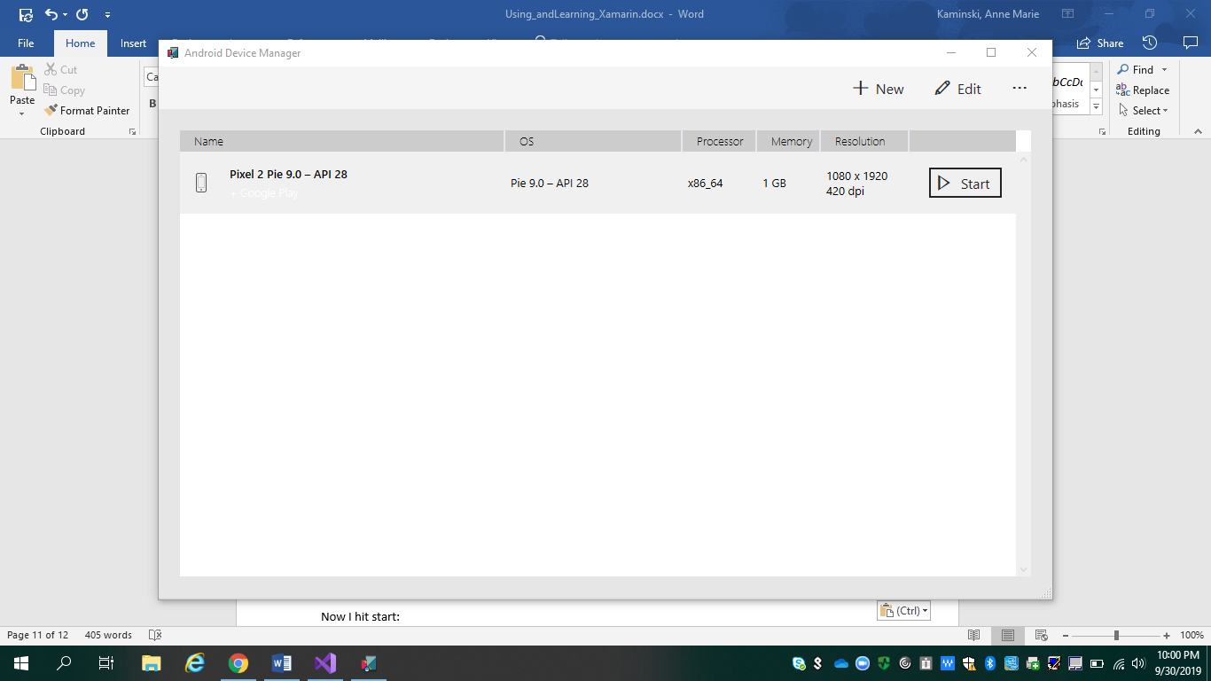

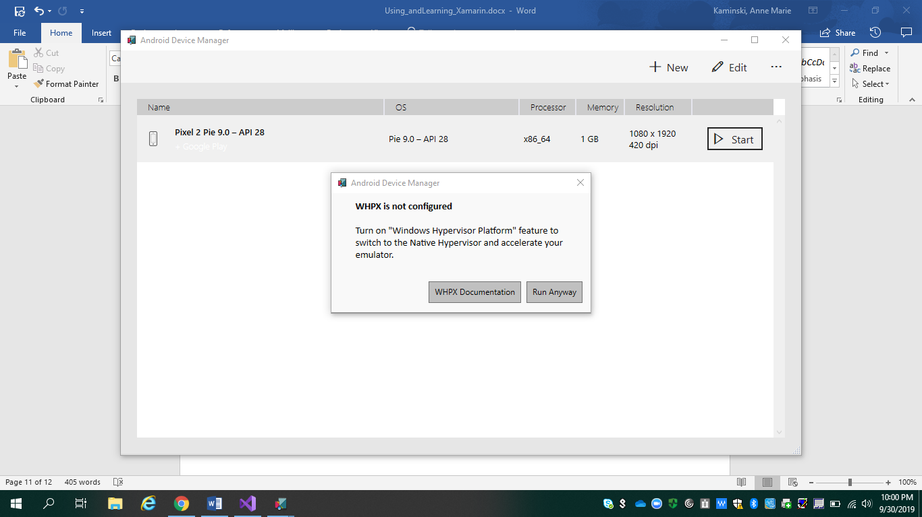https://docs.microsoft.com/en-us/xamarin/android/get-started/installation/android-emulator/hardware-acceleration?tabs=vswin&pivots=windows#hyper-v

Got an error message.

To fix this I turned on Hyper-V feature on my Windows 10 computer laptop

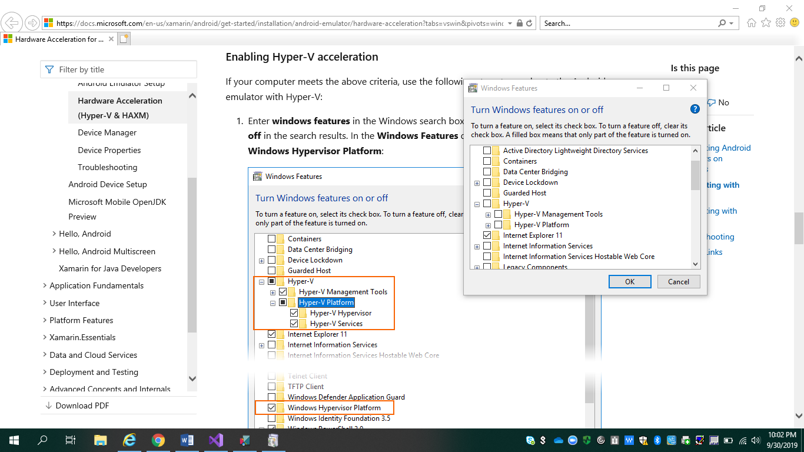

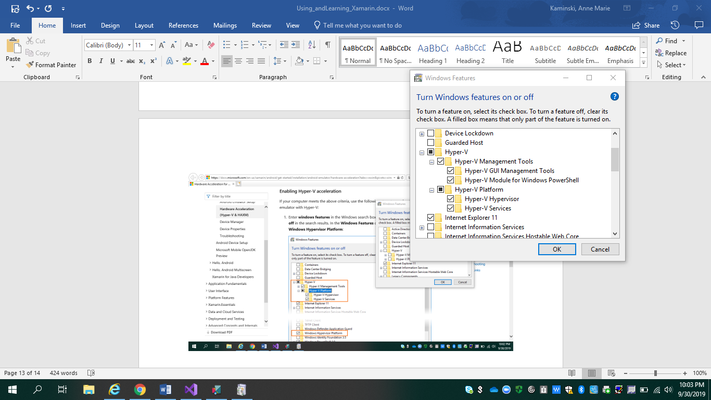

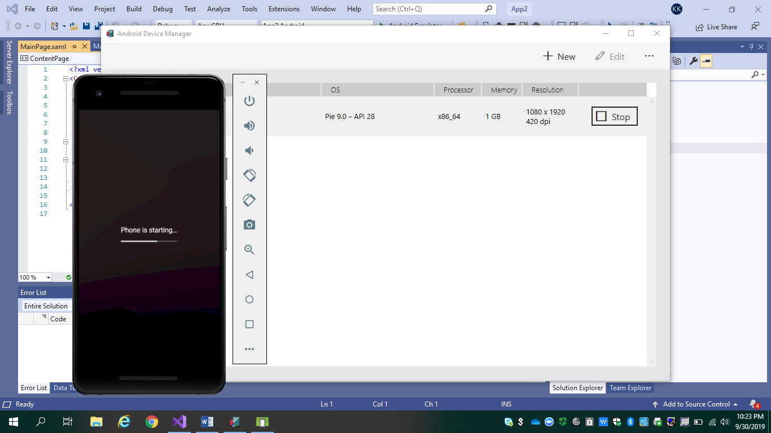

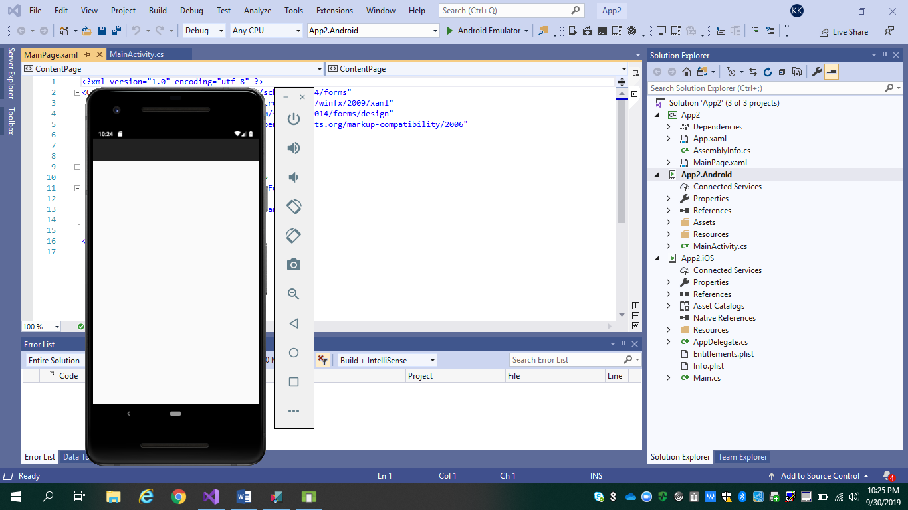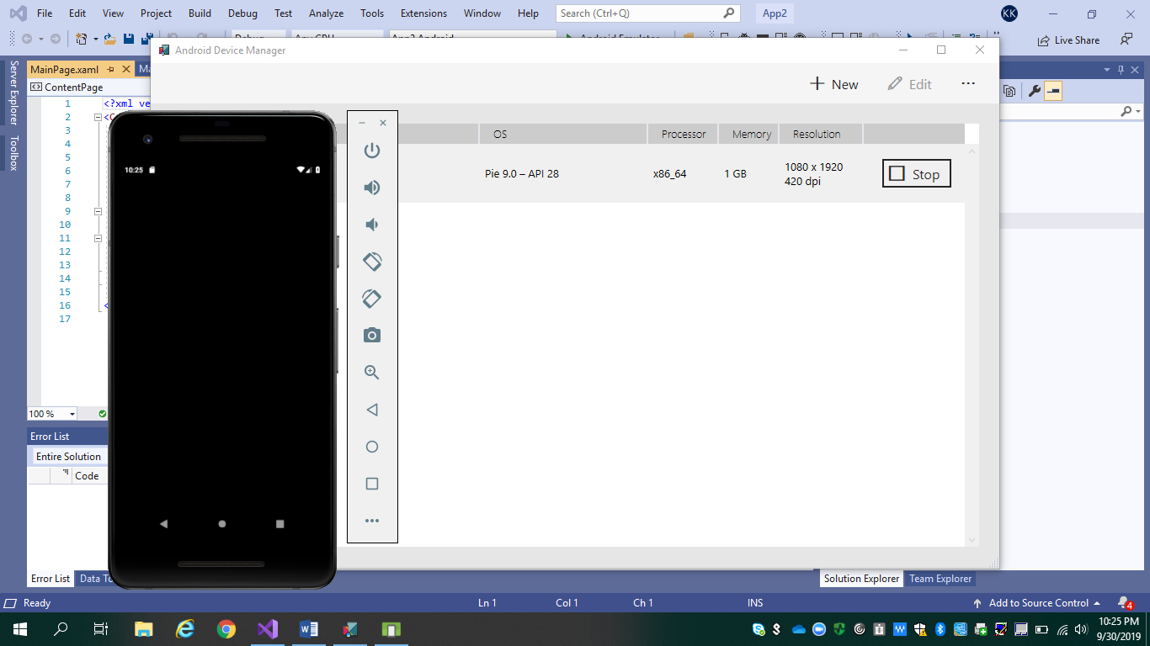

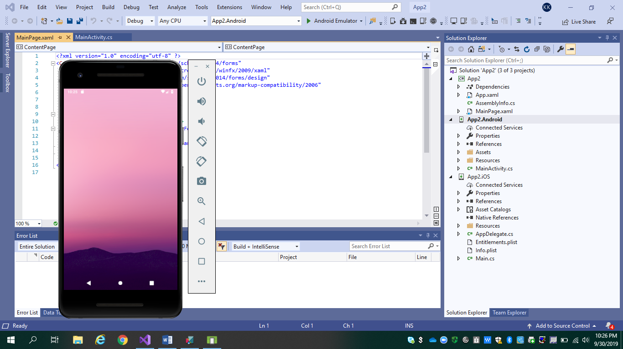

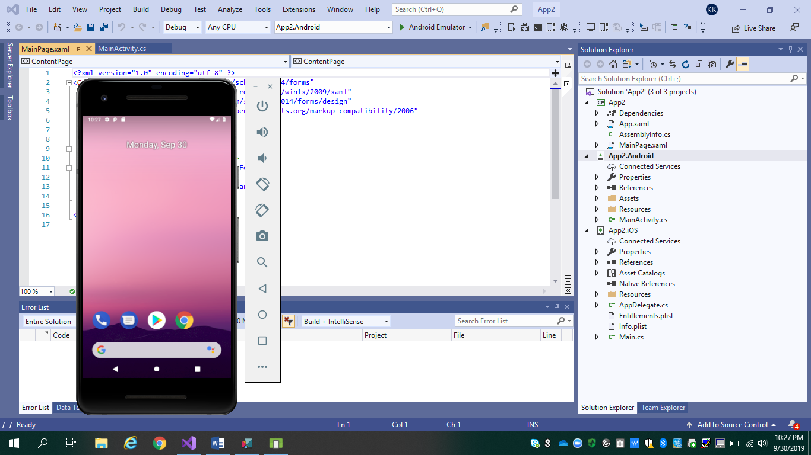

Once the android Emulator starts up I should see it in my drop down menu, and I do below:

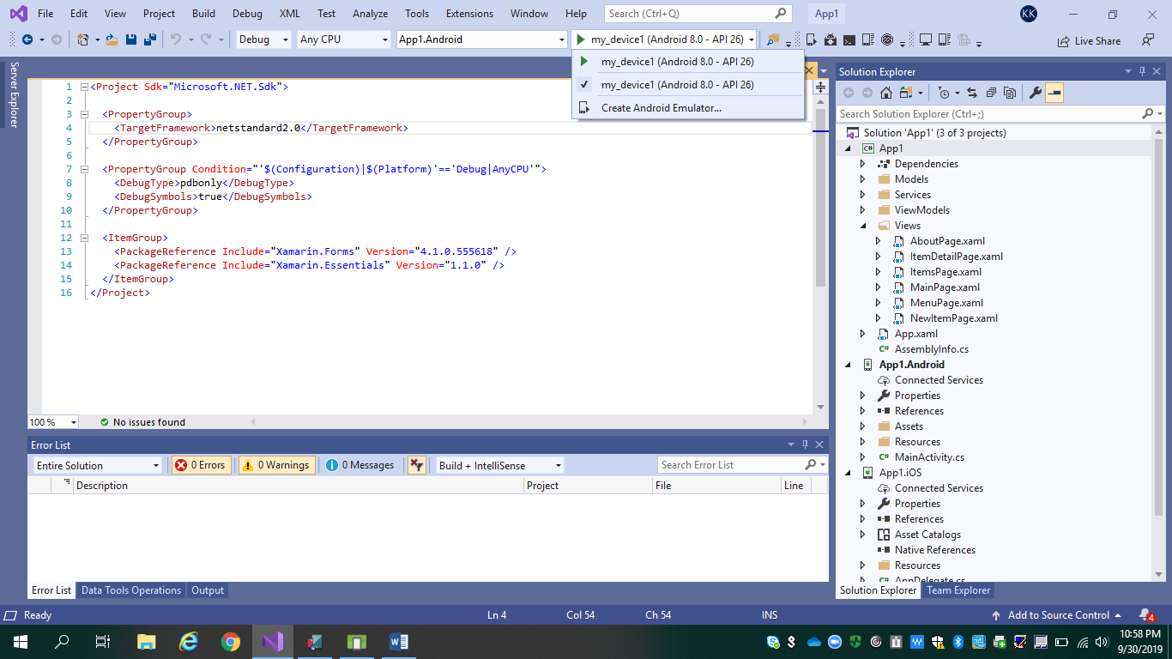

So I gave it a few seconds to full setup. Now that my android emulator is online I see it in my debug menu above.

It’s called my_device1 and all I have to do is hit debug. Now the first time I run, visual studio 2019 will install all the necessary requirements on that android emulator and then deploy to my emulator. I gave it a few seconds to deploy.

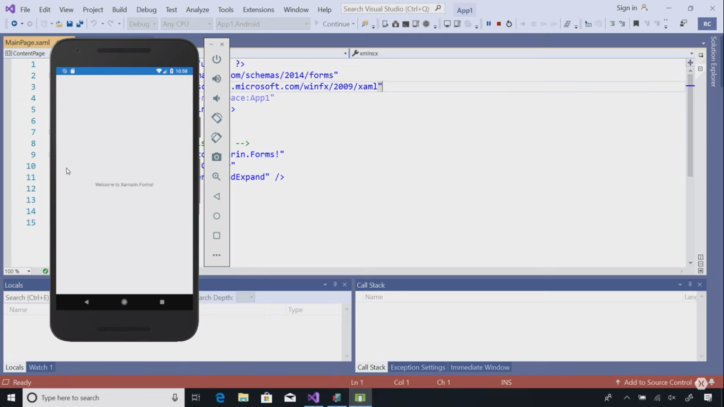

Now here we go from the above my application is launched and as you can see it says “Welcome to Xamarin.Forms!” just like it says inside of my cross platform Xamarin form Xamarin label text “Welcome to Xamarin.Forms!”

There you have it I just deployed my very first android application written in C# and .NET using Xamarin and visual studio 2019.

Helpful research I did below to learn Xamarin and start using it:

<https://docs.microsoft.com/en-us/>

<https://docs.microsoft.com/en-us/xamarin/>

<https://docs.microsoft.com/en-us/xamarin/get-started/installation/?pivots=windows>

<https://docs.microsoft.com/en-us/xamarin/get-started/what-is-xamarin>

<https://docs.microsoft.com/en-us/xamarin/whats-new/>

There’s even 20 exercises with step by step guidance to learn paths and modules in the link below:  
<https://docs.microsoft.com/en-us/learn/browse/?roles=developer&products=xamarin>

<https://docs.microsoft.com/en-us/xamarin/android/get-started/installation/android-sdk?tabs=windows>