Kevin Kaminski

10/30/19

I was tasked with making the following mobile GUI application below. It’s called view reservations and it has text fields and buttons. Picture of html page is below.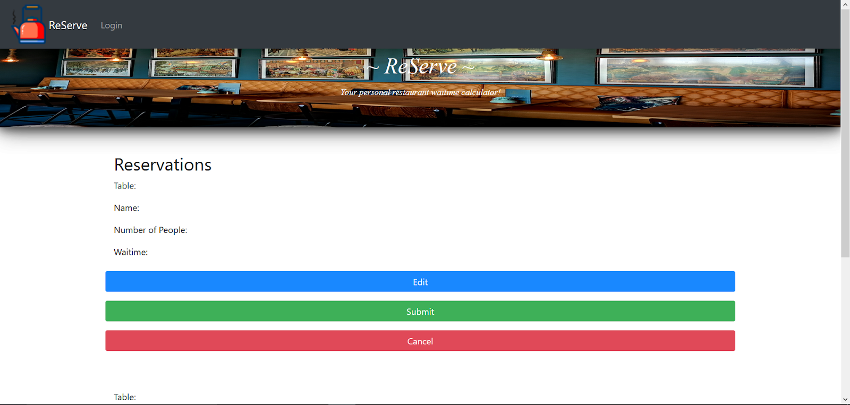

I ran into errors when trying to run the basic layout. But you can see from the picture on the right what I wanted to make is similar to what’s on page 1 of this document. There is still more research on coding with C# inside Visual Studio to be done.

