Kevin Kaminski

09/15/2019

I completed the database responsibilities below:

**DataBase Responsibilities:**

The database should create the following

* 1. Create a Table in SQL that has ID, EmailAddress, Password, RestaurantName, PhoneNumber columns. Please make sure that the EmailAddress and ID are unique data.

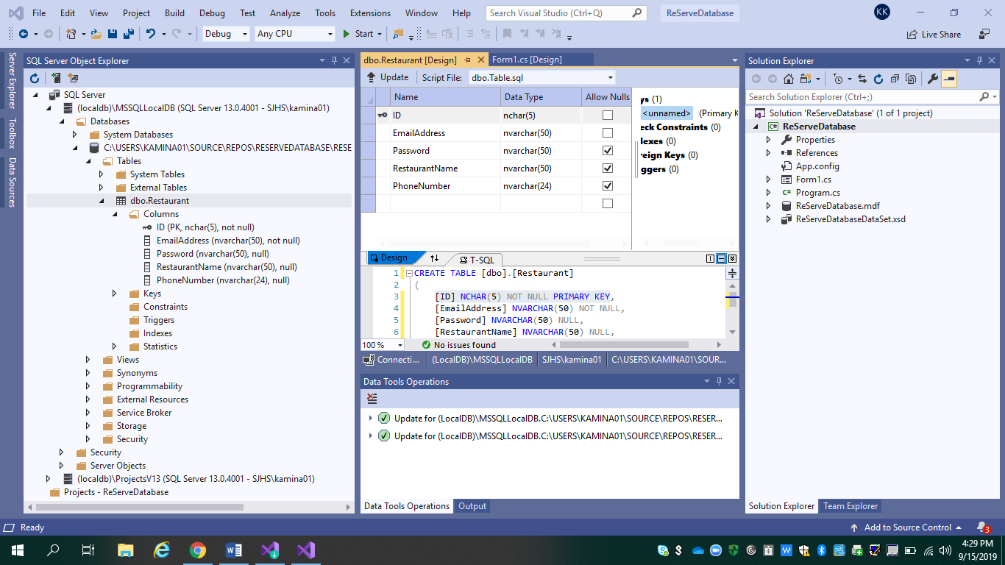Screenshot showing completed:

* 1. Should create a main class Named ReserveDTB. This is the class that the database team will be maintained during the whole project. Create a method Called **Boolean CompareInfo(string emailAddress, string Password)**. This method should go through all the rows in the table and check if the email address and password match any existed restaurants. If it does, return yes, else return no.

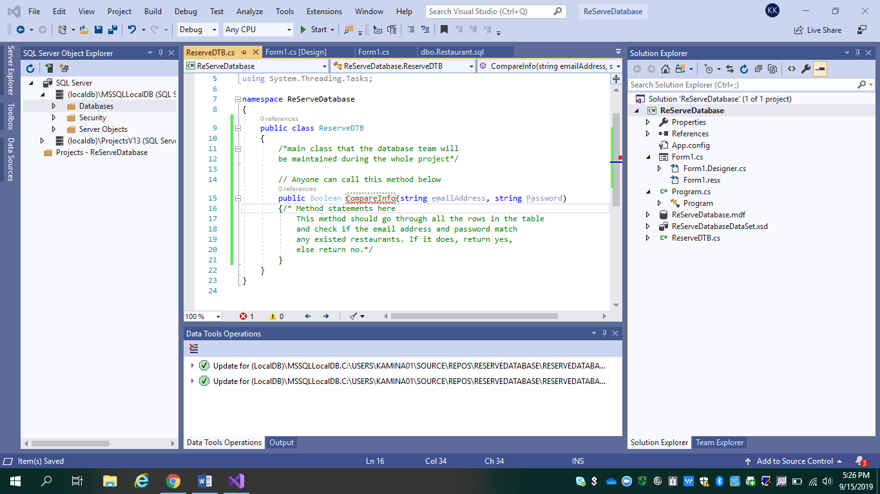Screenshot showing completed, but no statements inside yet:

**Researched the web and found helpful links for completing these responsibilities below:**

[**https://docs.microsoft.com/en-us/visualstudio/data-tools/create-a-sql-database-by-using-a-designer?view=vs-2019**](https://docs.microsoft.com/en-us/visualstudio/data-tools/create-a-sql-database-by-using-a-designer?view=vs-2019)

**Found a how to guide for part a.**

**Might use video below for adding a button and perhaps inserting data into the table.**

Video: <https://www.youtube.com/watch?v=RbYL18LFdNQ>

**Other helpful links:**

<https://docs.microsoft.com/en-us/dotnet/csharp/programming-guide/classes-and-structs/methods>

<https://www.youtube.com/watch?v=9OQU0GlCRB4>

<https://www.entityframeworktutorial.net/code-first/code-first-from-existing-database.aspx>

<https://docs.microsoft.com/en-us/visualstudio/ide/reference/generate-class-type?view=vs-2019>

**How to unzip and zip up the project from Microsoft Visual Studio:**

<https://www.youtube.com/watch?v=otgbfz159aI>