Embroidery Pattern Browser

2025 – Robert DiNapoli - rjgee@hotmail.com
Version 1.0.4

Hello, Hoarder!
Yes, I'm talking to you. Do you feel the need to download every pattern in existence? Do you feel you're playing Pokeman with patterns - 'Gotta catch them all'? Do you suffer from any of the following symptoms?
- You're in the Facebook groups daily, browsing for free embroidery pattern files.
- You download patterns for Michigan State. And you live in Ohio.
- You download patterns for nurses. And you're not a nurse. No nurses in your family. Geez, come to think of it, you don't even know any nurses!
You'll know you have the problem when this happens: You finally get the news: Your second cousin's wife's sister becomes a nurse! And now, you have an absolute need to find those nurse images that you downloaded so long ago. So you go into windows explorer and do a search... and windows sits there for 10 minutes trying to find those nurse images while it scans your drive. Eventually, it comes up with a list. And if you click one of those files in the list, the list disappears. And well, you have to search again.

Well, no more! (I mean, no more windows search problem – you'll still have the hoarding problem). This program was designed to allow you to search for embroidery pattern file names on your computer very quickly, display the images on the screen, and easily copy them to a USB drive for use in your embroidery machine. It's fast. It was designed from the ground up with speed in mind.

The way this program works – you scan your drive once and everything is stored in a database. You can then search for patterns instantly. Even if you have millions of patterns, you can scan for filenames in a fraction of a second. Yes, you read that right. Is this program for you ? Maybe. If you have a lot of embroidery patterns - tens of thousands or more, you'll likely find this program to be helpful. This program does not allow you to edit images or convert images to other formats. It's sole purpose is to quickly find the images that you currently have.

Note: Read this document top to bottom. I'll include little (Tech notes) prefaces, that you should probably read. But don't worry if you don't understand them all.

Program Overview
When you first open the program, it will look like this:

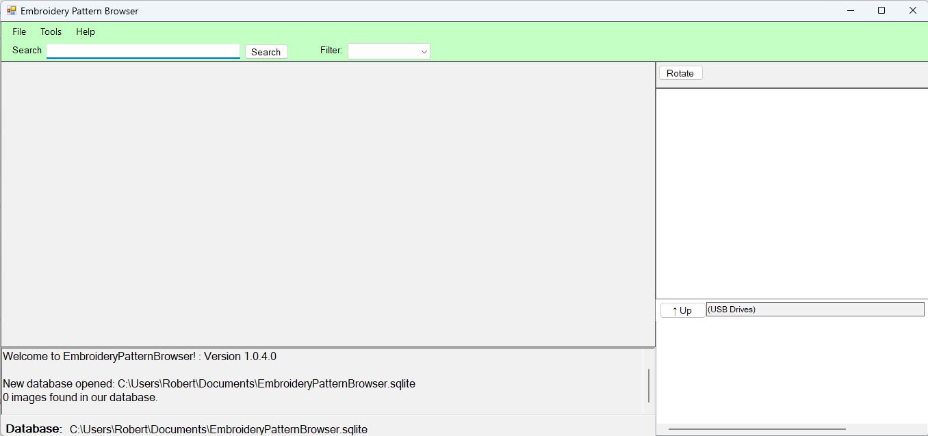

Let's go over the parts of the screen.

- At the very top, there is the menu bar with options of: “File”, “Tools” and “Help”.

“File” will allow you to Open a database and Scan for images.
“Tools” will allow you to Create a new database.
“Help” will allow you to read this help file.

We'll cover these options further down in the document.

- Right under the file menu, there is the search bar and option to filter by file type.

The “Filter” drop down allows you to tell the program to only show files of a certain type. The screenshot directly below shows the types of embroidery files that this program can read. By default, the filter is “Blank” – when you do a a search, it will return all file types.
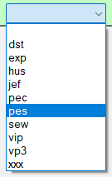

- In the middle of the screen, you'll see a large blank gray area. We use this area to display thumbnails of image files that are returned from our search.

- On the bottom of the screen, we have a logging area which will show you some information as you click through areas of the program. When you first launch the program, it will show you 'Welcome to EmbroideryPatternBrowser”, and show you the current program version. You'll also notice that it will show '0 images found in our database'. We will need to do a scan for our database to have image information. (More information on this below)

(Tech note): By default, your database will be located in your documents folder. And it will have a name of EmbroideryPatternBrowser.sqlite. You do have the option to create other databases, but the default database should suffice for most use cases. The last database you used will also open automatically as soon as you launch the program.

- On the right, top of the screen, you'll see one button to rotate the currently selected image.

- In the right, middle of the screen, we will display your currently selected image in a larger format than you see from the thumbnail. (This is the image that you can rotate.)

- On the right bottom of the screen, we have a USB drive directory browser. It will allow you to copy images to a USB stick from inside the program, without having to mess around with opening windows explorer.

Performing a Scan for new images
Let's jump right in and add some images to our database. Click on File → Scan for Images
You will get a popup, asking you which directory you want to scan.
- You can search your whole drive (for example, if you have all of your embroidery patterns on g:\)
- You can search one particular folder (for example, if your embroidery patterns are located in c:\embroiderypatterns
- I really don't recommend trying to search your whole c:\. Hopefully, you have your patterns scattered in some specific folders.
- When you do a scan, it will scan that folder and all subfolders. So if you scan c:\embroiderypatterns, it automatically scans all folders under this root folder.
- A scan will ONLY scan for files with the following extensions: .dst, .exp, hus, .jef, .pec, .pes, .sew, .vip, .vp3, .xxx. If you have other files on the disk, they are ignored for the purpose of this scan (and are not stored in the database)

Tech note: There are several directories that we won't scan: \windows, \program files, and a few other system type directories. If you choose one of these directories, you won't get an error, but it won't scan files in them either.

In this example, I'm going to scan g:\misc9. For you, select the folder you want, and press ok.

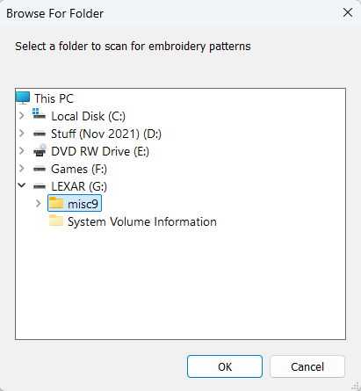
You will then get a series of popups. First, something like this:
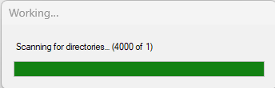

And then, something like this:
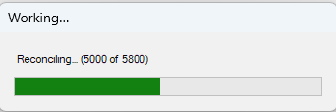
What's happening is that the system is scanning your filesystem for embroidery files. And then it adds them to the database. When finished, the bottom of the screen will display exactly what it did. In my example, I received a status line like this: Scan finished: Dirs: 5800, Files scanned: 54909, Added: 54909, Updated: 0, Deleted: 0, Elapsed: 37351 ms. In this case, we scanned 5800 directories under g:\misc9, found 54909 files, and it took 37351ms (37 seconds) to perform the scan.

You can perform the 'Scan for Images' on as many directories as you want.

You can also re-scan a directory that you have previously scanned before. And the scan is pretty smart.
If I were to scan g:\misc9 again, right now, it would show: Scan finished: Dirs: 5800, Files scanned: 54909, Added: 0, Updated: 0, Deleted: 0, Elapsed: 393 ms. Notice in this example, that it scanned the same number of files (54909), but Added: is 0 – it didn't need to add any new files to the database. If you removed one or more files from anywhere under g:\misc9, then the Deleted field would have the number of files it removed from the database (because they don't exist anymore!). And if you happen to change one of the files (let's say you're creating the pattern, and it's a work in progress.. if the file size changes from 50kb to 60kb, it will show under the Updated field).

Alright, we're done with searches. Some Tech notes here, and then we'll move on to the next section.

(Tech note) Under the covers, we perform the file scan in 2 phases. In phase, we scan the chosen directory (or drive letter), and scan for all sub-directories. If you happened to notice in the above screenshot that it said (Scanning for directories: 4000 of 1), it's because the program is currently scanning directory number 4000, from one selected root (g:misc9). In the second phase (reconciling), we scan through each of the sub-directories found in phase 1, we look for files, and compare the file information to that stored in the database. This is where the magic happens that can detect for changed files, or if you remove a file from the file system.

(Tech note) The database can become a bit large, depending on how many images you have. Figured on roughly 600 - 700 bytes per entry, depending on the length of the filename and directory path. Our 54,909 files we scanned above take up a 38mb disk file. Mathing here: 700 x 54,000 = 37,800,000 – or 38mb. As a rough guess / estimate: If you have a million files, figure on it taking up 1gb of disk space. It's really not that big in this day and age.

(Tech note) The scan is fast. Super fast. I can't find any way to make it any faster. One of the artificial intelligence systems I used for development couldn't make it any faster. I went to a second artificial intelligence system. (It got a little mad that I was cheating on it with the first system)... but in the end it couldn't make it any faster either. Really, it boils down to your 2 main things: your hard drive speed, and how many sub-directories we need to scan. Windows is really bad at scanning large numbers of directories and files. (If Windows was good, we wouldn't have a need for this program.) In my scan above, it took 37 seconds to scan 5800 folders. In this particular case, my images were on a slow, externally connected USB drive. (almost the worst case.) If your images are on an internal hard drive in the computer, expect a faster scan. And if your images are an SSD drive, expect even a faster scan. The second piece of the speed puzzle is writing the file data to the database. The database, by default (and purposely hard to change it's location), is located in your 'documents' folder. This will usually be on your c:\. So if you c: is an SSD it will be much faster than if your c: is an older, physical hard drive.

Important note about USB flash drives: During the scan and write to database, we need to store the path name of the file, so that we can later display the file on the screen after a search. Let's use an example: You decide to scan a USB flash drive and the flash drive is currently showing as H:. At some point in the future, you plug in the flash drive, and it shows up as I:. You won't be able to display any images on the screen after a search, because the database knows the file name having H:. In short, don't scan USB flash drives.

Second Important note about USB flash drives: Please, please, please, do NOT store your only copy of embroidery patterns on a USB flash drive. Flash drives are notorious for 'suddenly' corrupting data. You put a file on a drive. A year later you go to access that drive. And the drive is unreadable. Yes, you can lose patterns when stored on a hard drive also (either physical or SSD), but they are a lot more reliable than USB flash storage.

The note about flash drives applies to external hard drives plugged in through a USB port. If you frequently unplug and replug in drives, the drive MUST show up as the same drive letter for you to see images on the screen after a search.

In short, just be patient and let the system finish the scan. If you have a LOT of directories, it may take a while.

Searching
Click in the search box and type something.
- As a shortcut, you can press Alt-S to place focus on the search box. (It's a little bit faster than clicking in the search box every time.)
- As a shortcut, if the search text box is currently highlighted, you can just press the Enter key to start the search. (Or you can click the 'Search' button. Same result.)

In this example, I'm searching on the word “free”. The first thing to notice, is that once you click the search button, you should get results back near instantly!
- On the bottom of the screen, you'll see how many files match your search result. In my example, it shows that there are 2131 files that have the word free on them.
- Drag the scroll bar to easily scroll through the images.
- You can also use the arrow up/down or page up/page down keys on your keyboard to scroll.
- Left click on an image to have it displayed in the right hand window a bit larger. You can also click the rotate button to rotate the image. (It doesn't affect the image on the disk at all, you're only rotating it on the screen for viewing.)
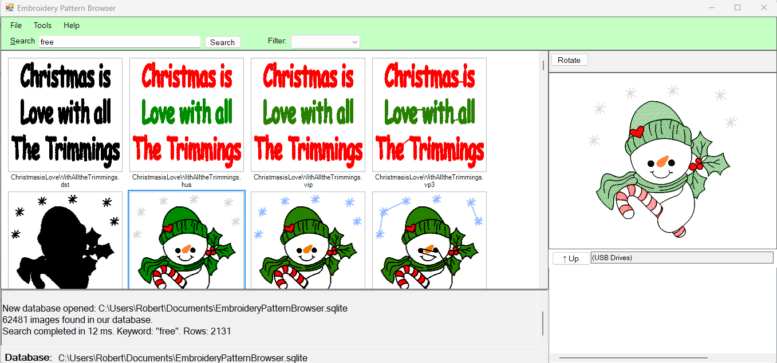
If you click the dropdown for “Filter”, you can filter on a file type. If I only want to see “Free” files that are .pes, notice that now there are only 270 files found. (You'll need to click the search button every time you change the Filter.)
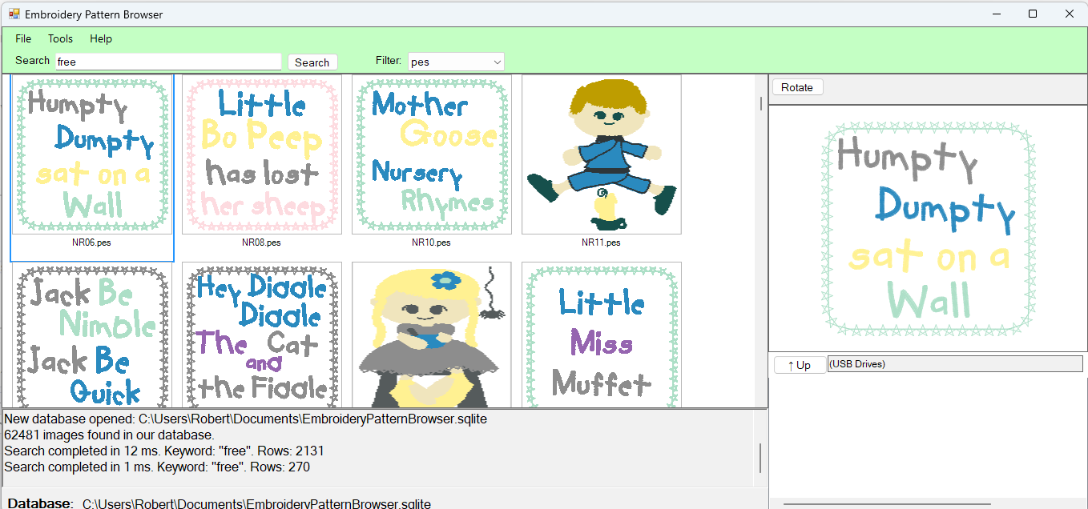

You can use multiple words in your search. In the example below, I'm searching for the term: Free Nursery. What this does, is that when you search, the file name must contain BOTH of these words. But not necessarily in order. The word Free and the word Nursery must exist in the filename somewhere.
Here's what that looks like. Notice that our search has returned only 29 rows now.
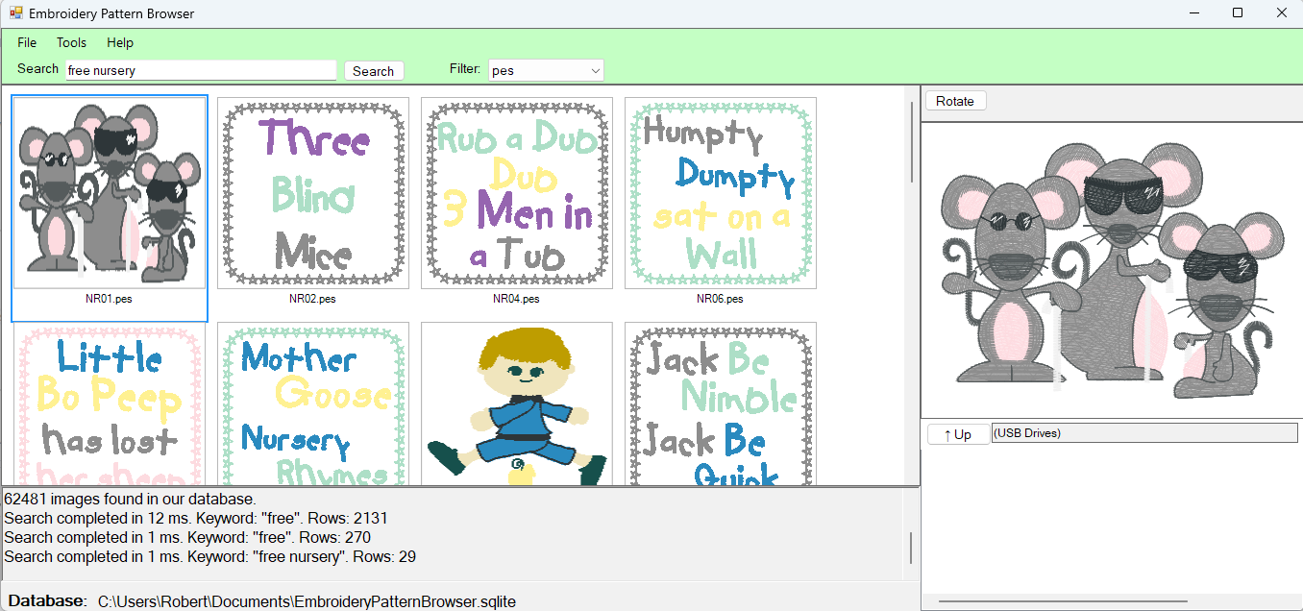
- You can search for a term in quotes, and it will do an exact match. For example, if I search for the term: “Super Cute”, it will now search for exactly that term. Contrast this with a search for: Super Cute, where both words can exist, in any position in the filename
- When searching, the sytem looks at the full directory path and filename of an item. For example, if I have a file called: g:\images\free\dogspattern\0001.pes. I could search on the word: images, free, dog, dogs, dogspatter, 0, 0001, and all of these terms would return the image in the search list.
- Searches work based on what it thinks are words, or the beginning part of a word. Continuing with the last bullet point, if I have a file called: g:\images\free\dogspattern\0001.pes, then searching on the word: pattern would NOT find this file.
- Searching is case insensitive. Searching on: free, Free, and FREE all yield the same result.
- If you try to search with non alphabetical characters, most of them will throw an error, including the period. Given the filename above, you can search for 0001 or pes, but 0001.pes will throw an error.
- You can also search on a single letter, and it will show you all files with that letter. In my example, since all of my image files are stored on g:\, I could search on the letter “g”, and it will show me every file on the drive.

If you move the mouse over an image, it will show you some information about the image: the full path to the image on disk, the shortened filename, the file size, and a field called metadata. (More on the metadata field below)
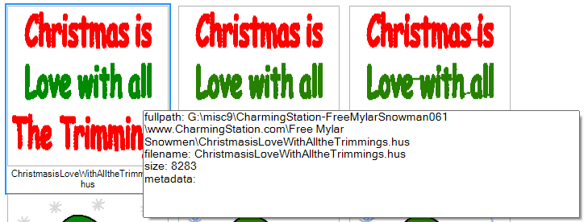

Right click options
Right click an image, and you get a few options
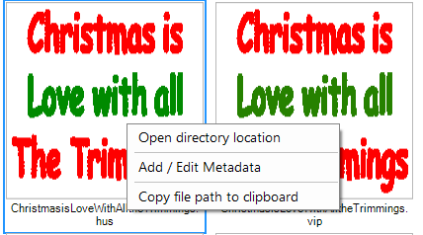

- Open directory location – clicking this will open up a new windows explorer window, showing the file in a directory. The filename you selected will be highlighted by default.
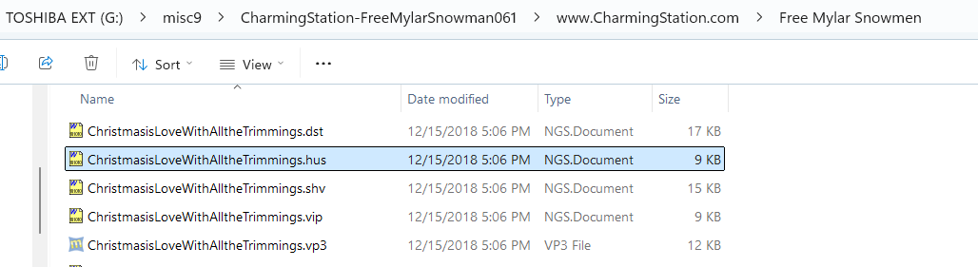
- Add / Edit Metadata – Clicking this option will pop up a small window that allows you to enter a little bit of information to help you find an image again in the future. In this example, I'm tagging the image with the word 'DianaQuilt'. This information is stored in the database for future use in searching. You don't need to save anything – once you press the OK button, the update is automatic.
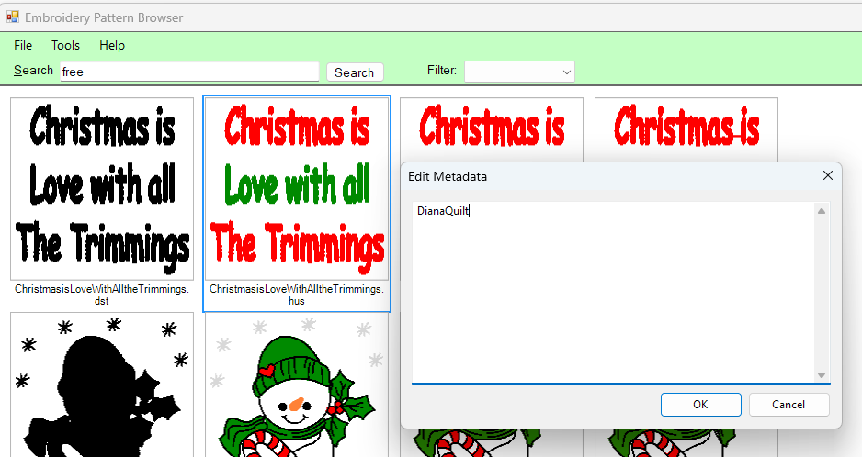

If we happen to do a search now on the word: Dianaquilt, the image will show up in the search results (in fact, it's pretty unique – the only image returned! You can also see by hovering over the image, that the metadata field now contains 'Dianaquilt'.
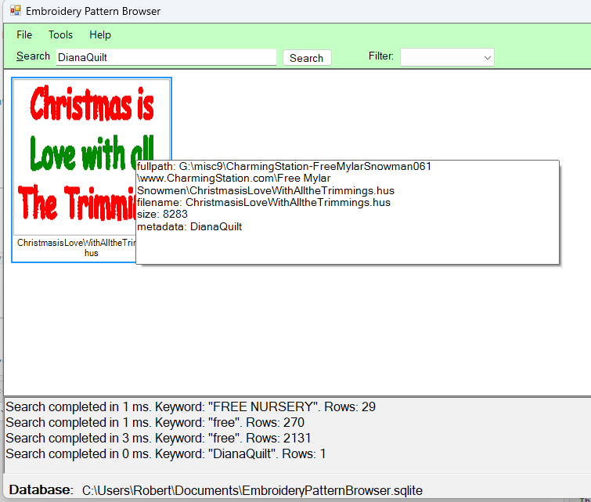
- Copy file path to clipboard – Choosing the option places the full directory and filename of the file onto the clipboard. This is meant so that you can easily copy the file to a USB drive using the built in USB browser in the lower right corner of the screen. Which takes us right into the next section... USB browser.

USB browser
In the bottom right hand corner of the screen, you can see the USB browser. If you don't have any usb drives plugged into your computer, it will look like this:
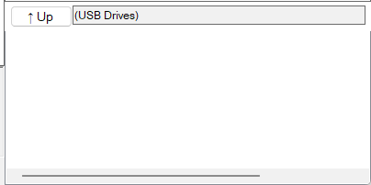
This area of the screen will automatically update if you plugin or remove one or more USB flash drives. In the screenshot below, you can see what it looks like with 1 drive plugged in. In this example, the flash drive shows up as drive letter I: and the USB flash drive has a name of “Charming”

(Tech note): This browser should only shows flash drives. You can't use it to copy files to your hard drive, sdcard, or any other devices connected to the USB bus. As soon as you plug in a flash drive to your system, it should automatically show up in this window. Unplug a flash drive and it should disappear from this window.
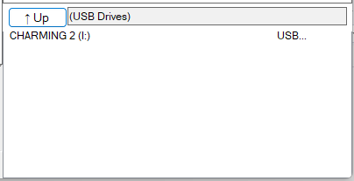
Double left click on the drive letter and it will show you the drive contents, both files and directories.
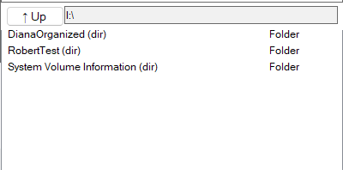
.
You can right click anywhere in the USB browser window and get a new popup menu:
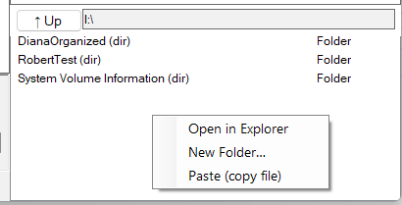
- Open in Explorer – this will open a new windows explorer window, showing the contents of the Flash drive
- New folder – allows you to create a new sub-directory on the flash drive
- Paste (copy file) – Once you have done a 'Copy file path to clipboard', you can click this option to easily copy the file to the USB drive.
  - Step 1 - copy
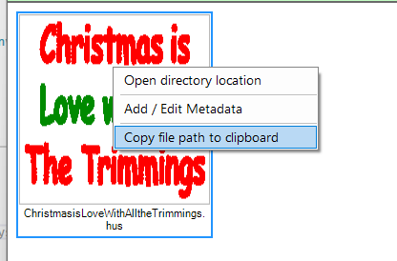
  - Step 2 – Paste (copy file). And you'll notice the file is now on the USB flash drive.
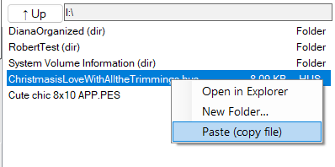

Creating a new database
You can click Tools → Create new database. You will get a popup like this:
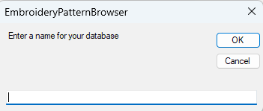
- Enter a name, press OK, and you'll have a new database. The database will be created in your documents folder. You'll notice on the bottom of the screen that it has automatically switch to your new database, and it will have 0 files in it.
- The next time you open the program, it will automatically be using your new database.
- To switch back the default database, perform File → open database, and choose the file: EmbroideryPatternBrowser.sqlite.

Logging file
This program does create a log file. It's in the documents folder, and has a filename of 'EmbroideryPatternBrowser.log'. It will keep itself small – the program will monitor the size of this file and keep it below 1 megabyte in size. Nothing amazing in here... if you get any errors, this could help me debug. While the screen has a box to show some basic information about program information, any type of error (stack trace) only gets output to this log file.

Notes
Why another program? Because I haven't found an existing one that met my needs. There are a lot of programs that will allow you to view your patterns, convert them to other formats, resize them, play with colors, etc. And they are much more amazing than anything I could ever write. But I haven't found one that can efficiently handle a large amount of files for searching. 2 Stitch Organizer looks amazing – and came close – but suffers from a fatal design flaw, As soon as you get into tens of thousands of file, it slows to a crawl. (mainly, because it converts every embroidery pattern to an image when scanning, and then puts every single image into one directory – so basically we're back to the problem of windows being crappy at managing large numbers of files). But that's besides the point – if there is another program that allows you to search for and browse large numbers of files effectively, I haven't found it.

10/12/25 - And now I'm going to ramble on a bit about artificial intelligence. You've probably heard news about it – it's coming for your job. If you have a technology job, that news is probably correct. I've been coding in one form or another since 11 years old. And I'm retired now. I was putting off the creation of this program for so long, thinking it was going to take “forever” to write this program. If I had to code it by hand... I would guess at least 2-3 months to get in all the niceties that make it fast under the covers: virtual just in time loading of images, image caching, the virtual file grid that can handle hundreds of thousands of files, the USB file browser – not to mention the actual reading of all of the embroidery file formats (which by the way is based on the amazing work in the EmbroidePy Project - https://github.com/EmbroidePy). Anyway, this is literally my first time playing with AI coding. The first time. And AI basically coded this whole project in minutes. 4 days for me to piece out all of the requirements, vibe code it, stitch the code together, and then test it. But AI wrote 90% of this code. In minutes. Sigh. I'll note that I had to really nudge it a lot. And it made a lot of stupid mistakes that we had to correct over and over and over again. But, still. Sigh.

Copyright notice
I don't own any of the images used in this documentation. I'm assuming they are all available for free use, but basing that on the word 'free' or 'freebie' in the filename. If you are the copyright owner for any of these images or files, and it's not free use, please let me know so that I can remove the file and image.

