|  |
| --- |
| Atari Inc.  LOGO_Atari.jpg |
| Asteroids |
| **Game Design Document** |
| Version #1.0  All work Copyright © 2017 by Atari Inc. Games.  All rights reserved. |
| **Rodrigo Januario da Silva** |
|  |

|  |
| --- |
| October 5th 2017 |

**Table of Contents**

[I. Game Overview 4](#_Toc494999375)

[II. Game Play Mechanics 4](#_Toc494999376)

[III. Camera 4](#_Toc494999377)

[IV. Controls 4](#_Toc494999378)

[V. Interface Sketch 5](#_Toc494999379)

[VI. Menu and Screen Descriptions 6](#_Toc494999380)

[VII. Game World 7](#_Toc494999381)

[VIII. Levels 7](#_Toc494999382)

[IX. Characters 7](#_Toc494999383)

[X. Non-player characters 7](#_Toc494999384)

[XI. Scoring 8](#_Toc494999385)

[XII. Sound Index 8](#_Toc494999386)

[XIII. Art / Multimedia Index 8](#_Toc494999387)

[XIV. Future Features 8](#_Toc494999388)

**Version History**

05/10/2017 – Document Creation.

06/10/2017 – Fixed the camera description text.

# Game Overview

*Asteroids* is an electronic game that puts the player in a spaceship inside an asteroid field. Periodically a flying saucer traverses the screen trying to hit the spaceship. The game objective is to shoot asteroids and the flying saucers without being hit. In order to increase the difficult the game increases the number of asteroids.

# Game Play Mechanics

The objective in *Asteroids* is to destroy as many asteroids and flying saucers as possible. The player controls a triangular space ship, which can move in any direction of the screen, rotate, and shoot. Once the ship started to move in one direction, it will continue until the player applies thrust in a different direction. Each game level begins with a few large asteroids moving in various directions and when shot, break into smaller and faster asteroids, which are harder to hit. In addition, big saucers and small saucers appear periodically shooting the spaceship. The bigger one shoots poorly, while the smaller one is more precise on its shots.

# Camera

*Asteroids* has a3rdperson sided point of view.

# Controls

*Asteroids* have five buttons that are used in the game:

* Left Rotate
* Right Rotate
* Thrust
* Fire
* Hyperspace

# Interface Sketch

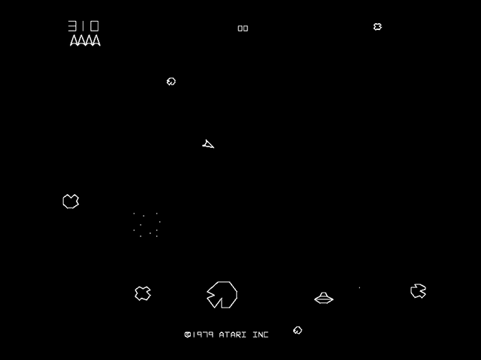

# Menu and Screen Descriptions

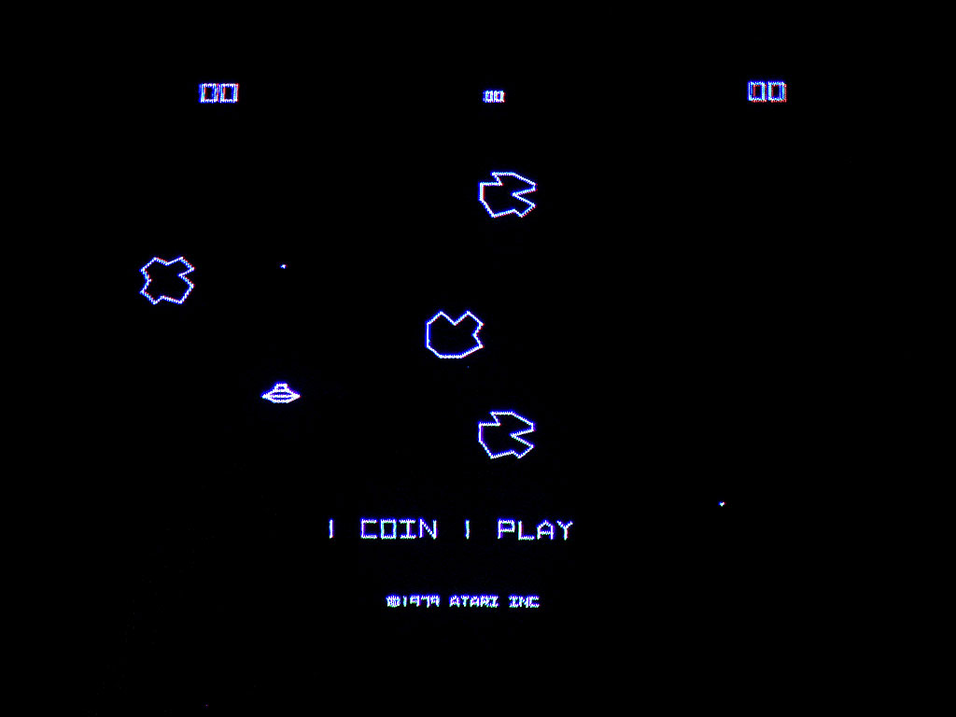

Asteroids start menu screen

**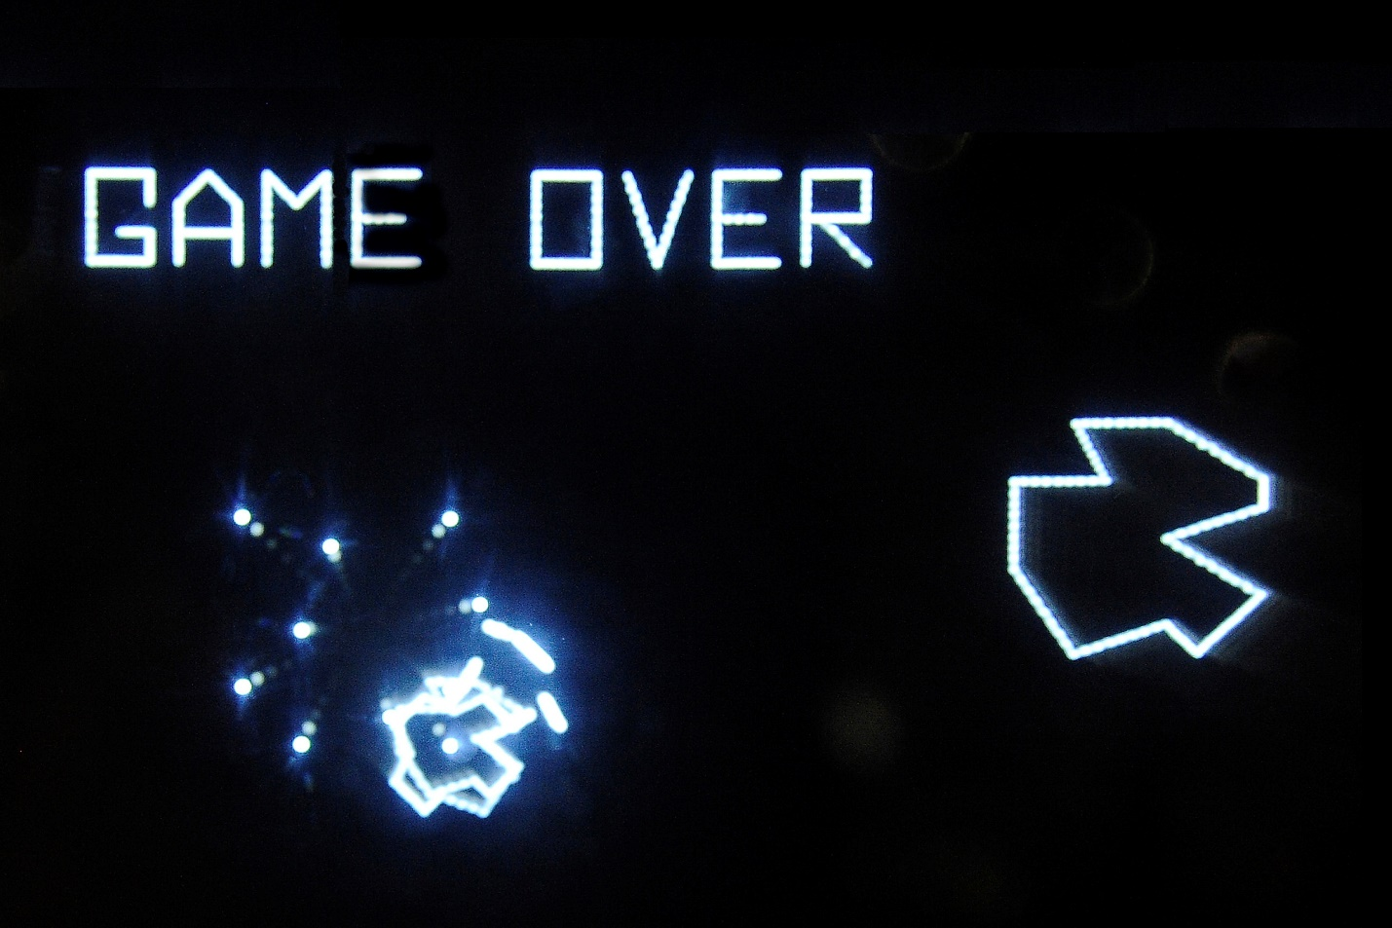**

Asteroids game over screen.

# Game World

*Asteroids* is a game that happens on the space, inside an asteroid field.

# Levels

Each *Asteroids* level begins with a set of big asteroids and ends when all the asteroids and flying saucers are destroyed.

# Characters

*Asteroids* has a triangular ship as its character.

# Non-player characters

Asteroids has as non-player characters a big flying saucer, which traverses the screen and shots the player’s ship imprecisely, a small flying saucer, which also traverses the screen and shots the player’s ship in a more accurate way and it also has big, medium and small asteroids which flies around the screen in various different directions. The medium asteroid appears when the big is hit and the small when the medium is hit.

# Scoring

In order to score the player has to hit the asteroids and the flying saucers.

# Sound Index

* Shot sound.
* Explosion sound.
* Asteroid movement speed sound.
* Flying saucer sound.

# Art / Multimedia Index

* Background asset
* Ship asset
* Flying saucer asset down scaled to the smaller one.
* Asteroid asset down scaled to the medium and smaller ones.

# Future Features

Future features include increased difficulty in later levels starting them with smaller asteroids and various flying saucers, different spaceship shots for each 10,000 points earned, which will be lost in case the player is hit and also power-up protection for the ship each 50,000 points earned, which will last until the ship is hit or 1 minute, whichever comes first.