|  |
| --- |
| Atari Inc.  LOGO_Atari.jpg |
| PONG |
| **Game Design Document** |
| Version #1.0  All work Copyright © 2017 by Atari Inc. Games.  All rights reserved. |
| **Rodrigo Januario da Silva** |
|  |

|  |
| --- |
| September 25th 2017 |

**Table of Contents**

[**Game Overview**](#_n3yv8qb0x90f)4

[**Game Play Mechanics**](#_b9lctxt6lsw)4

[**Camera**](#_8piy12erz7ws)4

[**Controls**](#_p4ty0he7van9)4

[**Interface Sketch**](#_gjdgxs)5

[**Menu and Screen Descriptions**](#_3w4p4wjs553)6

[**Characters**](#_16y7nqaclqrr)6

[**Scoring**](#_c4n5m9mgesi6)6

[**Sound Index**](#_4ygvcjmaos8s)7

[**Art / Multimedia Index**](#_nbskspvrhpw6)7

[**Future Features**](#_63ml30ffhf7o)7

**Version History**

25/09/2017 – Document Creation.

# Game Overview

*Pong* is an electronic game that simulates table tennis. Each player controls a paddle by moving it up and down on the screen to hit a ball back and forth. One player can compete against another player or a computer controlled paddle. Whichever player reaches eleven points is the game winner.

# Game Play Mechanics

*Pong* is a simulation of table tennis where a human player competes against another human player or a computer-controlled player. Each of the players starts with 0 points and they play moving their respective paddle in order to hit the ball and make sure that the competitor misses it. Whenever a player misses the ball, one point is granted to the other one. The game ends when one of the player reaches eleven points.

# Camera

*Pong* has a top-down point of view.

# Controls

*Pong* uses round buttons to be played. Rotating the button to the right makes the paddle go up and rotating the button to the left makes the paddle go down.

# Interface Sketch

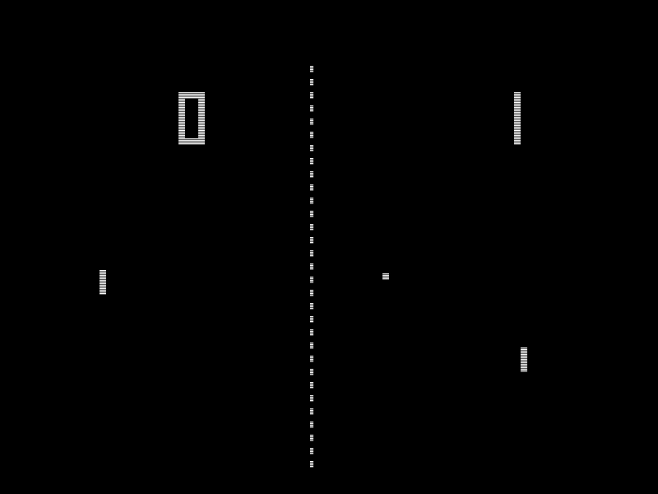

# Menu and Screen Descriptions

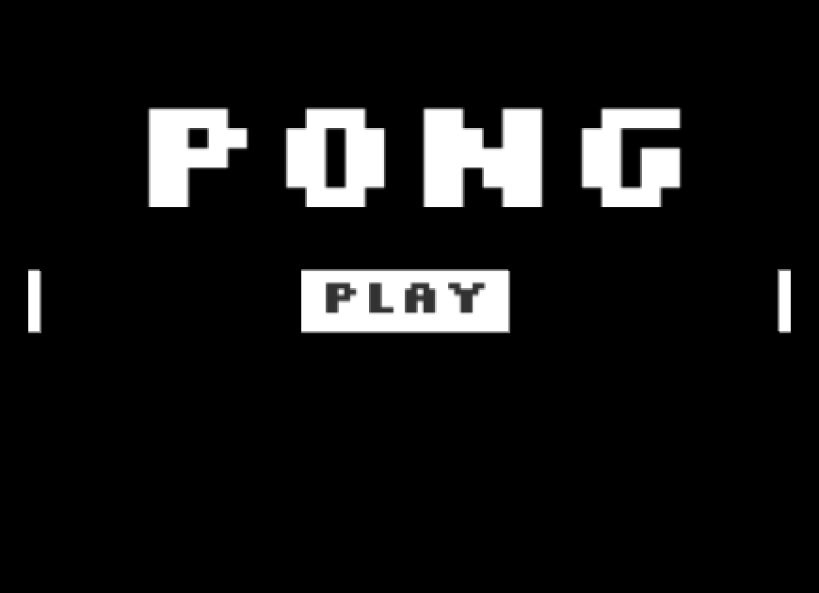

# Characters

*Pong* has two table tennis player competing against each other.

# Scoring

In order to score on player has to make the other player miss his hit on the ball.

# Sound Index

* Paddle hitting ball sound.
* Ball reflecting on the sides sound.
* Scoring sound.

# Art / Multimedia Index

* Background asset
* Paddle asset
* Ball asset
* Numbers 0 to 9 asset.

# Future Features

Future features include new levels for player against computer matches as bellow:

* After each win, a new match starts with the player’s paddle shrunk by its size minus the ball size until the player’s paddle has the length of two balls.
* After the player’s paddle shrinks to the minimum size, new matches will increase the computer-controlled paddle by the size of the ball until it reaches its initial size doubled.