# OLM TransportCo Demo

These are the instructions to simply run the assignment code and to create an Eclipse project.

## Prerequisites

* Eclipse IDE for Enterprise Java Developers.
* Apache Maven 3.6.3

## Github

The code can be accessed from Github.

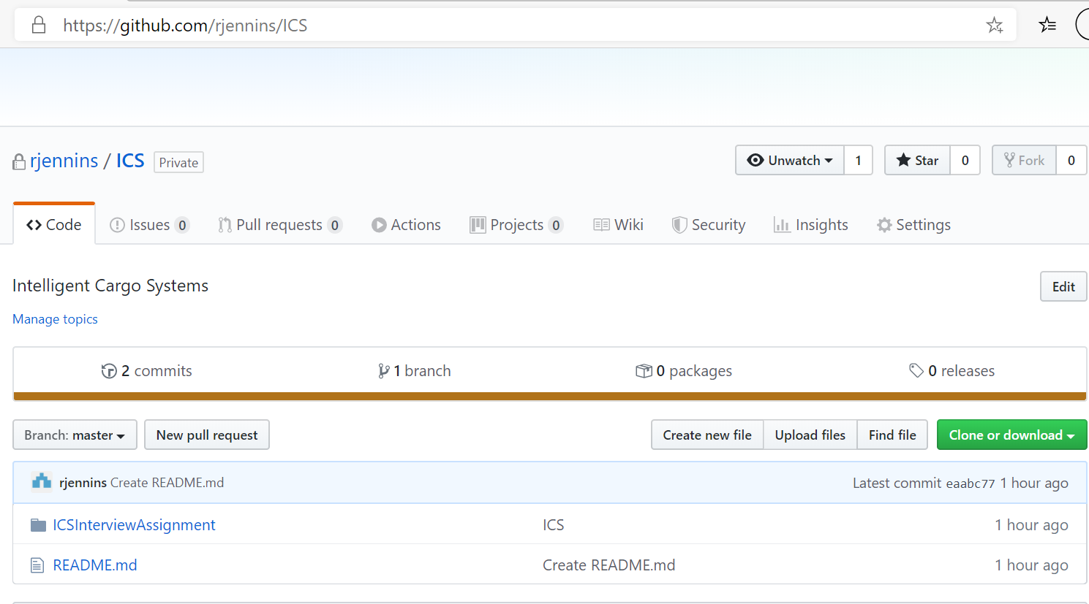

Download the project using the green button. This will create a file called ICS-master.zip. Extract all the data to a location where you want to have the Eclipse project. This will create a directory called ICS-Master. The sub directory inside this directory called ICSInterviewAssignment contains the project.

## Building and Running the Code in Standalone Mode

Open a Windows Power Shell and go to the directory ICSInterviewAssignment as below :-

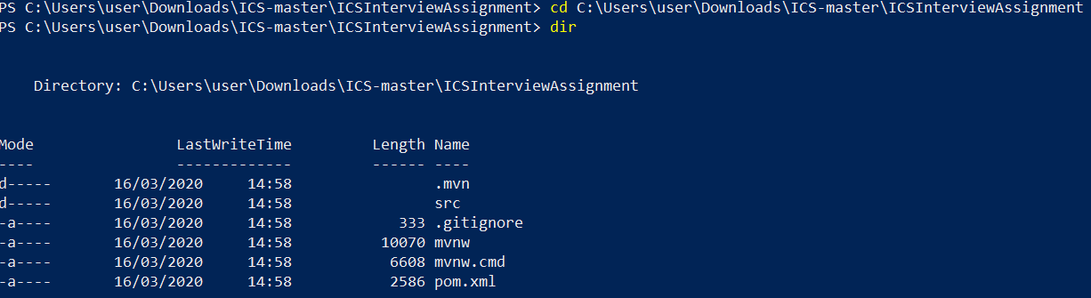

To build the project and run the unit tests call the following command (for this to work Maven needs to be deployed with the Maven bin directory in the system path variable) :-

mvn clean package spring-boot:repackage

When the about command has been executed you should see something similar to below :-

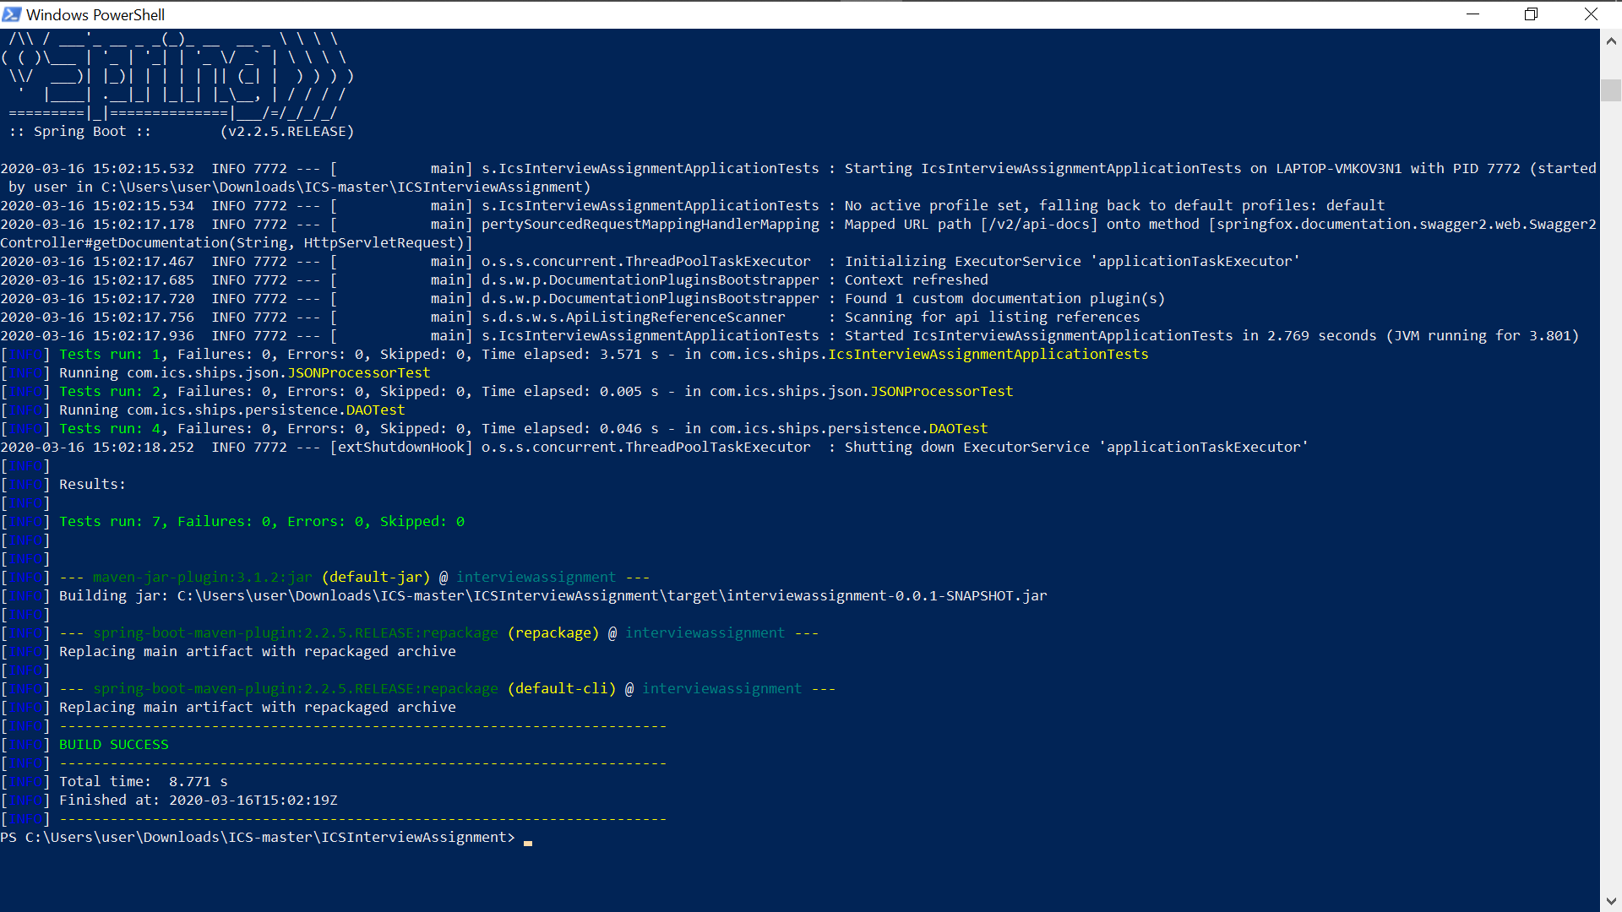

There are two ways to run the project in standalone mode :-

mvn spring-boot:run

OR

java -jar target/interviewassignment-0.0.1-SNAPSHOT.jar

Upon completion of either of the commands above you should see something similar to below on the screen :-

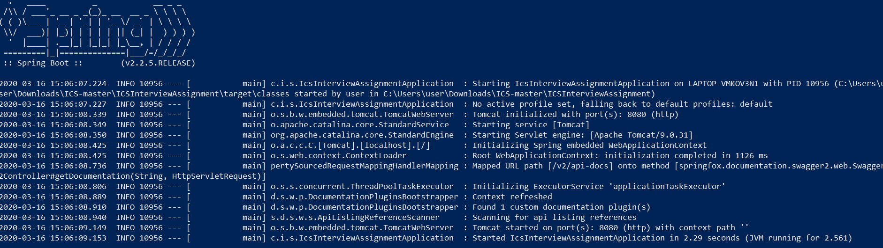

To test that the project has started correctly go to the Swagger URL :-

[http://localhost:8080/swagger-ui.html#](http://localhost:8080/swagger-ui.html)

The following screen should be displayed :-

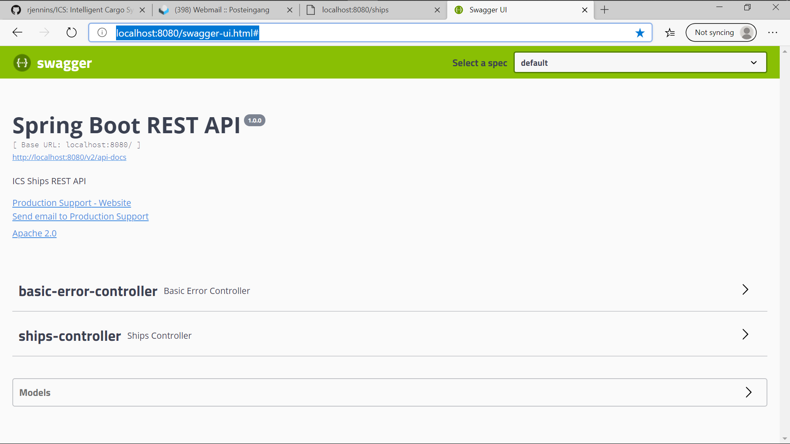

Click on “Ships-controller” and you will see all the methods as shown below :-

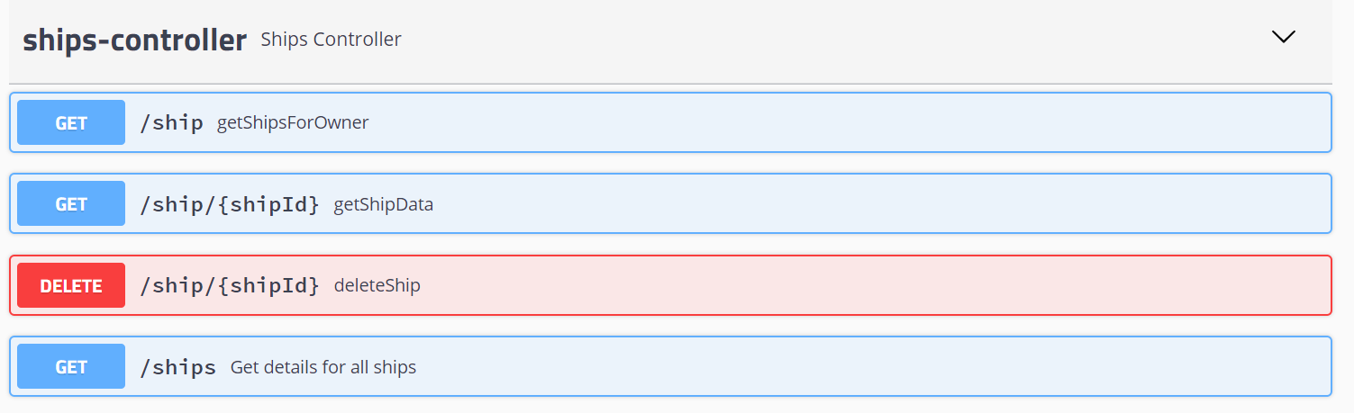

To call “getShipsForOwner” select the top blue button :-

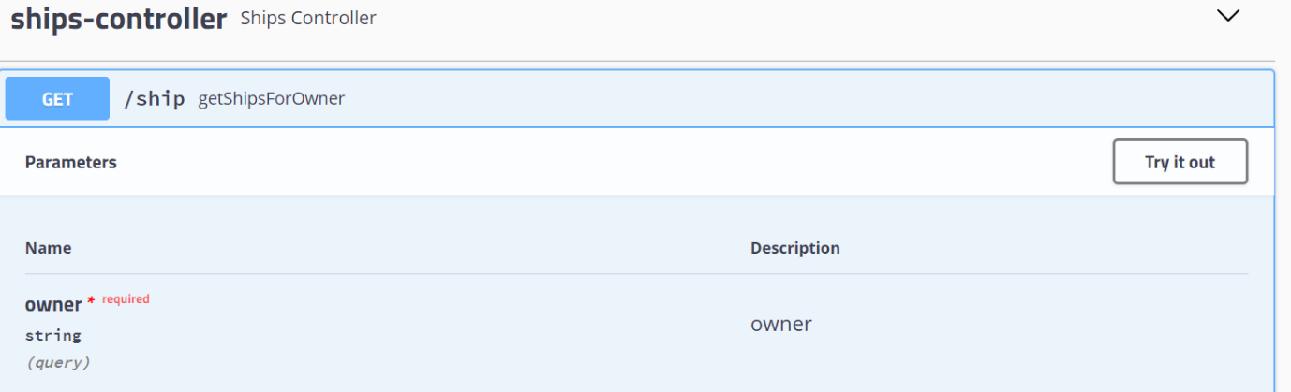

Now select the “Try it now” button. Enter an owner in the case below “Mitsui O.S.K. Lines”

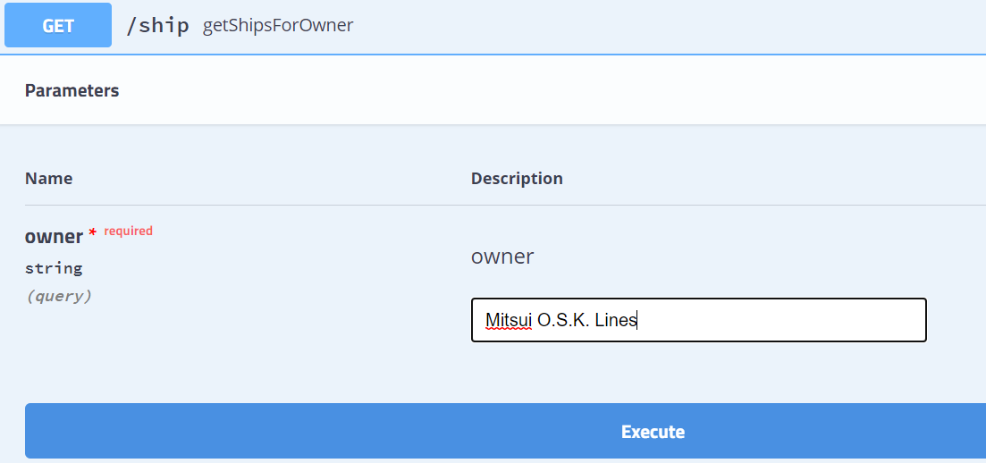

Upon execution you should see the following : -

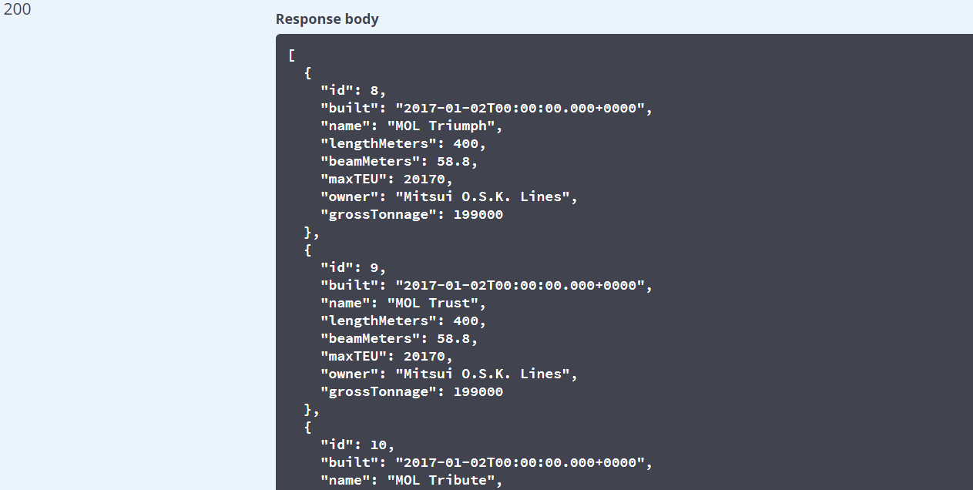

To call the URL directly in the browser the URL can be found in the “Curl” section shown below. For this example the URL is <http://localhost:8080/ship?owner=Mitsui%20O.S.K.%20Lines>

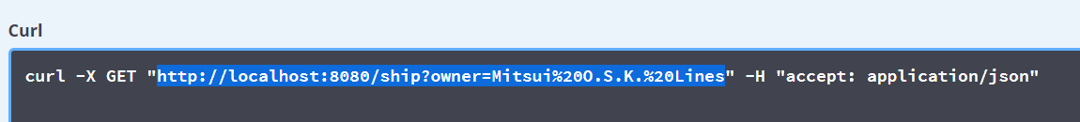

All the other methods follow the same pattern and should be self explanatory. Test data can be taken from the ships.json file.

## Creating the Eclipse Project

In Eclipse import the project taken from Github as follows (pick up the pom.xml) :-

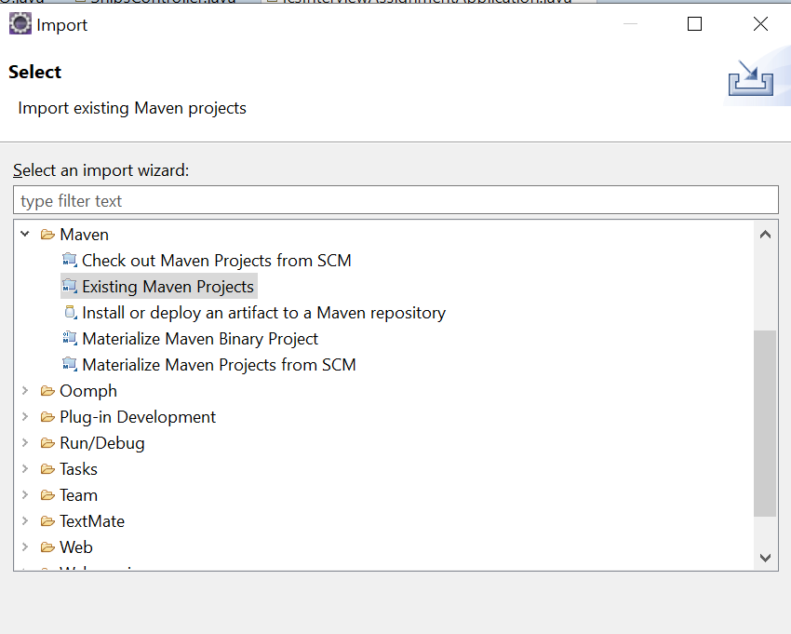

Browser to the extracted Github directory. In this case :-

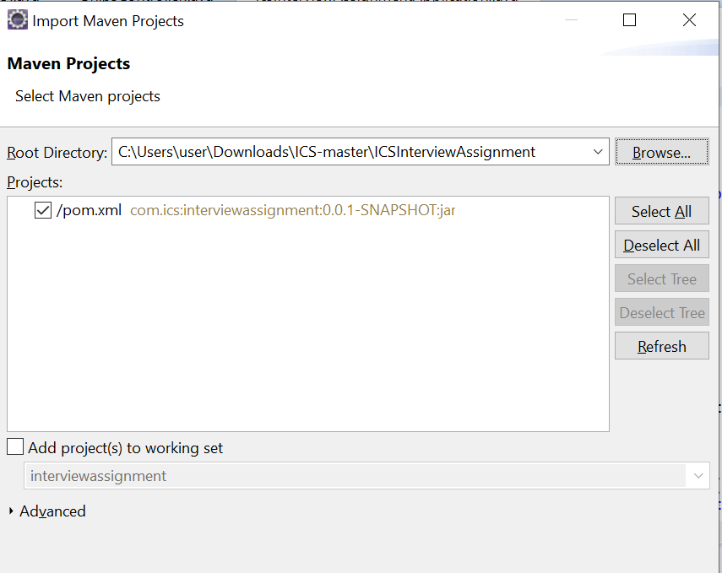

The project should be created in Eclipse. To run the application right mouse on the project and select “Run As” or “Debug As” and in turn “Spring Boot App”. In the console window you should see the following. To confirm the application has started up okay call the Swagger code :-

[http://localhost:8080/swagger-ui.html#](http://localhost:8080/swagger-ui.html)

