**OS LAB Assignment 3**

**Name: Shreya Pawar**

**CS C, Roll no: 29**

**Batch 1**

1) Write a shell script program to execute ls, date and echo commands repeatedly.

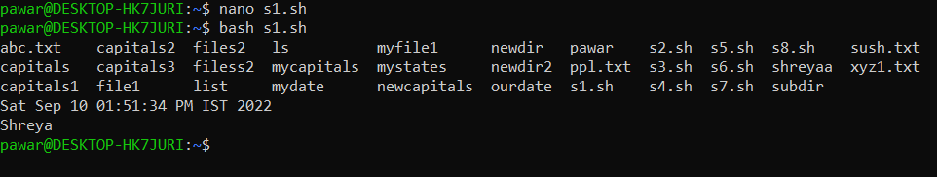

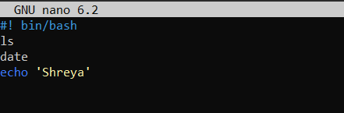

2) Write a shell script program to show the details related to shell, path and home directories of the user.

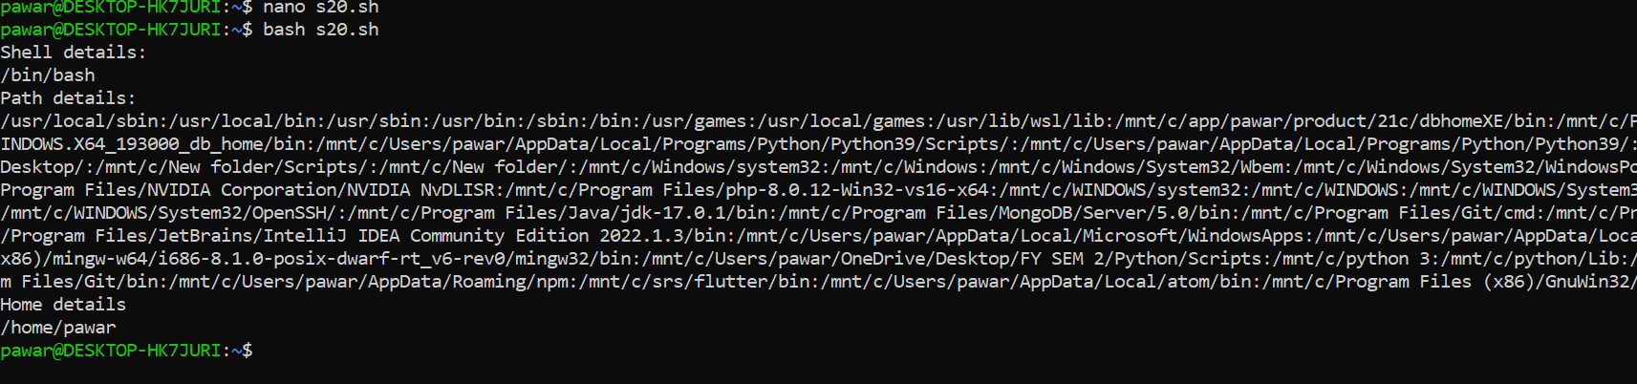

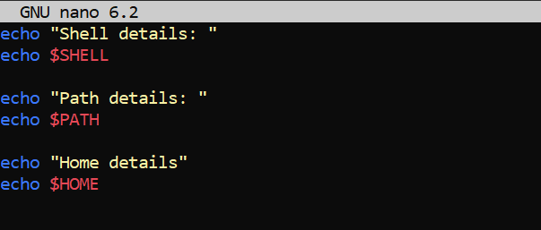

3) Write a shell script program to create two files. The name of the files will be passed by user using read function.

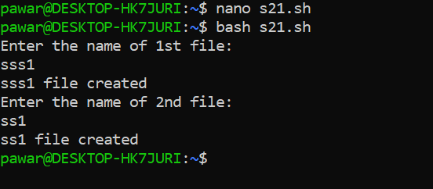

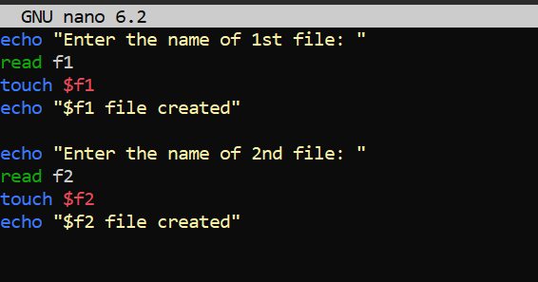

4)  Write a shell script program to create two files. The name of the files will be passed by user using command line arguments.

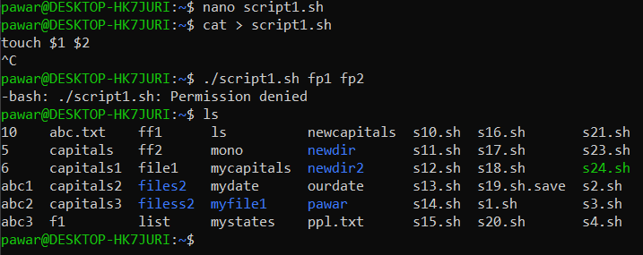

5) Write a shell script program to create two directories. The name of the files will be passed by user using read function.

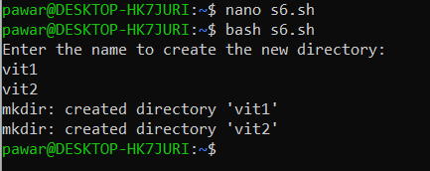

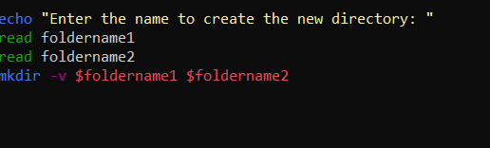

6) Write a shell script program to create two directories. The name of the files will be passed by user using command line arguments.

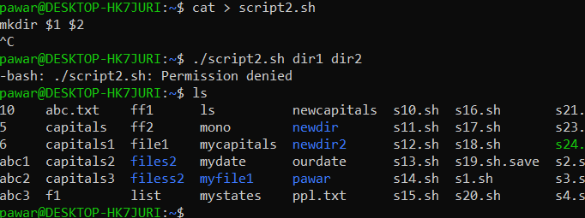

7) Write shell script to change the name of a file .Ask from user old filename and new filename.

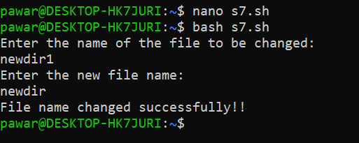

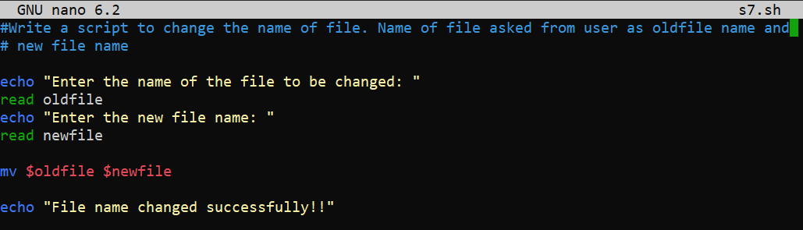

8) Write a shell script to find the largest number among three numbers.

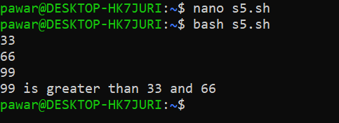

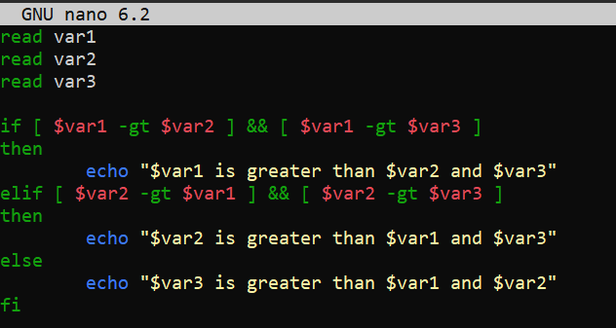

9)  Write shell script to create three files f1, f2, f3 using for loop.

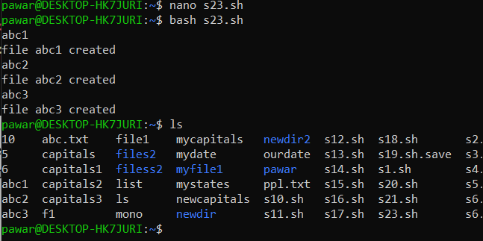

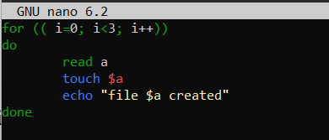

10) Write a shell script to display date and time. Assume 1 sec delay.

