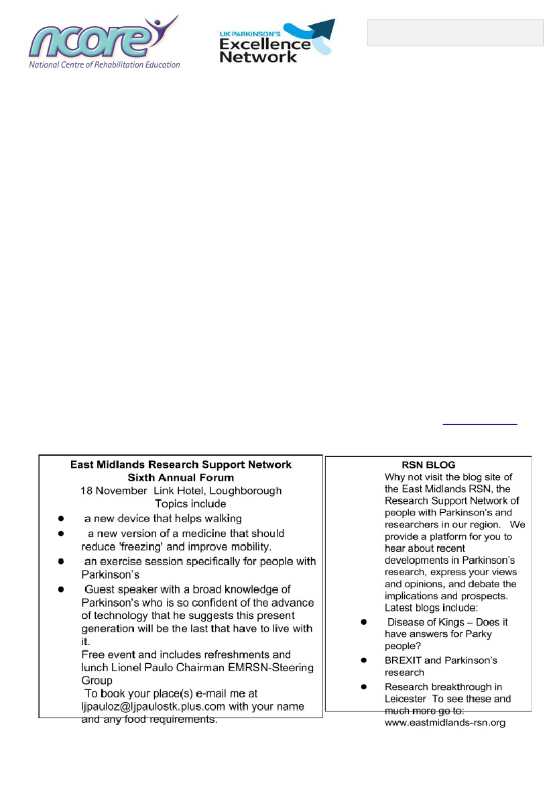
Derby Parkinson’s Symposium
Sat. 7 October 2017, 10am-3:30pm Education Centre, Royal Derby Hospital, Uttoxeter Rd, Derby, DE22 3NE
Who should attend:
People with Parkinson’s
Carers for people with Parkinson’s
Talks to Include:
● My gut feelings - about Parkinson's
● Looking after your brain
● The use of technology in Parkinson’s
● Maintaining healthy bones
Workshops:
● Looking after your bladder and bowels
● Dietary considerations for people with Parkinson’s
● Coping with diagnosis; self-care and wellbeing
● Continuing to work with Parkinson's and benefit entitlements if you need them
● High Impact Exercise [restrictions apply]
● Music and Dance to improve movement
● Carers’ workshop
● Impulsive and compulsive behaviours
Speakers to include:
Dr Richard Genever, Dr Christine Taylor, Dr Rob Skelly, Sue Hinds Osteoporosis Specialist Nurse
Caroline Bartliff, Specialist Speech and Language Therapist ,Fiona Lindop Specialist Physiotherapist
Clare Johnson Specialist OT, Helen Widdowson Physiotherapist , Rachael Stringer OT
Lisa Brown, Parkinson Nurse Specialist, Suzanne Filon Parkinson’s Nurse Specialist Karen Bown Parkinson’s UK
£10 per person ​Lunch and refreshments included Contact ​01332 254679 | dhft.ncore@nhs.net |​www.ncore.org.uk
Booking form available from Parkinson’s UK, Derby Branch, 210 Uttoxeter Rd, DERBY DE3 9AB

