Motor rotor, $m_{r}, I_{r}$

Gear box, $m_{g}, I_{g}$

Spring and load:

'm

'g

'g

damp

's

's

app

m

g

s

|  |  |
| --- | --- |
| Total Gearbox Torque $$τ_{g}= τ_{g}^{'}- τ_{s}^{'}- τ_{damp}$$ Parameters:  Gearbox damping: $b$ SEA Spring const: $K$ Gearbox ratio: $G$ Gains for gearbox: $k_{pg} , k_{dg}$ (These should be very high)  Gains for torque control: $k_{pt} , k_{dt}$ | Total Motor Torque $$τ_{m}= {τ^{'}}_{m}- {τ^{'}}_{g}$$ $${τ^{'}}_{m}= k_{pt}\left(τ_{act}- τ_{des}\right)+ k_{pt}\left({\dot{τ}}_{act}- {\dot{τ}}_{des}\right)$$ Spring Torque $$τ_{s}^{'}=K \left(θ_{g}- θ_{s}\right)$$ $τ_{s}= τ_{s}^{'}- τ_{app}$  **Inertial Parameters**  Motor rotor: $m_{r}, I_{r}$ Gearbox: $m_{g}, I_{g}$ Load: $m_{l}, I_{l}$ Spring and load: $m_{s}, I_{s}$ |

Issues to deal with:

* Modeling encoder resolution. Resolution is expressed in *r*, rad/count. This takes into account the 4x increase from lines to counts using quadrature decoding.

Measured angle = ((round) (actual angle / *r*)) * *r*

* Limiting the maximum speed of the motor and. To implement this, add viscous damping that starts in at 100% of max speed and rapidly increases from there.
* Gearbox efficiency. Use the data provided by HD systems:

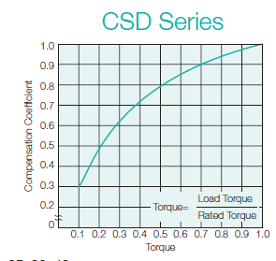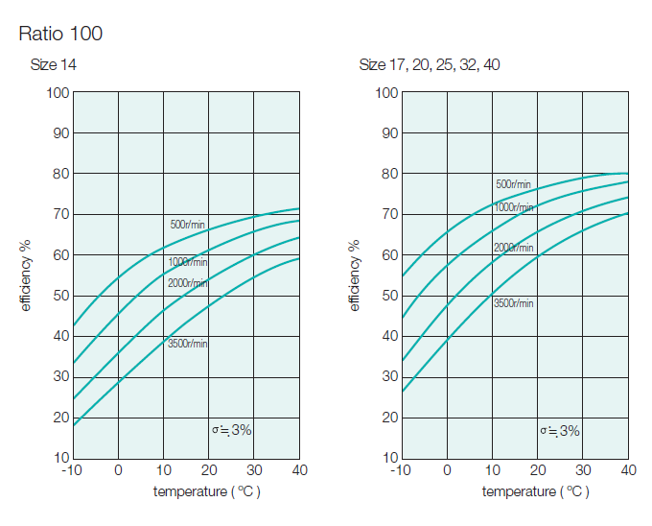



* Motor maximum torque from manufacturer limit.
* Amplifier max current. As a first approximation, it is a hard limit. A better model would be a first order thermal model that has an integrator and decay.
* Add in pure delay to feedback loop.
* Motor speed limit based on back emf constant and voltage.