kpPosition.val = 3000.0;

kdPosition.val = 70.0;

private final boolean USE_MOTOR = false; // true;

private final boolean DO_MOTOR_TORQUE_LIMIT = false; // true;

private final boolean DO_GEARBOX_SPEED_LIMIT = false; // true;

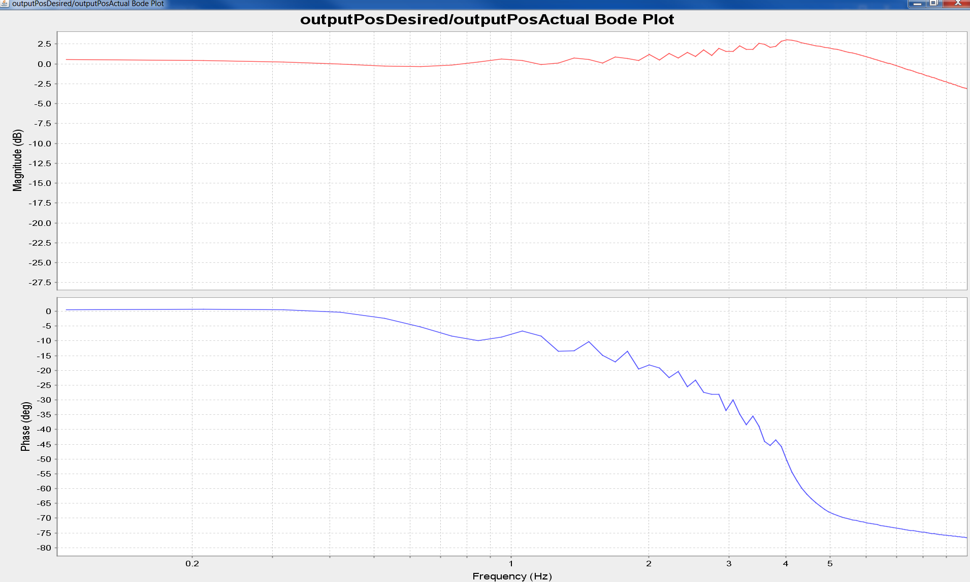

private final boolean USE_MOTOR = false; // true;

private final boolean DO_MOTOR_TORQUE_LIMIT = false; // true;

private final boolean DO_GEARBOX_SPEED_LIMIT = true; // true;

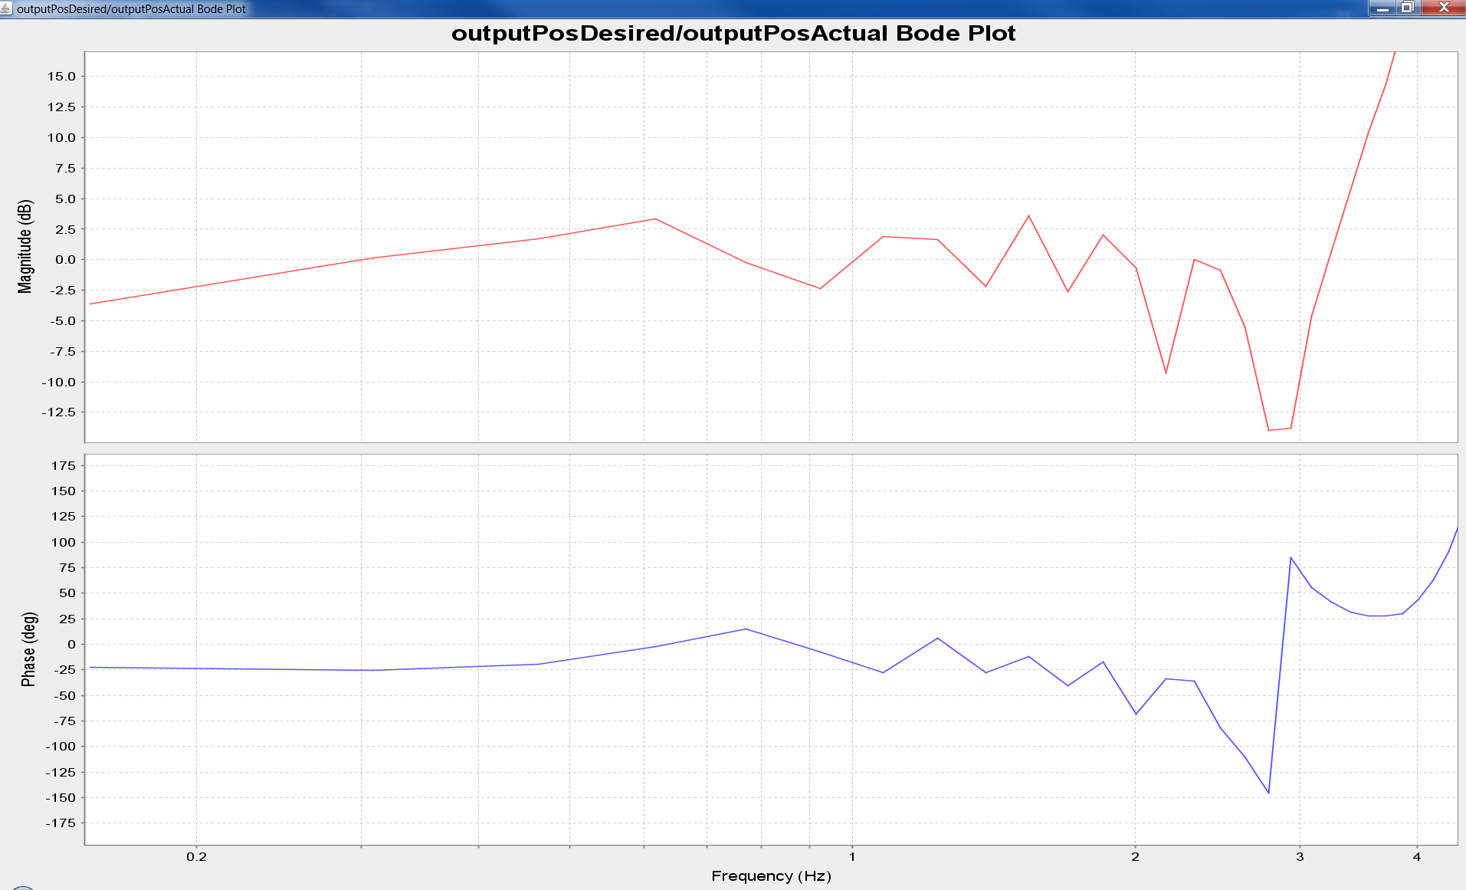

Try looking at stiffening the SEA spring

private final boolean USE_MOTOR = false; // true;

private final boolean DO_MOTOR_TORQUE_LIMIT = false; // true;

private final boolean DO_GEARBOX_SPEED_LIMIT = false; // true;

springConstant.val = 5.0 * 323.0; // Use a Units of Nm/rad

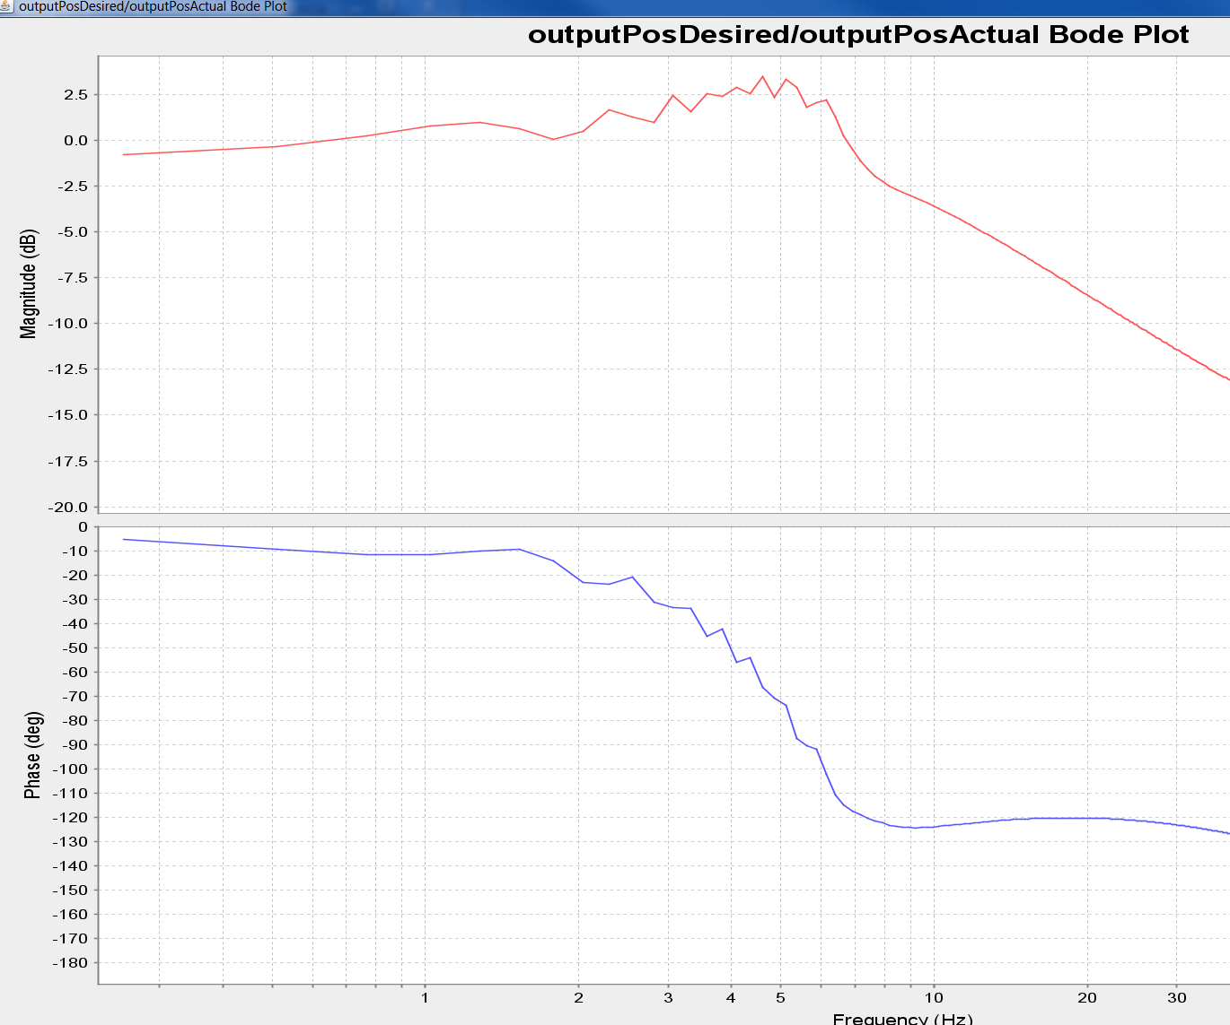

springConstant.val = 100.0 * 323.0; // Use a Units of Nm/rad

