Comparing torque and position control bandwidth

private final boolean USE_MOTOR = true; // true;

private final boolean DO_MOTOR_TORQUE_LIMIT = false; // true;

private final boolean DO_GEARBOX_SPEED_LIMIT = true; // true;

Set max gearbox to 10k RPM

public static final double MAXIMUM_GEARBOX_OUTPUT_SPEED = 10000.0 * RPM_2_RAD_PER_SEC / GEAR_RATIO;

Stiff actuator spring:

springConstant.val = 5.0 * 323.0; // Use a Units of Nm/rad

Stiff Harmonic drive:

kpGear.val = 130000.0; // This is the minimum measured value of the harmonic drive

kdGear.val = 1000.0; // Not sure how this related to critically damped.

Torque control

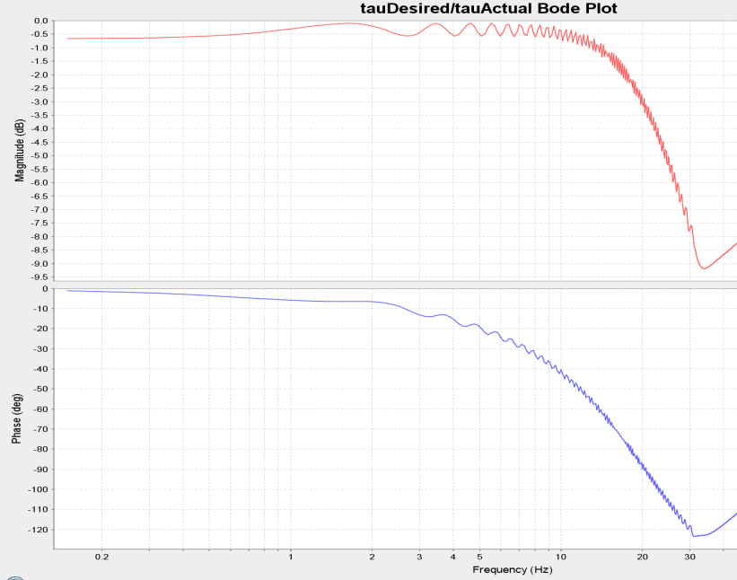

Position Control

Position control

kpPosition.val = 2000.0;

kdPosition.val = 90.0;

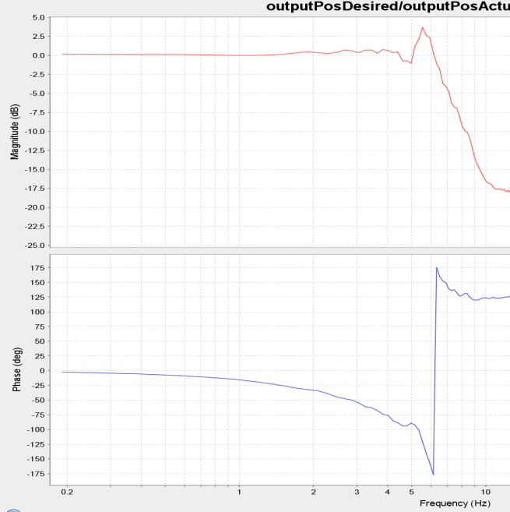

Questions to answer:

How does SEA spring stiffness affect torque and position control?

private final boolean USE_MOTOR = true; // true;

private final boolean DO_MOTOR_TORQUE_LIMIT = false; // true;

private final boolean DO_GEARBOX_SPEED_LIMIT = true; // true;

springConstant.val = 5.0 * 323.0; // Use a Units of Nm/rad

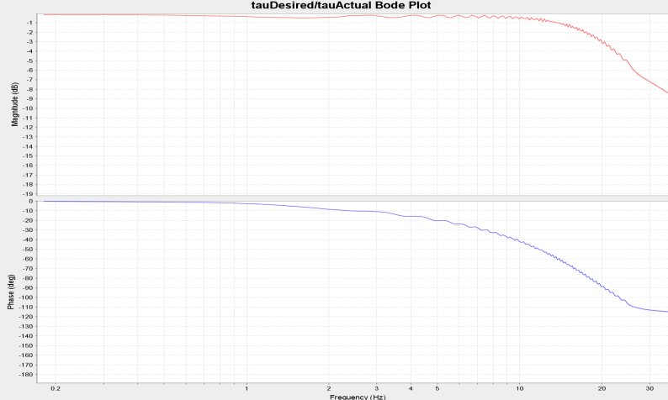

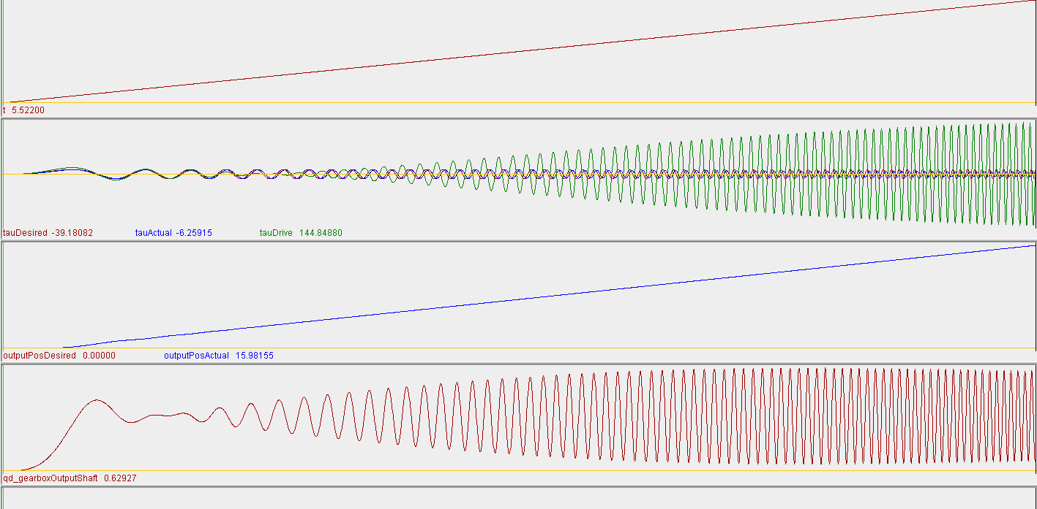

Reduce spring constant to

springConstant.val = 1.0 * 323.0; // Use a Units of Nm/rad

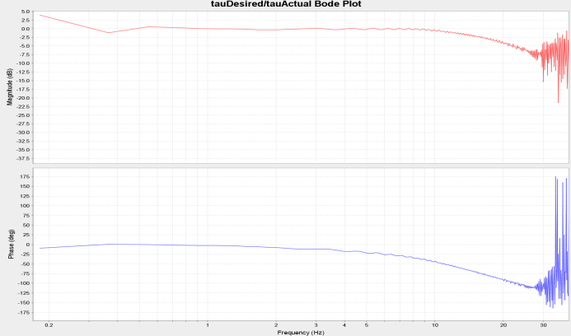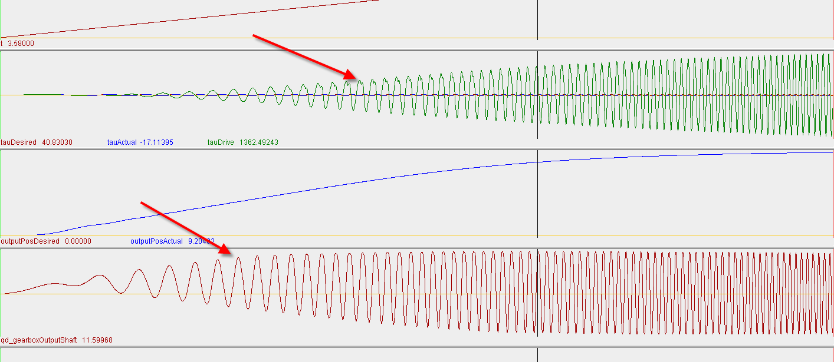

About the same performance, however, the gearbox output moves a lot more. Eventually, this max speed of the gearbox will be reached, or the actuator will saturate. Note, that this does not have actuator saturation modeled in.