# 计算器

--------2017级信息文艺复兴小组

1. 前期调查分析：

**计算器作为人们日常生活中必不可少的计算工具之一，大众使用量非常可观，小到学习计算，大到国家建设。计算器的种类也多种多样，有实物计算器，还有以软件形式的计算器.从简易程度又分为计算加减乘除的算术型计算器，可进行乘方、开方、指数、对数、三角函数、统计等方面的运算的科学型计算器等等。**

**二.人员分工**

**任建华：代码设计开发（开发代码）**

**胡志玲：策划协调（总体协调组员分工，提供建议支持）**

**刘健玲：前期资料调查（负责计算器前期资料调查，可行性分析）**

**王子健：界面美化设计（对程序前端界面进行编排美化）**

**薛博宇：bug测试（对程序进行运行检测，bug分析总结）**

**三.所用开发工具**

**Visual Studio（Windows应用窗口）**

**四.程序**

1. **程序主界面**

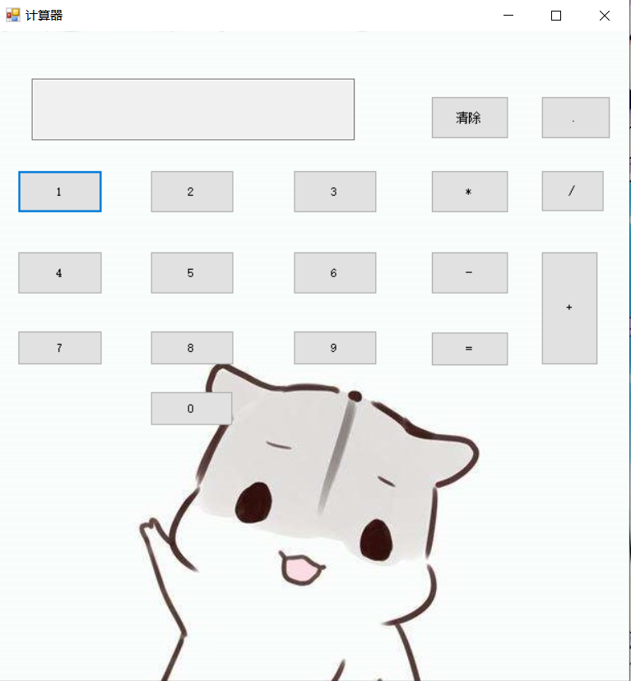

1. **程序运行实例：**

**加法**

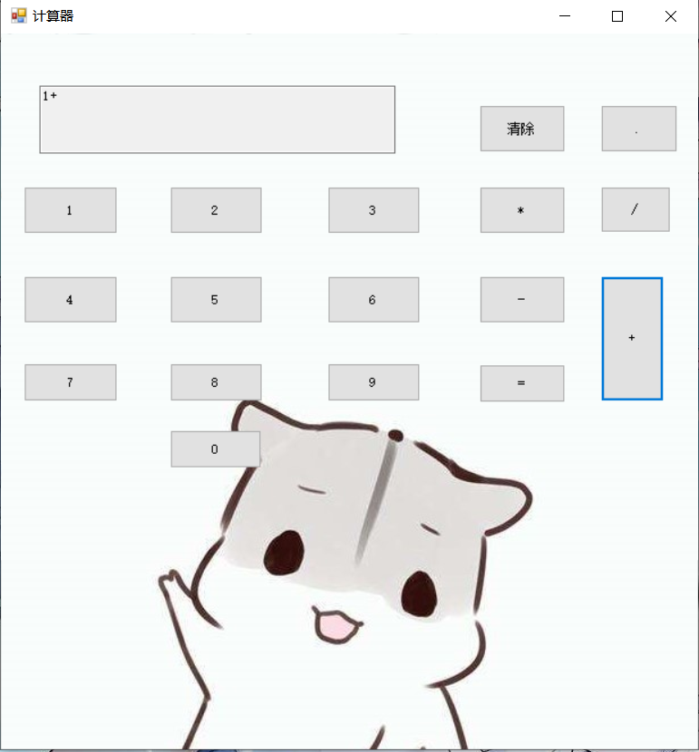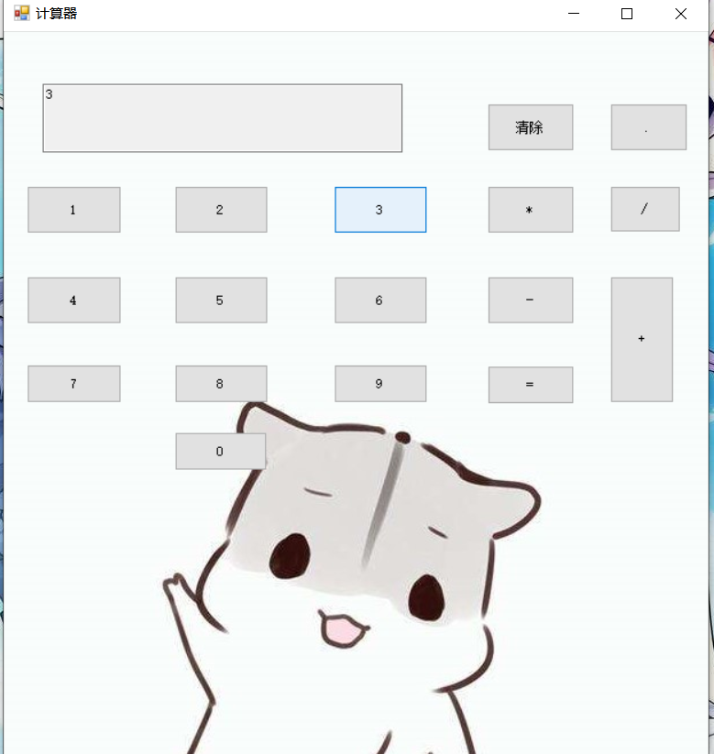

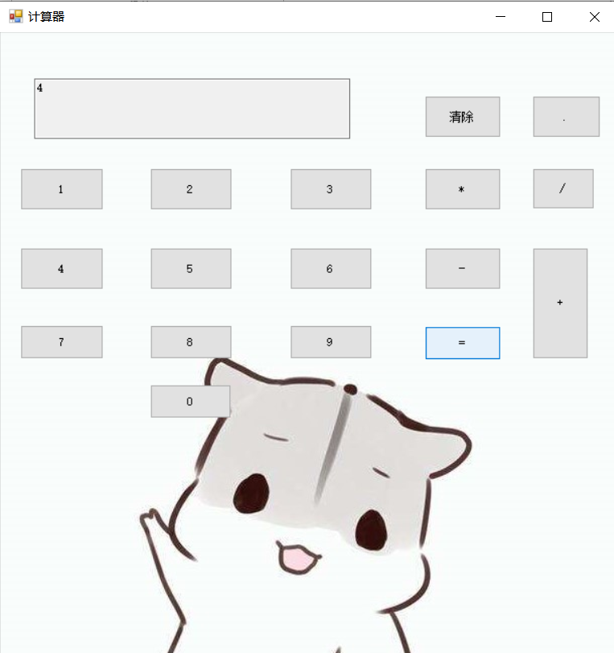

**减法**

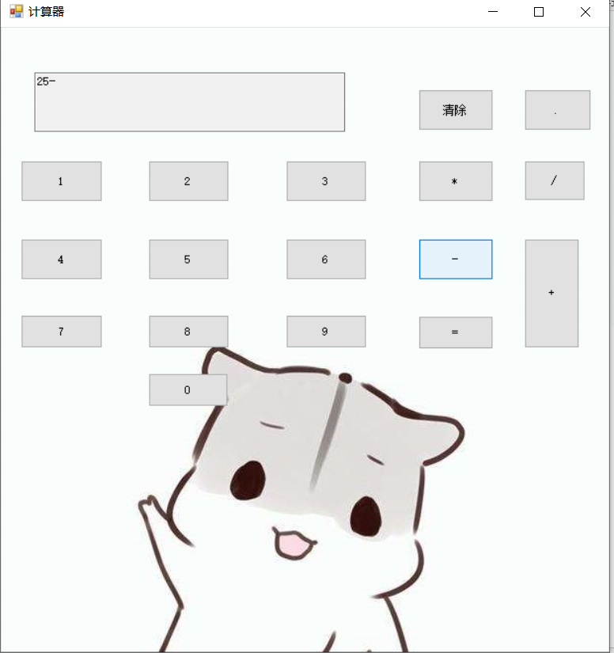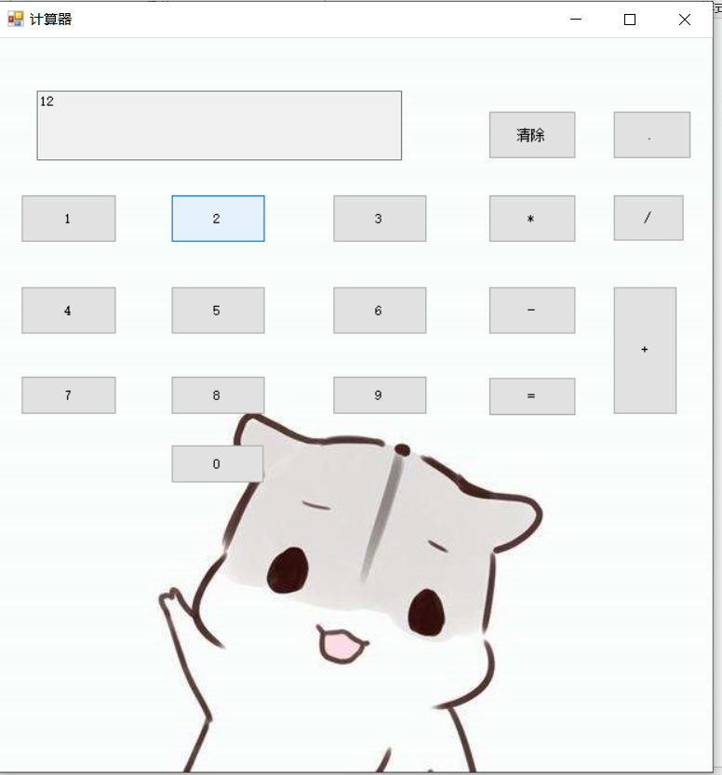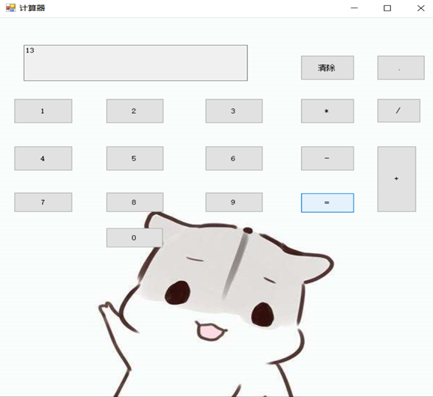

**乘法**

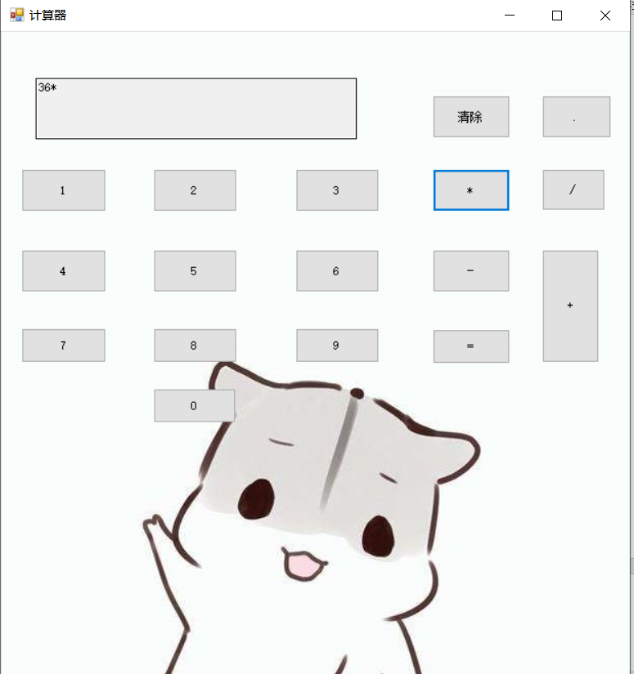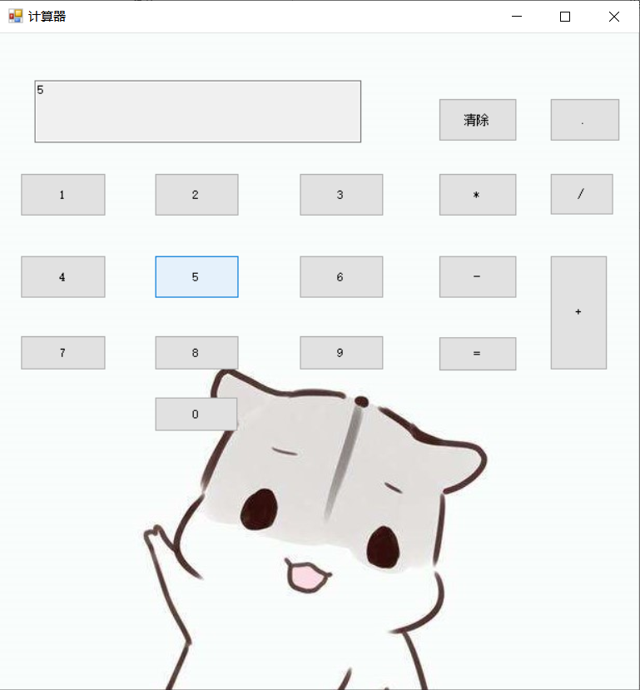

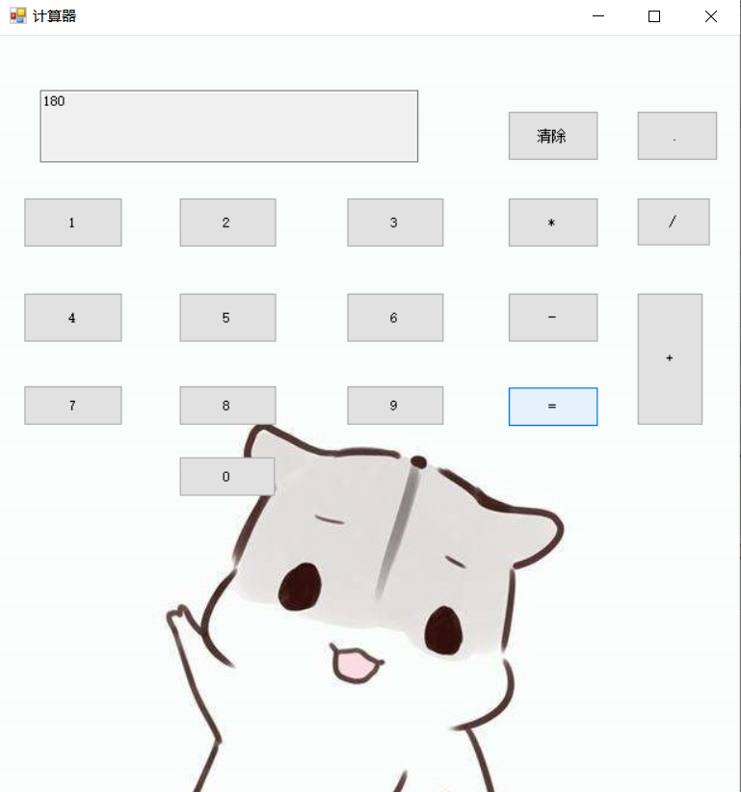

**除法**

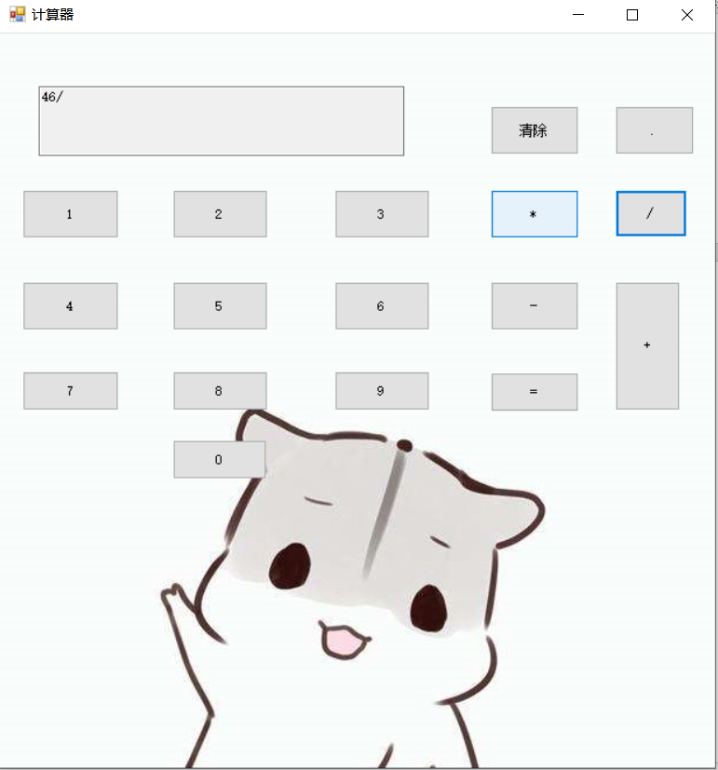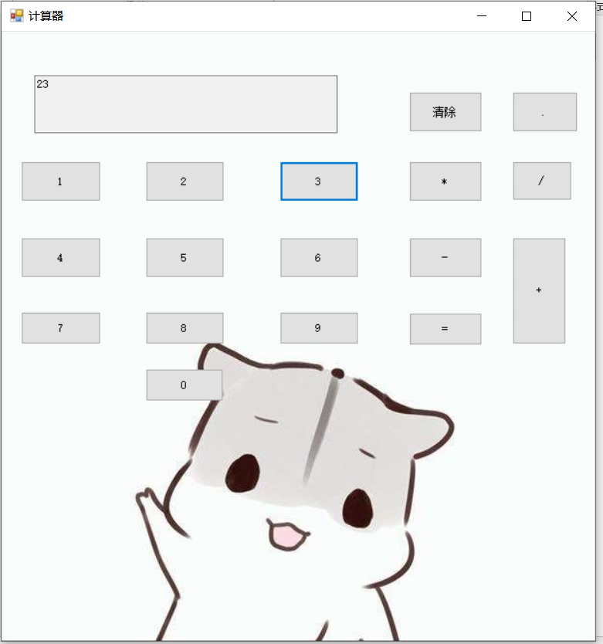

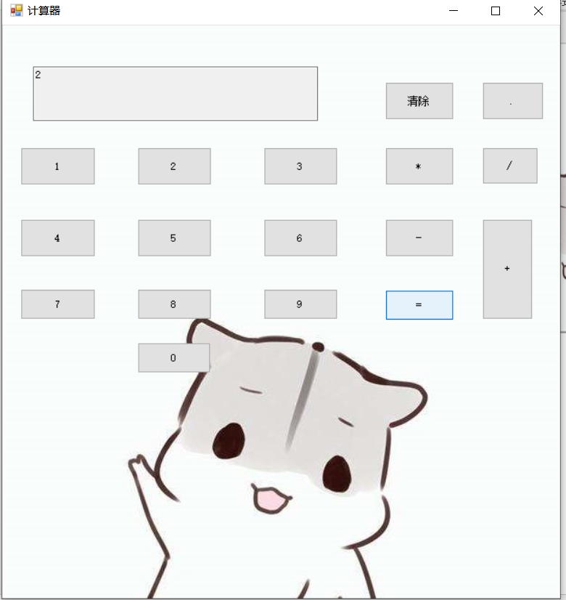

**五.开发过程展示**

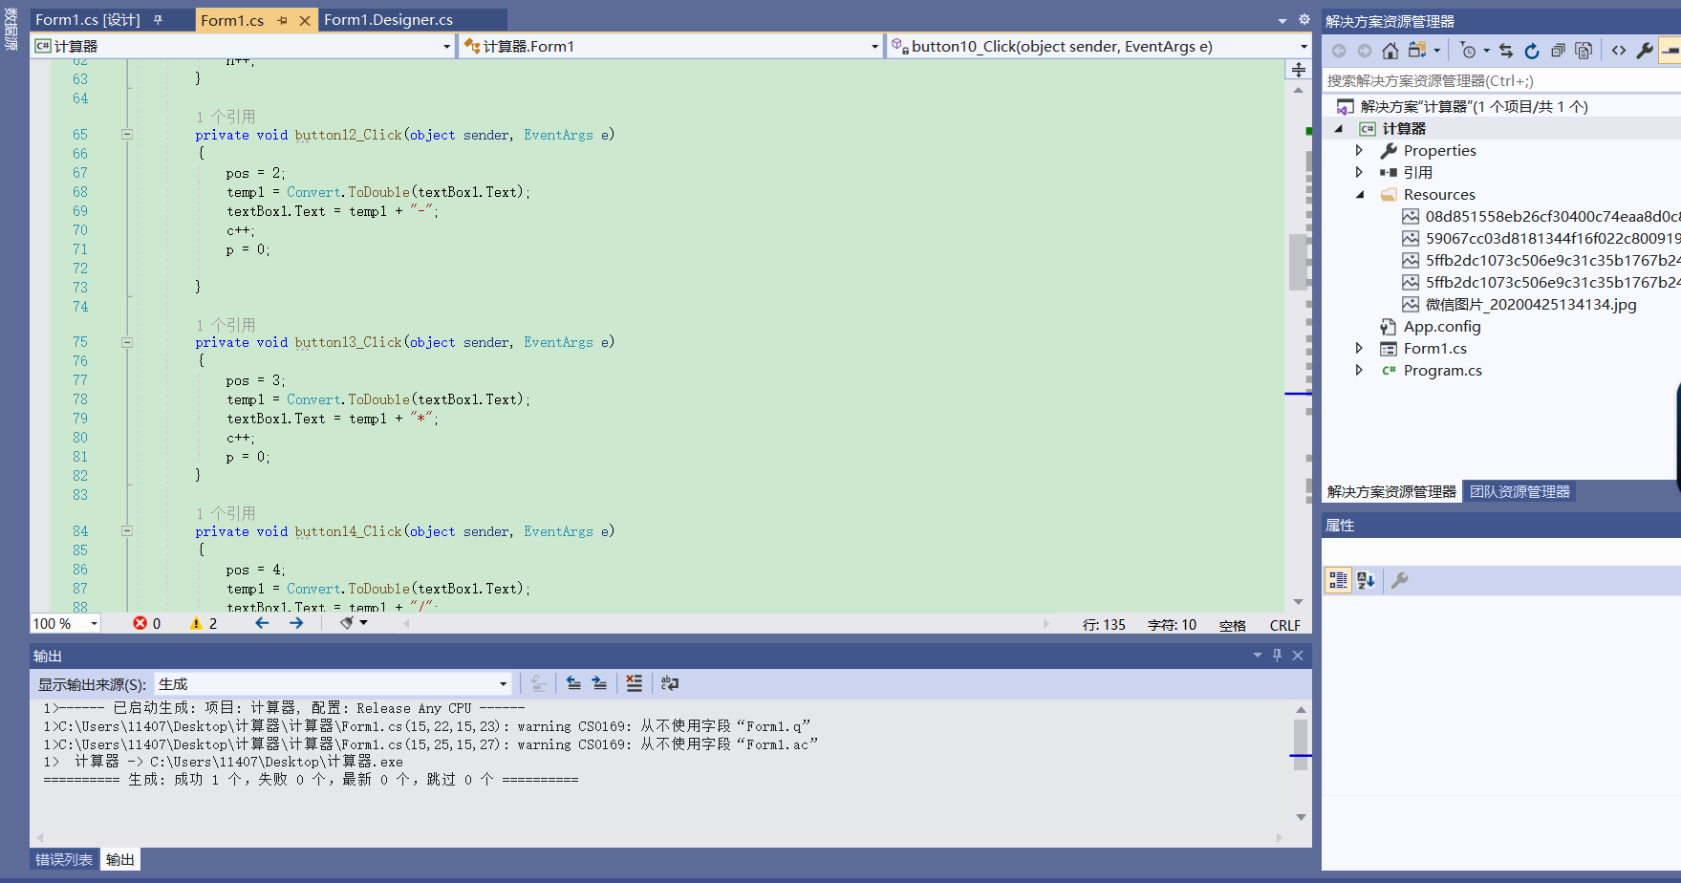

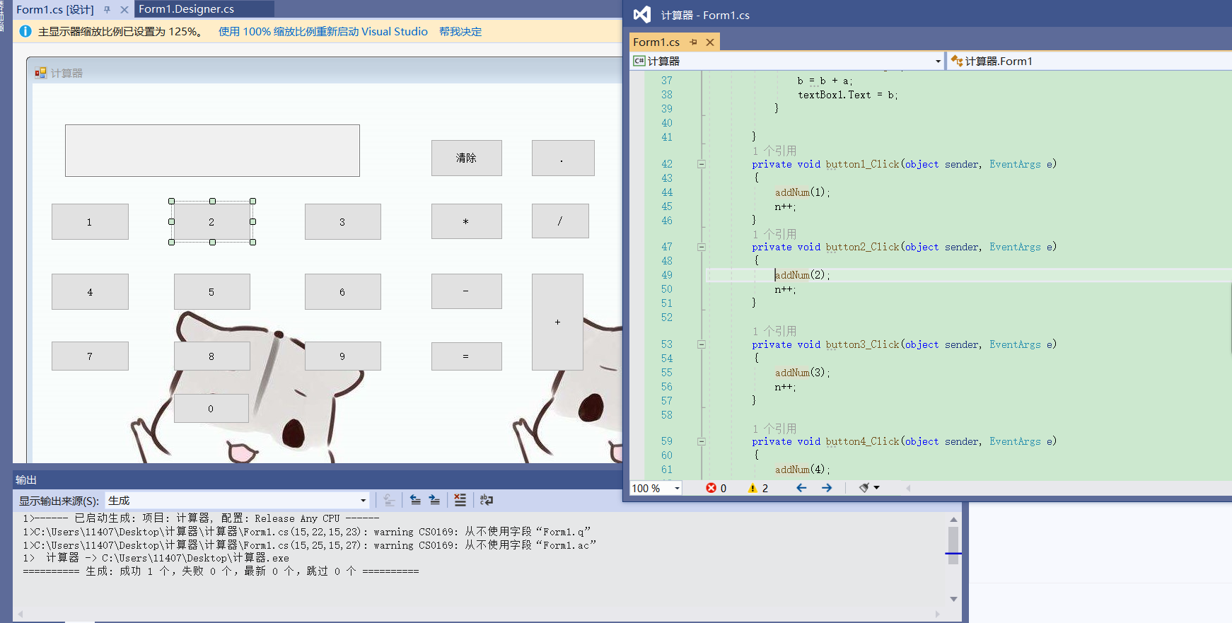

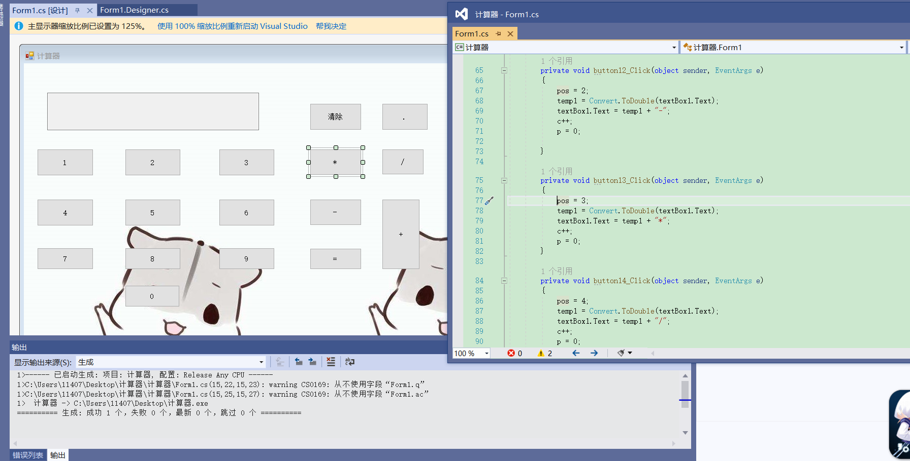

**五.Bug分析结果**

1. **无法计算复杂计算仅能计算加减乘除**
2. **显示窗口只能显示运算符及其前面的数字**
3. **不能算负数加减乘除否则运行错误**

**六.源代码**

using System;

using System.Collections.Generic;

using System.ComponentModel;

using System.Data;

using System.Drawing;

using System.Linq;

using System.Text;

using System.Threading.Tasks;

using System.Windows.Forms;

namespace 计算器

{

public partial class Form1 : Form

{

string a, b, q, ac;

int c = 0, d = 0, n = 0, p = 0, m = 0;

double temp1 = -1;

int pos = 0;

public Form1()

{

InitializeComponent();

}

private void textBox1_TextChanged(object sender, EventArgs e)

{

}

public void addNum(int num)

{

textBox1.Text = textBox1.Text + num.ToString();

if (c > 0)

{

textBox1.Text = "";

a = num.ToString();

b = b + a;

textBox1.Text = b;

}

}

private void button1_Click(object sender, EventArgs e)

{

addNum(1);

n++;

}

private void button2_Click(object sender, EventArgs e)

{

addNum(2);

n++;

}

private void button3_Click(object sender, EventArgs e)

{

addNum(3);

n++;

}

private void button4_Click(object sender, EventArgs e)

{

addNum(4);

n++;

}

private void button12_Click(object sender, EventArgs e)

{

pos = 2;

temp1 = Convert.ToDouble(textBox1.Text);

textBox1.Text = temp1 + "-";

c++;

p = 0;

}

private void button13_Click(object sender, EventArgs e)

{

pos = 3;

temp1 = Convert.ToDouble(textBox1.Text);

textBox1.Text = temp1 + "*";

c++;

p = 0;

}

private void button14_Click(object sender, EventArgs e)

{

pos = 4;

temp1 = Convert.ToDouble(textBox1.Text);

textBox1.Text = temp1 + "/";

c++;

p = 0;

}

private void button5_Click(object sender, EventArgs e)

{

addNum(5);

n++;

}

private void button6_Click(object sender, EventArgs e)

{

addNum(6);

n++;

}

private void button7_Click(object sender, EventArgs e)

{

addNum(7);

n++;

}

private void button8_Click(object sender, EventArgs e)

{

addNum(8);

n++;

}

private void button9_Click(object sender, EventArgs e)

{

addNum(9);

n++;

}

private void button17_Click(object sender, EventArgs e)

{

addNum(0);

n++;

}

private void button10_Click(object sender, EventArgs e)

{

pos = 1;

temp1 = Convert.ToDouble(textBox1.Text);

textBox1.Text = temp1 + "+";

d++;

c++;

p = 0;

}

private void button11_Click(object sender, EventArgs e)

{

double temp2 = Convert.ToDouble(b);

switch (pos)

{

case 1:

textBox1.Text = (temp1 + temp2).ToString();

break;

case 2:

textBox1.Text = (temp1 - temp2).ToString();

break;

case 3:

textBox1.Text = (temp1 * temp2).ToString();

break;

case 4:

textBox1.Text = (temp1 / temp2).ToString();

break;

}

}

private void button15_Click(object sender, EventArgs e)

{

textBox1.Text = "";

temp1 = 0;

pos = 0;

b = "";

a = "";

n = 0;

c = 0;

p = 0;

}

private void button16_Click(object sender, EventArgs e)

{

if (p == 0)

textBox1.Text = textBox1.Text + ".";

p++;

m++;

if (c > 0)

{

b = b + ".";

}

}

}

}