To change the quiz game questions, go to the scenes folder, then select persistent then select Data Controller.

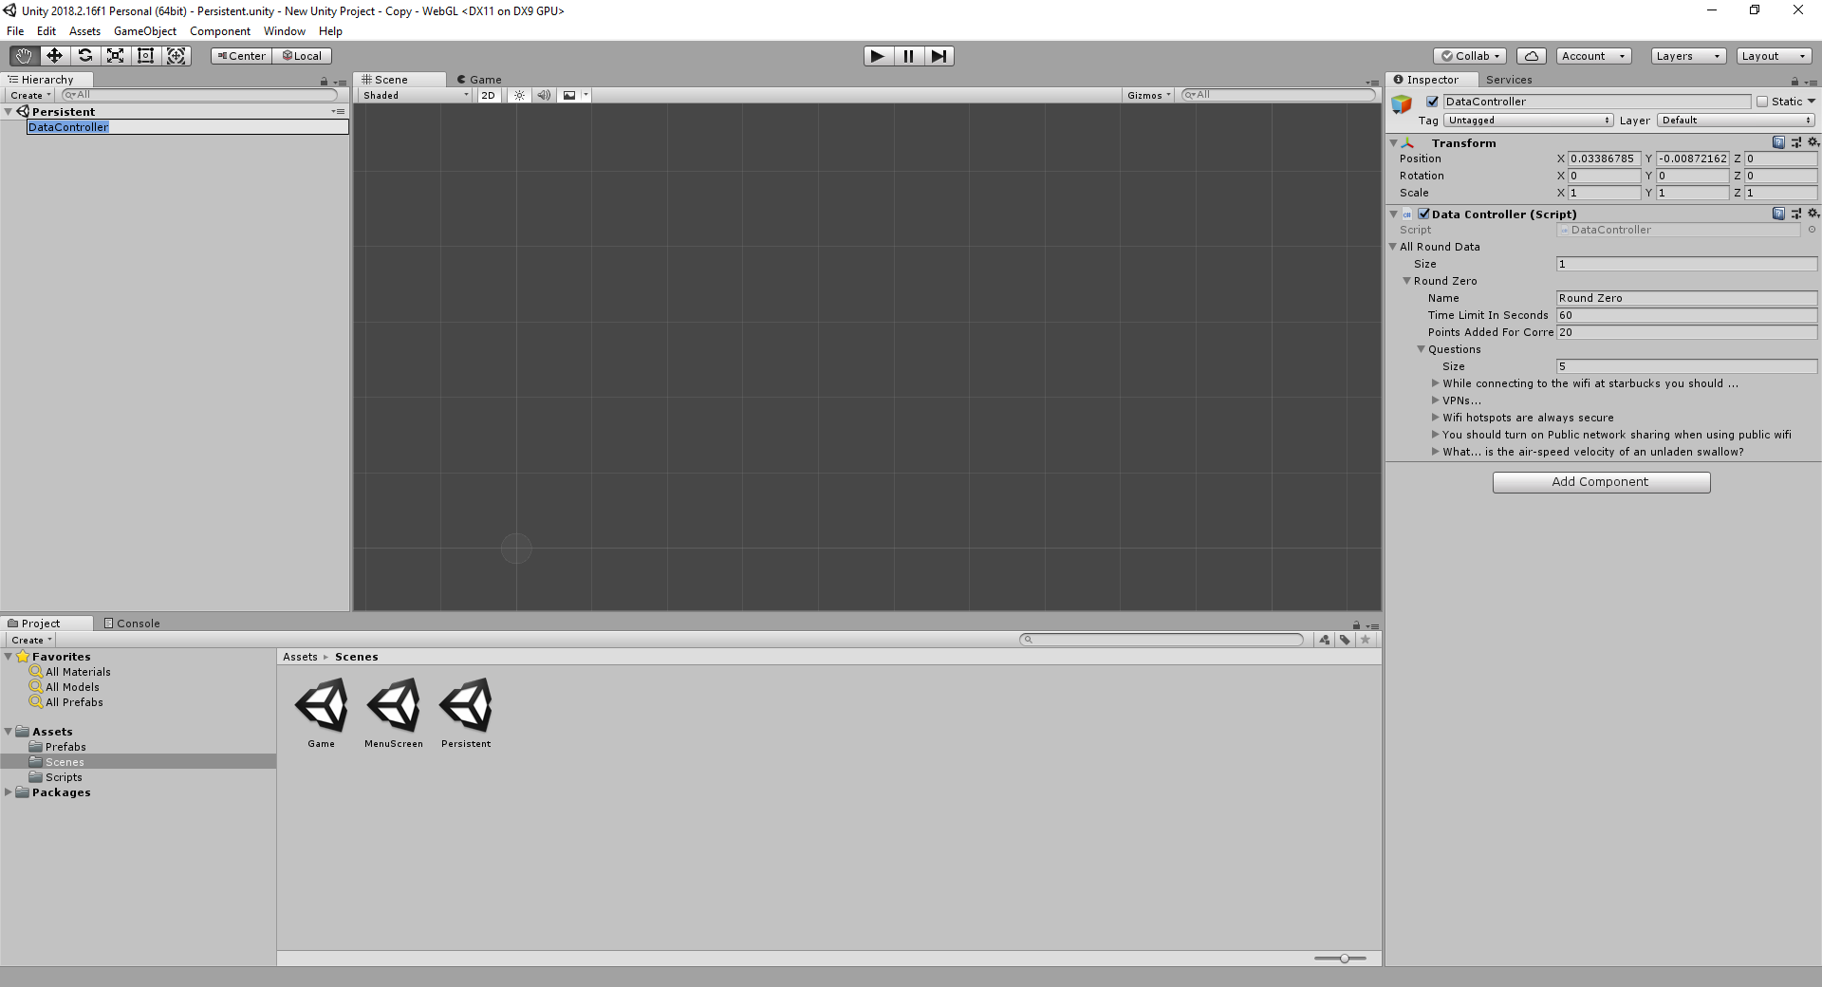

From here you can resize the quiz to customize questions and time.

Overall Guide to unity and how the code runs:

The Menu Screen displays what you see during the menu. Once you click the start game it displays the hidden Game scene and cycles through the questions. All code is in the Scripts folder. Actions are linked between the scripts and certain buttons through the Game controller (pic below). The Prefab allows you to recreate instances of the same object. In this case the answer button. The Persistent Scene is what stores the game data and lasts through run time. Without a general understanding of unity this guide could be hard to follow as linking scripts is very important to get the game running correctly. Adding text to certain scenes and changing general variables is easy.