Java Servlets are the Java programs that run on the Java-enabled web server or application server. They are used to handle the request obtained from the web server, process the request, produce the response, and then send a response back to the web server.

The entire life cycle of a Servlet is managed by the Servlet container which uses the javax.servlet.Servlet interface to understand the Servlet object and manage it. So, before creating a Servlet object, let’s first understand the life cycle of the Servlet object which is actually understanding how the Servlet container manages the Servlet object.

Stages of the Servlet Life Cycle: The Servlet life cycle mainly goes through four stages,

Loading a Servlet.

Initializing the Servlet.

Request handling.

Destroying the Servlet.

Properties of Java Servlet

Servlets work on the server side.

Servlets are capable of handling complex requests obtained from the web server.

Execution of Servlets basically involves Six basic steps:

The Clients send the request to the Web Server.

The Web Server receives the request.

The Web Server passes the request to the corresponding servlet.

The Servlet processes the request and generates the response in the form of output.

The Servlet sends the response back to the webserver.

The Web Server sends the response back to the client and the client browser displays it on the screen.

Servlets are built from two packages:

javax.servlet(Basic)

javax.servlet.http(Advance)

Week 7

7.Design a controller with servlet that provides the interaction with application developed in experiment 1 and the database created in experiment 5.

Aim: Development of servlet application using mysql+html+apache tomcat server.

DESCRIPTION:Eclipse IDE,Mysql,Apache Tomcat server are essential for performing the above program.

1. First download and install the Apache Tomcat Server https://tomcat.apache.org/download-90.cgi
2. Create Eclipse Dynamic web project
3. Add Dependencies and configure the apache tomcat server
4. Project Structure
5. MySQL Database Setup
6. Create UserServlet.java
7. Create web.xml
8. Create a login.html

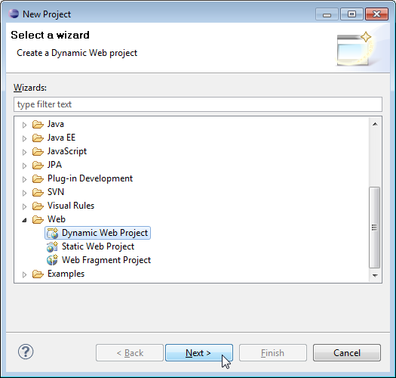

3. Click Next.

4. Enter project name as "login-servlet-jdbc-example";

5. Make sure that the target runtime is set to Apache Tomcat with the currently supported version.

**2. Add Dependencies**

Add the latest release of the below jar files to the lib folder.

- servlet-api.2.3.jar

- mysql-connector-java-8.0.13.jar

In Eclipse, paste these JAR files to your project directory: **WebContent/WEB-INF/lib**

**3. Project Structure**

Standard project structure for your reference -

**4. MySQL Database Setup**

Create a database

Create a table

Insert the data into the table

## 5. Create UserServlet.java

## import java.io.*;

## import javax.servlet.*;

## import javax.servlet.http.*;

## import java.sql.*;

## public class UserServlet extends HttpServlet {

## public void doGet(HttpServletRequest request, HttpServletResponse response)

## throws ServletException, IOException {

## response.setContentType("text/html");

## PrintWriter out = response.getWriter();

## try {

## Class.forName("com.mysql.cj.jdbc.Driver");

## Connection con = DriverManager.getConnection(

## "jdbc:mysql://localhost:3306/sampledb", "user", "password"); // Adjust your username and password

## Statement stmt = con.createStatement();

## ResultSet rs = stmt.executeQuery("SELECT * FROM users");

## while (rs.next()) {

## out.println(rs.getInt("id") + " " + rs.getString("name") + " " + rs.getString("email") + "<br>");

## }

## con.close();

## } catch (Exception e) {

## out.println("Error: " + e.getMessage());

## } finally {

## out.close();

## }

## }

## }

## 6.web.xml

## <web-app>

## <servlet>

## <servlet-name>ex4</servlet-name> <servlet-class> UserServlet </servlet-class>

## </servlet>

## <servlet-mapping>

## <servlet-name>ex4</servlet-name>

## <url-pattern>/login</url-pattern>

## </servlet-mapping>

## <welcome-file-list>

## <welcome-file>login.html</welcome-file>

## </welcome-file-list>

## </web-app>

## 7.Login.html

## <!DOCTYPE html>

## <html>

## <head>

## <meta charset="ISO-8859-1">

## <title>Insert title here</title>

## </head>

## <body>

## <div align="center">

## <h1>Employee Login Form</h1>

## <form action=" UserServlet " method="post">

## <table style="with: 100%">

## <tr>

## <td>UserName</td>

## <td><input type="text" name="username" /></td>

## </tr>

## <tr>

## <td>Password</td>

## <td><input type="password" name="password" /></td>

## </tr>

## </table>

## <input type="submit" value="Submit" />

## </form>

## </div>

## </body>

## </html>