Integrating the Healthcare Enterprise



IHE Radiology
Technical Framework Supplement

Standardized Operational Log of Events
(SOLE)

Draft in preparation for Public Comment
<The IHE Documentation Specialist will change the title to just “Draft for Public Comment” upon publication for public comment; leave “as is” until then.>

Date: November 1, 2016
Author: <Author Name or Technical Committee Name>
Email: <domain_name@ihe.net>

Please verify you have the most recent version of this document. See here for Trial Implementation and Final Text versions and here for Public Comment versions.

Foreword
This is a supplement to the IHE Radiology Technical Framework <VX.X>. Each supplement undergoes a process of public comment and trial implementation before being incorporated into the volumes of the Technical Frameworks.
General information about IHE can be found at: www.ihe.net.
Information about the IHE Radiology domain can be found at: ihe.net/IHE_Domains.
Information about the organization of IHE Technical Frameworks and Supplements and the process used to create them can be found at: http://ihe.net/IHE_Process and http://ihe.net/Profiles.
The current version of the IHE RadiologyTechnical Framework can be found at: http://ihe.net/Technical_Frameworks.
Comments may be submitted on IHE Technical Framework templates any time at http://ihe.net/Templates_Public_Comments. Please enter comments/issues as soon as they are found. Do not wait until a future review cycle is announced.

CONTENTS

Introduction to this Supplement 5
Open Issues and Questions 5
Closed Issues 6
General Introduction 7
Appendix A – Actor Summary Definitions 7
Appendix B – Transaction Summary Definitions 7
Glossary 7
Volume 1 – Profiles 8
<Copyright Licenses> 8
<Domain-specific additions> 8
X Standardized Operational Log of Events (SOLE) Profile 9
X.1 SOLE Actors, Transactions, and Content Modules 9
X.1.1 Actor Descriptions and Actor Profile Requirements 11
X.1.1.1 SOLE Event Reporter 11
X.1.1.2 SOLE Event Consumer 11
X.2 SOLE Actor Options 11
X.3 SOLE Required Actor Groupings 12
X.4 SOLE Overview 12
X.4.1 Concepts 12
X.4.2 Use Cases 12
X.4.2.1 Use Case #1: <simple name> 13
X.4.2.1.1 <simple name> Use Case Description 13
X.4.2.1.2 <simple name> Process Flow 13
X.5 SOLE Security Considerations 15
X.6 SOLE Cross Profile Considerations 15
Appendices 16
Appendix A – <Appendix A Title> 16
A.1 <Add Title> 16
Appendix B – <Appendix B Title> 16
B.1 <Add Title> 16
Volume 2 – Transactions 17
3.Y <Transaction Name [Domain Acronym-#]> 17
3.Y.1 Scope 17
3.Y.2 Actor Roles 17
3.Y.3 Referenced Standards 18
3.Y.4 Interaction Diagram 18
3.Y.4.1 <Message 1 Name> 19
3.Y.4.1.1 Trigger Events 19
3.Y.4.1.2 Message Semantics 19
3.Y.4.1.3 Expected Actions 20
3.Y.4.2 <Message 2 Name> 20
3.Y.4.2.1 Trigger Events 20
3.Y.4.2.2 Message Semantics 20
3.Y.4.2.3 Expected Actions 20
3.Y.5 Security Considerations 21
3.Y.5.1 Security Audit Considerations 21
3.Y.5.1.(z) <Actor> Specific Security Considerations 21
Appendices 22
Appendix A – <Appendix A Title> 22
A.1 <Add Title> 22
Appendix B – <Appendix B Title> 22
B.1 <Add Title> 22
Volume 2 Namespace Additions 22
Volume 3 – Content Modules 23
5 Namespaces and Vocabularies 24
6 Content Modules 25
6.X SOLE Event Definitions 25
X.4.1.1 Subject Verb Object methodology 26
6.X.1 Event Semantics 26
6.X.1 Event Encoding 26
Appendices 27
Appendix A – SOLE Events and Descriptions 27
A.1 RADLEX SWIM Events 27
Appendix B – <Appendix B Title> 27
B.1 <Add Title> 27
Volume 3 Namespace Additions 27
Volume 4 – National Extensions 28
4 National Extensions 28

Introduction to this Supplement
<Provide a brief overview of the volumes/sections of the Technical Framework that get changed/ added by this supplement. Provide 200 words or less describing this supplement.>

Open Issues and Questions
Number | Issue
1 | There are many different transport technologies for event reporting. The IT and other industries have not standardized these well. Usually problem specific constraints (plus not-invented-here) have driven many variations.  The profile proposes the use of Syslog, consistent with ATNA and allowing re-use of many systems that support ATNA and Syslog.  - Existing technologies in use for event logging  The following are four examples of event report transport. These are all in widespread use. There are also some important proprietary logging systems in use for mobile devices.  Syslog  This is the only one that has reached standardization, and it’s what DICOM and ATNA use. (So I guess it’s mulitply standardized.)  Syslog transport has a variety of performance and failure mode characteristics. These are probably acceptable but need to be recognized.  Journalctl  This is the emerging standard in Linux systems for internal journaling. There are tools to send selections from the journalctl logs to external journaling systems by means of Syslog. There are various drivers for this new journaling system. The primary ones (plus of course not-invented-here) are throughput, memory management, power management, and I/O management. An ordinary workstation will generate thousands of events per second during busy times such as system startup.  They wanted to keep the performance impact low, and a network based system like syslog did not fit.  There is no official standard organization responsible for this logging system.  Flume  Flume is a logging system being pushed by the Apache foundation. It’s primary target is massive continuous dataflows from many sources into a distributed database such as Hadoop for distributed queries by warehouse scale computing. An example use would be the collection of all the journalctl traffic for 10,000 nodes onto a distributed database of 100 database servers for analysis by 25 query/analysis nodes.  There is no official standard organization responsible for this logging system.  Bitcoin  It may feel odd to think of Bitcoin as a logging system, but what it records are events, mostly financial events like “A gave 2 bitcoins to B”. It is dealing with an environment where there is massive mutual lack of trust, the transaction log must be redundant and survive extensive attacks, and the transaction volume is small.  There is no official standard organization responsible for this logging system.  Android/Ios (phone/tablet use)  Both Google and Apple have switched from using Syslog to using internal logging methodologies that can be battery performance optimized. They tend to a two step system where the first step is internal logging is performed using the internal battery optimized method, and then a second step extracts selected relevant events from that log and sends them using another method. This other method is typically able to send large blocks of event reports efficiently.  There is no official standard organization responsible for these logging systems.  Syslog limitations that may matter are:  - It does not guarantee delivery. TLS connection failures may result in truncated or lost messages. (These are quite rare.) It is the event source responsibility to manage buffering and re-transmission in the even of connection losses.  - The per message overhead is low, but a connection must be maintained. This is primarily a concern for mobile and battery powered devices.  - Throughput is limited by network speed and buffering. This typically limits events to a few hundred to a few thousand per second. Higher volume event logs from large scale computing are one motivation for FLUME and similar high volume transports.  - Connection, buffering, and message synchronization make Syslog problematic when there are large bursts of messages at very high speed. For example, the generation of 10-50,000 messages in the first second of system boot of complex servers was motivation for Journalctl.
2 | Are there events in SWIM that should not be included in the profile? Are there other events that should be in the profile?
3 | Should an encoding different than the DICOM Audit Schema be used?  The profile assumes use of the DICOM Audit Schema so that ATNA tooling can be re-used.
4 | Should the event description continue to be done using the “subject verb object” methodology originally chosen by HL7, DICOM, and RFC-3881. This can continued to be used in DICOM and ATNA.
5 | Should this profile add the RESTful PUT of syslog messages that was proposed for ITI this year. It wasn’t ranked high enough for ITI, and was thought small enough that perhaps a CP was the right approach rather than a supplement.
6 | Are the RESTful Syslog query parameters sufficient? They are very coarse query controls. The primary query is to obtain all syslog reports over a time interval from specific sources. The query is against the Syslog message header parameters, and does not query inside the event message.  The bulk of event selection and analysis is performed within the Event Consumer.

Closed Issues
Number | Issue

General Introduction
Update the following appendices to the General Introduction as indicated below. Note that these are not appendices to Volume 1.
Appendix A – Actor Summary Definitions
Add the following actors to the IHE Technical Frameworks General Introduction list of Actors:
<Add any actor definitions for new actors defined specifically for this profile. These will be added to the IHE TF General Introduction list of Actors namespace.>

Actor | Definition
SOLE Event Reporter
SOLE Event Consumer
Appendix B – Transaction Summary Definitions
Add the following transactions to the IHE Technical Frameworks General Introduction list of Transactions:
<Add any transaction definitions for new transactions defined specifically for this profile. These will be added to the IHE TF General Introduction list of Transactions namespace.>

Transaction | Definition
Glossary
Add the following glossary terms to the IHE Technical Frameworks General Introduction Glossary:
<Any glossary additions associated with the profile draft go here.>

Glossary Term | Definition

Volume 1 – Profiles

<Copyright Licenses>
<General copyright licenses and permissions are listed in the IHE Technical Frameworks General Introduction. Add information on any standards referenced in the profile that are not already addressed in the permission section.>
Add the following to the IHE Technical Frameworks General Introduction Copyright section:

<Domain-specific additions>
<Some domains have specific sections, added as subsections to Sections 1 or 2, in their Technical Frameworks. These types of additions are allowed as long as they do not adjust the overall numbering scheme which needs to remain consistent across domains. If there are such additions, they should be included here.>

Add to section X …

X Standardized Operational Log of Events (SOLE) Profile
Efficient businesses use business intelligence tools to manage their business. The application of these tools to manage medical care has been limited in part because the information often resides in several different systems, and there are not standard ways to obtain the information. The SOLE profile defines a way to exchange information about events that can then be collected and displayed using standard methods.
Healthcare providers have a strong desire to increase throughput and efficiency, both to improve the quality and timeliness of care and to control costs. Such process improvement efforts depend on being able to capture workflow events and apply business intelligence tools. Such initiatives face several problems:
- Event information that is to be logged comes from many different systems but there is no easy way to collect and compile the events into a single collection
- The different systems recording the particular events being logged may have different understandings of the definition of the event, time point or measurement; the result is:
- Within a single institution, data is non-uniform across systems, degrading the value of the information
- Across institutions, it is hard to compare to evaluate best practices

X.1 SOLE Actors, Transactions, and Content Modules
This section defines the actors, transactions, and/or content modules in this profile. General definitions of actors are given in the Technical Frameworks General Introduction Appendix A at http://ihe.net/Technical_Frameworks.
Figure X.1-1 shows the actors directly involved in the SOLE Profile and the relevant transactions between them. If needed for context, other actors that may be indirectly involved due to their participation in other related profiles are shown in dotted lines. Actors which have a mandatory grouping are shown in conjoined boxes.

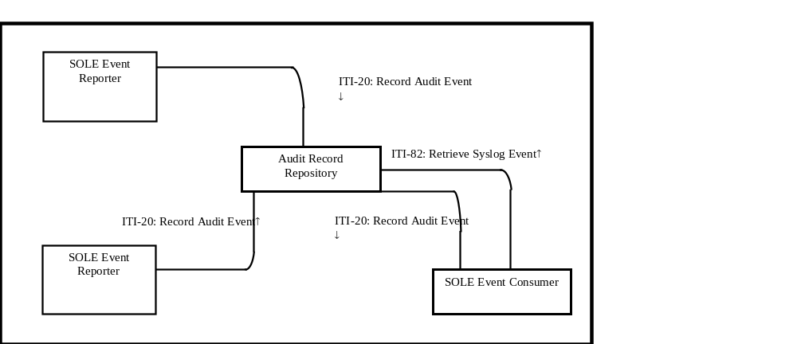
Figure X.1-1: SOLE Actor Diagram

Table X.1-1 lists the transactions for each actor directly involved in the <Profile Acronym> Profile. To claim compliance with this Profile, an actor shall support all required transactions (labeled “R”) and may support the optional transactions (labeled “O”).

Table X.1-1: <Profile Acronym> Profile - Actors and Transactions
Actors | Transactions | Optionality | Reference
SOLE Event Reporter | ITI-20 Record Audit Event | R | <Domain Acronym> TF-2: 3.Y1
SOLE Event Consumer | ITI-82 Retrieve Syslog Event | O | <Domain Acronym> TF-2: 3.Y1
SOLE Event Consumer | ITI-20 Record Audit Event | O | <Domain Acronym> TF-2: 3.Y1

Table X.1-1: SOLE Profile - Actors and Content Modules
Actors | Content Modules | Optionality | Reference  <this should be a reference to a location in Volume 3)
SOLE Event Reporter | SOLE Event | R | 6.X SOLE Event Definitions
SOLE Event Consumer | SOLE Event | R | 6.X SOLE Event Definitions
Note 1: The SOLE Repository shall accept any content, even malformed content. It might only archive and report on properly formed content that complies with the content rules in 6.x SOLE Events.

X.1.1 Actor Descriptions and Actor Profile Requirements
Most requirements are documented in Transactions (Volume 2) and Content Modules (Volume 3). This section documents any additional requirements on profile’s actors.

X.1.1.1 SOLE Event Reporter
<If the summary description of the actor in Appendix A is insufficient to understand its role in this profile, elaborate here.>
<Requirements on actors are predominantly contained inside transactions in volume 2. The main requirement on actors contained in volume 1 is to support the transactions identified in table X.1-1 and the content modules identified in table Z. Requirements that do not fit in those locations may be placed here.>

X.1.1.2 SOLE Event Consumer

X.2 SOLE Actor Options

Table X.2-1: Standardized Operational Log of Events - Actors and Options
Actor | Option Name | Reference  <either reference TF-3 or the applicable X.2.x subsection below table>
SOLE Event Reporter | No options defined | --
SOLE Event Consumer | No options defined | --

X.3 SOLE Required Actor Groupings
It is important that the time base for all of the actors be the same. The ITI

Table X.3-1: Standardized Operational Log of Events - Required Actor Groupings
<this Profile Acronym> Actor | Actor to be grouped with | Reference | Content Bindings Reference
Actor A | Time Client | <reference the section where the actors are defined in that profile, e.g., <Domain Acronym TF-1: x.x.x> | --
Actor B | Time Client | - -- <for example:-RAD TF-1: 14.1> | --

X.4 SOLE Overview
<Volume 2 documents each transaction/content module in isolation. This section shows how the transactions/content modules of the profile are combined to address the use cases.>
<Use cases are informative, not normative, and “SHALL” language is not allowed in use cases.>

X.4.1 Concepts
The SIIM Workflow Initiative in Medicine (SWIM™) is a Society for Imaging Informatics in Medicine sponsored initiative with initial goals of developing:
- common definition of the workflow steps within medical imaging departments;
- Key performance indicators that are defined using these workflow steps;
- Definitions of the data elements used to capture information about the workflow steps associated with these key performance indicators; and
The events described in SWIM http://siim.org/resource/resmgr/swim/SWIMRadlex1.xlsx. These are the events that are defined by this profile.
Additional events can be added to meet local needs, but recipient and reporting systems might not understand those event reports.
This profile defines these events semantically using the subject verb object methodology to establish the semantic details that are required in a report, or optional in a report. These semantics can be encoded in a various formats. This profile specifies an encoding using the DICOM audit event schema for transport. There are various potential transports that are possible for events. This profile specifies the use of the Syslog transport (RFC-5424).

X.4.2 Use Cases

X.4.2.1 Use Case #1: Track Study Reading Activities
The following scenario shows events from a routine radiology reading activity:
- Time synchronization occurs independently. These transactions may take place at any time. Correct time is needed to generate audit records with a correct timestamp.
- A user logs on to Image Display.
- The Image Display generates audit records.
- The Image Display initiates the query/retrieve transactions.
- The Image Display and Image Manager generate audit records.

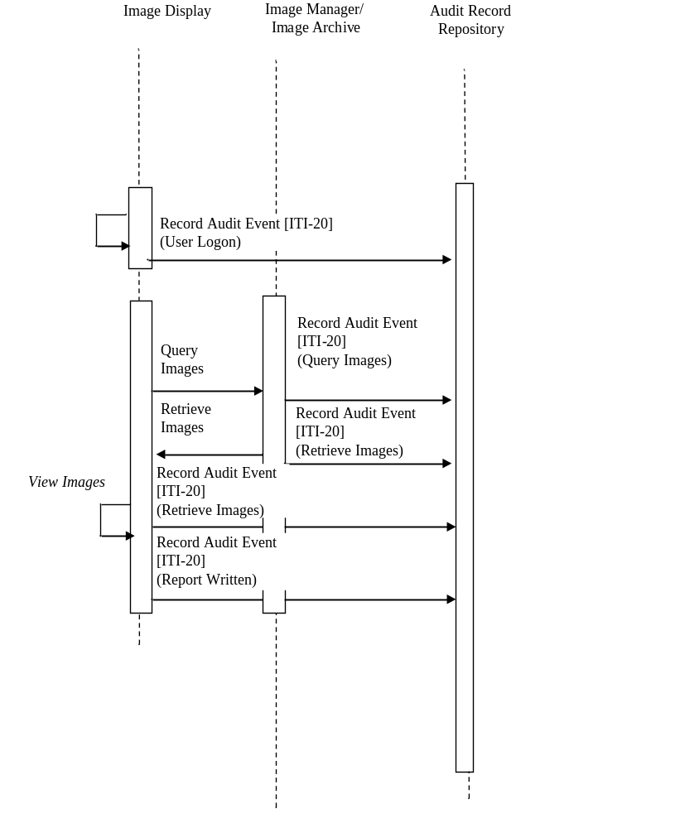
Figure 9.4.2.1-1: Authorized Node Process Flow

These SOLE events track activities during the reading process.
SOLE Event Consumers, such as business intelligence tools, workflow engine-management tools, and tools related to performance measurement, would retrieve blocks of event messages from the event log server.

X.4.2.2.1 SOLE Event Analysis

Pre-conditions:
The Audit Repository has a collection of SOLE Events to be analyzed.
Main Flow:
A SOLE Event Consumer queries the Audit Repository with a RESTful Syslog Query to obtain the SOLE Events to be analyzed.
The SOLE Event Consumer generates a report. (Reporting details are outside the scope of this profile.)
Post-conditions:
Report is generated.

X.4.2.3.1 Delayed Event Delivery

X.4.2.3.2 <simple name> Process Flow

Figure X.4.2.2-1: Basic Process Flow in <Profile Acronym> Profile

Pre-conditions:
A SOLE Event Reporter has accumulated events that need to be delivered to an Audit Repository or SOLE Event Consumer.

Main Flow:
The SOLE Event Reporter uses an HTTP PUT to deliver these audit messages in the same format as the HTTP GET used for RESTful Syslog Retrieve.

Post-conditions:
<Very briefly (typically one sentence) describe the state of the clinical scenario after this content module has been created including examples of potential next steps.>

X.5 SOLE Security Considerations
<Describe profile-specific security considerations. This should include the outcomes of a risk assessment. This likely will include profile groupings, and residual risks that need to be assigned to the product design, system administration, or policy. See the ITI document titled ‘Cookbook: Preparing the IHE Profile Security Section’ at http://www.ihe.net/Technical_Framework/index.cfm for suggestions on risk assessment, risk mitigation, and IT and security profiles.>
<If this is not a content module, delete the sentence below. If this is a content module profile, you may want to expound upon the security considerations provided by grouped actors.>
The security considerations for a content module are dependent upon the security provisions defined by the grouped actor(s).

X.6 SOLE Cross Profile Considerations

Appendices

Appendix A – <Appendix A Title>
Appendix A text goes here.
  - <Add Title>
Appendix A.1 text goes here
Appendix B – <Appendix B Title>
Appendix B text goes here.

  - <Add Title>
Appendix B.1 text goes here.

Volume 2 – Transactions
Add section 3.Y

3.Y <Transaction Name [Domain Acronym-#]>
<The “Y” in the heading should be the same as the # in the [Domain Acronym -#] title>

3.Y.1 Scope
This transaction is used to <…describe what is accomplished by using the transaction. Remember that by keeping transactions general/abstract, they can be re-used in a variety of profiles>

3.Y.2 Actor Roles
<Optional: if desired, in addition to the table, add a diagram as shown below to illustrate the actors included in this transaction, or delete the diagram altogether.>
Transaction Name [DOM-#]

Transaction Name [DOM-#]
Actor ABC

Actor ABC
Actor DEF

Actor DEF
Figure 3.Y.2-1: Use Case Diagram

Table 3.Y.2-1: Actor Roles
Actor: | <Official actor name; list every actor in this transaction.>
Role: | <Very brief, one phrase, description of the role that this actor plays in this transaction.>
Actor:
Role:
Actor:
Role:
<The assignment and use of role names in transaction specifications has proved to be very effective/efficient in Radiology, especially when existing transactions are re-used by additional actors. Following is an alternative example of the Role section. Delete which ever form of the role section you choose not to use.>

The Roles in this transaction are defined in the following table and may be played by the actors shown here:
Table 3.Y.2-1 Actor Roles
Role: | <Role Name:><Only unique within this transaction. Typically one word. The Role Name is analogous to SCU or SCP in DICOM Services.>
Actor(s): | The following actors may play the role of <Role Name>:  <Actor Name>: <optionally, the situation where the actor would play this role if needed for clarity.>”
Role: | <e.g., Requestor:  Submits the relevant details and requests the creation of a new workitem.>
Actor(s): | <e.g., The following actors may play the role of Requestor:  Workitem Creator: when requesting workitems  Workitem Performer: when performing unscheduled workitems>
Role: | <e.g., Manager:  Creates and manages a Unified Procedure Step instance for the requested workitem.>
Actor(s): | <e.g., The following actors may play the role of Manager:  Workitem Manager: when receiving a new workitem for its worklist.>
Transaction text specifies behavior for each Role. The behavior of specific Actors may also be specified when it goes beyond that of the general Role.

3.Y.3 Referenced Standards
- <e.g., HL7 2.3.1 Chapters 2, 3>
- <e.g., DICOM 2008 PS 3.3: A.35.8 X-Ray Radiation Dose SR IOD>

3.Y.4 Interaction Diagram
<The interaction diagram shows the detailed standards-based message exchange that makes up the IHE transaction.>
Actor A

Actor A
Message 1

Message 1
Actor D

Actor D
Message 2

Message 2

3.Y.4.1 <Message 1 Name>
<One or two sentence summary of what Message 1 accomplishes typically relating the message to the relevant standard. Avoid shall language in this upper level section. Do not duplicate the triggers, encoding, semantics, standards used, or expected actions. Those belong in the following sections.>
<Explicitly state if the multiplicity of an actor may be greater than one; i.e., if an actor (whether it is a client or server) can expect this message from a single source or multiple sources.>

3.Y.4.1.1 Trigger Events
<Description of the real world events that cause the sender (Actor A) to send Message 1 (e.g., an operator or an automated function determines that a new workitem is needed).>

3.Y.4.1.2 Message Semantics
<Detailed description of the meaning, structure and contents of the message, including any IHE specific clarifications of the message format, attributes, etc.>
<Start by describing the standard underlying the message and how the participating actors are mapped (e.g., “This message is a DICOM C-FIND Request. Actor A is the SCU. Actor D is the SCP.”).>
<Continue profiling the message by providing guidance or constraints on how the message parameters are populated, how the payload is encoded, how the message is structured and what the contents mean. These message semantics should both help the sender to construct the message and the receiver to interpret the message.>

3.Y.4.1.3 Expected Actions
<Description of the actions expected to be taken as a result of sending or receiving this message.>
<Describe what the receiver is expected/required to do upon receiving this message. >
<Avoid re-iterating the transaction sequencing specified in the Profile Process Flows as expected actions internal to the transaction. Doing so prevents this transaction being re-used in other contexts.>
<Explicitly define any expected action based on the multiplicity of an actor(s), if applicable.>

3.Y.4.2 <Message 2 Name>
<One or two sentence summary of what Message 2 accomplishes typically relating the message to the relevant standard. Avoid shall language in this upper level section. Do not duplicate the triggers, encoding, semantics, standards used, or expected actions. Those belong in the following sections.>
<Explicitly state if the multiplicity of an actor may be greater than one; i.e., if an actor (whether it is a client or server) can expect this message from a single source or multiple sources.>
<Repeat this section as necessary based on the number of messages in the interaction diagram.>

3.Y.4.2.1 Trigger Events
<Description of the real world events that cause the sender (Actor A) to send Message 1(e.g., an operator or an automated function determines that a new workitem is needed).>

3.Y.4.2.2 Message Semantics
<Detailed description of the meaning, structure and contents of the message, including any IHE specific clarifications of the message format, attributes, etc.>
<Start by describing the standard underlying the message and how the participating actors are mapped (e.g., “This message is a DICOM C-FIND Request. Actor A is the SCU. Actor D is the SCP.”).>
<Continue profiling the message by providing guidance or constraints on how the message parameters are populated, how the payload is encoded, how the message is structured and what the contents mean. These message semantics should both help the sender to construct the message and the receiver to interpret the message.>

3.Y.4.2.3 Expected Actions
<Description of the actions expected to be taken as a result of sending or receiving this message.>
<Describe what the receiver is expected/required to do upon receiving this message. >
<Avoid re-iterating the transaction sequencing specified in the Profile Process Flows as expected actions internal to the transaction. Doing so prevents this transaction being re-used in other contexts.>
<Explicitly define any expected action based on the multiplicity of an actor(s), if applicable.>

3.Y.5 Security Considerations
<Description of the transaction specific security consideration; such as use of security profiles.>

3.Y.5.1 Security Audit Considerations
<This section should identify any specific ATNA security audit event that is associated with this transaction and requirements on the encoding of that audit event. >

3.Y.5.1.(z) <Actor> Specific Security Considerations
<This section should specify any specific security considerations on an Actor by Actor basis.>

Appendices
<Detailed cross transaction relationships or mapping details are described in an appendix in Volume 2x. Volume 2 appendices may be informational or normative. Immediately after the title of a Volume 2 appendix, provide a very explicit statement defining whether this new appendix is informative or normative.>

Appendix A – <Appendix A Title>
Appendix A text goes here.
A.1 <Add Title>
Appendix A.1 text goes here
Appendix B – <Appendix B Title>
Appendix B text goes here.

B.1 <Add Title>
Appendix B.1 text goes here.

Volume 2 Namespace Additions
Add the following terms to the IHE General Introduction Appendix G:
<Please explicitly identify all new OIDs, UIDs, URNs, etc., defined specifically for this profile. These will be added to the IHE TF General Introduction namespace appendix when it becomes available. These items should be collected from the sections above, and listed here as additions when this document is published for Trial Implementation. This section will be deleted prior to inclusion into the Technical Framework as Final Text, but should be present for publication of Public Comment and Trial Implementation.>

Volume 3 – Content Modules
<The current version of the supplement template only addresses HL7 v3 CDA Content Modules. All CDA Content Modules will go in Section 6 of Volume 3 of each domain’s Technical Framework document. In the future, this supplement template may have additional sections for DICOM Content Modules (section 7 of Volume 3) and other types of Content Modules (section 8, etc., of Volume 3).
<Please note that prior to the release of the new template set, some domains may have defined CDA Content Modules in Volume 2 (e.g., PCC); however, going forward CDA Content Modules will be defined in Volume 3.>

5 Namespaces and Vocabularies
Add to section 5 Namespaces and Vocabularies
<Note that the code systems already defined in the Technical Framework of this domain may (but not required) be replicated here just to aid in the supplement review as a standalone document. Also note that the Section 5 table numbers and names are already defined in the TF Volume 3.>

codeSystem | codeSystemName | Description
<oid or uid> | <code system name> | <short description or pointer to more detailed description>
<oid or uid> | <code system name> | <short description or pointer to more detailed description>
<oid or uid> | <code system name> | <short description or pointer to more detailed description>

Add to section 5.1.1 IHE Format Codes

Profile | Format Code | Media Type | Template ID
<Profile name (profile acronym)> | <urn:ihe: > |  | <oids>

Add to section 5.1.2 IHE ActCode Vocabulary

Code | Description
<Code name> | <short one sentence description or reference to longer description (not preferred)>
<Code name> | <short one sentence description or reference to longer description (not preferred)>
<Code name> | <short one sentence description or reference to longer description (not preferred)>

Add to section 5.1.3 IHE RoleCode Vocabulary

Code | Description
<name of role> | <Short, one sentence description of role or reference to more info.>
<name of role> | <Short, one sentence description of role or reference to more info.>
<name of role> | <Short, one sentence description of role or reference to more info.>

6 Content Modules

6.X SOLE Event Definitions
The events described in SWIM http://siim.org/resource/resmgr/swim/SWIMRadlex1.xlsx are reported as SOLE events. The semantic content to be include in the report is defined in event semantics, and the encoding of those semantics defined in event encoding.
Instructions for preparing SVO description
Clarity is important, not academic purity when making an SVO description. Acceptable uncertainty and errors should be made clear to avoid later academic arguments about irrelevant errors. For example, if “start exam” time may be acceptably any time between calling for the patient in the waiting room and the patient being on the table, then say so.
SVO is much easier to implement with wide-shallow descriptions rather than deep-structured descriptions. Deeply structured definitions of Subject or Object often pose significant difficulty on the event reporter, and on finding events. For example, saying that the Subjects in an event were Doctor A, Doctor B, and Doctor C is usually preferable to explaining all the teaming relationship, seniority relationship, and organizational relationships the formed that team. It’s easy for the reporting system to determine that these three were the subjects. Keeping the reporters informed about all the reasons that these three were working together as a team is hard work. That hard work is not usually rewarded with more useful logs.
Time and Location
Define the time rules and location rules. This is best done with a global expectation, and perhaps a few event specific exceptions. An example from wildlife reporting events is that many of the rules and regulations are in terms of sun angle. This is usually expressed in terms like “5 minutes after local civil sunrise”. That turns into an accuracy requirement on the local time base, e.g., within 1 minute of UTC at all times, and an accuracy requirement on the location of within a few miles.
Observer
DICOM extended the SVO with the “Observer”. In most of the interesting events there is an observing person or system that does not participate in the event in any other way. Separating them out allows stricter rules to be placed on subjects, objects, and observer.
Consider what the event reporter will actually know, rather than expect it to deduce things. If something gets done 30 minutes late, it’s easy to report the event “complete”. It’s very hard to attach reasons. Also, consider the event reporter’s knowledge limitations and viewpoint.
Applying all these rules to the lightning event was useful in transforming the ancient Greek SVO of “Zeus throws lightning bolt” into a modern event reporting system:
“Electric field sensor ID-X (subject) detected (verb) electric-field-pulse (at time, amplitude, distance, direction) (object). This was recorded by data-logger Y. (observer)”
This flat approach makes it easy to track data records (based on data-logger history) and sensor calibrations (based on sensor ID) by keeping them out of the event report. The various participant IDs provide sufficient references. Flat data records are also preferred by most of the BI tools, such as R.
It can feel odd that SVO made the electric-field-pulse the object. The initial naïve thought is that the lightning must be the event. But the SVO process led to detection being the verb. Later, this proved very useful because it made it easy to deal with noisy detectors, false alarms, etc. All of those were detections of something. They were not all detections of lightning. In the data cleaning process the SVO choices made it quite natural and easy to explain false positives, calibration corrections, etc..

X.4.1.1 Subject Verb Object methodology
DICOM, ATNA, and the original RFC-3881 used the “Subject-Verb-Object” method of describing events. This methodology has been used for subjects ranging from ecological systems to quantum chemistry. It’s not the only methodology for describing events, but it’s simple and has a good track record. For example, the ancient Greeks would describe a lightning event as “Zeus (subject) throws (verb) thunderbolt (object)”.
In SVO every event is described in terms of

Subjects | There is at least one subject, and there may be many. These are called “active participants” in the DICOM schema. E.g., the radiologist in “Radiologist approves protocol”.
Verb | There is usually just one verb, although limits of vocabulary may for the creation of compound verbs. Be very careful about compound verbs. They often indicate that there are really two events that have been collapsed together that should be separated.  In the DICOM schema the verb is called the “event type”.
Objects | There is usually at least one object. These are all the things that are acted upon. The object need not be modified by the event, e.g., “Radiologist approves protocol”.  In the DICOM schema the objects are the “passive participants”.

6.X.1 Event Semantics
See sole-SVO-semantics.xls

6.X.1 Event Encoding
Rules to map onto DICOM Schema from SVO-semantics

Appendices
<Add any applicable appendices below; NA if none.>
Appendix A – SOLE Events and Descriptions
Appendix A text goes here.
A.1 RADLEX SWIM Events
The events are selected from the RADLEX SWIM list, https://github.com/ImagingInformatics/SWIM-Events

Appendix B – <Appendix B Title>
Appendix B text goes here.

B.1 <Add Title>
Appendix B.1 text goes here.

Volume 3 Namespace Additions
Add the following terms to the IHE Namespace:
<Please explicitly identify all new OIDs, UIDs, URNs, etc., defined specifically for this profile. These will be added to the IHE TF General Introduction namespace appendix when it becomes available. These items should be collected from the sections above by the author, and listed here as additions when this document is published for Trial Implementation. This section will be deleted prior to inclusion into the Technical Framework as Final Text, but should be present for publication of Public Comment and Trial Implementation.>

Volume 4 – National Extensions
Add appropriate Country section
4 National Extensions
none

