LGS Master's Programs: Tuition Pricing & Scholarship Analysis
Emory Laney Graduate School — Phase 2

April 22, 2026

Executive Summary
This report summarizes pricing, scholarship discounting, and peer benchmarking for Emory's Laney Graduate School master's programs, using an 8-year panel of student-level tuition and LGS-scholarship records (AY 2019–2026).
1. MDP is Emory's costliest and most-discounted master's — $108k average gross, $49k net, 55% discount rate across 135 students over the 8-year panel ($8.4M in LGS scholarships).
2. Two programs operate at 0% discount — Data Science (n=11) and MBID (n=8) show gross = net for every student. Obvious candidates for a pricing review.
3. Enrollment is bimodal — Computer Science (154) and MDP (135) together account for 59% of the 493-student sample; eight other programs share the remaining 41%.
4. Computer Science is 86% international — and still 49% discounted — Emory competes for these students on price as well as visa-friendliness; aid does not scale down as international share rises.
5. Emory sits mid-pack against peers — Annualized gross tuition ~$47–50k across Data/CS, Economics, and General buckets — below Columbia/NYU ($65–91k) and above Georgia Tech's in-state rates ($31–41k).

Discount Rates
Discount rates range from 0% to 55% across Emory's LGS master's programs. MDP, Computer Science, and Computer Science 4+1 all discount roughly half of sticker price, while Data Science and MBID give no institutional scholarship at all. The 8-year trend is broadly stable — year-over-year fluctuations sit within normal cohort noise and no program is systematically tightening aid.
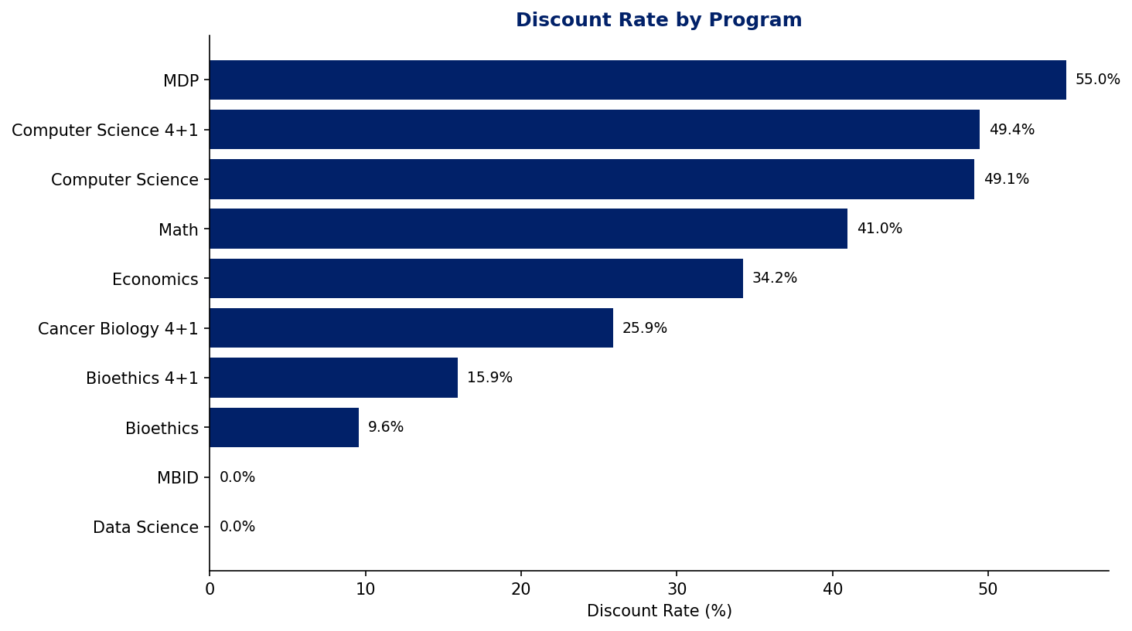
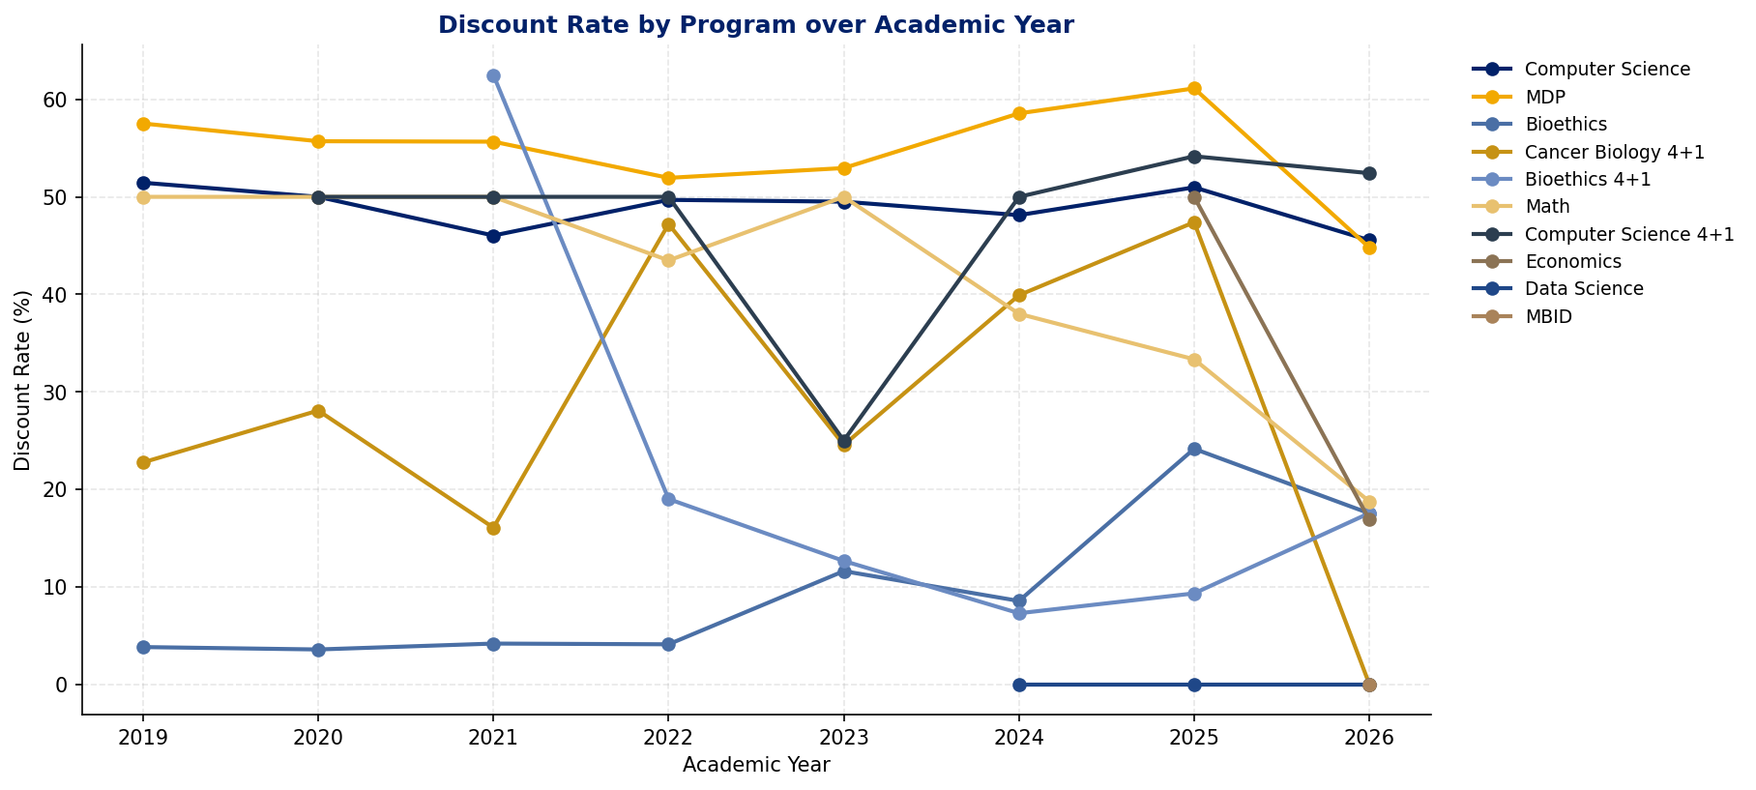

Gross vs Net Tuition
Sticker price and net price diverge most sharply for MDP ($108k gross → $49k net) and Computer Science ($66k → $33k). Programs with low or zero discount rates (Bioethics, Data Science, MBID) collect close to full sticker from every student. Gross-to-net gap is the clearest single view of where Emory is spending its tuition-discount dollars.
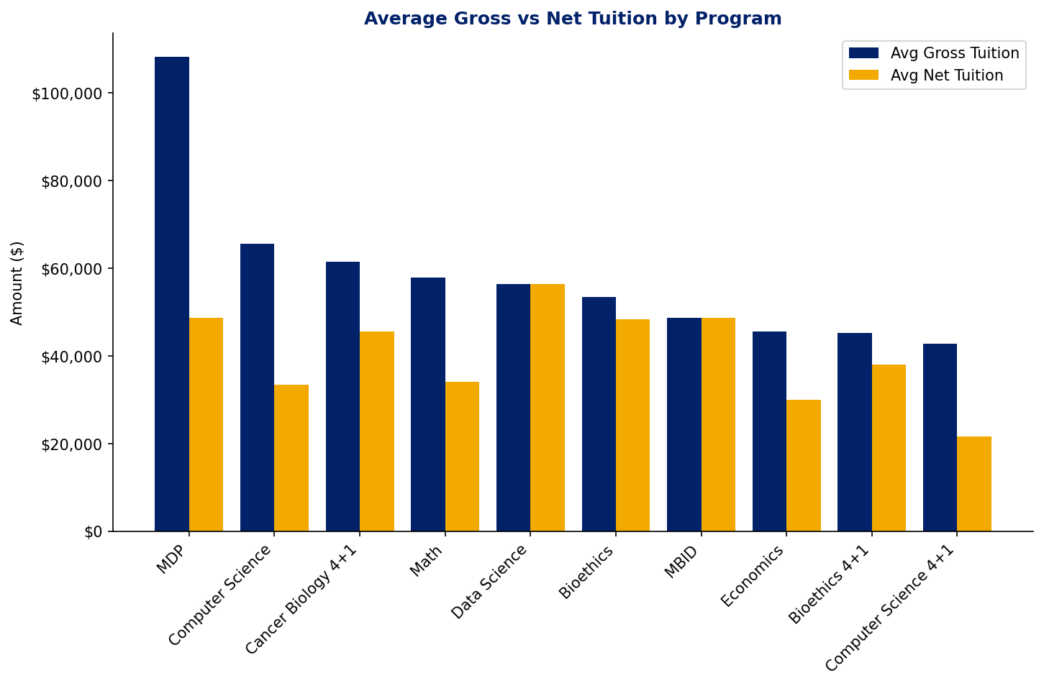

International Mix
Bubble size shows program enrollment; position shows international share vs discount rate. Computer Science is the clear outlier — 86% international yet still 49% discounted. Across the portfolio there is no inverse relationship between international share and aid: high-international programs are not systematically less aided, which contradicts the common assumption that international students primarily subsidize domestic ones.
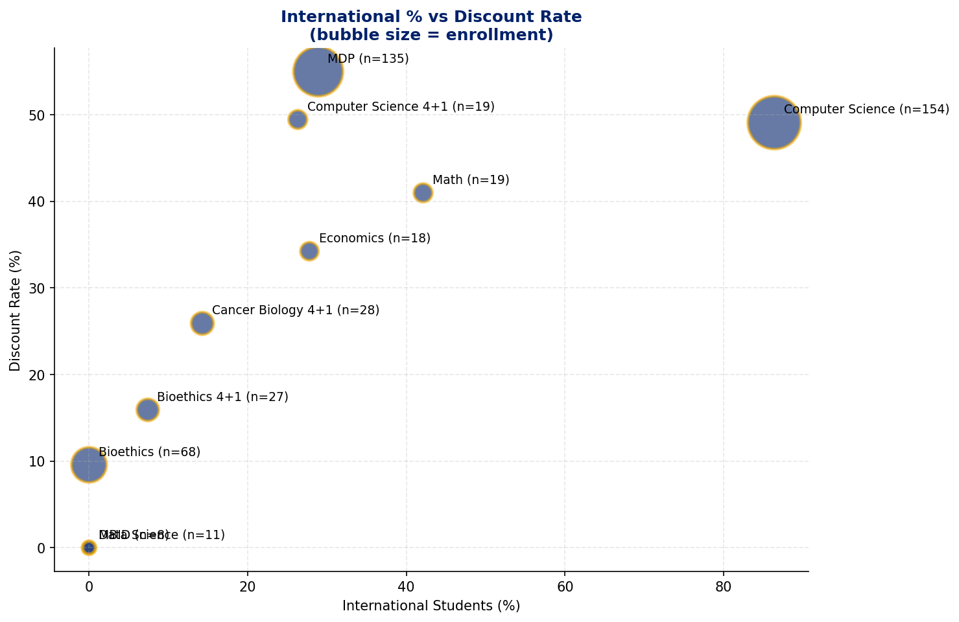

Enrollment Trends
The 8-year panel (AY 2019–2026) shows Computer Science climbing from the mid-30s to 60+ students per year, accounting for most of the overall growth in LGS master's enrollment. MDP remains Emory's other large program, steady in the 30–40 range per year. Smaller programs (Data Science, MBID, Economics) sit below 10 students per year throughout the window.
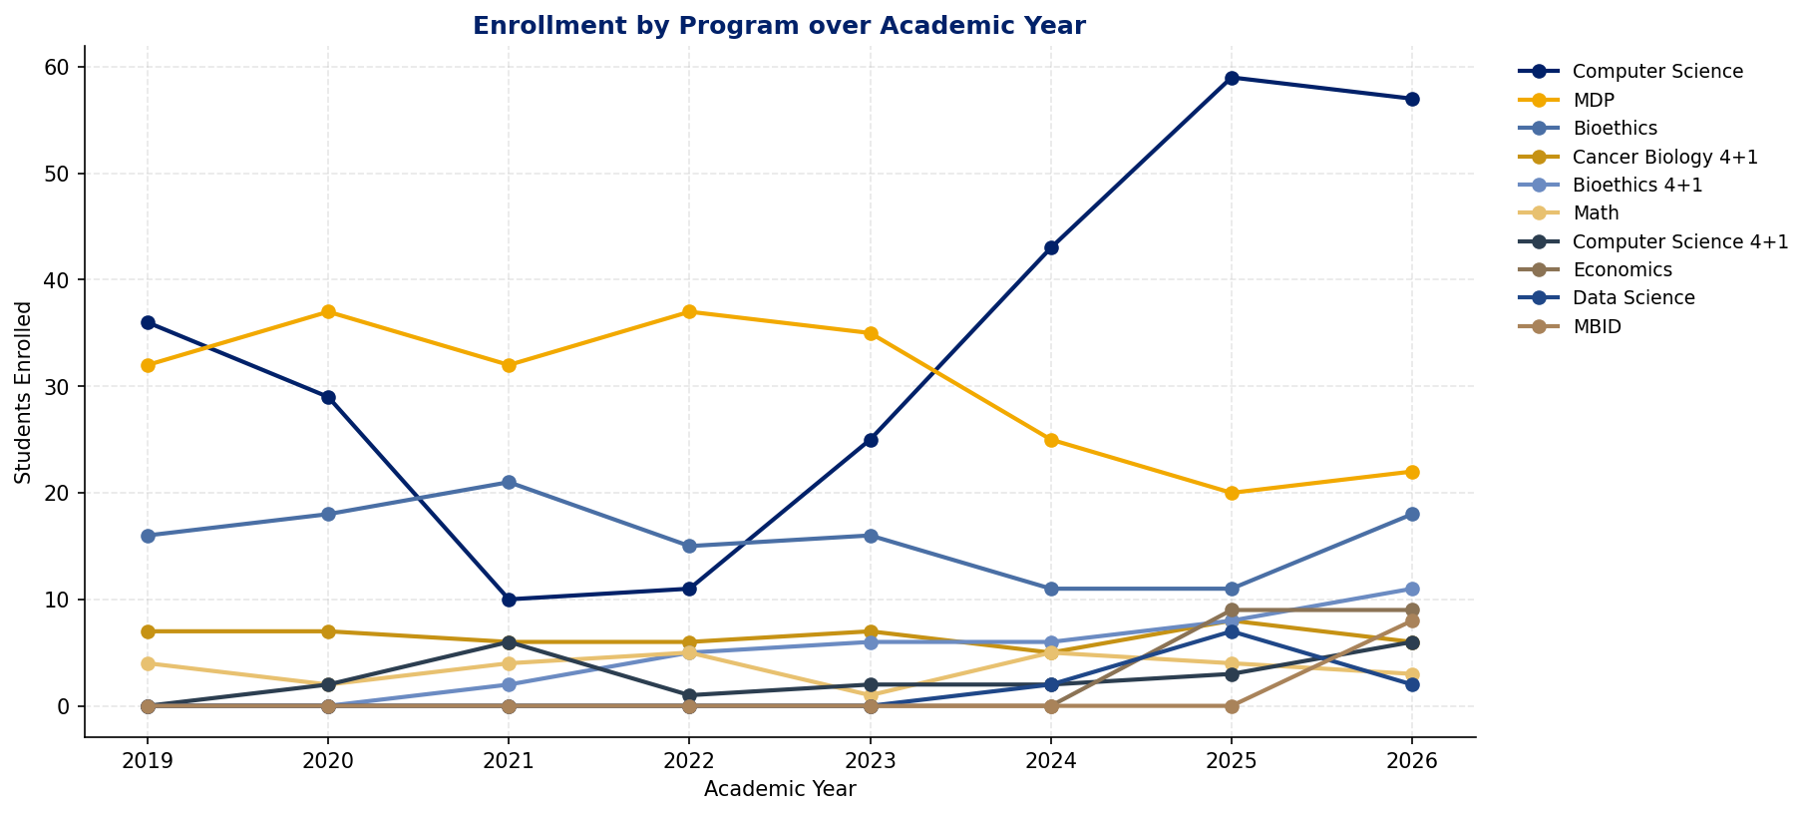

Peer Benchmarking
Using the corrected program-specific annualization, Emory's gross tuition sits firmly mid-pack: roughly $47–50k across Data/CS, Economics, and General program buckets. Columbia leads the peer set at $65–91k depending on discipline, with NYU close behind. Georgia Tech's in-state rates ($31–41k) undercut Emory in every bucket. The market splits into a high-tier (Columbia/NYU), a mid-tier (Emory), and a value tier (Georgia Tech).
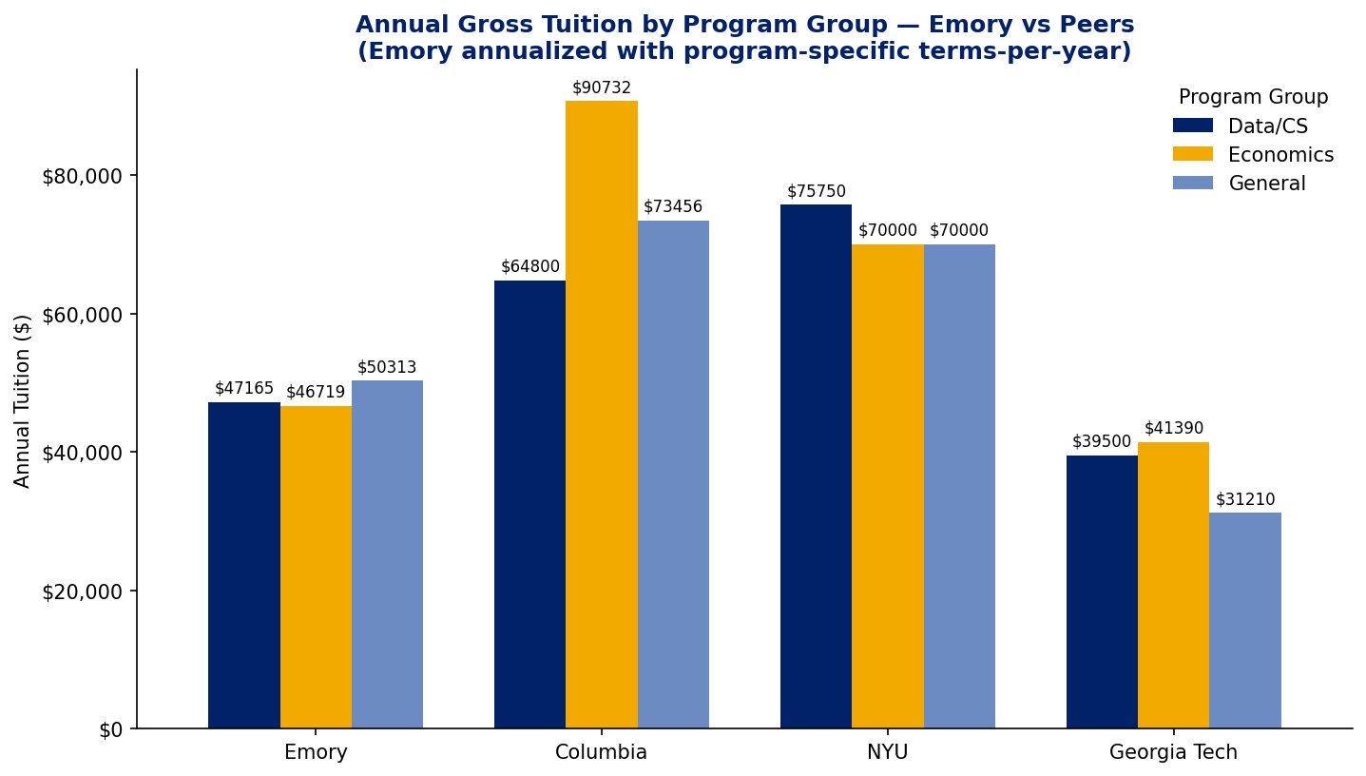

Data & Methodology
The analysis pipeline is implemented in analysis.ipynb and produces three Excel outputs (program_summary_output.xlsx, student_program_level_output.xlsx, and student_program_year_output.xlsx).
- Source data: institutional Excel exports of gross tuition billed and LGS scholarship awards; 8-year panel spanning AY 2019 through AY 2026.
- Net tuition is clipped at zero. In rare cases a kept scholarship exceeds billed tuition for a partial-term student; we report that student as paying $0 rather than a negative amount.
- Scholarship filter retains descriptions containing 'lgs' and drops external/federal awards (Pell, GRFP, Yellow Ribbon, Americorps, etc.) plus generic LGS 'special' awards, so discount rates reflect institutional aid only.
- Small-n programs are merged: ECONMS + ECON4P1MS → Economics; DATASCIMS + QTMMS → Data Science; DEVPRACMDP + HUMANRTCRT → MDP.
- Annualization for peer comparison uses program-specific terms-per-year (from the Information Sheet plus empirical seasonal distribution) rather than a blanket 2-term assumption. This corrects a ~33% understatement for 3-term programs such as MDP and Data Science.
- Programs with zero kept scholarship (Data Science, MBID) are retained in the summary with a 0% discount rate — this is intentional and flags potential pricing discrepancies.
Terms-Per-Year Lookup
acad_plan | terms/yr | source
COMPSCIMS, CS4P1MS, MATHMS, ECON4P1MS | 2 | Information Sheet (Fall-Spring)
BIOETHMA, BIOETH4P1, BMIDMS | 2 | empirical (Fall-Spring dominant)
ECONMS | 3 | Information Sheet (Summer-Fall-Spring)
DATASCIMS | 3 | Information Sheet (Fall-Spring-Summer)
QTMMS, DEVPRACMDP, HUMANRTCRT, BBS4P1MS | 3 | empirical (all three seasons ~equal)

