COPA input amplifier – Preliminary test summary

Results from the preliminary tests.
Tests date: 31-05-2024

Fundamental
1)
frequency 1 kHz
Amplitude (Vrms)1 V
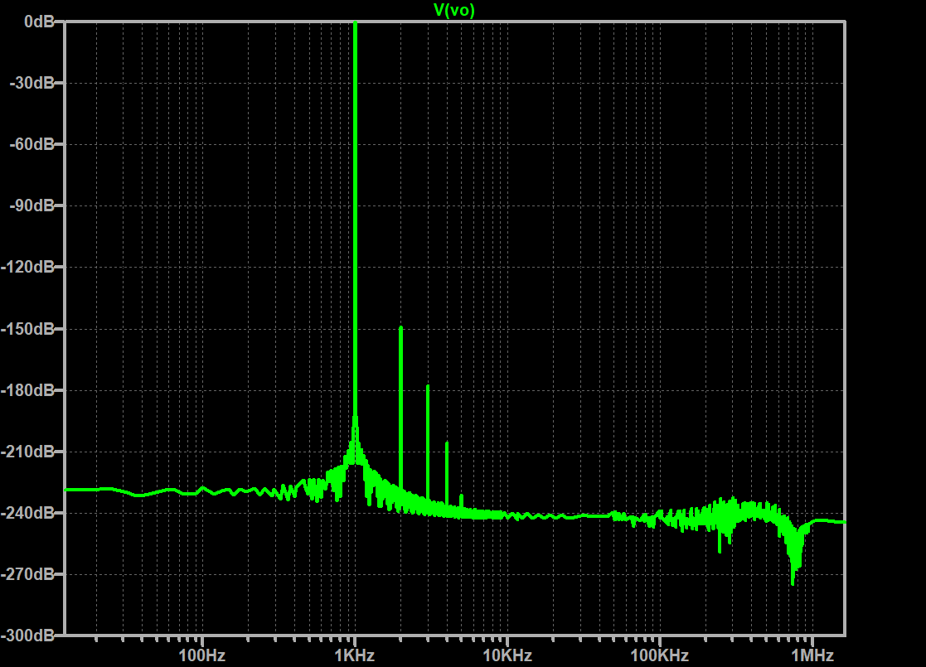
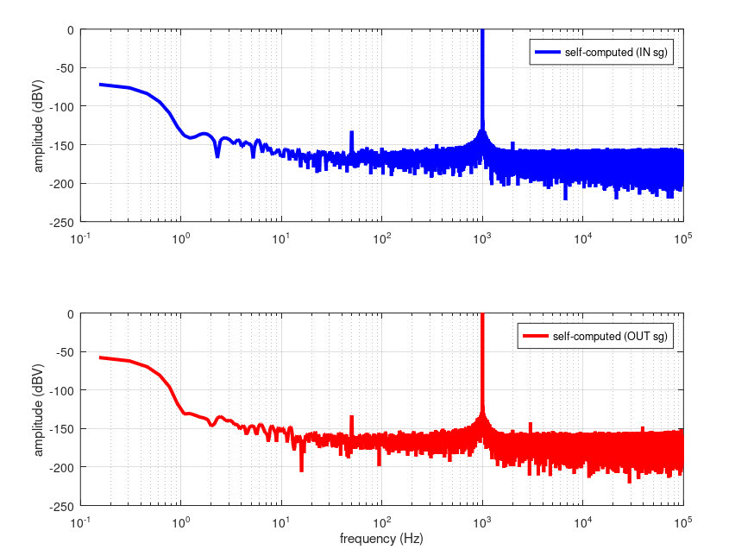

1000.2 0
2000.2 -152.96
3000.2 -144.66
4000.2 -163.63
5000.2 -159.78
6000.2 -165.8
7000.2 -164.39
8000.2 -163.73
9000.2 -166.4

Harmonic Frequency Fourier Normalized Phase Normalized
Number [Hz] Component Component [degree] Phase [deg]
1 1.000e+03 1.414e+00 1.000e+00 -0.01° 0.00°
2 2.000e+03 5.120e-08 3.622e-08 6.59° 6.59°
3 3.000e+03 1.809e-09 1.279e-09 -84.73° -84.73°
4 4.000e+03 7.521e-11 5.321e-11 -172.02° -172.01°
5 5.000e+03 3.044e-12 2.154e-12 82.82° 82.82°
6 6.000e+03 1.220e-12 8.633e-13 -9.16° -9.15°
7 7.000e+03 1.205e-12 8.528e-13 -12.36° -12.36°
8 8.000e+03 1.384e-12 9.788e-13 -8.30° -8.29°
9 9.000e+03 1.675e-12 1.185e-12 -10.02° -10.01°
Total Harmonic Distortion: 0.000004%(0.000000%)

2)
frequency 1 kHz
Amplitude (Vrms) 5 V
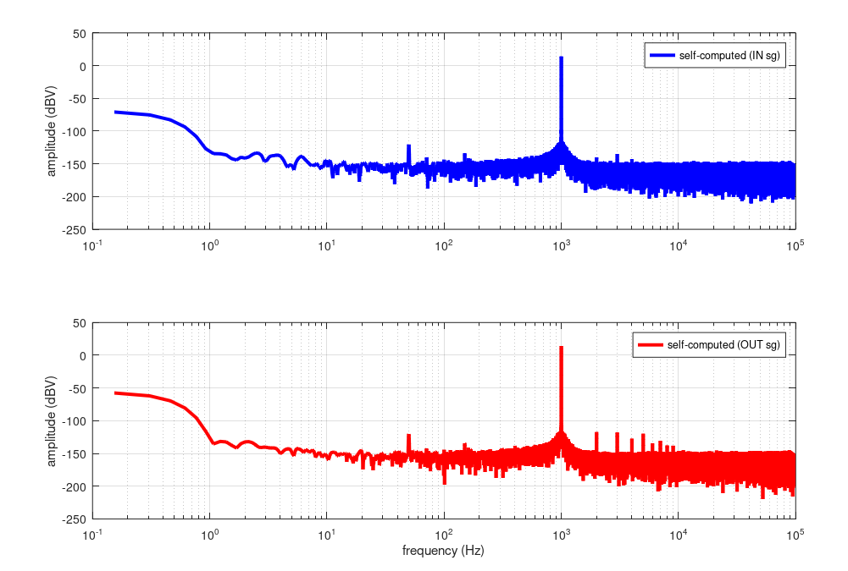
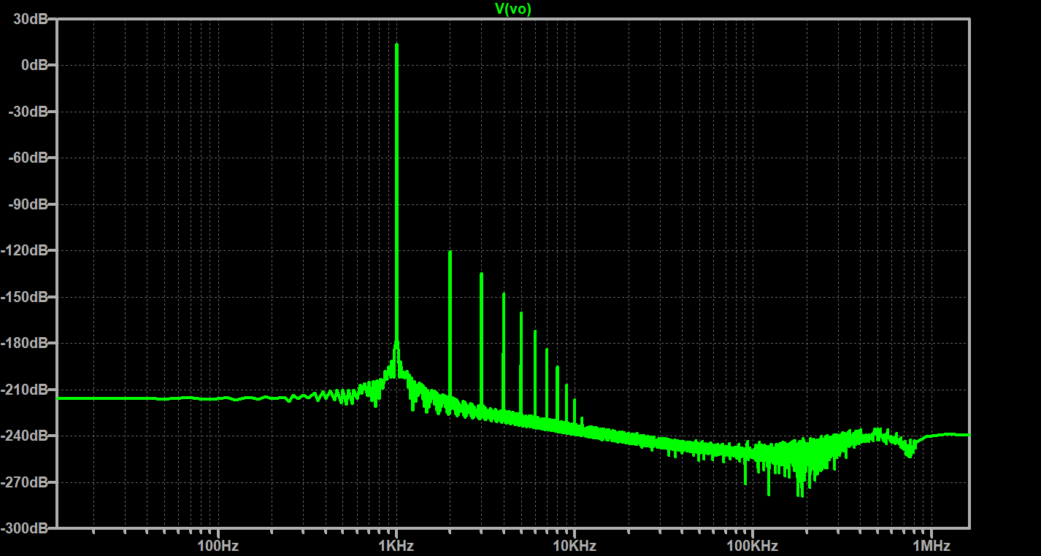

Table:
f (Hz) dBc
1000.2 0
2000.2 -131.27
3000.2 -134.25
4000.2 -146.23
5000.2 -142.71
6000.2 -163.89
7000.2 -166.89
8000.2 -169.80
9000.2 -170.66

Harmonic Frequency Fourier Normalized Phase Normalized
Number [Hz] Component Component [degree] Phase [deg]
1 1.000e+03 7.068e+00 1.000e+00 -0.01° 0.00°
2 2.000e+03 1.384e-06 1.958e-07 6.23° 6.24°
3 3.000e+03 2.622e-07 3.711e-08 -84.82° -84.82°
4 4.000e+03 5.915e-08 8.369e-09 -172.34° -172.33°
5 5.000e+03 1.430e-08 2.023e-09 99.21° 99.21°
6 6.000e+03 3.619e-09 5.121e-10 10.82° 10.83°
7 7.000e+03 9.403e-10 1.330e-10 -77.50° -77.50°
8 8.000e+03 2.425e-10 3.431e-11 -166.06° -166.05°
9 9.000e+03 6.543e-11 9.257e-12 98.23° 98.23°
Total Harmonic Distortion: 0.000020%(0.000000%)

3)
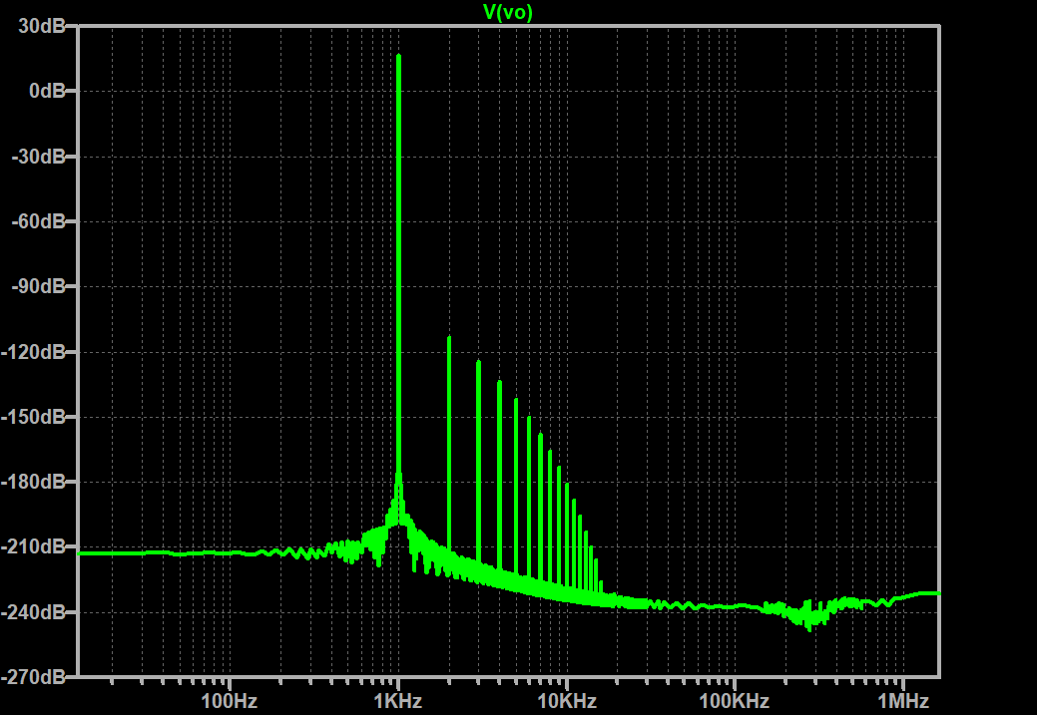
frequency 1 kHz
Amplitude (Vrms) 7 V

Harmonic Frequency Fourier Normalized Phase Normalized
Number [Hz] Component Component [degree] Phase [deg]
1 1.000e+03 9.895e+00 1.000e+00 -0.01° 0.00°
2 2.000e+03 2.995e-06 3.027e-07 5.82° 5.82°
3 3.000e+03 8.716e-07 8.809e-08 -84.94° -84.93°
4 4.000e+03 3.030e-07 3.063e-08 -172.63° -172.62°
5 5.000e+03 1.133e-07 1.145e-08 98.87° 98.88°
6 6.000e+03 4.440e-08 4.488e-09 10.41° 10.42°
7 7.000e+03 1.790e-08 1.809e-09 -78.27° -78.26°
8 8.000e+03 7.360e-09 7.439e-10 -166.92° -166.92°
9 9.000e+03 3.079e-09 3.111e-10 104.06° 104.07°
Total Harmonic Distortion: 0.000032%(0.000000%)

