Introduction to Hypersonic Flow:
Semester Project Report over HyShot II Test Section
Ryan John Krattiger (Student)
12377991, rjk9w5@mst.edu

[Abstract section to come in final report]

Nomenclature
α = angle of attack
θ = flow deflection angle
C_{p} = pressure coefficient
V = velocity magnitude

Introduction
The project geometry selected was chosen for its historical importance in the study of flight in the hypersonic flow regime as the first SCRAM jet to operate in the upper atmosphere.

Project Description

HyShot program
The HyShot program was started by The University of Queensland in Australia in order to test scramjet engine configurations. After an initial failure of the first HyShot sounding rocket, HyShot II became the “first” successful flight of a scramjet engine on 30 July 2002. The claim to be the first is disputed primarily by Russian scientist who reportedly performed test earlier; either way, it was a remarkable achievement for the field as its data gave the first good look at the conditions experienced inside of a scramjet engine in flight.
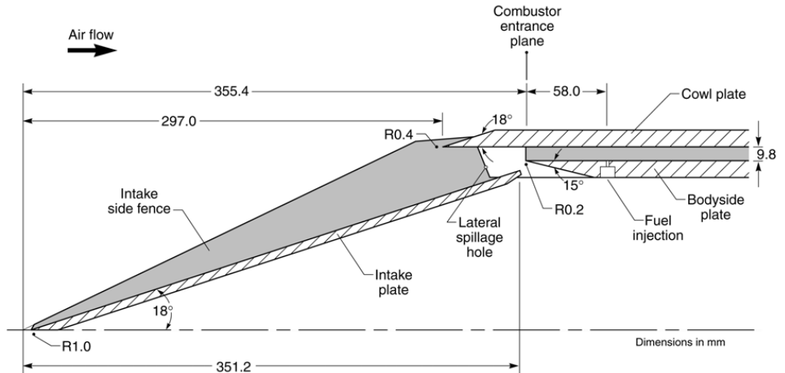Figure 1.Schematic of Scramjet Geometry et al Hass

GeometryTo the right in figure 1 a side veiw of the HyShot II test section is pictured. The geometry of the system will be modeled as a sharp, 2D wedge in order to simplify the analysis. This assumption is similar assumptions made by Hass et al. These assumptions can further be backed by the fact that there are walls on either side of the intake plate to prevent slipping off of the wedge. It is important to consider also that the walls also contribute to the boundary layer region, as a result the center of the wedge will have the closest relation to the results found in this report.Flight Conditions
The flight trajectory for HyShot II was highly parabolic. The flight path angle in the region where the test was made was approximately 69.5 degrees at 35 km with a free stream Mach number of roughly 7.75. These values were deduced from trends discussed in reference 2.

Flight Conditions

Methods Used
1) Newtonian Method

The Newtonian method is an excellent example of how theories found wrong in one era can find use in another. Newton proposed a model of fluid flow in which gas molecules are modeled as round balls that travel uniformly. When they collide with a surface they lose all of their velocity normal to the surface and continue to travel tangent to the wall they collided with. This ends up giving predictions of unacceptable error in low speed flow cases due to the neglect of random motion in the path of the molecules. As it was found later, Newton had found a very good model for the prediction of the pressure coefficient in hypersonic flow, which would not been considered as a flow regime until long after his time. The derivation of Newtons sine-squared law (Newtonian Method) can be found in reference 1. The resulting equation can be seen here in equation 1.

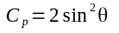 (1)
where theta is the flow deflection angle.

2) ...

Discussion

Conclusions

References
¹Anderson, John D., Jr. Hypersonic and High Temperature Gas Dynamics. McGraw-Hill, 1989. Print, Chaps 2, 3, ….

²Hass, Neal, Michael Smart, and Allan Paull, “Flight Data Analysis of the HYSHOT 2,” AIAA/CIRA 13th International Space Planes and Hypersonic Systems and Technologies Conference (2005): n. pag. Web

³Pecnik, Rene, Vincent E. Terrapon, Frank Ham, Gianluca Iaccarino, and Hienze Pitsch, “Reynolds-Averaged Navier-Stokes simulation of the HyShot II Scramjet Part 1: Numerics and non-reactive simulations,” AIAA Journal, Vol. 50, No. 8, 2012, pp. 1717-732. Web.

⁴HCain, T., Owen, R., and Walton, C., “HYSHOT-2 Aerodynamics,” Proceedings of the Fifth European symposium on Aerothermodynamics for Space Vehicles (ESA SP-563). 8-11 November 2004, Cologne, Germany. Editor: D. Danesy., p. 229

Senior Undergraduate Student, Department of Mechanical and Aerospace Engineering

