# AWS Non-Bastion Host Supplemental Document

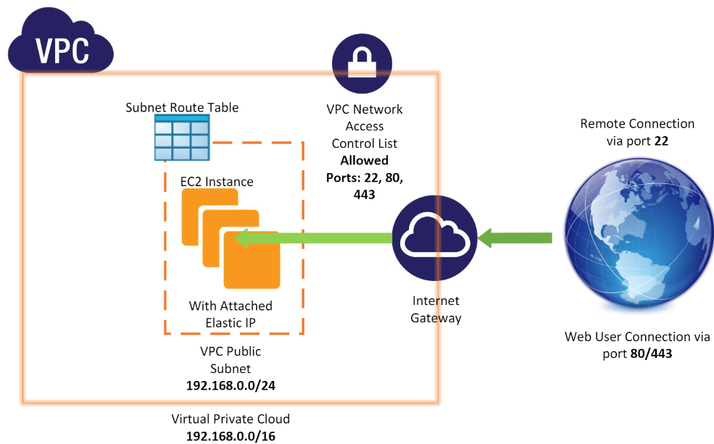

Virtual Private Cloud:

* 192.168.0.0/16 CIDR block allows for additional subnets in the future
* Network ACL restricts ingress/egress traffic to specified ports (22, 80, 443), may limit IP range to only accept SSH connections originating from the worksite

VPC Public Subnet:

* 192.168.0.0/24 CIDR block allows for 254 host IP addresses assignable
* Subnet Route table will be a custom addition in CloudFormation to interface with the Internet Gateway to allow connectivity to and from the EC2 Instance

Internet Gateway:

* Bridges the gap between the internet and the Virtual Private Cloud
* Performs NAT for the EC2 Instance’s public IP address

EC2 Instance:

* Equipped with an Elastic IP address (EIP), a static public IP address assigned to your AWS account until released
* Linux instance able to serve web traffic and support SSH connections for remote access