**Testing an all zero array**

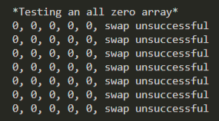

**Testing a decreasing order array from 7 to 0**

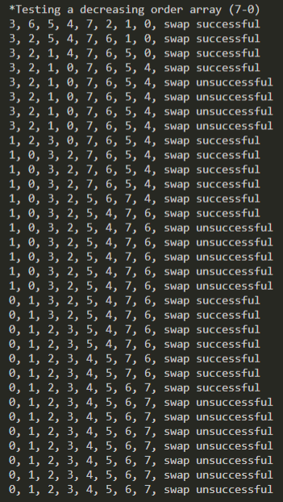

**Testing a negative array from 0 to negative 5**

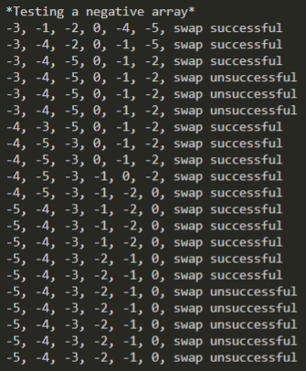

**Testing a random array with max element value of 100**

