Yugyung Lee
Tuesday - for lecturing, presentation, theory, Thursday - tutorial, “ICP” evaluation.
Time management, project management, and people management.
Your projects should be something different; not something somebody else has done.
Hackathon in November as part of the grade.
Form a team as soon as possible. 3 to 4 students (3 min, 4 max)

Project, have proposal, incremental development.

No late submissions.

“UML is important” - I’ve never used it in professional life.

2 team members for lab, ICP
4 for the project

About 12 journal articles to read and respond to.

Raj Anantharaman
Today’s lecture: https://umkc.app.box.com/s/xlj868gczm14yxry8jt087uucz7raus7
MEAN stack: The MEAN stack is MongoDB, Express.js, AngularJS (or Angular), and Node.js
The domains he wants us to work on:
Healthcare Digital Marketing Agriculture
Animal Health Engineering Telecommunication
Can work on a domain outside of that. E.g., Higher education.

Journals - Between now and next class, he will add guidelines for journals. Your presentation should be focused on elements in the guideline. Respond with critique, innovative ideas.
Team assignments for Journals are randomly picked, same group as your project team.

Exams may have information from the papers.
Lab assignments and 10 in class ICP (in class programming).
- ICP is individual; each person submits one.
- Lab can work with team; one submission per team.
Problem sets are extra credit.
Tutorials are due the day after.

At end of tutorial, submit feedback/attendance.

Project plan…
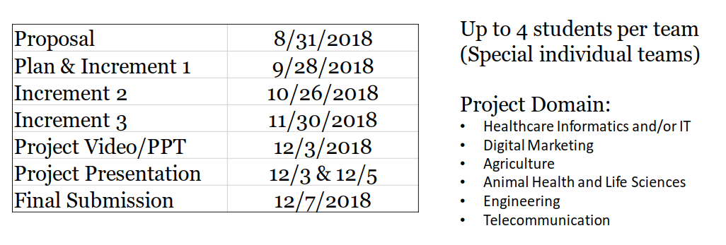
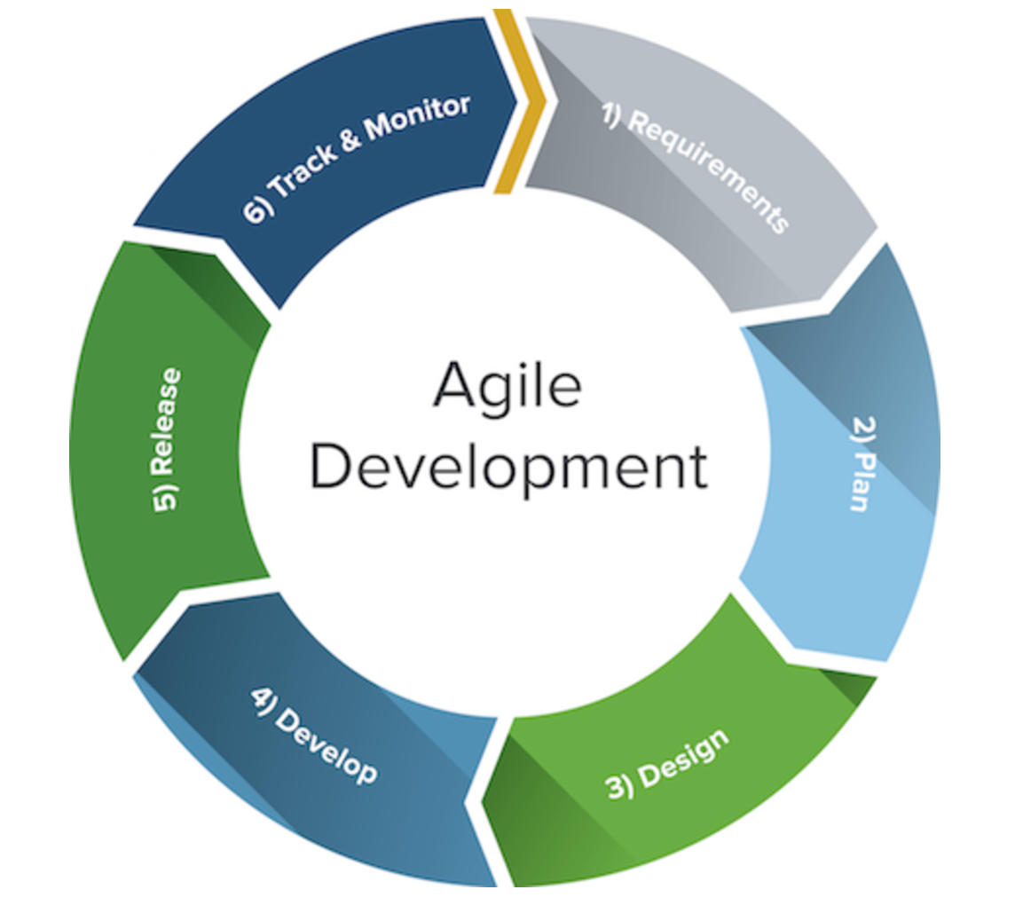
Try to identify project by Aug 31st. Have to record presentation ahead of time.

Infrastructure as a Service
Platform as a Service
Software as a Service

